

**Learner’s Workbook**

**A POSITIVE RESPONSE TO COVID-19**

**PROJECT-BASED LEARNING | LIFE ORIENTATION**

**GRADE**

**11**

**Learner’s Workbook**

**GRADE 11 Life Orientation**

**E³ PROJECT FOR TRIMMED ATP**

**A positive response to COVID-19**

COVID-19 SERIES | LEARNER’S WORKBOOK | GRADE 11

3

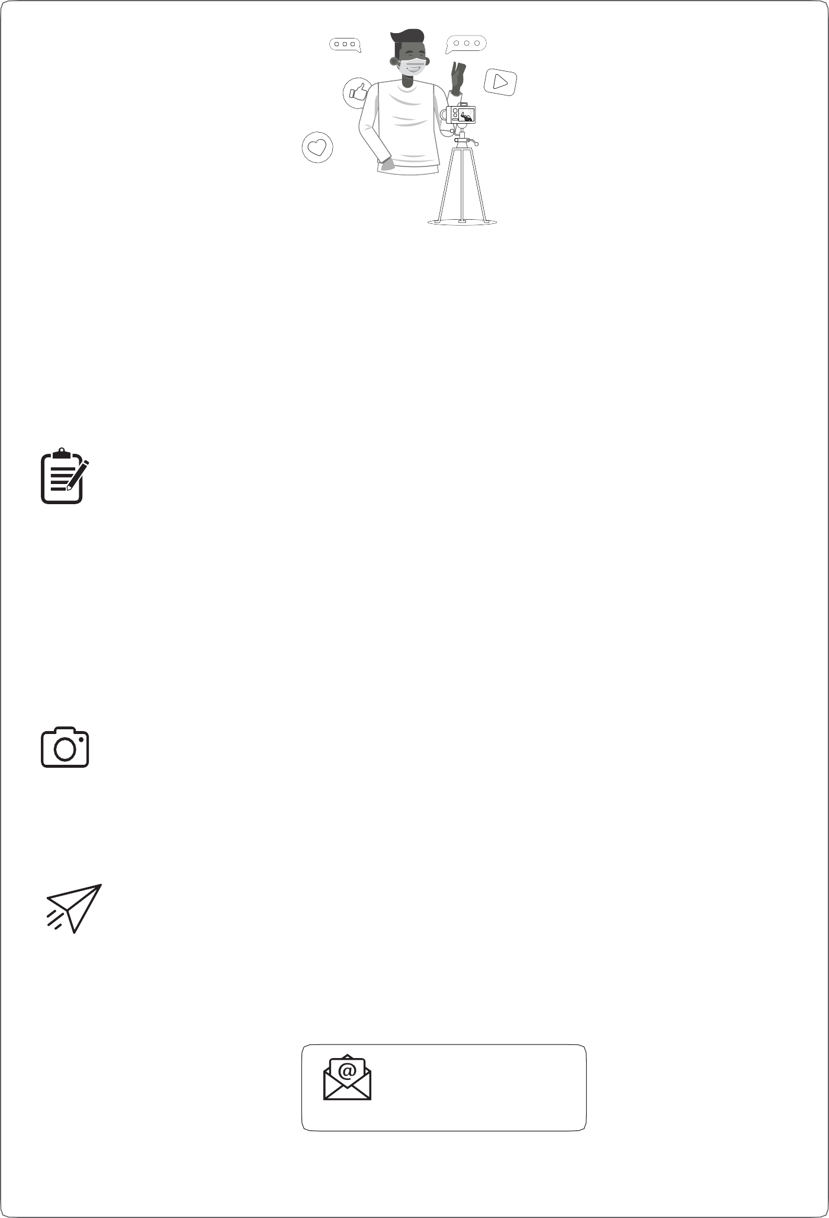

**Please send us pics/videos for our Facebook/Website**

**Send your pictures and videos!**

Dear learner

We are so excited to see your project and we would like you to share it with us so that we can profile it on our website and possibly on Facebook or Instagram. To do that, please follow these instructions very carefully.

**HOW TO PUT TOGETHER YOUR INFORMATION:**

**Tell us about your project:**

1.

2.

3.

4.

5.

6.

7.

Product or service you created:

Name of learner:

School:

Grade:

Describe your project (50 – 100 words).

Describe the biggest challenge you had doing this project (50 – 100 words). Describe what you would do better next time (50 – 100 words).

**Choose the right photographs to tell the story of your project**

1.

2.

3.

Choose three photographs that tell the story and progress of your project. Make sure that no-one’s face is clearly visible unless they are wearing masks.

Make sure the picture is in focus and clear.

**How to send your submission:**

1.

2.

3.

All submissions must be in a word document and the pictures must be in the document. You can send it to us on email.

You can email it yourself, or you can ask your parent/caregiver or teacher to do this for you. You must use this subject line on the email: Learner Project Grade 11 LO.

[info@ecubed-dbe.org](mailto:info@ecubed-dbe.org)

Email

If needed, we might ask you to make some changes to your submission in order to make it ready for uploading onto our website.

4

PROJECT-BASED LEARNING | LIFE ORIENTATION

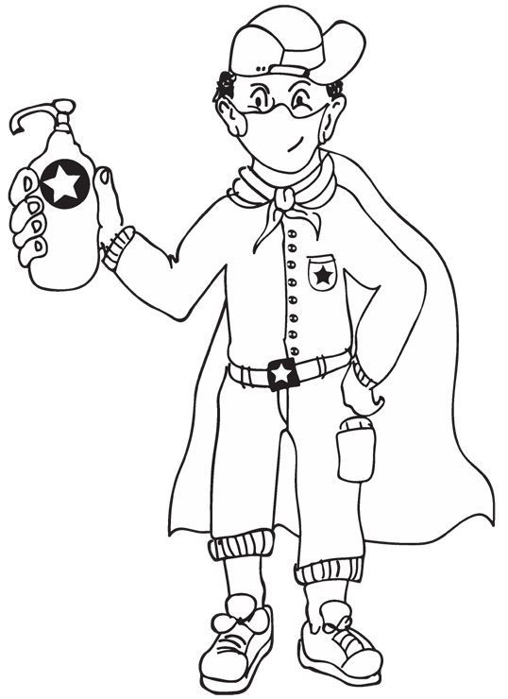

**Introduction**

Dear Grade 11 learner

Due to the COVID-19 pandemic, we have been at home for a very long time. We hope that you’ve reconnected with your family during these times, and are looking forward to school. School is going to be different, especially during group work. We know that learning is social, you have to chat to people for deeper learning. During the COVID-19 pandemic your discussion group will be a buddy-guard (one friend with whom you can discuss everything in class), your teacher and don’t forget that your family at home is also a good sounding board – to share ideas and ask for help with your project.

**Your task**

Together with your class mates, you will work on one of three possible projects for Life Orientation this term:

**Project 1:**

Compile a brochure including pictures and graphs, and some positive outcomes

on the socio-economic impact of COVID-19 on the lifestyle choices of South African youth Research how to find a job during COVID-19

Learn about managing your finances as a young adult.

**Project 2:**

**Project 3:**

**Resources to help you**

There are many resources at the end of this booklet. Make good use of them. It will help you to work independently. Let’s get going!

**Your support people:**

Choose one **buddy-guard**, someone with whom you can discuss everything in class.

Who is your buddy-guard?

What is your buddy-guard’s address or cell number?

Why did you choose him/her as a buddy-guard?

Who in your **family** is your advisor?

How will you get hold of your **teacher** if you need him/her?

Teacher’s cell number:

COVID-19 SERIES | LEARNER’S WORKBOOK | GRADE 11

5

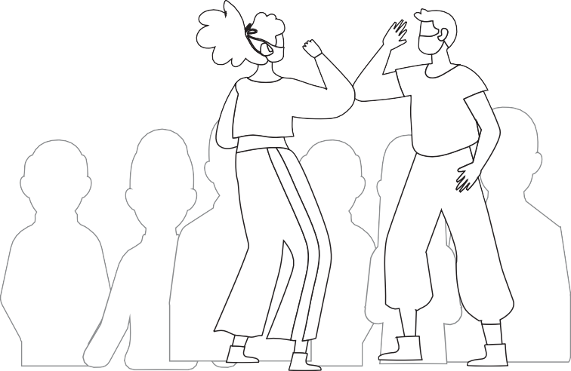

**PROJECT 1: Creating a brochure on the socio-economic impact of COVID-19 on the lifestyle choices of South African youth**

**STEP 1 – PLANNING**

✪ **Activity 1: Watch a video or read an article about COVID-19**

Read an article or watch a video about the socio-economic impact of the COVID-19 virus on South Africa. Please make notes while you are watching, **especially noting how the epidemic could be influencing your lifestyle and the income of your caregiver.**

✪ **Activity 2: Create a Mind Map of COVID-19**

What comes to mind when you think about COVID-19? Brainstorm with your buddy-guard (observe social distancing) and create a mind map in the space provided below.

 **NOTE: This is your baseline assessment. Researchers, like yourself, use baseline assessment to find out what information is out there so that you can use it to inform your own research.**

6

PROJECT-BASED LEARNING | LIFE ORIENTATION

✪ **Activity 3: Identify what puzzles you about COVID-19**

Create 4 questions about the “new normal” (life with COVID-19) that you really need answers to, especially as it affects yourself, your family, your future:

3.1

3.2

3.3

3.4

3.5

How do you think we can use the “new normal” and what we see around us to grow and get stronger?

3.6

Name three positive things that have emerged from the pandemic:

COVID-19 SERIES | LEARNER’S WORKBOOK | GRADE 11

7



3.7

What new ideas has COVID-19 activated that will help you reassess your future?

Your teacher has created a *Wh*-wall, for all your What, Why, When and Who-questions. Also create How? questions if you wish!

If you have any questions about schoolwork, the project, or personal dilemmas, please feel free to put it up on the wall.

 *A lifestyle choice is a personal and conscious decision to behave in a certain way and make choices according to your belief system.*

*Examples of lifestyle choices are*

* *living a fitness lifestyle that involves strict dieting,*
* *choosing not to drink any alcohol,*
* *education before entertainment,*
* *deciding to stay in a polygamous (one partner) partnership, etc.*

**STEP 2 – RESEARCH/FINDING OUT**

✪ **Activity 4: Discuss the lockdown and its effects on your personal lifestyle with your buddy-guard.**

**Answer the questions below.**

4.1

When was the lockdown introduced and why?

4.2

How did the lockdown affect your community and your personal life?

8

PROJECT-BASED LEARNING | LIFE ORIENTATION

HOW?

Thus my research topic is...

The **Big Question** for this project is...



4.3

During lockdown I felt:

4.4

How did it affect your family? My family reacted in the following way:

4.5

Did it achieve its intended outcomes? Explain and give examples.

4.6

What have you learned about yourself during lockdown?

Before lockdown I was:

Now I am:

Remember to use the Wh-wall for all your What, Why, When and Who-questions. You don’t have to write your name.



✪ **Activity 5: Conduct Interviews**

You are going to interview 2 business people and 2 households on the socio-economic impact of COVID-19 on

their families and on their businesses. Prepare at least 5 questions for each. You need to plan the interviews well in advance and **consider safety measures**: Use your phone (call or WhatsApp), or drop a questionnaire

and collect it later. If possible, record live interviews so you can refer to them later.

**Remember to keep your distance and wear your mask when conducting interviews. This is for your safety, and that of others.**

 Referencing Interviews: When you conduct an interview, remember to reference it as follows: Name of interviewee, Place of interview, date. E.g. Mrs E. Jantjies, Kimberley, 15 July 2020.

QUESTIONS FOR THE HOUSEHOLDS

1

2

3

4

5

COVID-19 SERIES | LEARNER’S WORKBOOK | GRADE 11

9



QUESTIONS FOR THE BUSINESSES

1

2

3

4

5

**Activity 6: Reflect on the interviews**

✪

Reflect on how you conducted the interviews. Did you enjoy them? Did the questions yield the answers you expect- ed? Were they successful and what would you do differently next time?

 Remember to make use of the Wh-wall for any question you might have, even if it’s personal. You need not sign your name if you choose not to.

✪ **Activity 7: Prepare a presentation**

Prepare a presentation for the class (use PowerPoint if available) on your findings.

 **Note: Find sources on how to prepare a presentation in your Resource Library at the back of this booklet.**

**STEP 3: MAKING AND SHOWING THE EVIDENCE**

**Activity 8: Plan your outline**

Collect brochures from different places to look for key features (lay-out and short copy) of a brochure. Start putting down ideas for your own brochure. Look for pictures for each sub-heading. Use resources for brochure design at the back of this booklet.

10

PROJECT-BASED LEARNING | LIFE ORIENTATION

Analysing the evidence: Read through all your notes based on interviews and observations and write down key features. This is the information that you will include in your brochure.

Start planning your outline below:

COVID-19 SERIES | LEARNER’S WORKBOOK | GRADE 11

11

Make a list of the resources your will need to make this brochure, e.g. A3/A4 paper, pens, etc.

Conclusion (back page)

Body (includes actual discussion on socio-economic effects of COVID-19 on the youth, career and entrepreneurial opportunities)

Introduction (front page)



**Who gave feedback**



**STEP 4: GETTING FEEDBACK AND CHANGING IF YOU NEED TO**

✪ **Activity 9: Get feedback**

Once you’ve got your first draft, try to get feedback so you can change or improve your product. Because of COVID- 19, you will have to ask your buddy-guard, parents and people that are safe to ask for their impression.

Listen to useful information to improve your brochure. Say what they advised and what you did. Get at least 3 people to give you feedback.

Write down what you changed, when you made changes and why:

**STEP 5: FINISHING OFF YOUR PROJECT**

✪ **Activity 10: Finish the project**

Using all the feedback and what you have learned after trying to improve your product, finish off your project item’s layout and design (fold type etc.) and the writing that goes with it. Complete your project.

Do it on A3 paper if possible, and do it one-sided, so that both sides can be viewed by the public. Your teacher will put it on the project wall at school.

 **NOTE:** Please make sure to add your WhatsApp number and name to your work for people to be able to give feedback.

**STEP 6: SHOWING OFF YOUR PROJECT**

✪ **Activity 11: Display of brochures and celebrating your achievement**

Who saw your project and what did they say about it? Ask at least 4 people. Write down their views or ask them to leave notes or send voice-notes.

 **NOTE:** Please make sure to add your WhatsApp number and name to your work for people to be able to give feedback.

12

PROJECT-BASED LEARNING | LIFE ORIENTATION

**Date of advice**

**What they said I should do**



Include a picture of the celebration (photo or a drawing).

**STEP 7: THINKING ABOUT IT AFTERWARDS**

✪ **Activity 12: Reflection**

Take your time to reflect on the academic and personal lessons you have learned by doing this project.

**REFLECTION 1 (Academic)**

The problem:

The solution:

COVID-19 SERIES | LEARNER’S WORKBOOK | GRADE 11

13

**Who gave feedback?**

**Score /7 and the reason**

The steps I went through to reach/make the solution:

My challenges:

I rate my final product as /7 because:

**REFLECTION 2 (Personal)**

1.

What did you love about working on this project?

2.

What made this project hard for you?

3.

What did you learn by working on this project?

* About yourself?
* About learning during COVID-19?

4.

What would you do differently if you did a project like this again?

14

PROJECT-BASED LEARNING | LIFE ORIENTATION

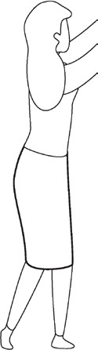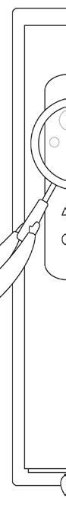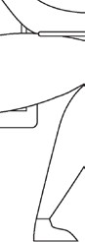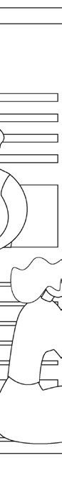

**PROJECT 2: How to find a job during COVID-19 – CVs, cover letters and interviews**

During this project you will research how to find and apply for a job during COVID-19 times. You will also compile your CV (Curriculum Vitae), write a cover letter in reply to a mock advertisement and prepare for the interview.

**STEP 1 – PLANNING**

✪ **Activity 1: Start with a discussion**

You will have a discussion in class about the pressures COVID-19 has placed on the job market. Do you have any per- sonal experience in this regard? Do you know of someone who has lost their job or are working for a smaller salary?

Please share your experience below:

How did these persons stay motivated?

✪ **Activity 2: Prepare the Big Question**

When we do research, it is imperative to start with a BIG question we would like to answer. Write your big question in the block below.

COVID-19 SERIES | LEARNER’S WORKBOOK | GRADE 11

15



**STEP 2 – RESEARCH/FINDING OUT**

✪ **Activity 3: Creative Thinking Exercise**

What are the normal resources one would use to look for a job? List at least 5 methods:

1.

2.

3.

4.

5.

NOW, with your buddy-guard, try to think of 10 NEW methods to look for a job during these times. Even if they sound odd, don’t give up until you have at least 10 ideas.

1.

2.

3.

4.

5.

6.

7.

8.

9.

10.

**Activity 4: How did they do it?**

✪

Do you know about something who did something extraordinary to get a job or stand out in a crowd of applications? Please write a short explanation below.

Now look for videos or stories of people online who went the extra mile to secure a job. What did you find?

When you apply for a job, there are three things you can get ready before application. What are those three things?

1.

2.

3.

16

PROJECT-BASED LEARNING | LIFE ORIENTATION



**STEP 3: MAKING AND SHOWING THE EVIDENCE**

✪ **Activity 5: Prepare your CV**

Your teacher will give you some mock advertisements (adapted from real job sites) to apply for. Look for good exam- ples of CVs and cover letters to polish your application. Start writing your CV in the space below.

✪ **Activity 6 – Decide on a job**

Which job are you going to apply for? Write it down below.

COVID-19 SERIES | LEARNER’S WORKBOOK | GRADE 11

17



✪ **Activity 7 – Produce a cover letter**

Carefully read the advertisement again. Are there any specific things you have to account for in your application? Keep them in mind when you start planning your cover letter below.

✪ **Activity 8 – Interview time**

With your buddy-guard, start role-playing the interviews as you imagine they would take place. You are the manager who interviews your buddy-guard for his/her job application. Then switch sides and act as the applicant. Study the advertisements carefully. What specific questions can you ask during the interview that fits in with the company and job offer? Write these down:

1.

2.

3.

**Activity 9 – Preparation is everything!**

✪

Find good sources (have a look at the Learner’s Resource Library at the back of this booklet) about preparing for an interview. What have you learned about preparing for the best interview?

Write down some ideas that appealed to you.

18

PROJECT-BASED LEARNING | LIFE ORIENTATION



**Now use these ideas when you do mock interviews with your buddy-guard**. Make WhatsApp/Cellphone videos of your interviews. It will take a few takes to perfect it. Practice in front of the mirror at home until you get it right.

**STEP 4: GETTING FEEDBACK AND CHANGING IF YOU NEED TO**

✪ **Activity 10 – Get feedback**

Show your CV, rough cover letter and video interview to family members at home. Ask for feedback on what to change. They can fill in this form:

Are you happy with the feedback? Why, or why not?

Why do YOU think feedback is important?

COVID-19 SERIES | LEARNER’S WORKBOOK | GRADE 11

19

**Date of advice**

**Who gave feedback**

**What they said I should do**





**STEP 5: FINISHING OFF YOUR PROJECT**

✪ **Activity 11: The final steps**

Now it is time to put the final package together. You will shortly show off your work to the rest of the school. Brainstorm ideas with your class and teacher about how to present your work to younger grades or other teachers, or even parents (if they are allowed to visit).

Use this checklist to finish off your project. Add more items if necessary:

**STEP 6: SHOWING OFF YOUR PROJECT**

✪ **Activity 12: Setup**

Help your teacher to set up the space where you will be showing off your project. Follow COVID-19 regulations to keep everyone safe.

What are you excited about?

What are your fears?

**STEP 7: THINKING ABOUT IT AFTERWARDS**

✪ **Activity 13: Reflect on the process**

**REFLECTION 1 (Academic)**

The problem:

20

PROJECT-BASED LEARNING | LIFE ORIENTATION

**Nr**

**Item**

**Done**

1.

CV complete, all changes made

2.

CV typed out or written out neatly with no mistakes

3.

Cover letter final copy written out neatly

4.

Best video take saved for playback

5.

6.

The solution:

The steps I went through to reach/make the solution:

My challenges:

I rate my final CV as /7 because:

I rate my final cover letter as /7 because:

I rate my final video interview as /7 because:

**REFLECTION 2 (Personal)**

What did you love about working on this project?

What made this project hard for you?

What did you learn by working on this project?

* About yourself?

* About learning during COVID-19?

What would you do differently if you did a project like this again?

COVID-19 SERIES | LEARNER’S WORKBOOK | GRADE 11

21

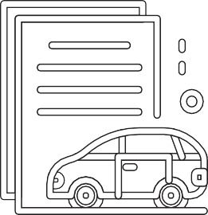

**PROJECT 3: How to manage your finances as a young adult**

This project will give you insight into the money matters of young adults. Through research you will find out about good and bad money practices and the consequences thereof. You will share your findings in a short, to-the-point article that you will publish on Facebook.

**STEP 1 – PLANNING**

✪ **Activity 1: Start with a discussion**

Young adults often make money-mistakes due to inexperience. Discuss some stories you have heard or experienced in regards to bad or good money practices with your teacher and the rest of your class.

What do you think would be the BIG question to research here? Write it in the block:

**STEP 2 – RESEARCH/FINDING OUT**

✪ **Activity 2: Find out for yourself**

Write down the names of 4 young adults (it can be your older brothers and sisters, cousins or neighbours) you can interview to find out about money practices. They may choose to stay anonymous.

What will you ask them during the interviews? Make a list of questions and review with your buddy-guard.

1.

2.

3.

4.

22

PROJECT-BASED LEARNING | LIFE ORIENTATION



5.

6.

7.

**Activity 3: What is out there?**

✪

Look for online and other sources (books, magazine articles, YouTube videos, online articles, interviews, and pod- casts) about money practices of young adults. Make a list of sources and your observations next to it:

✪ **Activity 4: What works?**

Discuss with your buddy-guard: What makes a great online article stand out? Why do some draw your attention while you just scroll past others? Write down the main points of your discussion:

**STEP 3: MAKING AND SHOWING THE EVIDENCE**

✪ **Activity 5: Put your research together**

Collect all the research you have done (interviews, discussions, online and other) and to summarise, put together 5 basic points.

1.

2.

3.

4.

5.

COVID-19 SERIES | LEARNER’S WORKBOOK | GRADE 11

23

**Source**

**ISBN/URL**

**Observation/What I learned**

✪ **Activity 6: Great headlines**

Use these five points to create a catchy headline for your article. Don’t stop at one. Journalists sometimes write as many as 20 headlines for the same article. (E.g. 5 things you should know about money when you leave school).

Your headlines:

✪ **Activity 7: Your article**

Use the template below to start writing your article.

24

PROJECT-BASED LEARNING | LIFE ORIENTATION

Catchy Headline:

First sentence (introduction paragraph)

1. Subheading: (Add at least two sentences to explain)

2. Subheading: (Explain)

3. Subheading: (Explain)

4. Subheading: (Explain)

5. Subheading: (Explain)

Closing: (Say something to summarise it all)





**STEP 4: GETTING FEEDBACK AND CHANGING IF YOU NEED TO**

✪ **Activity 8 – Get feedback**

Show your article outline to family members at home. Ask for feedback on what to change. They can fill in this form:

Are you happy with the feedback? Why, or why not?

Why do YOU think feedback is important?

**STEP 5: FINISHING OFF YOUR PROJECT**

✪ **Activity 9: The final steps**

Use the feedback you got above to make the suggested changes (if you agree!) and write your final article in the space below.

COVID-19 SERIES | LEARNER’S WORKBOOK | GRADE 11

25

**Date of advice**

**Who gave feedback**

**What they said I should do**

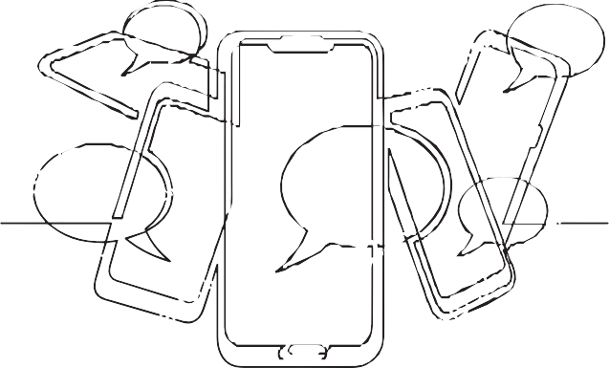



**STEP 6: SHOWING OFF YOUR PROJECT**

✪ **Activity 10: Publish online**

Now neatly type out your final article on your phone in a WhatsApp to you buddy-guard (and teacher or parent). Check each other’s final articles. Give feedback on spelling and formatting. Can you simplify it even more?

Give it a final overview and then cut and paste onto your Facebook page (or the school’s). Add an image (check for copyright) if you can. You can make a few friends pose for a photo in stock image style.

Follow the views, likes and shares. These are not always an accurate indication of the quality of your work, but it gives you an idea of what draws attention.

After a day or two, write the outcomes in the table below.

✪ **Activity 11: Final feedback**

Ask 3 friends or family members to give feedback in the Comments section. Write it here.

**STEP 7: THINKING ABOUT IT AFTERWARDS**

✪ **Activity 13: Reflect on the process**

**REFLECTION 1 (Academic)**

The problem:

26

PROJECT-BASED LEARNING | LIFE ORIENTATION

**Date of Comment**

**Who gave feedback**

**Their final impression**

Number of views

Number of likes

Number of shares

Interesting Comment 1

Interesting Comment 2

Interesting Comment 3

The solution:

The steps I went through to reach/make the solution:

My challenges:

I rate my final article as /7 because:

**REFLECTION 2 (Personal)**

What did you love about working on this project?

What made this project hard for you?

What did you learn by working on this project?

* About yourself?
* About learning during COVID-19?

What would you do differently if you did a project like this again?

COVID-19 SERIES | LEARNER’S WORKBOOK | GRADE 11

27

**LEARNER’S RESOURCE LIBRARY**

**ARTICLE ON SOCIO-ECONOMIC IMPACT OF COVID-19 IN SOUTH AFRICA**

The Social & Economic Impact Of COVID-19 On South Africa

**by Melodie Labuschaigne and Ciara Staunton**

May 08, 2020Posted by Silk Road Briefing

South Africa is a key member of China’s Belt & Road Initiative as well as being a member of the BRICS grouping and a member of the Beijing supported Asian Infrastructure Investment Bank. In this article we look at the situation on the ground concerning COVID-19 in the country.

**Current Situation**

As at April 16, South Africa has reported 2,506 cases of COVID-19 and 34 deaths. Testing is taking place with over 80,000 individuals examined thus far. The majority of cases have been in Gauteng (865) the Western Cape (587) and Kawazulu Natal (443).

COVID-19 has shown its potential devastating impact elsewhere, but it is a particular cause for concern in South Africa. First, while public health strategies such as social distancing and regular hand washing are encouraged, such strategies are a privilege many cannot afford in the crowded informal settlements that accounted for 13% of all house- holds, many of which may not have access to running water. Second, the high rate of TB and HIV among the population, in addition to the number of those not on treatment for HIV, have led to concerns that this could impact the severity of COVID-19 in South Africa and make its population more susceptible to the virus. Third, while health systems in high income countries (HICs) are being stretched, most South Africans rely on the public health care system that is under-re- sourced and will struggle to meet the demand of the epidemic. While the virus does not discriminate on the basis of race, sex or borders, it is likely that it will disproportionately affect the poor and those suffering from other co-morbid- ities. Although the number of cases as of 15 March 2020 in South Africa remained relatively low in comparison to the rest of the world (61 confirmed cases; 0 deaths) President Cyril Ramaphosa stated that ‘urgent and drastic’ measures were necessary to limit the spread of the virus and address this emergency. As such, a State of Disaster was declared by the President on 15 March thereby giving Dr Nkosazana Dlamini Zuma, the Minister of Cooperative Governance and Traditional Affairs power to limit certain rights and freedoms within South Africa.

Under this Act, a series of regulations restricting, among other things, the movement of persons, goods and the dis- semination of information, were promulgated. These regulations include prohibiting foreign nationals from high risk countries (as defined by the WHO) from entering South Africa from 18 March 2020 and restricting gatherings to 100 individuals. A further series of restrictions, including a “lockdown” on the movement of its citizens from midnight on 26 March were announced on 23 March 2020.

In announcing these further restrictions, President Ramaphosa noted that COVID-19 is particularly dangerous for South Africa in light of high levels of poverty, malnutrition, HIV and TB. At the time of the announcements South Africa had the highest number of cases in Africa albeit a low number relative to countries worldwide. The restrictions introduced were at that time the most stringent in Africa, as South Africa was then the only country on the African continent to require all of its citizens to remain at home. The measures announced on 15 March and 26 March repre- sent the most comprehensive limitation on the freedom of movement and assembly of all South Africans since apart- heid. A failure to adhere to these measures may result in a fine and imprisonment of six months or more.

**Freedom of Movement and Assembly**

The initial restrictions on movement pertained to entry into South Africa and the limitation of gatherings. Initially gatherings of no more than 100 individuals were permitted, but as of midnight 26 March, all gatherings including congregating for prayer is prohibited, with the exception of funerals that are restricted to 50 people. Foreign nation- als from high risk countries were prevented from entering South Africa from 18 March. As of midnight on 26 March, all but essential movement is prohibited. The leaving of a residence is only permitted to buy essential goods, seek medical attention, buy medical products, collect social grants, attend a funeral of no more than 50 people, or access public transport for essential services during specified times. Leaving a house for exercise or to walk a dog is not per- mitted. Movement between provinces and districts is prohibited. Cumulatively, these measures go further than any restrictions on movement under the apartheid government.

28

PROJECT-BASED LEARNING | LIFE ORIENTATION

Any individual who is suspected of having COVID-19 or has been in contact with a person who has tested positive for COVID-19 cannot refuse to consent to be tested. If the test is confirmed positive, they cannot refuse to submit to treatment, isolation or quarantine.

**Restrictions on Movement of Goods**

As of midnight on 26 March, only essential goods may be sold. This includes any food and animal food products; cleaning and hygiene products; medical and hospital supplies; fuel, coal and gas, and basic goods, including airtime and electricity. The selling of alcohol and cigarettes are expressly prohibited. Price controls on certain goods have also been introduced, including toilet paper, hand sanitiser and some food products. Failure to comply can result in a fine, imprisonment of up to 6 months, or both.

**Censorship**

The South African Constitution guarantees freedom of expression and this includes “freedom of the press and other media” and “freedom to receive or impart information or ideas”, which are derogable rights. The COVID-19 regula- tions criminalise the intentional misrepresentation or publishing of a statement that a person or persons has/have COVID-19. The regulations also criminalise the publishing of a statement (including via social media) that intends to deceive another person about any measure taken by the government to address COVID-19. The focus is on disin- formation and is aimed at preventing the spread of false cures that have been seen in the context of HIV. The risk of censorship that does not observe standards of necessity and proportionality in this time is that it may have the

opposite effect and limit access to valuable and reliable information for public health. There is evidence within South Africa that this has already occurred as the Ministry of Health has stated that the dissemination of information is cen- tralised to government, information requests by the press should be directed to the NICD and has it instructed other experts in South Africa not to talk to the press. Considering the NICD is currently overwhelmed, this has led to con- cerns that access to information has already been limited.

**Enforcement of Regulations**

Under the 2002 Act, financial, human and other resources may be released and during his 23 March address, President Ramaphosa announced that he had directed the South African National Defence Force (SANDF) to be de- ployed to support the South African Police Service (SAPS). The SANDF are now patrolling the streets enforcing the lockdown. Already there have been allegations of the use of rubber bullets and other abuse. While these regulations apply to the COVID-19 crisis only, it is unclear when this epidemic will be deemed to have passed, and whether they may be used as a template for other public health emergencies which include the current TB and HIV epidemics.

While such restrictions, particularly restrictions on movement, are harsh and can be followed in other HICs, it remains to be seen whether these restrictions will ultimately be a near impossible balance between restricting the spread of COVID-19, and depriving many in South Africa of their access to food, water and basic hygiene.

While every place has problems because of the coronavirus crisis, countries like South Africa don’t have the capacity or resources to rebound on their own, unlike the United States, Britain and even China. They will need debt relief, budget supplements, and a commitment to get back to business as usual as soon as possible. South African compa- nies that have built markets on the back of an integrated global trade network need to be aware of, and ready to act on, the vulnerabilities that their trade dependence creates. Recommended actions include: create a view of critical products and suppliers; have contingency plans in place; consider the financial and legal implications; communicate; and conduct scenario analysis.

Further reading of the COVID-19 impact on South Africa and Africa in general can be seen here:

* **South Africa: The Impact Of Covid-19 On Key Industries**
* **The Impact Of Covid-19 On African Economies**

The situation in South Africa remains fluid and could become socially volatile in some regions. It will be interesting to note how far China is prepared to assist countries such as South Africa that have been supportive of Chinese access into African and global markets, and what the much-touted “win-win” scenario means when economies are faltering and domestic health concerns become paramount. To what extent will Beijing extend the branch of assistance over- seas remains as yet an unanswered question during these difficult times.

This article previously appeared on **Verfassungsblog**. Reproduced with kind permission.

COVID-19 SERIES | LEARNER’S WORKBOOK | GRADE 11

29

HOW TO reference this source: Labuschaigne, M. Staunton, C. 2020. *The Social & Economic Impact Of COVID-19 On South Africa,* viewed on 2 June 2020, < http[s://w](http://www.silkroadbriefing.com/news/2020/04/16/social-economic-impact-covid-19-south-africa/)ww[.silkroadbriefing.com/ne](http://www.silkroadbriefing.com/news/2020/04/16/social-economic-impact-covid-19-south-africa/)w[s/2020/04/16/social-economic-impact-c](http://www.silkroadbriefing.com/news/2020/04/16/social-economic-impact-covid-19-south-africa/)o[vid-19-south-africa/](http://www.silkroadbriefing.com/news/2020/04/16/social-economic-impact-covid-19-south-africa/)>

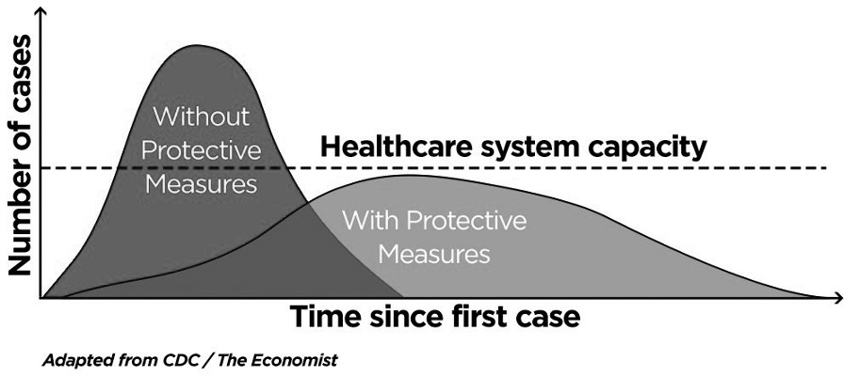

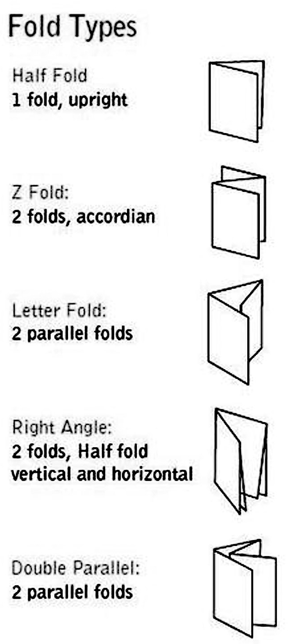

**DEFINITIONS SOCIO-ECONOMIC AND FLATTENING THE CURVE**

DEFINITION: Social economics also referred to as socio-economics, is concerned with the relationship between social and economic factors within society. Socio-economics is the social science that studies how economic activity affects and is shaped by social processes. It also refers to the ways that social and economic factors influence the environment.

DEFINITION: Flattening the curve is a public health strategy to slow down the spread of the SARS-CoV-2 virus during the COVID-19 pandemic. The curve being flattened is the epidemic curve, a visual representation of the number of infected people needing health care over time. (SOURCE: Wikipedia)

**HOW TO MAKE A BROCHURE**

A brochure is an informative paper document that can be folded into a template, pamphlet, or leaflet. Below are some fold types to consider. The fold type should effectively support the type of information shared in the document.

**Creative tips for great brochures:**

**1.**

**Know the purpose**

Start by asking your target audience why they think they need a brochure. Or what would they like to read in such a brochure. How much time will they spend scanning it?

**Limit fonts**

You don’t need many fonts – just a heading, subheading and body copy font. Don’t overbear the reader. Keep it simple.

**Get the copy right**

Great copy is often undervalued in brochure design. Spend a lot of time on copy and rewrite or rework until it is perfect. Headlines should be decided on last. First get the message right.

**Keep end in mind**

Always keep the end purpose of your brochure in mind. What is the message you want to convey when someone opens it?

**Plan first**

Start by putting ideas on paper and sketching designs. Start asking for feed- back in the early stages.

**Make a good first impression**

Does the brochure draw attention? Do you want to pick it up to read more?

**Get the imagery right**

You need a good and clean design for a brochure to be effective. One idea must follow the next. Don’t overuse colour and imagery. Sometimes simple is really effective.

**2.**

**3.**

**4.**

**5.**

**6.**

**7.**

SOURCE: Mimeo.com

30

PROJECT-BASED LEARNING | LIFE ORIENTATION



**HOW TO PREPARE A GREAT PRESENTATION**

**1. Show your Passion and Connect with your Audience**

It’s hard to be relaxed and be yourself when you’re nervous.

But time and again, the great presenters say that the most important thing is to connect with your audience, and the best way to do that is to let your passion for the subject shine through. Be honest with the audience about what is important to you and why it matters. Be enthusiastic and honest, and the audience will respond.

**2. Focus on your Audience’s Needs**

Your presentation needs to be built around what your audience is going to get out of the presentation.

As you prepare the presentation, you always need to bear in mind what the audience needs and wants to know, not what you can tell them. While you’re giving the presentation, you also need to remain focused on your audience’s re- sponse, and react to that. You need to make it easy for your audience to understand and respond.

**3. Keep it Simple: Concentrate on your Core Message**

When planning your presentation, you should always keep in mind the question:

What is the key message (or three key points) for my audience to take away? You should be able to communicate that key message very briefly. Some experts recommend a 30-second ‘elevator summary’, others that you can write it on the back of a business card, or say it in no more than 15 words. Whichever rule you choose, the important thing is to keep your core message focused and brief. And if what you are planning to say doesn’t contribute to that core message, don’t say it.

**4. Smile and Make Eye Contact with your Audience**

This sounds very easy, but a surprisingly large number of presenters fail to do it.

If you smile and make eye contact, you are building rapport, which helps the audience to connect with you and your subject. It also helps you to feel less nervous, because you are talking to individuals, not to a great mass of unknown people. To help you with this, make sure that you don’t turn down all the lights so that only the slide screen is visible. Your audience needs to see you as well as your slides.

**5. Start Strongly**

The beginning of your presentation is crucial. You need to grab your audience’s attention and hold it.

They will give you a few minutes’ grace in which to entertain them, before they start to switch off if you’re dull. So don’t waste that on explaining who you are. Start by entertaining them. Try a story (see tip 7 below), or an atten- tion-grabbing (but useful) image on a slide.

**6. Tell Stories**

Human beings are programmed to respond to stories.

Stories help us to pay attention, and also to remember things. If you can use stories in your presentation, your audience is more likely to engage and to remember your points afterwards. It is a good idea to start with a story, but there is a wider point too: you need your presentation to act like a story. Think about what story you are trying to tell your audi- ence, and create your presentation to tell it.

SOURCE: [https://www.skillsyouneed.com/present/presentation-tips.html](http://www.skillsyouneed.com/present/presentation-tips.html)

COVID-19 SERIES | LEARNER’S WORKBOOK | GRADE 11

31

**How to reference the source:** Staff writer, 2019, *Presentation skills you need*, viewed 2 June 2020, <http[s://w](http://www/)ww. skillsyouneed.com/present/presentation-tips.html>



**ARTICLE: COVID-19 CAN HAVE POSITIVE OUTCOMES**

RICHARD CALLAND: COVID-19 CAN HAVE POSITIVE OUTCOMES

**Richard Calland**

18 Mar 2020

(John McCann/M&G)

COMMENT

If only climate change could muster the same immediate political impact as Covid-19. Or as one wit suggested on Twitter: the climate needs to hire the coronavirus’s spin doctor. Which begs the question: Could the spread of Covid- 19 be the paradigm-shifting global shock that wakes us up to the peril that lies ahead?

There is uncertainty about how long the pandemic will last and how deep and long-lasting the economic crash will be. Like the 1918-1919 Spanish flu that is regarded as the nearest comparator to Covid-19, enormous social upheaval will result. The political implications are as numerous and as unpredictable as they are going to be profound.

During the first phase, the decision-making skill and composure of political leaders is sorely tested. Trust is the crucial commodity. At a time of social crisis, people look to the elected government for leadership, for reassurance and for a sense of hope. They want to know that a clear-minded plan is being put in place and executed decisively.

On Sunday night, President Cyril Ramaphosa passed that initial test. He was calm (though clearly anxious) and meas- ured. He encouraged confidence in the government’s ability to handle the crisis and communicated its strategy with admirable clarity.

The package of measures announced were proportional to the scale of the crisis, and well-timed. As leading experts of the World Health Organisation (WHO) who have frontline experience of epidemics such Ebola and pandemics such as the severe acute respiratory syndrome (SARS) coronavirus of 2003 have said, it is much better to be a bit early in taking decisive action to contain the spread of Covid-19 than being a little too late (as China and Italy were).

It is now reasonably clear from the global pattern that has emerged that the key moment is when the infection rate hits about 100, with local transmission. From then, the curve soon spikes — within two weeks it will probably increase to several thousand.

Early travel restrictions, aggressive testing, assertive tracking, and the imposition of strict quarantine rules, have proved to be important. South Korea and Taiwan are the best examples.

32

PROJECT-BASED LEARNING | LIFE ORIENTATION

Universal healthcare, skilled public health management and proactive communication to compel social compliance are also vital if a country is to avoid the worst case scenario — all of which raises questions about South African’s capaci- ty for managing the crisis effectively when infection rates rise exponentially.

Ramaphosa’s Cabinet ministers — a remarkable 18 of them — then laid out more detailed plans at a marathon press conference on Monday morning. Again, most passed the trust test.

Health Minister Zweli Mkhize exuded confidence and competence. So far, he is having “a good war”. Social crises always produces political winners and losers. Mkhize, as well as Ramaphosa, could be one of the biggest winners. Both need it, but especially Mkhize.

In the run-up to the ANC national elective conference at Nasrec in December 2017, Mkhize was a leading light and the out-going treasurer general — potentially on course for the top job in 2022 or 2027.

But he had an utterly disastrous conference. Having allowed himself to be lured into a hopeless stalking horse “third way” position, the KwaZulu-Natal politician lost traction with both the Ramaphosa and Nkosazana Dlamini-Zuma fac- tions — and on the day of the election itself had to meekly decline the nomination for the position of deputy president in the face of certain humiliation.

Now he can use his handling of the virus as a launchpad for getting his political career back on track.

But much will depend on what happens next, in phase two. The weak link in the Cabinet chain of 18 on Monday morning was the transport minister, Fikile Mbalula. Crises tend to expose the flakes and the fakes. Mbalula was uncon- vincing about how the government plans to handle the danger of contagion posed by public transport.

This is the country’s Achilles heel. Hundreds of thousands of working-class people travel in congested taxis and trains. A small number of infectious people could trigger mass infection. Neither the government or the private sector have clarified who is still required to come to work, given this high risk context.

And so back to the Spanish flu. Confounded at the time, epidemiologists later ascertained that the apparently “demo- cratic” brutal randomness of the pandemic was not quite what it had seemed and that poorer, working-class people had been disproportionately affected.

This, in turn, prompted a wave of anti-imperialist social protest. The Great Crash at the end of the 1920s and the consequent rise of fascism intervened. But after World War II, it was not the conservative war-time leader Winston Churchill who was elected in Britain, but Labour’s great social reformer, Clement Attlee, leading to the Beveridge report and the creation of the world’s largest welfare state, which had huge influence around the world.

This virus could go either way — encouraging further support for authoritarian government or spawning a new com- mitment to progressive or even radical social democracy.

At times of crisis, people tend to look to the government for help. It can serve to remind them of the importance of the state to stability, to public health and wellbeing, and to economic security and welfare when a disaster such as a pan- demic affects normal life.

Supplanted in many places by autocrats or neo-fascists, trust in representative, liberal democracy has been in decline in the past two decades — including in South Africa as a result of a decade of state capture — the virus could help restore trust in democratic government and thereby provide a springboard for an ambitious programme of progressive reform.

Already, it is focusing minds on important structural issues concerning access to universal health care, the idea of a basic income grant, and on arresting the preoccupation with economic growth at all costs — ahead of economic development.

There is enough evidence of how China’s rapacious market-capitalism-on-steroids approach to rapid growth may be an underlying reason for why the virus originated in Wuhan.

One immediate lesson that has been extracted is that global supply chains are too tightly time-dependent. When large parts of China went into lockdown it was inevitable that the knock-on effect on global supply chains would tip the world’s economy into recession.

This does not mean that globalisation should be abandoned. On the contrary, the need for global co-operation and com- munication has never been greater. Besides, digital connectivity makes it impossible to put the genie back in the bottle.

But it does mean that we now have to come to terms with the fact that when the unstoppable force of growth meets the immovable objective of planetary and ecological boundaries, something has to give.

COVID-19 SERIES | LEARNER’S WORKBOOK | GRADE 11

33

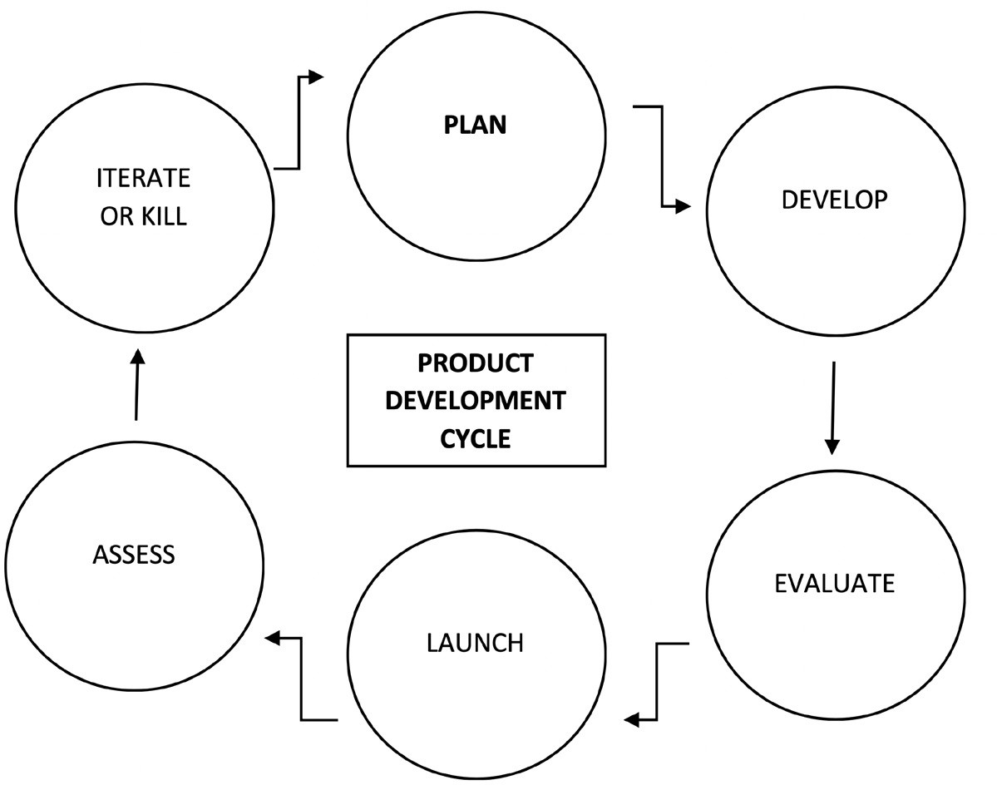

We now need to prepare for being apart in ways we have never been apart before and we need to be together in ways we’ve never been together before, without knowing how.

As the writer and public intellectual Bayo Akomolafe puts it “the times are urgent, let us slow down”. Now, the virus will force many of us to do so, while no doubt reflecting that one of the chief lessons of the pandemic is that we are all deeply connected.

How ironic that many of us will have to practice “social distancing” in order to have this pause for thought.

Will the moment pass or will it spur us to collective action? This is the political challenge, and opportunity, for leaders and activists alike.

Clearly, much of life will never be quite the same again — professionals will never travel as promiscuously as they used to, and offices will increasingly become outdated and irrelevant. Working remotely will become far more common, aided by technological gadgetry.

Public health systems will have to prepare for future threats, just as fossil fuel-based energy complexes will need to be swiftly replaced by renewable forms of energy.

And so regardless of whether in a year or more society tries to pick up where it left off before Covid-19 arrived, the fact is the pandemic represents a painful dress rehearsal for what lies ahead with climate change.

The virus makes the case that climate change has so far failed to prove: that our economic model is fundamentally un- sustainable. If this doesn’t transform social behaviour and the way we manage our economic and ecological resources, then nothing will. The political risks, and stakes, could not be higher.

**Richard Calland is an associate professor in public law at the University of Cape Town and a founding partner of the Paternoster Group**

**SOURCE:** https://mg.co.za/article/2020-03-18-richard-calland-covid-19-can-have-positive-outcomes/

**PRODUCT DEVELOPMENT CYCLE**

The product development cycle consist of the following stages: Plan, Develop, Evaluate, Launch, Assess, Iterate or Kill.

34

PROJECT-BASED LEARNING | LIFE ORIENTATION

HOW TO reference this source: Calland, R. 2018, *Richard Calland: COVID-19 can have positive outcomes,* viewed 2 June 2020, <https://mg.co.za/article/2020-03-18-richard-calland-covid-19-can-have-positive-outcomes/>

**Plan**

The planning stage consist of work that needs to be done before any development commences. You want to make sure you have a valid business case for the product and a solid strategic plan to give your startup the best chance

of success.

To begin Market Research and Competitive Analysis should be carried out, to get an understanding of the market, and the key players in them. This research will need to answer questions such as:

•

•

Who are your target audience?

Is there a need for the product? Can it be validated by thing like surveys, customer interview or consumer spending figures?

Who are the competitors in the market and how will the product be able to compete with them? What is the poten- tial market share for the product?

•

**Develop**

Simply put this is when the product or service business is built.

The first release is likely to be an MVP (minimum viable product) containing the core features necessary for the product to be of use to your customers and succeed in the market.

**Evaluate**

Early feedback is key to test the assumption made during the Plan stage. There is no need to wait until the product is completed to perfection before you start evaluating it’s features, the sooner features can be validated the better. If the feedback from the evaluation says that some features need changing, then tweak them.

**Launch**

Launching the product involves letting your target audience know the product is live. This can be done with Press Announcement & Interviews, advertising, creating public launch events, etc.

**Assess**

Similarly to the Evaluation stage, each feature of the product will need to be tested and evaluated to see if a feature worth keeping and iterated on or being dropped from the product completely.

During the assessment stage you will also need to support marketing & sales efforts. This is done by assessing what effect advertising, social media and CRM (Customer relationship management) campaigns have on product engage- ment and revenue.

**Iterate and Kill**

Once assessment and evaluation of the product features is complete, a decision needs to be made on which features to keep and upgrade and which to remove.

For the features that prove not useful for the customer, and don’t generate engagement or revenue, those should be removed. For the features that are kept, they will need to be iterated on and upgraded, to ensure competitiveness. This involves starting the Product Development Cycle all over again.

COVID-19 SERIES | LEARNER’S WORKBOOK | GRADE 11

35

HOW TO reference this source: Farbey, Y, 2016. *The product life cycle and product development cycle*, viewed on 2 June 2020, <https://defineproducts.com/product-life-cycle-product-development-cycle-bccb9c5aabf2>

**FINDING WORK DURING COVID-19 AND STAYING MOTIVATED (ARTICLE EXCERPT FROM FORBES MAGAZINE).**

**Wilding:** Unemployment has hit record levels during COVID-19, which means more people are job searching than ever before. What can readers do to stand out from the pack?

**Aries:** Now more than ever, it’s important to ensure that your entire job search strategy tells a clear and com- pelling story. From your cover letter and resume to your LinkedIn profile and even how you present yourself in virtual interviews, people *trust* people who are consistent.

So develop a clear story that explains the motivation behind your job search: why are you looking and what are you looking for, really? Explain what choices you’ve made in the past that have led you to where you are today. If you can distill all your experiences down to a clear story that’s reinforced again and again throughout all your job search assets, you’re more likely to be perceived as memorable, trustworthy, and authentic.

**Wilding:** How should readers think about pivoting their job search strategies? Are certain strategies more or less effective in this “new normal”?

**Aries:** Well, gone are the days of coffee meetings and networking events. Welcome to the age of online networking. I am such a big believer in networking your way to your next job, that it’s imperative you continue to grow and activate your network even while practicing social distancing.

So what does that look like? Sending lots of initial outreach emails - to former colleagues, mentors, friends, and friends of friends - and asking for a virtual meeting, preferably over video chat. Then, make the most of your meeting by sharing your story and asking about theirs. What’s motivated their past career decisions? What are the trends they’re seeing in the indus- try? What do they enjoy most about their current workplace?

Try to identify common values and shared experiences to foster connection. And then ask outright for their advice. Be spe- cific about what kind of support you need most like getting resume feedback or making an email-introduction to another contact, or putting in an internal referral with HR.

Finally, you cannot drop the ball when it comes to the follow-up game. That’s where you have the chance to show your contact that you’re the reliable, gracious professional you say you are. Send a timely (read: within 24 hour) thank you note and send along anything else they might need to help you - like a pre-written brief blurb they can use when making email introductions on your behalf, i.e.

**Wilding:** If you’re not hearing back from employers right now, what else can you do to stay active in your search?

**Aries:** Job-searching is a skill in and of itself. So if you find yourself feeling a bit stuck, skill-building in this department might be a wise use of your time. Seek out free guides and podcasts that cover professional development topics, or work on your leadership and communication skills over on platforms like LinkedIn Learning.

Take this time to audit your online presence to ensure your online brand is helping - and not hurting - your job search odds. And if you want to really come across as a polished professional, build out a CV website to ensure your digital footprint is one you can be proud of.

**Wilding:** What mistakes should we avoid while job searching during the COVID crisis?

**Aries:** In times of uncertainty, job-seekers can panic and start applying to everything and anything. Resist this urge. What you’re really grasping for is the sensation of progress - which is inherently motivating - but this way of going about it

can be misleading. If you’re applying half-heartedly to a job a day just to cross it off your TO DO list, you may be falling victim to *vanity metrics* — basically, you’re keeping score of a number that doesn’t *really* matter. Aim for quality instead of quantity.

A better way to measure progress is in terms of relationship-building, since networking can have a much better ROI when it comes to finding the right opportunities (did you know that referred candidates are 15 times more likely to be hired than ap- plicants from a job board?). Aim to have 3-5 informational interviews a week and give your all to the few applications you send out to job postings you *really* want. A targeted appeal will yield better results than the buckshot approach now made possible by all the emergence of “easy apply” buttons.

**Wilding:** What tips can you offer for sustaining motivation amid the uncertainty?

**Aries:** We can all be our harshest critics and most anxiety-riddled echo chambers. Get out of your own head and call a friend or loved one. When you’re feeling fearful, vulnerable, and worried, we need connection. It can be hard to seek out, of course, but it’s kind of like exercise in that way: it’s hard to get started, but you almost *always* feel better afterwards. Pick

36

PROJECT-BASED LEARNING | LIFE ORIENTATION

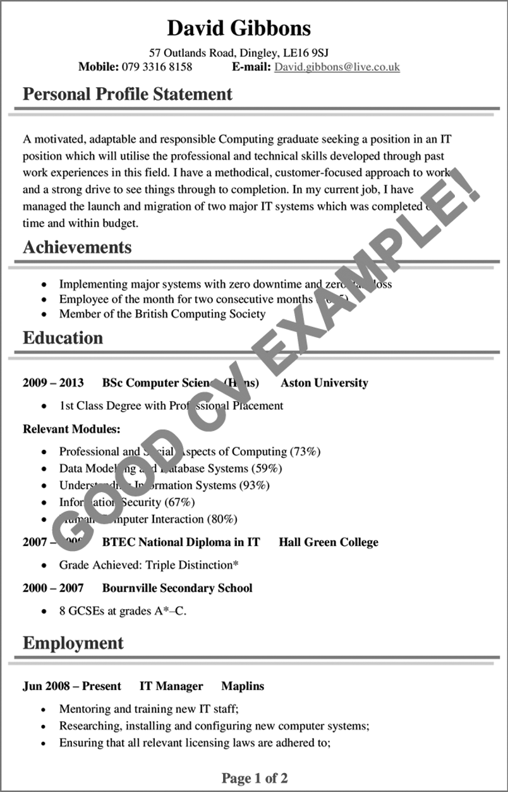

up the phone or hop on video chat and talk through your search with a trusted ally. Odds are, they’ll not only be ready and willing to cheer you on, but they might even share a helpful tip or offer to provide support in moving your search along.

SOURCE: [https://www.cvplaza.com/cv-examples/good-bad-cv/](http://www.cvplaza.com/cv-examples/good-bad-cv/)

**EXAMPLES OF CVS (CURRICULUM VITAE)**

COVID-19 SERIES | LEARNER’S WORKBOOK | GRADE 11

37

HOW TO reference this source: Wilding, M, 2020. How to job search in the age of COVID-19 according to a career coach. Viewed on 2 June 2020, <http[s://w](http://www.forbes.com/sites/melodywilding/2020/04/27/)ww.f[orbes.com/sites/melodywilding/2020/04/27/](http://www.forbes.com/sites/melodywilding/2020/04/27/) how-to-job-search-in-the-age-of-covid-19-according-to-a-career-coach/#6c7c22655e33>

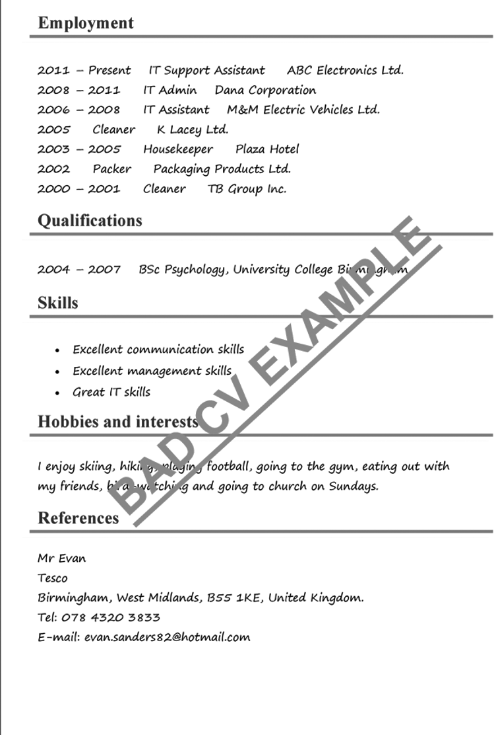

SOURCE: http[s://w](http://www.cvplaza.com/cv-examples/good-bad-cv/)ww[.cvplaza.com/](http://www.cvplaza.com/cv-examples/good-bad-cv/)cv[-examples/good-bad-cv/](http://www.cvplaza.com/cv-examples/good-bad-cv/)

38

PROJECT-BASED LEARNING | LIFE ORIENTATION

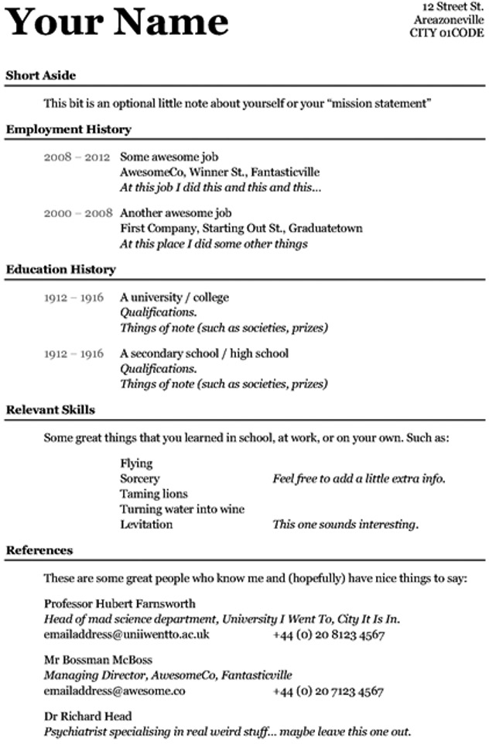

SOURCE: <http://2016mostdecoration.blogspot.com/2015/10/cv-templates.html?m=0>

COVID-19 SERIES | LEARNER’S WORKBOOK | GRADE 11

39

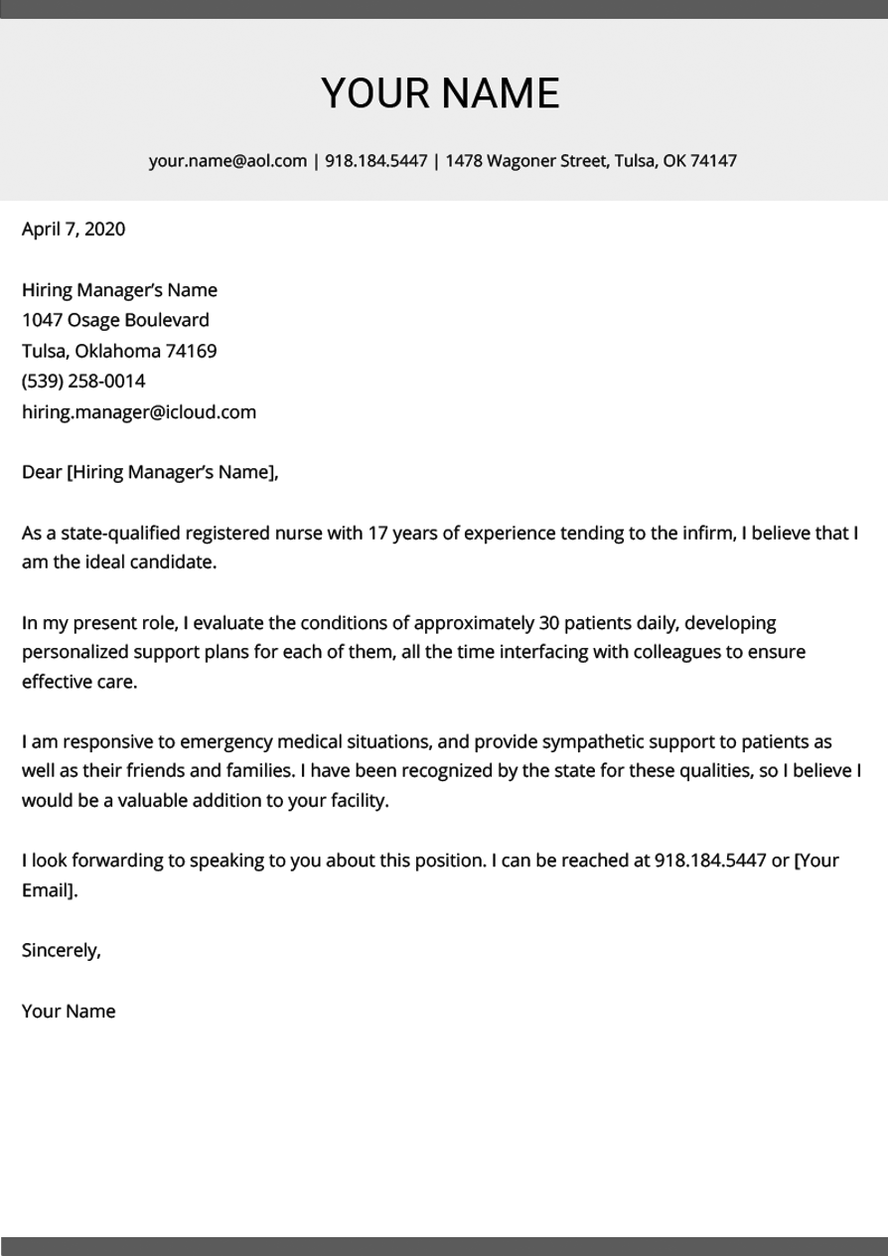

40

PROJECT-BASED LEARNING | LIFE ORIENTATION

**MOCK ADVERTISEMENTS FOR EMPLOYMENT**

Source: Generated by The Bizwoman Writing Hub

COVID-19 SERIES | LEARNER’S WORKBOOK | GRADE 11

41

**Servers wanted:**

**R 25 per hour plus tips**

Restaurant re-opening and need hard-work- ing servers. Possibility of training to become a waiter or barista.

Looking for friendly individuals who love serving people. Must be neat and clean at all times.

COVID-19 recoveries welcome!

Please send CV with 3 references to [PatroupalousS@mail.co.za](mailto:PatroupalousS@mail.co.za)

**Java Developer R25 000 p.m.**

**Qualifications and Experience Required:**

* Relevant B-Tech, IT Diploma or Degree in Computer Science or Information Technology (preferable).
* Oracle Java Certification (SCJP / OCJP etc.) an advantage.
* More than 5 years’ experience
* Experience in Java Technology Platform/Java Technology Platform
* Ability to meet travel requirements, when applicable

**Technical Competencies Required:**

* Must have experience working with in Java8, Maven 3, Spring, Spring Boot, Junit
* Additional experience in working with Spring Data, JPQL, Swagger, Feign, Orika, Lombok, Spring JMS, FICO, Openshift, EA Sparx, UML
* HTML / XML Skills: HTML, XHTML, XML validation and processing.

**Professional Skill Requirements:**

* Proven success in contributing to a team-oriented environment
* Excellent leadership, communication (written and oral) and inter- personal skills

Please send CV and cover letter, with applicable documents to Mike Smith [msmith@mail.co.za](mailto:msmith@mail.co.za)

**Crime scene cleaners R6500 p.m.**

Hard-working cleaners wanted at firm that specialises in crime scene cleaning.

We provide all protective gear, cleaning products and transport from the office to the places of work. Send CV with references to Pete Tshabalala at [info@tshabalalascleaning.com](mailto:info@tshabalalascleaning.com)

Please note:

* 3 months’ probation
* Medical aid and retirement plan
* 21 days leave per year

**Want to learn while you work? R1500 p.m.**

We are looking for passionate computer gamers/programmers who will be testing new sites, games, etc.

Become an intern and learn from the best. Our top guys and gals earn up to

R30 000 p.m!

OWN transport to work and back!

Please send your application to [freddy@internswanted.co.za](mailto:freddy@internswanted.co.za)

**Mathematics Tutors needed R50 per hour**

Are you good at maths? Do you find it easy to explain the concepts to others? Then you are the right person for our after school centre!

Join us in great working conditions in our roomy garden studio (coffee and lunch included every day).We tutor children from the ages of 9 to 13.

Please send a WhatsApp video introducing yourself to Winnie Direko at 087 0000003.

If you make it through the first screening, please get your CV ready for the next phase.

**Junior bookkeeper needed R11500 p.m.**

Junior bookkeepers need to send application with references and applicable documents (diploma or degree, or at least 3 years’ ex- perience) to RachelDahl@bookkeepingpros. co.za

Please don’t apply if you don’t have the fol- lowing skills:

* Fast worker, ability to focus
* Great team worker
* Interested in further training on job
* Ability to work longer hours during crunch times (with overtime pay)

**Caretakers wanted R5500 p.m.**

We are looking for three more caretakers to take care of our pa- tients at home.

You don’t need a nursing degree or diploma, but we are looking for the following skills:

* Good with people of all ages and races
* Caring personality
* Problem solver, think on feet
* We provide Level 1 training
* Own transport advantages

If you are a perfect match, please send your CV and a letter of intro- duction PLUS 3 references to [Bets@nursing.co.za.](mailto:Bets@nursing.co.za)



**HOW TO ACE YOUR FIRST JOB INTERVIEW ONLINE**

**Top Tips for How to Ace Your Online Video Job Interview**

Career Advice Expert

*by Randall S. Hansen, Ph.D.*

This article covers tips for how to prepare for a video interview, how to succeed in a video interview, and what to do after a video interview.

**Before Your Video/Online Interview**

**1. Determine the Best Hardware to Use**

If you have multiple devices (such as a computer, tablet, smart phone, etc.), choose the one you are most com- fortable with -- and the one with the most reliable tech- nology. For most, a computer will be best. If necessary, invest in purchasing -- or borrowing -- the best technol- ogy to use for the interview.

**2. Select the Proper Location for the Interview**

The ideal scenario for your interview location is a

secluded room in which you can shut out distractions (and noises), control the lighting, and display a generic back- ground. Ideally, you’ll want to have some diffused lighting so as not to create shadows or glare, plus a plain wall as your backdrop. You should also have a

location in which you can be seen on camera from about the waist up.

**3. Test All the Technology**

Test your connection. Test your camera. Test your lighting. Test your sound. Test the video program. Make sure you understand how it all works. And test it all again right before the interview commences.

**4. Schedule at Least One Mock Interview**

Under as close to identical circumstances as possible, schedule an interview with a friend, colleague, or family member.

*Practice your interviewing skills, as well as the functions of the technology. If you can, record the interview so you can play it back for yourself. If you can’t record it, ask your friend, colleague, or family member for as much feedback as possible -- especially for how you look and sound.*

**5. Plan for Glitches**

Have a backup plan ready if something goes wrong the day of the interview. For example: confirm with the interview- er, in advance of the interview, that you’ll switch to a phone call should technology or connection issues crop up.

**6. Complete Full Interview Preparations**

Don’t skimp on your interview prep. Conduct research on the employer, prepare responses to expected interview questions, formulate a few questions you want to ask, and determine the best professional outfit for the interview.

42

PROJECT-BASED LEARNING | LIFE ORIENTATION

**Day of the Video/Online Interview**

**1. Test All Equipment Prior to Interview Time**

Do a run-through at least an hour before your interview time. And then do another run-through around 30 minutes before the interview time.

**2. Dress Professionally**

Remember, nothing too flashy or suggestive with clothing. *Be on the safe side with clothes. Do research on the general dress code for the industry you’re interviewing in.*

If you’re unsure what will work best, view yourself in the monitor. For most, something along the lines of business casual will work (unless you’re interviewing in a buttoned-up profession like finance).

**3. Turn Off Before the Interview Starts, and Go Under**

Remember to turn off all apps and programs that might interrupt the interview. Also, silence your phone. Go to your interview location and shut out all distractions, and give yourself around 10 minutes to collect yourself and do any last-minute preparations.

**5. Remember Your Nonverbals**

Make solid eye contact and smile at appropriate times. Have good posture and even lean in a bit. Learn more about the importance of nonverbal cues in job interviews.

**6. Look Directly into the Camera**

You might be tempted to look at the monitor or yourself, but focus on making eye contact with your interviewer via the camera.

**7. Have a Conversation**

Speak in a conversational voice, just as you would in an actual interview situation.

**8. Notes if You Need Them**

Unlike other interview situations, you can have some notes in front of you (off camera) to remind you of critical issues you want to highlight, but do NOT overuse them, or you will look odd on camera.

**9. Take a Second**

When responding to questions from the interviewer, nod, but take a second before responding in case the connection is weak - so that you don’t end up talking over the interviewer.

**After the Video/Online Interview**

**1. Write a Thank-You Note**

Just as with any other job-hunting situation, follow up your interview with a thank-you note to your interviewer(s). Check out LiveCareer’s thank you letter samples for guidance.

**2. Follow-Up on Progress**

The hiring process is a lengthy one, most likely with several more rounds of interviews, so you’ll need to be patient -- but that does not mean you should not follow-up occasionally to express your interest in the job.

COVID-19 SERIES | LEARNER’S WORKBOOK | GRADE 11

43

HOW TO reference this source: Hansen, R (date unknown). Top tips for how to ace your online video job interview. Viewed on 2 June 2020 at <http[s://w](http://www.livecareer.com/resources/interviews/prep/acing-online-video-interview)ww[.liv](http://www.livecareer.com/resources/interviews/prep/acing-online-video-interview)ec[areer.com/resources/interviews/prep/acing-online-video-interview](http://www.livecareer.com/resources/interviews/prep/acing-online-video-interview)>

**7.20**

**SHORT STORIES ABOUT GOOD AND BAD MONEY PRACTICES**

*Source: Generated by the Bizwoman Writing Hub*

44

PROJECT-BASED LEARNING | LIFE ORIENTATION

**Atlegang and Nomsa starting dating** in February and would eat out (or get takeaways) almost every night. Since they had to stay home for lockdown and couldn’t indulge in fast food, they discovered that they saved thousands per month on their food bill! And both have lost at least 5 kilo’s as a result of eating healthy, home- cooked food.

**Clara Singh was awarded a bursary** for studying teaching.

The bursary included a monthly stipend of R2000 per month. Students usually use this for food, books and transport. Clara decided to go and stay with her dad who lived much closer to the University. There was only one problem: He expected to be fed and served as master of the house. Clara soon discovered that her money would go much further if she stayed at her mother’s place who was much more frugal. Even with higher trans- port fees, she was still better off.

**Millicent Botha thought she had struck it lucky** when she was offered a job for R12 000 per month just after graduating as a dental assistant. She was looking forward to a life of luxury!

Then she discovered she was short of money every single month.

First, she found that her company was deducting fees for professional registration on the dental board, also pension, UIF and tax, which means that she only took home R9500 per month.

After transport (she pays a colleague R200 per week for a lift), her Jet account (of around R2000 per month), her boarding (she shares a townhouse for R3500 per month), her medical aid (R2300) and all the takeaway lunches at work (she buys lunch at around R50 each day), she hasn’t got much left. In fact, she often has to ask her mother for a loan.

Can you think of ways for her to cut her costs so that she can start saving for an overseas holiday to visit her sister in Thailand?

**Tebogo Nhlanhla works as a help tutor** at an after school studio. He earns R4000.00 per month. Tebogo’s uncle helped him to devise a budget when he started working. He saves 20% of his salary every month.

Two years into his job, Tebogo saw an ad for a second hand car he would love to have. He had saved up R19 200 over the two years and the car was advertised for R35 000. The owner was happy with an initial payment of R20 000 and he and Tebogo signed a contract for monthly repayments until the full amount was settled.

**Mike and Petunia are both well educated**. Petunia is a marketing professional and Mike a junior bookkeeper. They were married two years ago and were living the high life until they sat down to have the “We would like a child”-talk.

Going through their finances, Mike said: “It was the first time that Petunia saw my account and I saw hers. One should really talk about these things from the start of the relationship!” Upon inspection, he discovered that they cannot afford having a child. They already had R1.4 million in debt between the two of them. This included a bond on their house, cars they were still paying off and huge amounts of credit card debt.

“Nobody ever tells you to sit down and talk,” says Mike. “Both of us thought the other one was on it.” Mike and Petunia plan to pay off most of their debt (this means no eating out, no vacations and no new clothes or cars) in the following two years. “Then we would like to welcome a baby into this new stress free environment! We will even have a medical aid for him. I just wish we did this earlier,” said Mike.

**HOW TO WRITE A GOOD ONLINE ARTICLE**

**HOW TO WRITE A GOOD INTERNET ARTICLE**

To write a good article for internet publishing you need to keep it short, simple and direct.

**Why?**

We have analysed web statistics from tens of thousands of site visitors. They suggest that surfers don’t like to read long articles. Most spend between a few seconds and a minute or two on a page, and then move on.

Web surfers probably make a quick assessment of the page based on the first paragraph. Or they skim it for key points. Or they bookmark or print the article for later reference. The number of people who spend time reading long articles is very low.

Some topics may require longer and complex articles. But in general your article will be better if you:

**Keep It Short**

We recommend a word length between 300 and 800 words. If you want to write more than this, break it up into smaller articles. For topics that require thousands of words, produce several articles and then a summary page that links all the other pages together. (This page contains just over 500 words.)

**Keep Paragraphs (And Sentences And Words) Short**

~~Surfers, whose first language may not be English or, for native English speakers, whose time is precious, will not~~ ~~be able to skim-read the type of convoluted paragraph construction that, notwithstanding the necessity of multiple~~

~~sub-clauses, requires the reader’s patience and indulgence in order to deconstruct, analyse and interpret complex phra-~~ ~~seology within his or her own mind in order to abstract and assimilate the central point that you are trying to commu-~~ ~~nicate throughout your literary creation (This paragraph has a Flesch-Kincaid score of 34.8!).~~

Make it easy for your reader. Say what you mean using a few well-chosen words.

**Make It Practical And Useful**

When you write your article, try to make it an information reference or a checklist of ‘how to’. If something needs further explanation, put it in a separate article. Make that new article short, simple and direct.

**Start Off With Your Key Points**

Make your main points in the first sentence. The rest of the article should then expand on those points.

**Make It Easy To Read**

Microsoft Word can provide readability statistics. Press F7. If the statistics don’t appear, check “show readability statistics” under Tools / Options / Spelling & Grammar. We recommend you aim for a Flesch-Kincaid score of 8.0 or lower, and a readability score of 60% or higher.

(This page has a Flesch-Kincaid score of 7.6 and readability of 63.6%.)

These targets may seem unrealistically low. You may be tempted to think that your article makes sense to you, so it will be OK. However, rewriting your article to achieve better scores will almost certainly make it a better internet article.

You can improve your readability scores by:

•

•

•

•

•

breaking long sentences into shorter sentences replacing long sentences with bullet points rewriting passive sentences

using shorter words

using headings to organise the text

COVID-19 SERIES | LEARNER’S WORKBOOK | GRADE 11

45

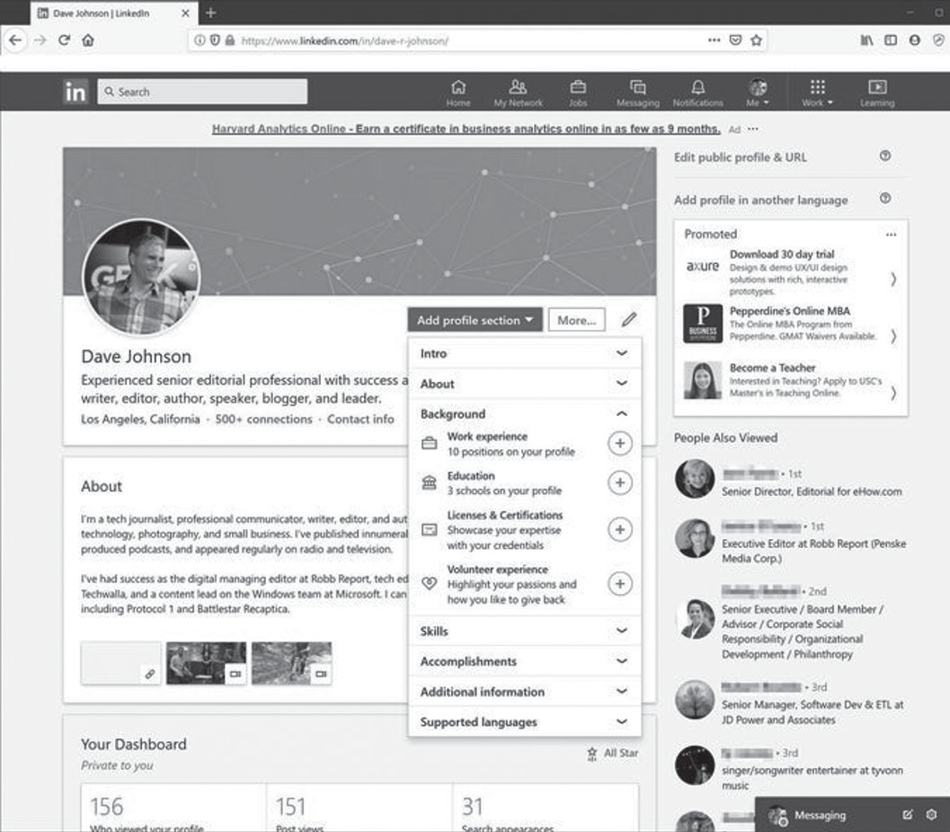

**Conclusion**

As the old saying goes, ~~there is only one way to eat an elephant: one bite at a time~~ there is only one way to publish on the internet: one small article at a time.

The evidence from our web statistics suggests that surfers prefer a series of shorter, sharper articles to long ones. These types of articles also generate more leads for consultant authors and/or advertising income.

Prior to publication of your articles, you can get some feedback from other members, authors or editors at this site. Publish a draft article in the sandbox and post the link (from the details page) in the members’ forum.

(Return to Editors or Editors Guidelines )

©2007 Steve Myers. Copyright and trademark information

**WHAT IS LinkedIn?**

**A beginner’s guide to the popular professional networking and career development site**

**D**

**Dave Johnson** Sep 6, 2019, 8:05 PM

Like Facebook, Instagram, Twitter, and a dozen others, LinkedIn is a social network. And like any other social network, it’s owned by a big tech company: Microsoft.

But unlike most social net- works, LinkedIn is a professional networking site, designed to help

people make business connections, share their experiences and resumes, and find jobs.

**LinkedIn essentials**

Despite the professional focus, LinkedIn is quite similar to social networking sites like Facebook. It’s based on principles like connecting to friends (or, in the case of Linke- dIn, “connections,”), posting up- dates, sharing and liking content, and instant messaging other users.

LinkedIn also puts a professional spin on ideas you know from Face-

46

PROJECT-BASED LEARNING | LIFE ORIENTATION

HOW TO reference this source: Myers, S. 2007. How to write a good internet article. Viewed on 2 June 2020 < http[s://w](http://www.teamtechnology.co.uk/metarasa/editors/guidelines/how-to-write-a-good-internet-article/)ww.t[eamtechnology.co.uk/metarasa/editors/guidelines/how-to-write-a-good-internet-article/](http://www.teamtechnology.co.uk/metarasa/editors/guidelines/how-to-write-a-good-internet-article/)>



book. Your profile, for example, becomes a resume, complete with work experience, accomplishments, recommenda- tions, and referrals from colleagues.

The site also offers things you won’t find in other places, like a full-featured career board, where you can search for and apply for jobs. Many employment services are now compatible with LinkedIn — when applying for a position, you may be able to share your LinkedIn profile, which sometimes means you won’t need to painstakingly enter your work

experience into a long online form.

It should be clear that LinkedIn is a tool you can use to enhance your professional networking and job searching activities.

Many people use the site to grow their contacts and find career opportunities, and the Jobs section of the site is a powerful tool for finding and applying for jobs. There are settings on LinkedIn that let you alert recruiters that you’re actively job searching as well.

**WHAT IS ZOOM?**

**A COMPREHENSIVE GUIDE TO THE WILDLY POPULAR**

**VIDEO-CHATTING SERVICE FOR COMPUTERS AND SMARTPHONES**

Even if you don’t work from home, you’ve probably heard of Zoom.

In light of the coronavirus crisis, the videoconferencing app has become the standard for connecting with others face- to-face virtually in both business and per- sonal settings.

Zoom is now the video communication platform of choice for federal govern- ments, tech startups, religious communi- ties, and of course regular people looking to chat — and even party — with their

friends and family.

Zoom is a cloud-based video communications app that allows you to set up virtual video and audio confer- encing, webinars, live chats, screen-sharing, and other collaborative capabilities.

You don’t need an account to attend a Zoom meeting, and the platform is compatible with Mac, Windows, Linux, iOS, and Android, meaning nearly anyone can access it.

COVID-19 SERIES | LEARNER’S WORKBOOK | GRADE 11

47

How to Reference this Source: Johnson, D. 2019. ‘What is LinkedIn?’: A beginner’s guide to the popular profes- sional networking and career development site, accessed on 2 June 2020 at <http[s://w](http://www.businessinsider.com/)ww[.businessinside](http://www.businessinsider.com/)r[.com/](http://www.businessinsider.com/) what-is-linkedin?IR=T>



**WHAT ABOUT SKYPE?**

Of course videoconferencing apps aren’t new. Zoom is just one in a long line of communication tools that also include Skype.

Skype is software that enables the world’s conversations. Millions of

individuals and businesses use Skype to make free video and voice one-to-one and group calls, send instant messages and share files with other people on Skype. You can use Skype on whatever works best for you – on your mobile, computer or tablet.

Skype is free to download and easy to use.

If you pay a little, you can do more – like call phones and send SMS. You can pay as you go or buy

a subscription, whatever works for you. And in the world of business, this means you can bring your entire ecosystem of workers, partners and customers together to get things done.

48

PROJECT-BASED LEARNING | LIFE ORIENTATION

**How to Reference this Source**: Antonelli, W. 2020. *What is Zoom? A comprehensive guide to the wildly popular video-chatting service for computers and smartphones,* accessed on 2 June 2020 at <https://www.businessinsid- er.com/what-is-zoom-guide?IR=T>