Teacher’s Project Notes
A POSITIVE RESPONSE TO COVID-19
PROJECT-BASED LEARNING | LIFE ORIENTATION
GRADE
11

Dear Teacher
Provided herewith is a Learner’s Project Workbook and a set of Teacher’s Project Notes for the School- Based Assessment (SBA) Task for Term 3 as per the SBA Plan in Section 4 of the CAPS. These documents are specially created to support you with COVID-19 issues for your subject as per the trimmed Annual Teaching Plan (Section 3) for Term 3.
Most importantly it is envisaged that this will lessen your workload as we come to grips with the disruptions caused by COVID-19.
The Learner’s Workbook and Teacher’s Project Notes were created by DBE-E3, a unit at the National Department of Basic Education which is rolling out Project-Based Learning (PBL) in schools, to better prepare learners for a changing world. Although you may not be part of the DBE-E3 Programme as yet, these projects are created to:
1.
Engage learners in processing the pandemic which is affecting their lives and those of their families;
Promote learner self-reliance and independent learning using safety measures; and Encourage social learning in a safe environment.
2.
3.
Where did this all start?
E3: Entrepreneurship, Employability and Education is currently being rolled out in SA schools. The DBE-E3 Unit, in response to the National Development Plan, has been working in public schools since 2018 to advocate the eventual implementation of Activity-Based Learning, with a special focus on PBL. E3 is part of a DBE programme to introduce Thinking Skills for a Changing World into the curriculum in its effort to reduce youth unemployment substantially by 2030.
How did this work in 2018 and 2019?
Initially three provinces in 2018, and then all nine provinces in 2019, implemented PBL in Term 3, the term in which the SBA is an actual project. This meant that the projects, written by teachers for teachers were available to select schools by the provinces as part of a pilot research project. In this initial phase schools on the programme were provided with projects for Life Skills Grade 4-6, EMS Grade 7-9 and Life Orientation Grade 10 to 11.
The Learner’s Workbook and Teacher’s Project Notes are as a critical resource for you during COVID-19, and the beginning of activity-based learning and PBL as a teaching method the DBE- E3 is consciously promoting.
We truly respect your anxiety during this time, and acknowledge your commitment. We appreciate all your hard work.

TEACHER’S PROJECT NOTES
GRADE 11 Life Orientation
E³ PROJECT FOR TRIMMED ATP
A positive response to COVID-19

CONTENTS
TEACHER AGENCY AWARD 6
LEARNER PROJECT PORTFOLIO FOR E³ WEBSITE 7
RUBRIC TO RATE THE LEVEL OF COMPETENCIES AND E-MINDSET 8
PART 1 – SETTING THE SCENE 9
1.
2.
3.
4.
The trimmed projects - E³ response to COVID-19 9
Social Learning during COVID-19 (Coronavirus) 10
Generic Project outline for all Projects 10
Teacher’s Resource Pack 12
PART 2 – THE PROJECTS 13
5.
6.
Projects Summary and CAPS alignment. 13
The Projects in more detail 16
PART 3 – TEACHER’S RESOURCES 29
PROJECT RESOURCES
7.1
7.2
7.3
Letter to parents/caregivers 29
Primary vs Secondary resources 30
The big question in research 31
TEACHER DEVELOPMENT NOTES
7.4
7.5
7.6
7.7
7.8
7.9
7.10
Traditional vs. Activity-based Learning 33
The Project-based Learning Cycle 34
The PBL facilitator 35
The E³ competencies which we are trying to achieve 36
The journey to PBL via Enquiry-based and Problem-based Learning 36
Bridging the unemployment gap through Education 37
The E³ learning cycle – pedagogical paradigms 38
TEACHER AGENCY AWARD ENTRY FORM

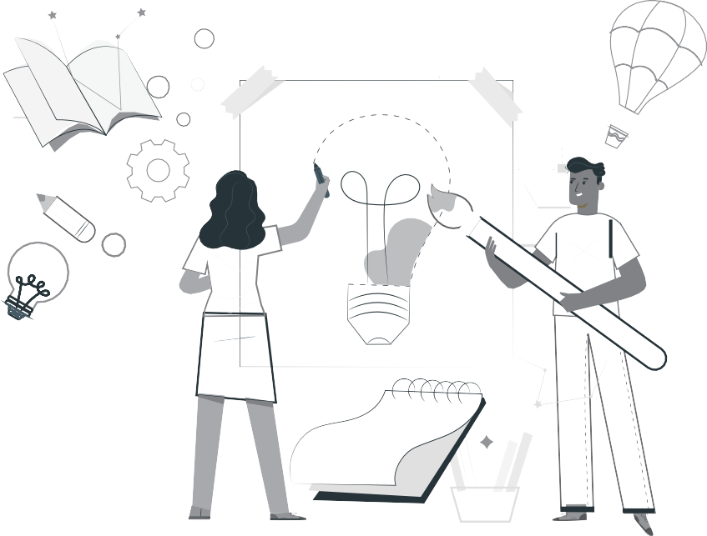
RECOGNISING SOLUTION-SEEKING TEACHERS
ENTER THE TEACHER AGENCY AWARD
If it’s going to be, it’s up to me
SO WHY?
To reward you for being awesome! You have shown that you care, that you have found a solution to a problem that helps others and that you have just gone ahead and made it happen.
We want to acknowledge and reward you and tell the world you are our hero! We want to reward you if you can show us that you are
self-motivated, self-directed and want to grow - and if you are driven by purpose and the desire to help others.

WHO ME?
Yes you! Any teacher or school official who is doing something for the greater good.
WAIT WHAT?!
So here’s what you need to show us - you need to be able to tell us that you:
1
2
3
Had the courage to just get going Had belief in yourself to just do it
Activated a range of competencies that makes you THE person that this new crazy world needs to fix it and solve its problems such as:
3.1
A great character who is self-motivated to be a SA citizen who cares, who is curious about fixing things and who has the energy, enthusiasm and resilience to carry on.
The ability to think and be creative, figure things out, find the information you need and make sense of it.
How you made connections, how you collaborated and communicated with others as you stood in their moccasins to solve problems.
WHAT WILL I WIN?
T&Cs: We will be awarding exciting, significant prizes of up to R5000 per prize winner. These will go to worthy recipients from each province whose solutions meet the criteria on the entry form. These will be judged by E³. Awards will be announced in the first week of every month starting in August 2020. If no worthy entry is received that merits a prize, E³ reserves the right not to award a prize for that month.
The last winners will be announced in the first week of October 2020 when this opportunity closes.
Keep an eye of the E³ website to see if you have won and to celebrate the other winners and admire their solutions.
3.2
3.3
SO HOW MUST I APPLY?
It’s really simple - just fill in the form at the back of this book and submit it to us.
Or submit the form on the E3 website:
www.e3-dbe.org www.ecubed-dbe.org
WHEN MUST I HAND IT IN?
NOW! You can apply anytime whenever. This is an ongoing opportunity that has no deadline. How cool is that?
6
PROJECT-BASED LEARNING | LIFE ORIENTATION

CALLING ALL TEACHERS!

Think you lead the way in creating solutions to problems?

Enter this award and be rewarded and recognised for your unique problem-solving abilities.

Please send us pics/videos for our Facebook/Website
Send your pictures and videos!
Dear learner
We are so excited to see your project and we would like you to share it with us so that we can profile it on our website and possibly on Facebook or Instagram. To do that, please follow these instructions very carefully.
HOW TO PUT TOGETHER YOUR INFORMATION:
Tell us about your project:
1.
2.
3.
4.
5.
6.
7.
Product or service you created:
Name of learner:
School:
Grade:
Describe your project (50 – 100 words).
Describe the biggest challenge you had doing this project.(50 – 100 words). Describe what you would do better next time (50 – 100 words).
Choose the right photographs to tell the story of your project
1.
2.
3.
Choose three photographs that tell the story and progress of your project. Make sure that no-one’s face is clearly visible unless they are wearing masks.
Make sure the picture is in focus and clear.
How to send your submission:
1.
2.
3.
All submissions must be in a word document and the pictures must be in the document. You can send it to us on email.
You can email it yourself, or you can ask your parent/caregiver or teacher to do this for you. You must use this subject line on the email: Learner Project Grade 11 LO.
info@ecubed-dbe.org
Email
If needed, we might ask you to make some changes to your submission in order to make it ready for uploading onto our website.
COVID-19 SERIES | Teacher’s Project Notes | GRADE 11
7

8
PROJECT-BASED LEARNING | LIFE ORIENTATION

RUBRIC TO RATE THE LEVEL OF COMPETENCIES AND E-MINDSET
Did your entrepreneurial mindset grow whilst managing this project? |  |  |  | Personal rating  (1=Poor, 4=Excellent)
 |  |  |  | Pre-project | Post-project
Competencies | Character | Citizenship | I am very committed and involved in various activities in my community and people regard me as someone to follow in my circle of influence.
 |  | Curiosity | I am very curious about everything around me and all my senses are alerted to possibilities which I always put into practice.
 |  | Resilience | When I face challenges I am always excited about the possibilities and I always get up after I have been unsuccessful. I am always enthusiastic about what I have learned in the process.
 | Thinking | Creativity | I always use my imagination to come up with original ideas and/or I am always creating new things.
 |  | Critical thinking | I always form judgements based on my ability to analyse and evaluate objectively.
 |  | Reasoning | I always think about things in a logical and sensible way and I always come up with conclusions easily.
 | Collaboration | Collaboration | I always produce good work / things by working well with people (individuals or a team).
 |  | Communication | I am always successful in conveying or sharing ideas or feelings.
 |  | Empathy | I have a highly developed ability to understand and share the feelings of others.
E-Mindset | Agency | Growth mind-set | I am always open to new information and am always willing to change my beliefs, assumptions and actions as a result.
 |  | Motivation | I always do what needs to be done without needing to be influenced by other people or situations. I always find a reason or the strength to complete a task, even when it is challenging, without giving up or needing anyone else to encourage me.
 |  | Internal locus of control | I always have control of my life and my work is always my own and it is because of this that I experience success often. I never blame others or circumstances on my lack of success.
 |  | Regulation of emotion | I always respond to the demands of a situation with emotions that are socially tolerable and sufficiently flexible to allow spontaneous or delayed reactions – whichever are appropriate.
 | Self-efficacy | Tasting success | I have always done things successfully enough to give me “the taste of success” that makes me motivated to want more and to believe that I can get it.
 |  | Socially relatable  role model | I have always been fortunate to have been exposed to excellent role models that I can relate to and who make me motivated to want to be like them.
 |  | Positive support | I have always been fortunate to have had someone who has been a positive support to me and who has encouraged me and seen me as a person.
 | Solution-  seeking | Resourceful | I always find quick and clever ways to overcome difficulties and find solutions.
 |  | Problem solving | I always find solutions to difficult or complex problems.

PART 1 – SETTING THE SCENE
1. THE TRIMMED PROJECTS - E³ RESPONSE TO COVID-19
We have been asked by the DBE to create projects for the new trimmed curriculum. In the past, lead teachers would gather and projects would be created during a writer’s workshop. A similar process is being followed now, but remotely.
In Grade 11 we shall be working on three larger projects. Learners will create a brochure to ascertain the socio- economic impact of COVID-19 on the lifestyle of South African youth; they will also explore ways to find employment during COVID-19 and research the financial traps that young adults fall into. You are not expected to undertake all these projects as they need only one SBA mark.
Time frame for project completion
The assessment for Term 3 is a project. As a teacher, you will know your learners and their context best, so adjust the project as necessary. This is why we have included an MS Word version so you can edit or translate if you’d like to.
Please note that learners will be working on their own for the most part of the project. Your role is to support the learner wherever it is possible. Create a Question-wall (see overleaf) and remember to promote the Wh-wall because there will be unrelated questions to the project, personal issues, traumatic events, etc.
Use this opportunity to press learners to do as much research and investigating as is possible – if we plan this well, we shall succeed. This is an excellent chance to develop learner agency and self-reliance.
Ideas for planning:
1.
Write a letter to the caregivers, parents, family and siblings (an exemplar letter is part of this pack for your use) explaining the need for their support.
Break up the projects into small deadlines that you will check regularly.
Help learners manage some social learning. (See social learning on the next page.)
PLEASE NOTE: Part 1 and Part 2 of this booklet must be printed and are the minimum project resources you as teacher will need. However, the rest of the booklet contains valuable tools for personal development, as well as very good sources in support of the project. You don’t have to look anywhere else.
PLEASE NOTE: Don’t forget to enter the Teacher’s Agency Awards - see page 6.
This programme is accompanied by podcasts, audio recordings and videos. You will find them in the following places:
™ *Simon Sinek: Start with Why*https://www.youtube.com/watch?v=u4ZoJKF_VuA
Simon Sinek talks about the importance of doing with purpose, relating every initiative back to Why we do it.
™ *Project-based Learning at High Tech High*https://www.youtube.com/watch?v=ZhoWYZN2_Rg
High Tech High is a school in San Diego which has embraced PBL whole-heartedly with fantastic and inspiring results. Integration is the basis upon which this school has built its success.
™ *Michael Fullen: New Pedagogies for Deep Learning*https://www.youtube.com/watch?v=-39PNs4sCmQ Michael Fullen is one of the high masters in the world of Active Learning Pedagogies. Here he describes the 6 Cs and their value in the curriculum.
™ *New Experiments in self teaching: Sugata Mitra*https://www.youtube.com/watch?v=dk60sYrU2RU Sugata Mitra’s ‘Hole in the Wall’ experiment began in 1999 when he put a computer in a slum in India, the
results were amazing and the experiment has since grown. The overwhelming conclusion is this: “if children have interest, education will happen”.
2.
3.
4.
5.
6.
COVID-19 SERIES | Teacher’s Project Notes | GRADE 11
9

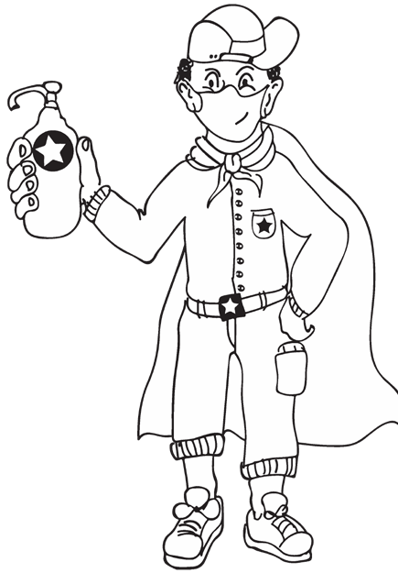
™ *Roger Martin on Integrative Thinking*https://www.youtube.com/watch?v=3Fw0dDO6Wgo
Roger Martin talks about the skill of coming up with a solution to a problem in a way that only focuses on the positive outcomes rather than the negative.
™ Also see https://learn.ecubed-dbe.org/resources/
7. Encourage learners to document the process of their projects (see learner submission instructions) for the E³ website which will provide a space for showcasing learner excellence. Email: info@ecubed-dbe.org
2. SOCIAL LEARNING DURING COVID-19 (CORONAVIRUS)
Individual learners will be “scientists” and go through a process (including elements of design thinking, problem- based learning, etc.) which will guide them to solve a problem. Learners will not have groups to work with, but the social learning can be facilitated by:
2.1
Notes/WhatsApps/face-to-face questions to teachers (give them a contact number or place a box for queries at the door of your classroom).
2.2
A WH-wall for Who? Why? What? (and also How?) questions that are posted on the wall. Learners write their open-ended question in large letters on pages that can be stuck on the wall, anonymously if learners wish. You could review all the questions once a week (after they have been on the wall for at least 48 hours) and answer the important questions. The questions need not be about the project – it is a great opportunity to allay general fears about the “new normal” of living and going to school during the pandemic and also to encourage questioning techniques.
Have learners appoint a buddy-guard (a safe critical friend whom s/he has identified before the project has started. The pair will agree that they give each other support and feedback at school with social distancing and via text and WhatsApp messages).
The family care-givers will also have a letter sent to them to explain their role.
2.3
2.4
3. GENERIC PROJECT OUTLINE FOR ALL PROJECTS
STEP 1: Planning
1.
Learners brainstorm the problem that needs to be solved on their own, or with their buddy-guard, teacher or family. The brainstorm could also be a class activity done by the entire class.
Learners list questions that will help them think of the BIG question that will guide them in solving the problem.
They write down the topic of their research – the BIG question.
2.
3.
10
PROJECT-BASED LEARNING | LIFE ORIENTATION

HOW?

STEP 2: Research/Finding out
1.
They note down five sources of information from the following that they are planning to use to gather information:
•
•
•
People they could interview Articles they could read Websites they could go onto
2.
They identify someone who might help them if they need information whilst stuck at home.
STEP 3: Making and showing evidence
1.
2.
3.
What equipment will be needed to create the project item?
Where will information on how to make the item be found? How many times did they try before they got it right?
STEP 4: Getting feedback and changing if you need to
1.
2.
3.
Learners get feedback from their buddy-guard, parents or caregivers or teacher. They use information they have gathered to improve their product.
They note what they changed, when they made changes and why.
STEP 5: Finishing off the project
Using all the feedback and what was learned after trying to improve their product, learners finish off their project item and the writing that goes with it.
STEP 6: Showing off your project
1.
2.
They show off their project to as many people as it is safe to show it to.
People who view the projects (even those at home) write down their feedback or leave notes or send voice notes. Learners ensure that their WhatsApp number is on the project item and notes.
The final item is taken to school and the teacher and learners arrange that the projects are shown to the rest of the school.
3.
STEP 7: Thinking about it afterwards (Academic and Personal Reflection)
Academic Reflection:
1.
2.
3.
4.
5.
The problem The solution
Steps I went through to reach the solution My challenges
Rating my final product
Personal Reflection:
1.
2.
3.
4.
What did I love about working on this project? What made this project hard for me?
What did I learn by working on this project? About myself? About COVID-19? What would I do differently if I did a project like this again?
COVID-19 SERIES | Teacher’s Project Notes | GRADE 11
11

4. TEACHER’S RESOURCES
See the Resource Pack in Part 3 of these notes to help you manage the project and to help you save time. Included you will find:
Practical Assistance, e.g.:
1. PROJECT RESOURCES
A letter to the parents and caregivers.
The difference between Primary and Secondary Resources; How to formulate the big question, etc.
2. TEACHER DEVELOPMENT NOTES, e.g.:
Project based learning is a new pedagogy for teachers. We’ve included the E³ model and a variety of interesting articles to develop your PBL skills.
The Project-based Learning (PBL) Cycle and your role as a Project Manager; The journey to Project-based Learning which starts with Enquiry-based Learning and Problem-based Learning, etc.
Resources in the Learner’s Workbook
The Learner’s Project Workbook is enriched with many resources to help the learner complete the project independently. We are aware that learners will not have access to primary and secondary sources, so we’ve tried to address this obstacle.
And now, for a summary of the Grade 11 project.
12
PROJECT-BASED LEARNING | LIFE ORIENTATION

Œ PLEASE NOTE:
- After introducing the CAPS topic in class, learners are orientated towards the project and then left to deal with the project as an individual learner with access to all their resources.
- The number of weeks allocated to a topic in the CAPS does not mean that the length of the project is limited. Remember: the project is a tool to allow deeper investigation into a serious problem that impacts learners.
- We recommend that a learner be given 3 to 4 weeks to complete a project.

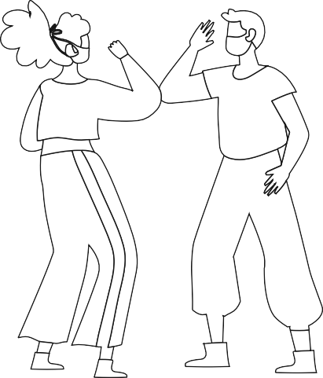
PART 2 – THE PROJECTS
5.
PROJECTS SUMMARY AND CAPS ALIGNMENT
COVID-19 SERIES | Teacher’s Project Notes | GRADE 11
13
PROJECT 1: Creating a brochure on the socio-economic impact of COVID-19 on the lifestyle choices of South African youth
Alignment CAPS (trimmed ATP)
Description of Project
Week: 1-4
Development of the self in society

Healthy and balanced lifestyle choices:
- Characteristics of a healthy and balanced lifestyle: physical, psychological, social, emotional and spiritual facets
- Factors that impact negatively on lifestyle choices
- The effects COVID-19 on lifestyle choices
- Risky behaviour and situations
Personal safety, road use, substance use and abuse, sexual behaviour, risk of pregnancy
- Teenage suicides, hygiene and dietary behaviour, sexually transmitted infections (STIs), HIV & AIDS and peer pressure
- Youth Risky Behaviour and COVID -19
Socio-economic environment:
- Literacy, income, poverty, culture and social environment.
- Factors that impact positively on lifestyle choices
- COVID-19 and lifestyle choices
- Positive role models: Parents and peers; personal values; belief system; religion; media, social and cultural influences; economic conditions
- Role modelling and the spread of COVID-19
- How parents conduct themselves amidst COVID-19

Project 1:
Learners research, design and create a brochure on the socio- economic effects of COVID-19 on the lifestyle choices of South African youth.
The aim of the project is to involve every learner in class in the creation (researching, writing
and illustrating) of a brochure on: COVID-19 and its socio- economic impact on the lifestyle choices of South African youth.
If COVID-19 regulations allow at the time, the brochures can be displayed at an open day. The school can invite parents, the whole school community and members from media houses to be part of this event.
Alternatively the grade 11 project can be on display for enjoyment by the rest of the school.
Don’t leave out the public display. These motivate learners to give of their best work.

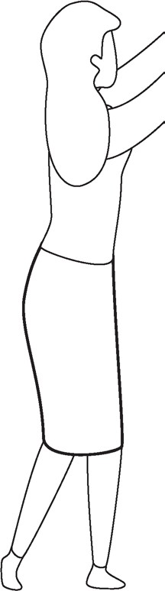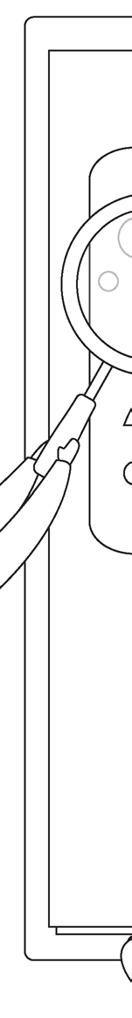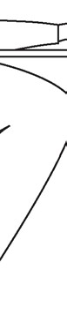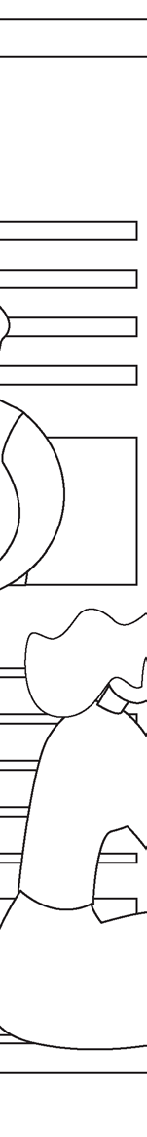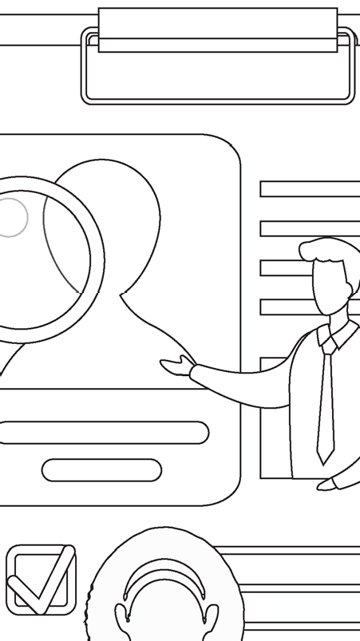
14
PROJECT-BASED LEARNING | LIFE ORIENTATION
PROJECT 2: How to find a job during COVID-19 – CVs, cover letters and interviews
Alignment CAPS (trimmed ATP)
Description of Project
Week: 5-8
Careers and career choices
Competencies, abilities, and ethics that will assist in:
- Securing a job and developing a career
- Managing meetings, managing a project and office administration skills
- Interview skills: personal appearance and preparation for typical questions
- Ethics and ethical behaviour
- On-line application processes as a result of COVID-19
Personal expectations in relation to job/career of interest:
- Expectancy and reality
- Chances of success and satisfaction
- Suitability audit
- Working and studying from home and increased usage of online busi- ness operations due to COVID-19
Knowledge about self In relation to the demands of the world of work and socio-economics conditions:
- Skilled, semi-skilled, unskilled, and physical labour
- Additional and higher education studies required for different careers
- Expectancy, reality and perseverance
Changing work settings and new skills resulting from COVID-19

Project 2:
Learners research ways to find employment during COVID-19 times.
They look at challenges and advantages of finding work in the space of the “new normal”.
They create their own CVs, cover letters and prepare for online interviews by interviewing one another on video-call/making videos of interviews.
Finally, they present their findings at a public event (they might want to introduce their research to younger grades in school) if and should COVID-19 regulations allow.
Learners can also present their CVs and cover letters to industry specialists (e.g. restaurant owner) for feedback from a real source.

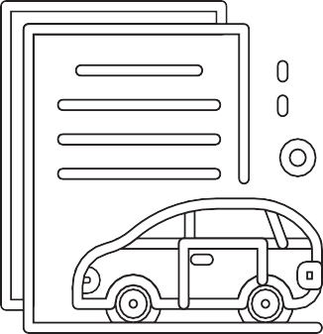

PROJECT 3: How to manage your finances as a young adult
Alignment CAPS (trimmed ATP)
Description of Project
Week: 4-5
Development of the self in society
Socio-economic environment:
- Literacy, income, poverty, culture and social environment
- Positive role models: Parents and peers; personal values; belief system; religion; media, social and cultural influences; economic conditions
- Role modelling and the spread of COVID-19
- How parents conduct themselves amidst COVID-19
Competencies, abilities, and ethics that will:
- Assist in securing a job and developing a career
- Managing meetings, managing a project and office administration skills
- Interview skills: personal appearance and preparation for typical questions
- Ethics and ethical behaviour
- On-line application processes as a result of COVID-19

Project 3:
Many learners think once they graduate from school or university and earn money that they’ve made it, but they don’t look at essential expenses: rent/bond, study loans, medical aid, petrol/transport,
car instalments, life and car insurance etc.
During this project learners research the so-called financial traps that young adults fall into.
They use their research to write a Facebook article on this topic.
Examples might include:
- What every young adult should know about their finances
- What they never told you about budgeting
- Making the right decisions with your fist pay cheque, etc.

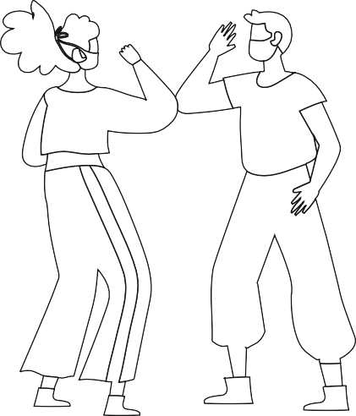
6. THE PROJECTS IN MORE DETAIL
The following step-by-step unpacking of the project explains the tasks and your role in managing the project. Items marked with (*) can be found in PART 3 of this booklet.
6.1
PROJECT 1: Creating a brochure on the socio-economic impact of COVID-19 on the lifestyle choices of South African youth
16
PROJECT-BASED LEARNING | LIFE ORIENTATION

Project 1: STEP 1 - Planning

TASK
Teacher’s Role
Resources
Competencies
Watch a video or read an article about the COVID-19 pandemic and its influence on society.
Take notes on the topic.
Draw a mind-map to show what they have learned from the video/article.
Start thinking of how final product (brochure) should look after the research (STEP 2) and creation (STEP 3) phases.

- Show the video or share the article.
- Ask learners to make notes while watching/reading.
- Explain how a mind-map works and ask learners to use a mind-map
to organise their ideas around the video/article.
- Explain the outcome of the project: A brochure with researched in- formation on the socio-economic impact of COVID-19 on the lifestyle choices of South African youth.
4. Learners complete Step 1 in Learner’s Workbook.

Screen to watch video clips.
Possible video clips: https://www.face- book.com/unicef/ videos/257278336 2941937/ AND
https://youtu.be/ IAmMsfxevzI
*Article about COVID-19 Black/white board
to demonstrate
mind-mapping;
*How to make a brochure
Textbook
Learner’s Workbook

Character Citizenship Curiosity Resilience Mindset
Connection Collaboration Communication Empathy
Thinking Creativity Critical thinking Reasoning

Œ NOTE: Please track Competencies
The column on the far right is for you to mark/underline which competencies you think you touched on, or were developed, in each step or task. E.g. Citizenship.

COVID-19 SERIES | Teacher’s Project Notes | GRADE 11
17
Project 1: STEP 2 - Research/ Finding out

TASK
Teacher’s Role
Resources
Competencies
Discuss lockdown (in pairs):
- What is the meaning thereof?
- When and why was it introduced?
- Did it achieve its intended outcome?
- What is the meaning of flattening the curve?
Provide statistics to support views.
Do impact research via interviews with 2 families and 2 businesses. ASK how they mitigated impacted areas e.g. education, funerals, entertainment, transport?
Record interviews on cell phones.
Present the outcomes of interviews in the next class.
IDENTIFY career or entrepre- neurial opportunities created by the COVID-19 Pandemic.
- Ask learners to discuss the concept of lockdown in pairs.
- Give learners the opportunity to debate the effectiveness of lock- down and share their views.
- Discuss primary and secondary sources of research.
- Ask learners to deepen their re- search by doing interviews with fam- ilies and businesses.
- Show samples of brochures and types of folds to the class. Discuss how to summarise and present information.
- Learners present outcomes of interviews in class. They prepare a PowerPoint demonstration. Remind them to add ideas for career or entrepreneurial opportunities as a positive outcome of COVID-19.
- Learners start planning the outlines of a brochure containing all the researched information. They can collect brochures from different places to look for key features.
- Primary and Secondary sources
- Definitions: lockdown and flattening the curve
- How to create a brochure (samples)
- Guide on good Presentation
Textbook
Learner’s Workbook
Extended Learning Opportunity:
Interviews can be conducted across different business sectors, e.g. Education, Entertainment, Restaurants, etc.

Character Citizenship Curiosity Resilience Mindset
Connection Collaboration Communication Empathy
Thinking Creativity Critical thinking Reasoning

Project 1: STEP 3 Making and showing the evidence

TASK
Teacher’s Role
Resources
Competencies
Learners do a PowerPoint presentation about the outcomes of interviews with families and businesses
re COVID-19 positive and negative impact on lifestyle choices of SA’s youth.
Plan and start creating a colourful, effective brochure with important information on the COVID-19 impact on South African youth lifestyle choices.
Add positive outcomes in the form of career and entrepreneurship opportunities.

- Give learners opportunity to present their PowerPoint presentations of research/interview outcomes. Pick up interesting points for further discussion. Encourage class to ask questions.
- Give them time to start planning their brochures.
- Learners now independently work on putting their brochures together.
- Remind them to also add positive outcomes of the COVID-19 pandemic in the form of career and entrepre- neurial opportunities.
- Learners finish their rough brochures for feedback.

Screen for PowerPoint presentations.
A4 paper and coloured pens for brochure design and creation. The final brochure should be on
2 x A3 pages (one-sided) to make display easier.
* Article on Positive outcomes of COVID-19
Extended Learning Opportunity:
Learners can download Apps to create electronic designs. Many brochure design Apps are available for cell phones e.g. Canva, Brochure Maker, Adobe Spark.
Learner’s Workbook
Character Citizenship Curiosity Resilience Mindset
Connection Collaboration Communication Empathy
Thinking Creativity Critical thinking Reasoning

18
PROJECT-BASED LEARNING | LIFE ORIENTATION

Project 1: STEP 4 - Getting feedback and changing if you need to

TASK
Teacher’s Role
Resources
Competencies
Learners show their brochures to class mates, family, buddy-guard and other people (via safe channels like WhatsApp and social distancing, etc.)
Learners collect feedback from all sources.
Learners implement changes suggested by feedback.

- Ask learners to show their brochures to family members and members of the community for feedback.
- Ask learners to implement the changes suggested by feedback.
- Explain why feedback is important. Learners have to realise that it will never be perfect the first time. They must learn to keep on improving and pushing the standard.
- Learners complete Step 4 in Learner’s Workbook and get as much feedback as possible on their ideas. They consider
making changes.

Learner’s Brochure designs;
Learner’s Workbook
*The product design process

Character Citizenship Curiosity Resilience Mindset
Connection Collaboration Communication Empathy
Thinking Creativity Critical thinking Reasoning

Project 1: STEP 5 - Finishing off your project

TASK

Teacher’s Role

Resources

Competencies

Learners work at home or in class, finishing off their brochures with changes they are considering after the feedback.
Brainstorm ideas on the safety for the final showing of their brochures at school
– to the rest of the community or the rest of the school if it is still unsafe.
Online is an option.
Talk about safety measures for public display according to COVID-19 regulations.

- Guide learners through the process of change and adaptation of their brochures, and the reason for these changes. Explain importance of iteration and reviewing project as part of the improvement of the final quality.
- Give them time to complete or redesign their brochures in class.
- Brainstorm ideas with learners for the public display of their brochures. (In class? In the school hall? Online? Safety measures?)
3. Learners prepare brochures for display. Remember that they should be one-sided so viewers can see entire brochure on display. They help with the set-up for the public display.

Learner’s Workbook
Poster with learner- generated rules for COVID-19 safety, to display at brochure expo.

Character Citizenship Curiosity Resilience Mindset
Connection Collaboration Communication Empathy
Thinking Creativity Critical thinking Reasoning

COVID-19 SERIES | Teacher’s Project Notes | GRADE 11
19

Project 1: STEP 6 - Showing off your project

TASK
Teacher’s Role
Resources
Competencies
Learners present their brochures to other classes/ rest of the school/parents or members of the community according to plan (and with safety measures in mind)

- Help learners to set up their display.
- Appoint a COVID-19 officer or two from class. They should see to it that all COVID-19
regulations are followed during any public event.
- Use rubric to assess the project.

Public area for presentation
Sanitiser, masks, gloves or other safety measures
* Rubric
Learner’s Workbook
Extended learning opportunity:
Display brochures online on school’s website, Facebook or a specially created blog.

Character Citizenship Curiosity Resilience Mindset
Connection Collaboration Communication Empathy
Thinking Creativity Critical thinking Reasoning

Project 1: STEP 7 - Thinking about it afterwards

TASK
Teacher’s Role
Resources
Competencies
Reflection on success or failure of the project and lessons learned

- Please don’t skip this step.
- Give learners time in class to reflect on the success of their project (academically and personally).
- Do the teacher’s reflection rubric.

*Teacher’s Reflection rubric
Learner’s Workbook

Character Citizenship Curiosity Resilience Mindset
Connection Collaboration Communication Empathy
Thinking Creativity Critical thinking Reasoning

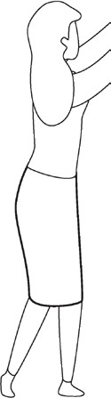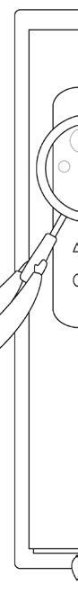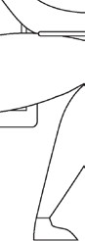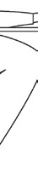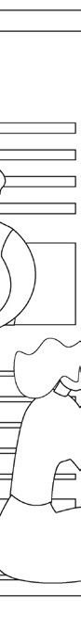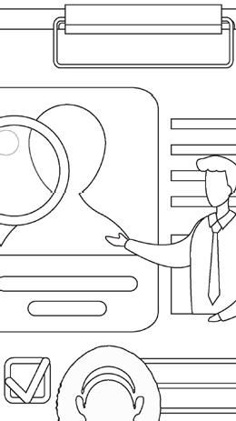
6.2
PROJECT 2: How to find a job during COVID-19 – CVs, cover letters and interviews
20
PROJECT-BASED LEARNING | LIFE ORIENTATION

Project 2: STEP 1 - Planning

TASK
Teacher’s Role
Resources
Competencies
Learners brainstorm employment issues (Particularly looking for work) during COVID-19.
They develop the BIG question and prepare to do research.
Outcomes of the project are the public display of well-designed CVs, cover letters and video-interviews.

- Start a discussion on the pressure COVID-19 has placed on the job market. Give learners turns to share their personal experiences with family members.
- Share the outcome of the project: Learners create personal CVs, practise writing cover letters and interview each other to prepare for their job hunting days.

*Article in source library re finding work during COVID-19, and how to stay motivated
Learner’s Workbook

Character Citizenship Curiosity Resilience Mindset
Connection Collaboration Communication Empathy
Thinking Creativity Critical thinking Reasoning

Project 2: STEP 2 - Research/ Finding out

TASK
Teacher’s Role
Resources
Competencies
Learners research ways in which to find employment and resources for finding job openings.
Creative thinking exercise: Thinking of ways
(not the norm) to find work in these times. Thinking out of the box in regards to applications.
Find examples of people who took out-of-the- ordinary steps to get their dream jobs

- Guide learners in finding resources to research ways in which they can apply for jobs during COVID-19 times.
- Allow learners to debate creative ways in which they could apply for or create out-of-the-norm work for themselves and others.
- Discuss the tools (CVs, cover letters, etc.) you need to apply for a job.
3. Allow time for research and finding of appropriate sources.

*Article in source library re finding work during COVID-19, and how to stay motivated
*Examples of CVs, cover letters, etc.
*Mock advertisements for which they can apply
(on which to model their cover letters)
*Motivational stories or videos of people who went out of their way to apply for their dream
jobs, e.g. Zappos https:// youtu.be/6ef2rCW6RkM
Learner’s Workbook
Character Citizenship Curiosity Resilience Mindset
Connection Collaboration Communication Empathy
Thinking Creativity Critical thinking Reasoning

COVID-19 SERIES | Teacher’s Project Notes | GRADE 11
21
Project 2: STEP 3 Making and showing the evidence
TASK
Teacher’s Role
Resources
Competencies
Learners start putting together their CVs and cover letters according to the mock advertisements.
They interview one another on WhatsApp video call for the mock positions.

- Guide learners in putting their own CVs together.
- Guide learners in writing cover letters for mock advertisements.
- Allow learners a few days to prepare for and do the video-interviews.
- Discuss the ethics of job application and online interviewing.

*Examples of CVs and cover letters
*Mock job advertisements
*Article: How to prepare for your first job interview
*Articles: How to ACE an online interview
Learner’s Workbook

Character Citizenship Curiosity Resilience Mindset
Connection Collaboration Communication Empathy
Thinking Creativity Critical thinking Reasoning
Project 2: STEP 4 - Getting feedback and changing if you need to
TASK
Teacher’s Role
Resources
Competencies
Learners show their CVs and cover letters, as well as video interviews to class mates, family, buddy-guard and other people (via safe channels like WhatsApp and social distancing, etc.)
Learners collect feedback from all sources.
Learners implement changes suggested by feedback.

- Ask learners to show their CVs, cover letters and video interviews to family members and friends for feedback.
- Ask learners to implement the changes suggested by feedback.
- Explain why feedback is important. Learners have to realise that it will never be perfect the first time. They must learn to keep on improving and pushing the standard.
- Learners get as much feedback as possible on their ideas.
They consider making changes.
Learners’ CVs and cover letters
Videos of interviews (or prepared answers)
Learner’s Workbook
Extended Learning Opportunity:
Ask learners to find as many online CV sites as possible and upload their CVs to at least one or two sites.
* Explain how “LinkedIn” works
Character Citizenship Curiosity Resilience Mindset
Connection Collaboration Communication Empathy
Thinking Creativity Critical thinking Reasoning
Project 2: STEP 5 - Finishing off your project
TASK
Teacher’s Role
Resources
Competencies
Learners work at home or in class, finalising their
CVs and cover letters after feedback.
Brainstorm ideas on the safety for the final showing of their CVs and cover letters (also videos of interviews if possible) to the rest of the school if it is still unsafe to allow parents to attend.
Talk about safety measures for public display according to COVID-19 regulations.

- Guide learners through the process of change and adaptation of their CVs and cover letters. Explain the importance of iteration and reviewing as part of the improvement of the final quality
of their creations.
- Give them time to complete their work in class.
- Brainstorm ideas with learners for the public display of their work. (In class? In the school hall? Online? Safety measures?)
3. Learners prepare for display. They help with the set-up for the public display.
CVs, cover letters and videos of mock job inter- views to display.
Learner’s Workbook
Extended learning opportunity:
Ask someone from the in- dustry (as per mock adver- tisements) to view all CVs, cover letters and choose three top candidates for mock interviews in front of the whole class (Online if COVID-19 is an issue)
* Explain how to use Skype or Zoom
Character Citizenship Curiosity Resilience Mindset
Connection Collaboration Communication Empathy
Thinking Creativity Critical thinking Reasoning

22
PROJECT-BASED LEARNING | LIFE ORIENTATION

Project 2: STEP 6 - Showing off your project

TASK
Teacher’s Role
Resources
Competencies
Learners present their CVs, cover letters and video interviews to other classes/rest of the school/ parents and/or industry specialists (as per mock advertisements).

- Help learners to set up their display.
- Appoint a COVID-19 officer or two from class. They should see to it that all COVID-19 regulations are followed during any public event.
- Use rubric to assess the project.

Public area for presentation
Poster with learner- initiated safety rules
Sanitiser, masks, gloves or other safety measures
* Rubric
Learner’s Workbook

Character Citizenship Curiosity Resilience Mindset
Connection Collaboration Communication Empathy
Thinking Creativity Critical thinking Reasoning

Project 2: STEP 7 - Thinking about it afterwards

TASK
Teacher’s Role
Resources
Competencies
Reflection on success or failure of the project and lessons learned.

- Please don’t skip this step.
- Give learners time in class to reflect on the success of their project (academically and personally).
- Do the teacher’s reflection rubric.

* Teacher’s Reflection rubric;
Learner’s Workbook

Character Citizenship Curiosity Resilience Mindset
Connection Collaboration Communication Empathy
Thinking Creativity Critical thinking Reasoning

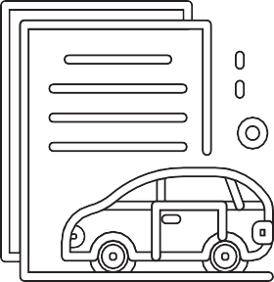
6.3
PROJECT 3: How to manage your finances as a young adult. Create a Facebook article to help other young people.
COVID-19 SERIES | Teacher’s Project Notes | GRADE 11
23
Project 3: STEP 1 - Planning

TASK
Teacher’s Role
Resources
Competencies
Learners discuss habits of their older friends/siblings with regard to money.
How much do school leavers earn? What do they do with their money?
What else do they know about budgeting and monthly expenses, etc?

- Guide learners in their discussion about money and money practices of young adults.
- Learners isolate their BIG question in their Learner’s Workbook. Each will have his/ her own big question.
- Explain the outcome of the project:
A Facebook article for young adults about money practices.

- Short stories of good and bad money prac- tices in young adults and the consequences.
- Video of Ludwick https:// youtu.be/ YFad3LKt7_U (Drybath) Learner’s Workbook

Character Citizenship Curiosity Resilience Mindset
Connection Collaboration Communication Empathy
Thinking Creativity Critical thinking Reasoning

Project 3: STEP 2 - Research/ Finding out

TASK
Teacher’s Role
Resources
Competencies
Learners do interviews online or via WhatsApp with young adults in the community who have been successful or unsuccessful with their money choices.
They can also interview older family members to ask what they would have done differently if they had another chance.
They use other resources like articles and videos to gather all the information they will need.

- Explain good interviewing practice to students. Remind them to observe COVID-19 protocols.
- Please help in the finding the appropriate resources – each student will have his/her own challenge and topic.
- Discuss the features of a good online article:
  - Striking headline
  - Strong first sentence
  - Paragraph length
  - Language use
  - Subheadings
  - Pictures/graphics

- Articles about money practices in young adults
- What makes a good online article?
Learner’s Workbook

Character Citizenship Curiosity Resilience Mindset
Connection Collaboration Communication Empathy
Thinking Creativity Critical thinking Reasoning

24
PROJECT-BASED LEARNING | LIFE ORIENTATION

Project 3: STEP 3 Making and showing the evidence

TASK
Teacher’s Role
Resources
Competencies
Learners put together all their research in a short article.

- Please give learners the opportunity to write and rewrite their first draft.
- Explain basic concepts of editing:
  - Check on structure and form (see*Features of a good online article)
  - Check on language use (Buddy guard can peer review)

Learner’s Workbook

Character Citizenship Curiosity Resilience Mindset
Connection Collaboration Communication Empathy
Thinking Creativity Critical thinking Reasoning

Project 3: STEP 4 - Getting feedback and changing if you need to

TASK
Teacher’s Role
Resources
Competencies
Learners show their first draft to classmates, family,
buddy-guard and other people (via safe channels like WhatsApp and social distancing, etc.)
Learners collect feedback from all sources.
Learners implement changes suggested by feedback.

- Ask learners to show their draft article to family members and friends for feedback on content and heading/sub headings.
- Ask learners to implement the changes suggested by feedback.
- Explain why feedback is important. Learners have to realise that it will never be perfect the first time. They must learn to keep on improving and pushing the standard.
- Learners get as much feedback as possible. They consider making changes.

Learners’ articles
Learner’s Workbook

Character Citizenship Curiosity Resilience Mindset
Connection Collaboration Communication Empathy
Thinking Creativity Critical thinking Reasoning

Project 3: STEP 5 - Finishing off your project

TASK
Teacher’s Role
Resources
Competencies
Learners work at home or in class, finalising their articles after feedback.
Discuss online publication in class – what are the procedures, ethics, etc.

- Guide learners through the process of change and adaptation of their articles. Explain the importance of iteration and reviewing as part of the improvement of the final quality of their creations.
- Give them time to complete their work in class.
- Discuss the ethics of using online media, and how to publish.
  - What tags to use
  - Click baiting
  - Secrecy/safety of information
  - POPI

*How online writing differs from print media writing.
Learner’s Workbook
- POPI
- Online ethics

Character Citizenship Curiosity Resilience Mindset
Connection Collaboration Communication Empathy
Thinking Creativity Critical thinking Reasoning

COVID-19 SERIES | Teacher’s Project Notes | GRADE 11
25

Project 3: STEP 6 - Showing off your project

TASK
Teacher’s Role
Resources
Competencies
Learners publish their articles online and follow the discussion on social media.
Who liked it?
What are the comments?
How many have shared their insights?

- Help and support learners to publish their final copies of their articles.
- Support them in reacting to comments, show how to keep track of likes and shares. (Explain how.)

* Rubric
Learner’s Workbook

Character Citizenship Curiosity Resilience Mindset
Connection Collaboration Communication Empathy
Thinking Creativity Critical thinking Reasoning

Project 3: STEP 7 - Thinking about it afterwards

TASK
Teacher’s Role
Resources
Competencies
Reflection on success or failure of the project and lessons learned

- Please don’t skip this step.
- Give learners time in class to reflect on the success of their project (academically and personally).
- Do the teacher’s reflection rubric.

* Teacher’s Reflection rubric;
Learner’s Workbook

Character Citizenship Curiosity Resilience Mindset
Connection Collaboration Communication Empathy
Thinking Creativity Critical thinking Reasoning

Project 1: Brochure on socio-economic effects of COVID-19 on the lifestyle choices of South African youth.
6.4
RUBRICS
26
PROJECT-BASED LEARNING | LIFE ORIENTATION
Criteria

Level Descriptors

Total Mark
Mark obtained
1. Designed and created brochure

0
1
2
3
4
5

5

Brochure not designed and created

Created brochure not eye catching

Created brochure was eye catching

Created brochure Eye catching and structured

Created brochure Eye catching. well-structured

Created brochure, colourful and well-structured
2. Socio-economic effects of Covid 19 on the lifestyle choices of South African youth.

0
1
2
3
4
5

5

Responses given not relevant to youth

Inadequate responses and not qualified

Elementary with few qualified and well researched responses

Moderate with few qualified and well researched responses

Skilful with most qualified and well researched responses

Exceptional and well qualified and well researched responses

3. Illustrations

0
1
2
3

3

No illustrations

Message from Illustrations not clear

Message from Illustrations was clear

Message from Illustrations was clear and empowering

4. Public display

0
1

1

Brochure not availed for display

Brochure availed for display

TOTAL
14

Project 2: Searching for Employment
COVID-19 SERIES | Teacher’s Project Notes | GRADE 11
27
Criteria

Level Descriptors

Total Mark
Mark obtained
2.1 Challenges and advantages of finding work in this day and age

0
1-2
3-4
5-6
7-8
9-10

10

No response/ Challenges and advantages not relevant to COVID-19 era
Limited Responses focused on either challenges or advantages.

Limited Responses focused on challenges and advantages.

Adequate Responses focused on challenges and advantages

Proficient Responses focused on challenges and advantages
Excellent Responses focused on limited challenges and advantages
2.2 Research: Ways to search em- ployment during COVID-1 9

0
1 - 2
3 - 4
5 - 6

6

No response / Strategies not written

ONE strategy was investigated

More than ONE strategies were investigated

More than ONE strat- egies were investi- gated and advices given

2.3 Created Personal CV

0
1
2
3

3

CV not presented

CV presented not detailed and structured

Detailed and structured CV presented with personal informa- tion, knowledge and skills.

Detailed and well- structured CV pre- sented with personal information, knowledge and skills. Needed by the job markets
2.4 Proof of the inter- view session

0
1
2
3
4
5

5

No proof submitted

Inadequate ques- tions and respon- ses for interview conducted
Elementary ques- tions and respon- ses for interview conducted
Moderate questions and responses for interview conducted

Skilful questions and responses for interview conducted
Exceptional ques- tions and respon- ses for interview conducted
2.5 Presentation

0
1

1

No plans to present the product to organisations

Reasonable plans to present the product to institutions for developmental feedback
TOTAL
25

Project 3: Financial traps that young adults fall into
28
PROJECT-BASED LEARNING | LIFE ORIENTATION
Criteria

Total Mark
Mark obtained

3.1 Face Book Account

0

1

2

2

No account / caption

Account not clear

Account very clear

3.2 Financial traps that young adults fall into

0

1

2

3

3

Financial traps not given

Financial traps given

Financial traps given and explained

Financial traps given and well explained

33 What most of the youth do not know about budgeting

0

1

2

3

3

Financial literacy / Budgeting skills hindrances not known

Financial literacy / Budgeting skills hindrances not explicit

Financial literacy / Budgeting skills hindrances explicit

Financial literacy / Budgeting skills hindrances very explicit

3.4 Making informed financial decisions with my finances

0

1

2

3

3

Financial management skill lacking

Fair financial management skills and knowledge displayed.

Good financial management skills and knowledge displayed.

In-depth financial management skills and knowledge displayed.

TOTAL

11

PART 3 – TEACHER’S RESOURCES
PROJECT RESOURCES
This section offers you all the resources you might need in launching your project, reflecting on your personal devel- opment as an active learning facilitator and Project-based Learning Project Manager and practical thinking and other tools to help you in carrying out the project, e.g. step-by-step instructions and information sheets and rubrics.
7.1 LETTER TO THE PARENTS
You may print the letter below to use.
COVID-19 SERIES | Teacher’s Project Notes | GRADE 11
29

Date

Dear Parents, Siblings and Caregivers
The Grade 11 learner in your care will be doing a project or two during the next few weeks.
A large part of the project will be done at school, but an important part will be done after school, at home.
How can you help?
- The project plan is quite structured with dates for each step clearly set out. Check the deadlines and help your child understand the importance of keeping to a schedule.
- The project asks learners to share information with the family at home and also to ask for feedback and advice. Please set aside some time to help when needed. Perhaps you can ask one member of the family to be the “Advisor” for the family. Your child will have to note the feedback/advice as part of the project, so this is a serious matter for your child.
- The Project Pack has all the information resources your child needs, but you may be asked for advice on how to do something. Your experience as an adult will give your child the support needed.
Good luck! Let’s learn from each other and offer our children support, empathy and care.

Teacher

7.2 PRIMARY AND SECONDARY RESOURCES
Sources of information are often categorized as primary or secondary depending upon their originality.
Primary Sources
1.
2.
3.
Direct or first-hand evidence about an event, object, person, or work of art
Published materials written or produced by someone with first-hand experience of the event. Individual viewpoint of a participant or observer.
Examples of primary sources:
•
•
•
•
•
•
•
•
•
•
•
•
•
Interviews, surveys, and fieldwork
Diaries, personal letters, and correspondence
Internet communications on email, blogs, and newsgroups Photographs, drawings, and posters
Books, magazine and newspaper articles and ads published at the time Public opinion polls
Speeches
Original documents (birth certificates, property deeds, trial transcripts) Research data, such as census statistics
Official and unofficial records of organizations and government agencies Radio interviews, DVDs, and video recordings
Government documents (COVID-19 pamphlets, reports, etc.) Scientific journal articles reporting experimental research results
Secondary Sources
1.
2.
3.
4.
Describe, discuss, interpret, comment upon, analyse, evaluate, summarize, and process primary sources Written or produced after the fact with the benefit of hindsight
Lack the freshness and immediacy of the original material
Collect, organize, and repackage primary source information to increase usability and speed of delivery, such as an online encyclopaedia.
Can be written or non-written (sound, pictures, movies, etc.).
5.
Examples of secondary sources:
•
•
•
•
•
•
•
•
•
•
Bibliographies Biographical works
Reference books, including dictionaries, encyclopaedias, and atlases Articles from magazines, journals, and newspapers after the event Literature reviews and review articles (e.g., movie reviews, book reviews) History books and other popular or scholarly books
Works of criticism and interpretation Commentaries and treatises Textbooks
Indexes and abstracts
https://sccollege.edu/Library/Pages/primarysources.aspx
30
PROJECT-BASED LEARNING | LIFE ORIENTATION
How to reference this source: Staff writer, date unknown. Identifying primary and secondary source,
viewed on 2 June 2020, <https://sccollege.edu/Library/Pages/primarysources.aspx>

7.3 THE BIG QUESTION IN RESEARCH
Essential questions, or driving questions, are a key element of project-based learning, so we’ve outlined 14 essential question stems to help you craft the most engaging PBL essential questions.
1.
How can improve ?
How can studying different cultures improve our understanding of our community? How can robotics improve the healthcare industry?
How can access to clean water improve communities, especially during coronavirus?
2.
How can be applied to ?
How can entrepreneurship skills be applied to subjects like science and geography? How can entrepreneurship skills be applied in our daily lives?
How can ethics be applied to solve environmental problems?
3.
How can change ?
How can individuals change their communities? How can kindness change bullying?
How can the human behaviour change the environment?
4.
How would you design a new ?
How would you design a new school?
How would you design a new system to purify water? How would you design a new flag for your community?
5.
How does affect ?
How do poor eating habits affect communities around the world? How does bullying affect our community?
How does violence affect our daily lives?
6.
What impact did/does have on ?
What impact does climate change have on the environment during the 20th century? What impact does the Corona virus have on children’s sense of security?
What impact does social media have on our understanding of the facts surrounding the coronavirus pandemic?
7.
What makes a good/effective ?
What makes a good library? What makes an effective school? What makes a happy classroom?
8.
How do/does impact my community?
How does racism impact my community?
How does the food grown in our region impact what people eat? How does bullying and violence impact my community?
COVID-19 SERIES | Teacher’s Project Notes | GRADE 11
31

9. What is the relationship between and ?
What is the relationship between maths and everyday life? What is the relationship between science and entrepreneurship? What is the relationship between transportation and trade?
10. What would be without ?
What would our school be without classrooms?
What would the Earth’s climate be like without the atmosphere? What would the world be without art?
11. If you were in charge of , what would you change?
If you were in charge of our school, what would you change?
If you were in charge of our community, what would you change? If you were in charge of Facebook, what would you change?
12. How can you use to inspire ?
How can you use poetry to inspire change?
How can you use storytelling to inspire people take better care of the environment? How can you use science to inspire people to eat healthier food?
- What if ?
What if you could go back in time, what would you change? What if South Africa did not have schools?
What if the world lost the internet for one year?
- How might your community change if ?
How might your community change if it were twice as big?
How might your community change if it rained every day for a year?
How might your community change if every person were given R1 million?
Seeing the different ways learners approach an essential question is one of the most rewarding parts of project-based learning, and you’ll get to learn a lot about the learners in your class! Engage students through project-based learning by providing them with great PBL essential questions, then watch them dive in and take control of their own learning.
https://www.penpalschools.com/blog/easy-project-based-learning-question-stems-for-essential-questions
32
PROJECT-BASED LEARNING | LIFE ORIENTATION
How to reference this source: Staff Writer, 2020. PBL: Easy essential stems for project-based learning, viewed on 2 June 2020, <https://www.penpalschools.com/blog/easy-project-based-learning-question-stems-for-essential- questions>

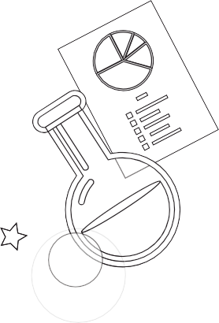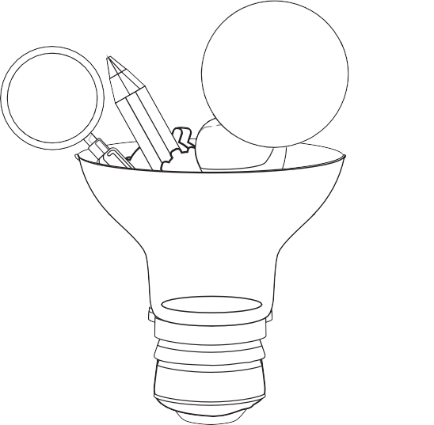
TEACHER DEVELOPMENT NOTES
7.4
TRADITIONAL VS ACTIVITY-BASED LEARNING
COVID-19 SERIES | Teacher’s Project Notes | GRADE 11
33
Traditional — teacher centred

Activity-based — learner centred

Basic learning

In-depth learning

Bigger class size

Smaller groups within class

Isolated subjects

Integrated/interdisciplinary subjects

Product-oriented

Process-oriented

Learning by repetition

Learning through active involvement

Concepts are facts to memorise

Concepts are questions to be investigated

Quantitative evaluation (numerical testing)

Authentic assessment (competencies, integrated, mindset)

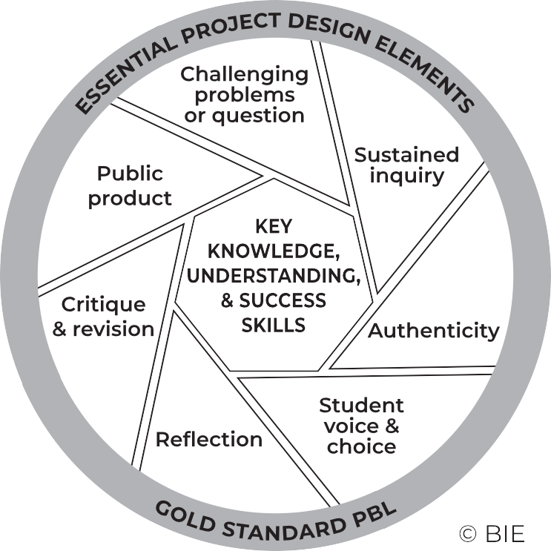
7.5 THE PROJECT-BASED LEARNING CYCLE
Below please find the Key Knowledge, Understanding and Success Skills to help you manage the project.
Challenging problem or question: Why is this project critical? What is the problem in society and at school being addressed in this project? Keep talking about how this project will solve a local or global problem.
Sustained enquiry: Are learners being “researchers”? Are they doing the research and getting deeper and deeper into the problem or are you doing all the talking? Look at the second circle overleaf
to remind you of your role: manage activities and scaffold student learning. Learners must not be allowed to give up – you must “build a culture” of getting to the bottom of the problem and coach them when they lose their way. With time E3 will be developing thinking tools to ensure that you are equipped with strategies to take the enquiry to a new level. (See overleaf for the current PBL learning cycle with a built-in innovation cycle.)
Authenticity: Keep the project real by referring to learners’ own lives – this is about them and their world.
Student Voice and Choice: Although learners did not choose this project, make it fun and real, and applicable to their own world, so that they own it. Their voices and opinions are what your deeper goal is – encourage their views and applaud each contribution.
Reflection: To truly embed learning, learners should be able to reflect on what they have learned and be able to think of better ways of doing things. The reflection activities in the worksheets are not just for fun. Encourage learners to spend time on them as this will deepen their learning.
Critique and Revision: This process is to help learners experiment with their innovation and learn how to improve their work and thinking. As you assess and evaluate their products (not them!) learners will see that there are different ways of solving problems. It is important that learners hone their curiosity and learn how to “stick it out” and keep trying, not giving up when it doesn’t work first time round.
Public Product: At the end of the project what does the learner have to show or to brag about? Ensure that there is a Project Culmination Week in which each grade displays their products during a week selected by the management team to ensure that as many parents and other stakeholders as possible attend.
34
PROJECT-BASED LEARNING | LIFE ORIENTATION

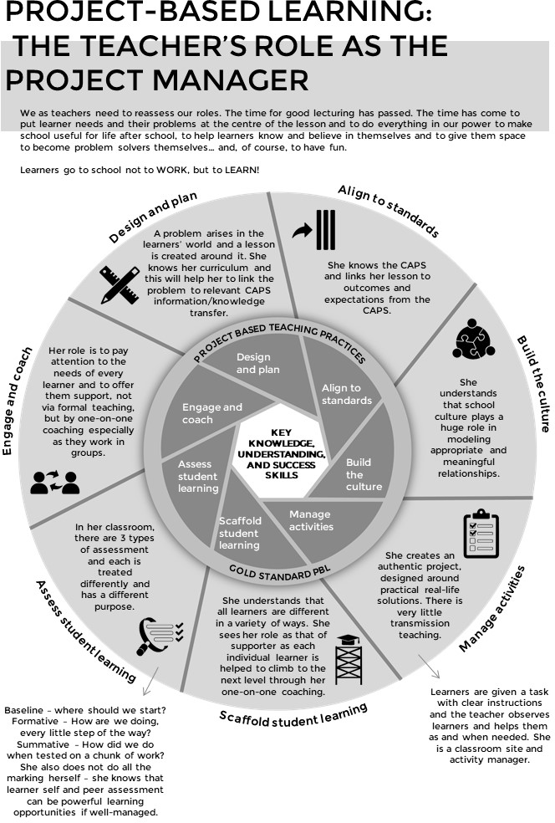
7.6 THE PBL FACILITATOR
COVID-19 SERIES | Teacher’s Project Notes | GRADE 11
35

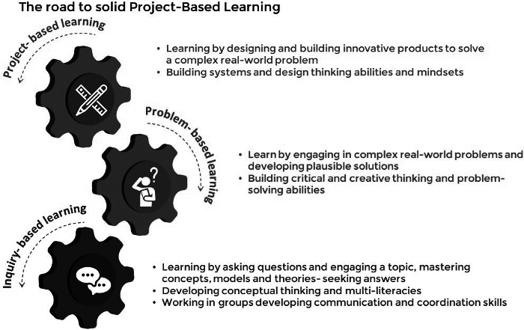
7.7
THE E3 COMPETENCIES WHICH WE ARE TRYING TO ACHIEVE
THE E3 COMPETENCIES WITHIN THE CAPS
THINKING
CHARACTER
CONNECTION
creativity
critical thinking and reasoning
citizenship curiosity resilience
mindset
collaboration communication
empathy
These appear in the competencies column of your planning. Please highlight each competency that was addressed during the lesson.
7.8
THE JOURNEY TO PBL VIA ENQUIRY-BASED AND PROBLEM-BASED LEARNING
36
PROJECT-BASED LEARNING | LIFE ORIENTATION

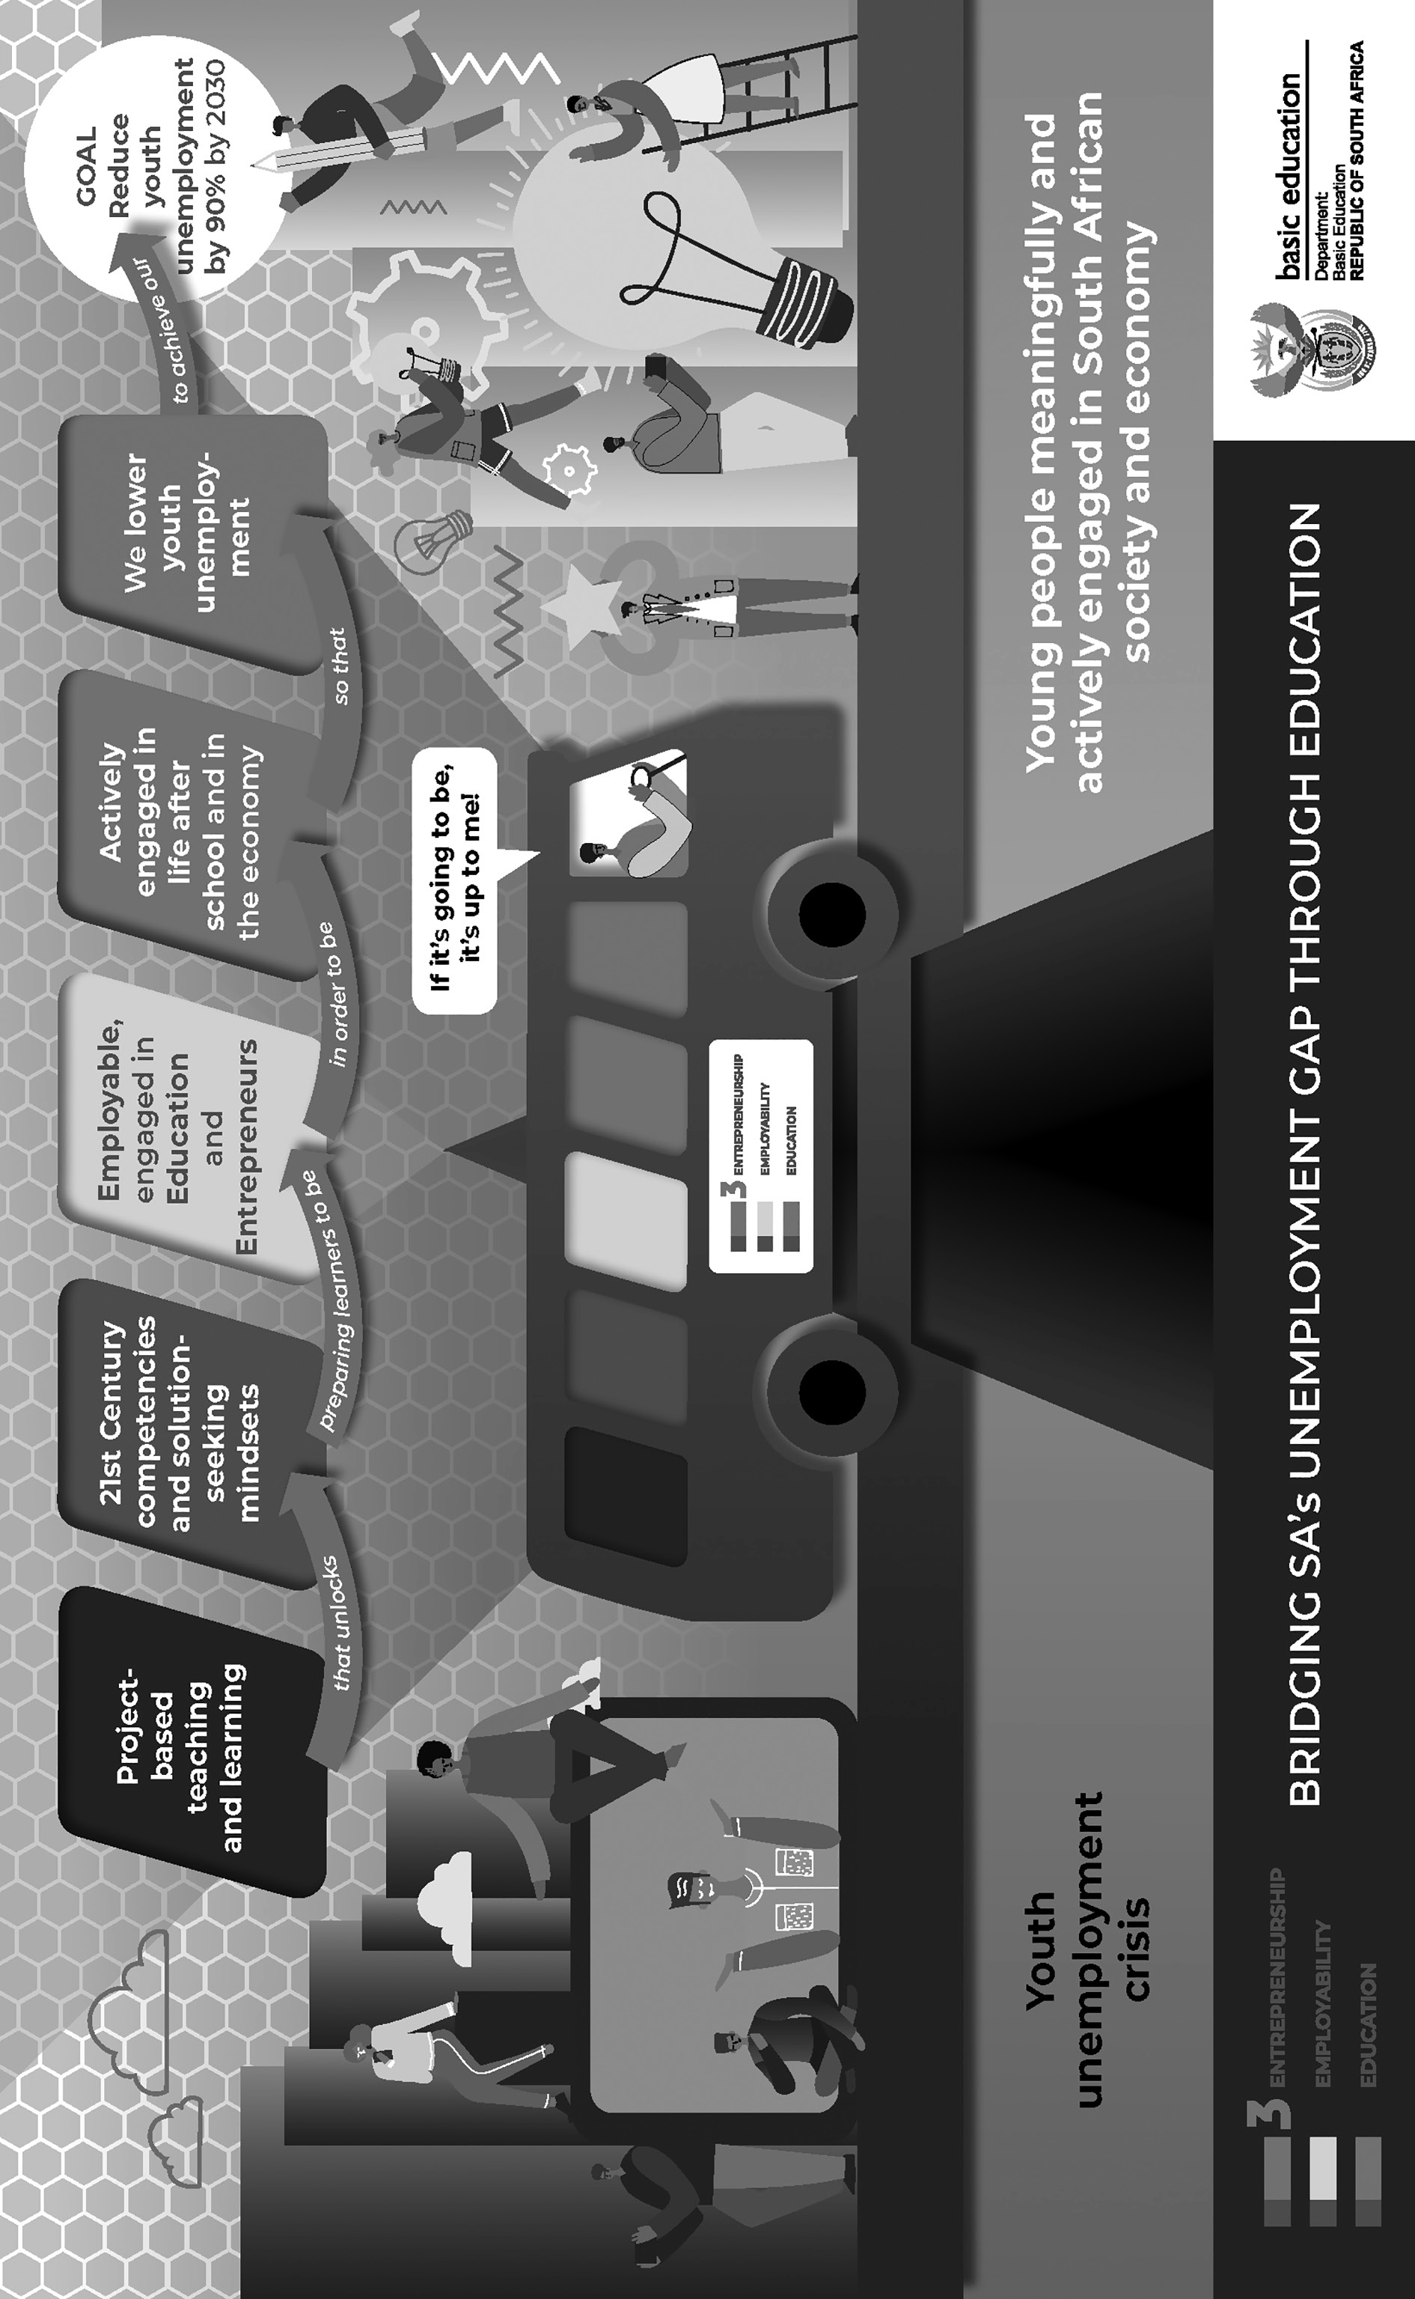
7.9
BRIDGING THE UNEMPLOYMENT GAP THROUGH EDUCATION
COVID-19 SERIES | Teacher’s Project Notes | GRADE 11
37

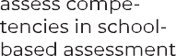
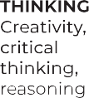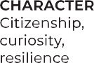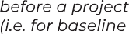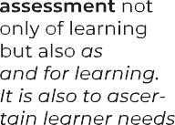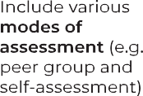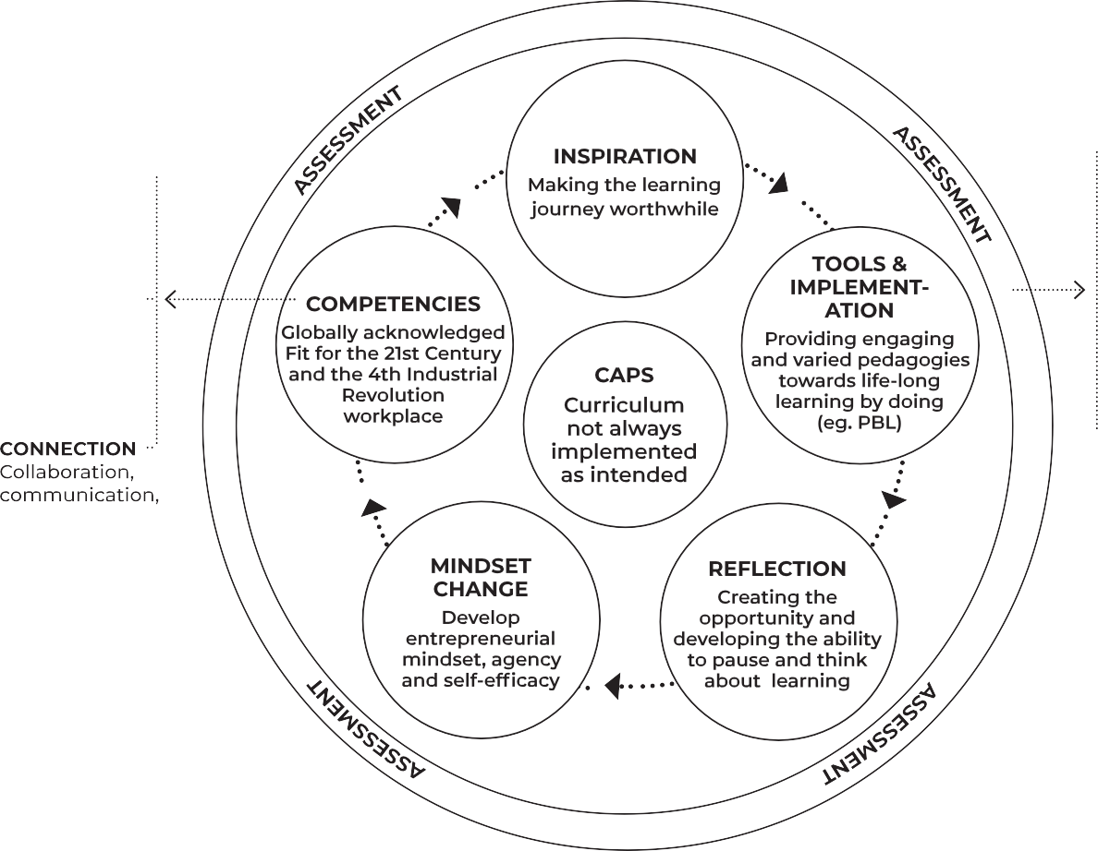
7.10
THE E3 LEARNING CYCLE – PEDAGOGICAL PARADIGMS
38
PROJECT-BASED LEARNING | LIFE ORIENTATION

Email your completed form to info@ecubed-dbe.org with the subject line “Teacher Agency Award submission
info@ecubed-dbe.org
Name of your solution:
Why did you choose this name?
Identifying the problem: (Maximum 200 words)
I identified the following problem in my school/community/at home:
E3 Teacher Agency Award Form | Page 1 of 5

Name:
Position: (e.g. Teacher, SMT, etc.)
If teacher:
Subject taught:
Grade:
School name:
District:
Province:

Your contact details:

Email:
Cell number:
WhatsApp number:

TEACHER AGENCY AWARD FORM

Trying, adapting the process until problem was solved: (Maximum 200 words)
Initially I …. Then …. Eventually I could solve the problem in this way: ……
E3 Teacher Agency Award Form | Page 2 of 5

Collaboration and access to information: (Maximum 200 words)
I collaborated with …. And accessed information from …. which helped me in the following ways…
Creativity and innovation: (Maximum 200 words)
My solution was very creative because I …. My solution was unique and innovative because …
E3 Teacher Agency Award Form | Page 3 of 5

Meeting E3 standards: (Maximum 200 words)
Explain why you are an E3 ambassador and tribe member. Use phrases like the following in your explanation:
I care and want to help others: ………………………………………………………...
I am a problem-solver:……………………………………………………………………….
I am awesome: …………………………………………………………………………………...
I am driven by purpose:……………………………………………………………………….
I have courage and self belief:……………………………………………………………….
I can keep going, despite challenges:………………………………………………………
E3 Teacher Agency Award Form | Page 4 of 5

Provide us with each of the following (please include clear notes on the pictures and videos):
- Your 4 best pictures (2 in portrait and 2 in landscape)
- A VoiceNote of not more than a minute reflecting on your growth in this project
- A short video that shows an important episode in the project
- If minors appear in the photos and video, please submit permission from parents or caregiv- ers that these photos appear on E3 platforms.
E3 Teacher Agency Award Form | Page 5 of 5

