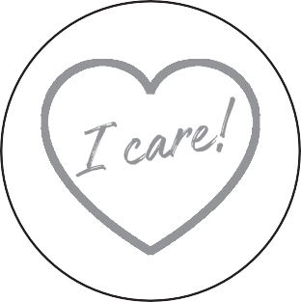

**3 ENTREPRENEURSHIP**

**EMPLOYABILITY**

**Learner's Workbook**

**THE I-CARE PROJECT**

**PROJECT-BASED LEARNING I**

**6**

basic education

#

8

Department:

Basic Education

REPUBLIC OF SOUTH AFRICA

,t.,*f*·-t. ;

'A i' i



**Table of contents**

***Appeal to learners for pictures and videos for E3 Facebook and Website***

***2***

**Introduction to the I-CARE project**

**3**

**Ice breaker**

**4**

**The project:**

* Step 1 – Planning
* Step 2 – Research/Finding out
* Step 3 – Making and showing the evidence
* Step 4 – Getti ng feedback and changing if you need to
* Step 5 – Finishing oﬀ the project
* Step 6 – Showing oﬀ your project
* Step 7 – Thinking about it afterwards

**5**

5

9

10

11

12

12

13

**Post-project reading activity: “The Little Soldier”**

**14**

**Assessment rubric**

**21**

**Learner's Library:**

* What is bullying?

**22**

22

22

22

23

23

24

24

24

25

•

•

•

•

•

•

•

•

Types of bullying Where to ﬁnd help How to get out of the bullying habit Body armour

Protect yourself with personal armour Abuse and Abandonment; why pets are at risk during this pandemic How to care for your pets

Making a bird-feeder

**The I-CARE Project LEARNER’S Workbook**

**Grade 6 | Life Skills | Term 3**

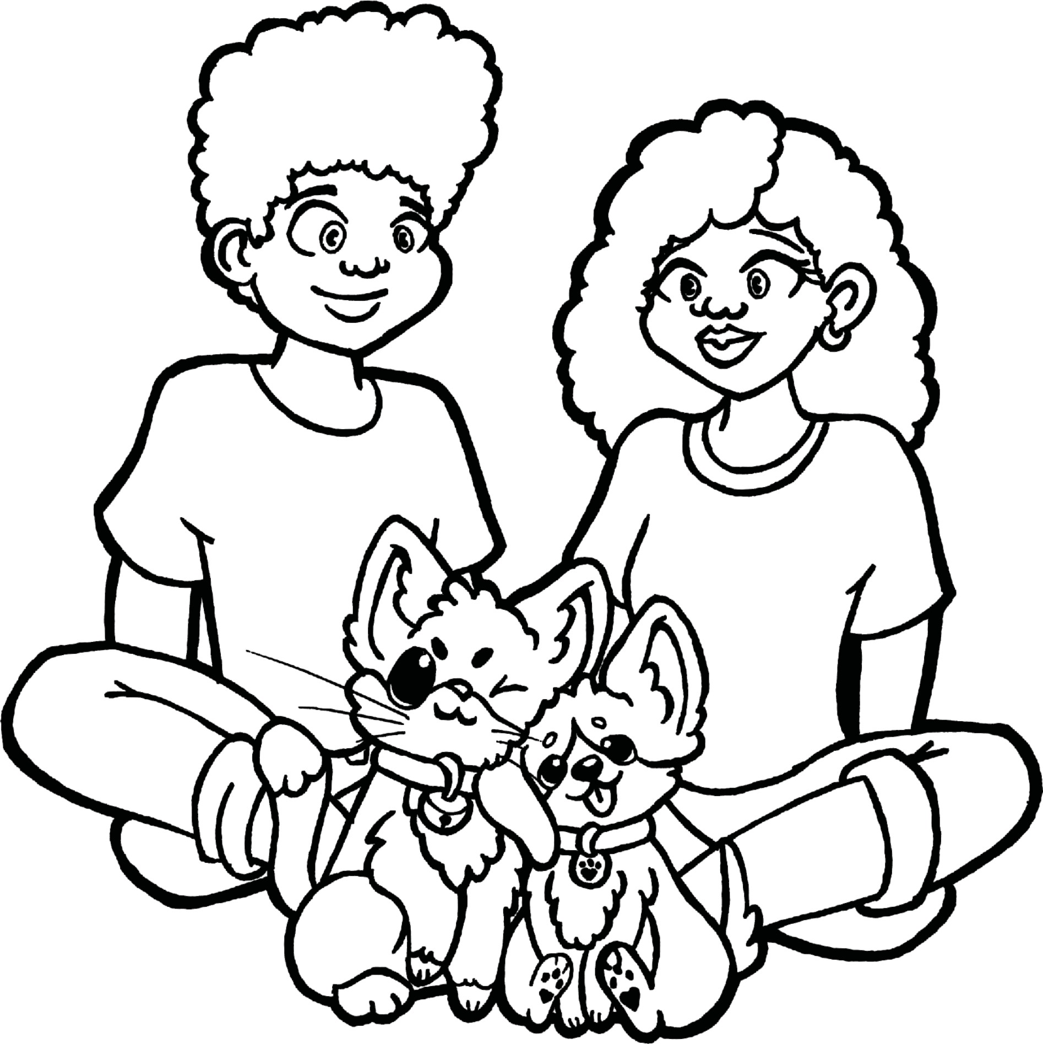

1



**E³ LEARNER'S WORKBOOK | GRADE 6 | LIFE SKILLS | TERM 3**

**The I-CARE Project**

**The I-CARE Project LEARNER’S Workbook**

**Grade 6 | Life Skills | Term 3**

1





**Send your pictures and videos!**

**Please send us pics/videos for our Facebook/Website**

Dear learner

We are so excited about this project and we would like you to share it with us once it is complete so that we can proﬁle it on our website and possibly on Facebook or Instagram. To do that, please follow these instructions very carefully.

**How to put your information together:**

**Tell us about your project:**

1. Name of project:
2. Name of learner:
3. School:
4. Grade:
5. Describe your project. (50 - 100 words)
6. Describe the biggest challenge you had doing this project. (50 - 100 words)
7. Describe what you would do better next time. (50 - 100 words)

**Choose the right photographs to tell the story of your project**

1. Choose three photographs that tell the story and progress of your project.
2. Make sure that no-one’s face is clearly visible unless they are wearing masks.
3. Make sure the picture is in focus and clear.

**How to send your submission:**

1. All submissions must be in a word document and the pictures must be in the document.
2. You can send it to us on email.
3. You can email it yourself, or you can ask your parent/caregiver or teacher to do this for you. You must use this heading on the email: Learner Portfolio Grade 6 Life Skills

If needed, we might ask you to make some changes to your submission in order to make it ready for uploading onto our website.

**The I-CARE Project LEARNER’S Workbook**

**Grade 6 | Life Skills | Term 3**

2

**Email**

[**info@ecubed-dbe.org**](mailto:info@ecubed-dbe.org)

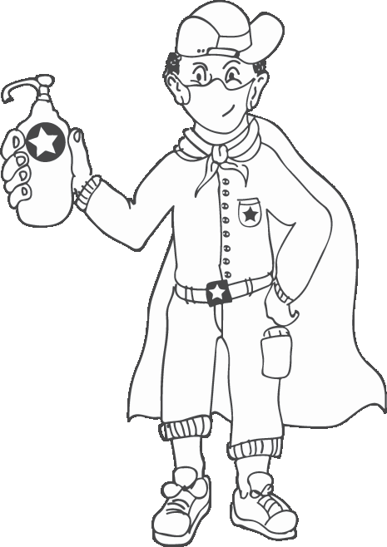



**Learner’s Workbook**

**GRADE 6**

**E³ Projects for Trimmed ATP**

**The I-CARE Project**

**Introduction**

Dear Grade 6 learner

You have just returned to school after a long stay at home. The coronavirus has meant that you have had more time to be with your family, but it may also have been quite scary as you have thought about your life and that of your loved ones. School is now a very diﬀerent place from when you were last here, but it must be good to see your friends again. Let's work together to share warmth and caring. How can you do this? Not by hugging them or giving them a high ﬁve! Rather show your friendship by keeping yourself healthy and by keeping your distance. Why should we do this? Because we are afraid? No! We should keep to the safety rules because we care, about ourselves, our family, our pets. Instead of hiding away from scary situations, put on your armour and start protecting yourself and your pets.

Together with all your classmates, you will do a project that shows that the coronavirus will make us stronger if we show caring. You will do a project to show that you care about yourself and your pets and you will create solutions to protect people and animals who are having a hard time because of bullies. You will start your research by thinking about people and animals being bullied and, like a scientist, research ways of helping them (and yourself if you have been bullied) by oﬀering suggestions for protecting themselves.

There are many resources at the end of this booklet. Make good use of them. They will help you to work independently (on your own), because you will not be able to work in groups. School is not much fun without our friends, and we do not learn so well if we have nobody to share with, so what can we do to share our ideas and get feedback?

Here are some ideas:

**1**

Choose one **buddy-guard**, someone with whom you can discuss everything in class using WhatsApp. If you chat face- to-face, remember to keep your social distance. Make a promise that you will be special partners for the project.

Also choose a **sibling, family member** or **caregiver** to share ideas with at home.

Your **teacher** could also be part of your “group”.

**2**

**3**

**The I-CARE Project LEARNER’S Workbook**

**Grade 6 | Life Skills | Term 3**

3

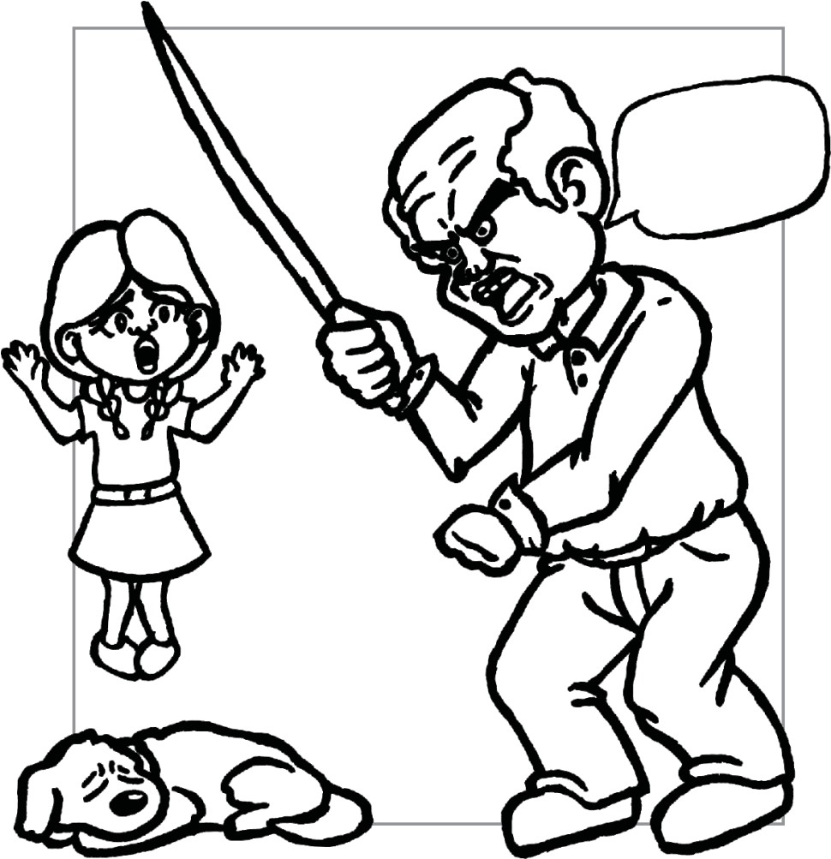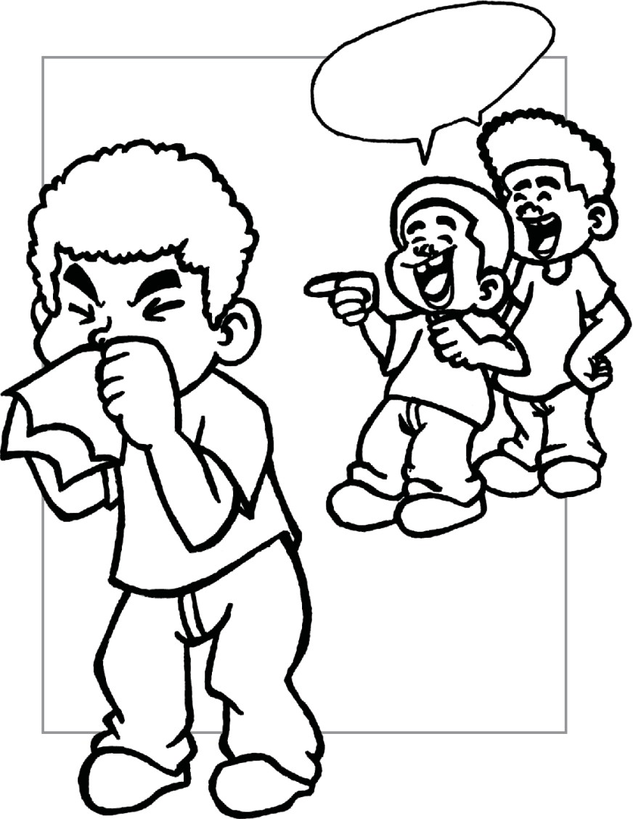

**Ice breaker**

Look at the pictures below. What is the problem with these feelings expressed by the learners? What can you as a scientist learn about the causes of the feelings? What can you recommend we do to ﬁx the problem?

1

2

What is the problem in these two pictures? List three questions for each picture you could ask to get to the bottom of the problem:

Picture 1: “Coronavirus!”

?

1.

?

2.

?

3.

Picture 2: “Bad dog”

?

1.

?

2.

?

3.

**The I-CARE Project LEARNER’S Workbook**

**Grade 6 | Life Skills | Term 3**

4





**Survey**

Complete this survey by answering yes or no to the questions. Once you have completed the questions, read them to a person sitti ≐ ng near you. They answer by showing a thumbs up for “yes” and a thumbs down for “no”. Remember to stay a safe distance away and don't give the person the page to touch. After that you need to get one of your family members to complete the questionnaire.

How many of these questions did you answer “Yes” to?

If you answered “Yes” to even one of these questions you could become a bully. We do not need bullies in our society and bullying is not only when people are mean to each other, it is also when they are mean or cruel to animals.

**The I-CARE Project LEARNER’S Workbook**

**Grade 6 | Life Skills | Term 3**

5

**QUESTIONS**

**YOU**

**YOUR BUDDY- GUARD**

**A FAMILY MEMBER**

1.

Are you sometimes mean to people?

2.

Do you sometimes pull faces at a person or show them mean signs?

3.

If a person told you a story about another learner, have you told that story to someone else?

4.

Have you knowingly excluded (left out) someone from a game or conversation?

5.

Have you ever hit, punched or pinched anyone?

6.

Have you called someone hurtful names or given them a name because of their physical features?

7.

Have you been part of a group that does not allow others to join or leave your group?

8.

Have you ever threatened to harm another person?

9.

Have you ever sent mean pictures or said mean things about another person on social media?

10.

Have you ever written something bad about someone on a piece of paper and passed it around the class?



___________________________



**How are you feeling after this ice breaker?**

Write down what you are feeling after the survey by completing this:

**PLANNING**

When doing research, you have to start with a problem. Finding the real problem is part of research. You are going to be like a scientist and do a research project on what type of bullies you get and about cruelty to animals.

What are the questions that come up in your mind after thinking of the pictures above? down three questions:

What?

Write

Why?

How?

**The I-CARE Project LEARNER’S Workbook**

**Grade 6 | Life Skills | Term 3**

6

Explain why you are feeling this way:

5) Great

4) Pretty good

3) Okay

2) Not too good

1) Bad



**Your project**

Topic: **Understanding bullying and cruelty to animals and making a plan to stamp out cruelty.**

In this project you will create three items: a poster, a shield of armour cut out of cardboard and a bird-feeder, or any other object to show you care for animals.

Create a mind-map summarizing the answers to these research questions:

What is bullying? Name four types of bullying and what each of them means. Give three reasons why people bully other people.

Give three steps people who bully can take to change their ways. Why people are cruel to animals.

Ÿ Ÿ Ÿ Ÿ

Ÿ

Find old cardboard and cut out a shape like a shield. (See Learner Library for ideas.) On it you will stick all the things you can do to protect yourself against bullies – this is how you will arm yourself against cruel people. Decorate it. Make sure you have at least 4 ways of shielding yourself against bullies and cruel people. Also: make sure you show clearly where a victim can ﬁnd help.

**The I-CARE Project LEARNER’S Workbook**

**Grade 6 | Life Skills | Term 3**

7

**Item 2: A cardboard shield - Stamping out cruelty**

**Item 1: Poster Mind-map - Understanding bullying**

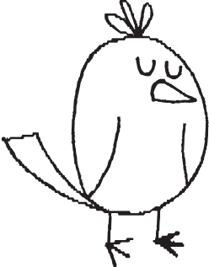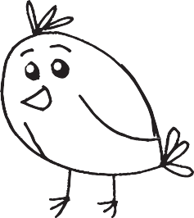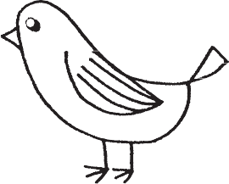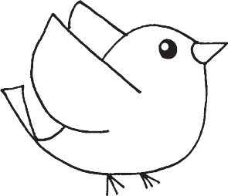

(Discuss and then make an item to show caring for animals.)

***1. Discussion:***

Discuss with your buddy-guard how we can all show kindness during COVID-19 and generally:

Three ways of being kind to others during COVID-19:

Three ways of taking care of and protecting animals, also during COVID-19:

***2. Showing I-CARE***

Make an object to show how much you care for animals – they cannot speak for themselves!

You can make any item using waste materials – if you are stuck, we suggest you go to the Library at the end of these notes to see how to make a birdfeeder.

Write down what you have decided to make:

Make a label for your item showing the following information:

**The I-CARE Project LEARNER’S Workbook**

**Grade 6 | Life Skills | Term 3**

8

Title: e.g. bird-feeder How does it show caring? Nearest place of safety for animals: Name:

Date:

**Item 3: Bird-feeder - Caring for Animals**





**RESEARCH / FINDING OUT**

There are many ways of ﬁnding information for the three items in your project. Please use three diﬀerent ways to collect information for this project:

***Types of research***

•

People you could interview? How to reference: Morobe, M. 29 July 2020, Johannesburg.

Articles you could read in the Learner’s Library at the back of this workbook (from the internet)?

How to reference:

Gordon, S. 2019, *7 ways to build social skills and prevent bullying*, viewed 2 June 2020,

<https://[www.verywellfamily.com/how-to-build-social-skills-and-prevent-bullying-](http://www.verywellfamily.com/how-to-build-social-skills-and-prevent-bullying-) 460718>

Your textbook?

How to reference:

Mohapi, J (2019). *Life Skills for All* Cape Town, Alpha Publishers.

•

•

Complete the table below to show how you found your information:

**The I-CARE Project LEARNER’S Workbook**

**Grade 6 | Life Skills | Term 3**

9

**ITEM**

**TYPE OF RESOURCE**

**REFERENCE**

**HOW IT WENT?**

**1**

**Poster**

Textbook

Articles from the internet

Interview with one other person that you think understands bullying

**2**

**Armour to stamp out bullying**

Textbook

Articles from the internet

**3**

**Bird-feeder or other caring item**

Articles from the internet

The internet if you choose your own item



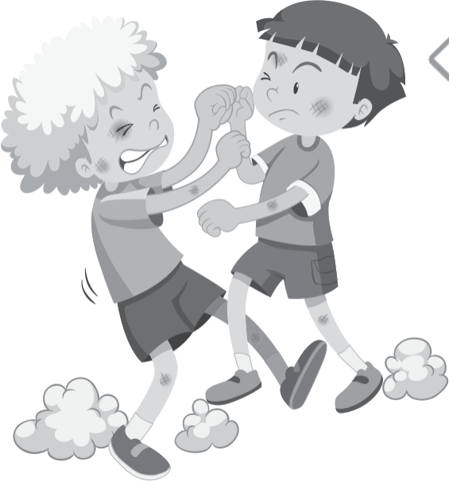

**MAKING AND SHOWING THE EVIDENCE**

**Item 1**

Making a poster: **Understanding bullying**

You now know where to ﬁnd the information. What else do you need? Collect everything before the time. Resources:

**Item 2**

Making a shield, body armour called **Stamp out bullying!** You now know where to ﬁnd the information.

What else do you need? Collect everything before the time.

Resources:

**Item 3**

Making an **I-CARE** object to show you care about animals You now know where to ﬁnd the information.

What else do you need? Collect everything before the time.

Resources:

**The I-CARE Project LEARNER’S Workbook**

**Grade 6 | Life Skills | Term 3**

10



**Item 1**

Practise your poster here by drawing a rough mind-map in the space below.

**Item 2**

Draft a plan for your shield and complete the labels using words that show you are armed against bullying.

Now that you have done your planning, ﬁnish oﬀ your poster, shield and bird-feeder at home.

**The I-CARE Project LEARNER’S Workbook**

**Grade 6 | Life Skills | Term 3**

11

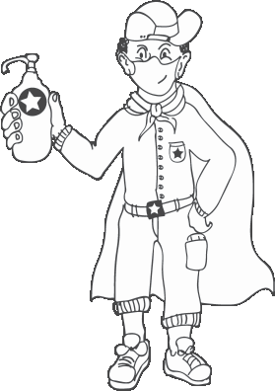



**GETTING FEEDBACK AND CHANGING IF YOU NEED TO**

Ask your buddy-guard, your family and other people (keep your distance!) for feedback on your self-feeder. Use their feedback to improve your product. Say what they advised and what you did. Get at least 3 people to give you feedback.

Write down what you changed, when you made changes and why.

**The I-CARE Project LEARNER’S Workbook**

**Grade 6 | Life Skills | Term 3**

12

**DATE OF ADVICE**

**WHO GAVE FEEDBACK**

**WHAT THEY SAID I SHOULD DO**

Who at home is your advisor?

How will you get hold of your teacher if you need him/her?

Teacher’s cell number

Who is your buddy-guard?

What is your buddy-guard’s address or cell number?

Why did you choose him/her as a buddy-guard?





**FINISHING OFF THE PROJECT**

Using all the feedback and what you have learned after trying to improve your poster and bird- feeder, ﬁnish oﬀ all three your project items and the writing that goes with them.

What did you change?

Did it improve your I-CARE bird-feeder and poster? Explain:

**SHOWING OFF YOUR PROJECT**

Take your I-CARE item to school and ask your teacher to show your work oﬀ to the rest of the school. Ask at least 2 people to score your project out of 7.

Ask people to write a note saying what they thought about the project. Place a few assessment sheets near your project for comments:

Name of visitor: Date:

**The I-CARE Project LEARNER’S Workbook**

**Grade 6 | Life Skills | Term 3**

13

**ITEM**

**RATING**

**COMMENT / FEEDBACK**

I-CARE item shows care in the making

Project maker showed passion

**WHO GAVE FEEDBACK**

**SCORE / 7 AND THE REASON**





**THINKING ABOUT IT AFTERWARDS**

1. What did you love about working on this project?

2. What made this project hard for you?

3. What did you learn by working on this project?

•

About yourself?

•

About protecting yourself from bullying and caring for pets?

•

About changing your ways if are a victim or helping people who may turn into bullies one day?

•

About learning during COVID-19?

4. What would you do diﬀerently if you did a project like this again?

**The I-CARE Project LEARNER’S Workbook**

**Grade 6 | Life Skills | Term 3**

14

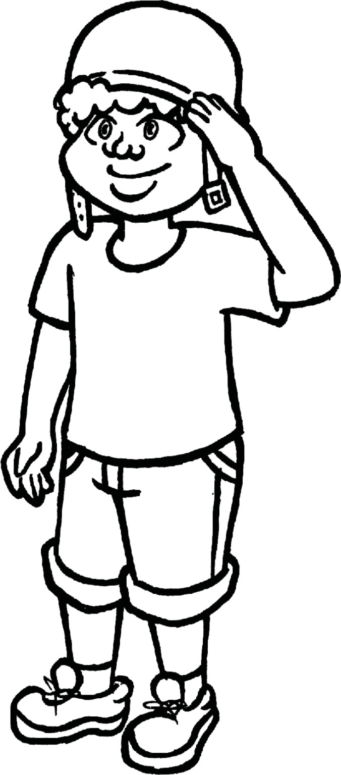



**Post-project reading activity**

**The Little Soldier *by N. Maduna***

**Caring for each other:**

Read the play “The Little Soldier” who also had to arm himself, this time against coronavirus.

If there is time you can ask your teacher if you can sit at your desks and act out the play. Remember to keep social distancing.

**The Little Soldier**

**Characters**

*Teboho (The little soldier) Lerato (Mother) Japhta (Father)*

*Pinky (Neighbour) Sesi (Neighbour) Olwethu (Teboho's friend) Sonnyboy (Teboho's friend) Priest*

As the coronavirus hits the world, Teboho (a 13-year-old boy doing grade 6) is sitti 쌰怀怀쑐怀ng on the step in front of his house watching his friends playing in the street. He is thinking hard about the reopening of schools.

**ACT 1**

***Scene 1*** *(The doorstep in front of Teboho's house facing the street.)*

**Teboho:** *(Thinking aloud)* I can't lie that I don't miss my friends. I miss playing with my friends. Look how happy Olwethu and Sonnyboy are. They're playing in the street as if the coronavirus story is a lie. I wonder if we all gonna die … lots of people are saying it's the end of the world. What's gonna happen?

**ACT 2**

***Scene 2*** *(Pinky, Lerato and Sesi are returning from the shops.)*

**Pinky:** They are crazy, my child is not going to school! **Sesi:** Keng, they wanna kill our children.

**Lerato:** Bathong, our children should go back to school …besides, the Government promised to keep them safe.

**The I-CARE Project LEARNER’S Workbook**

**Grade 6 | Life Skills | Term 3**

15



**Pinky:** Government! Promises, where are the jobs they promised? **Lerato:** We not talking about jobs, but our children's future.

**Sesi:** My child will repeat that grade, I'm not gonna kill my child! **Lerato:** But you let your child play on the streets. Don't you think he will get infected? **Pinky:** Lerato, why don't you become a politician?

**Lerato:** Let's face the facts… yes, Corona is dangerous, but we have to teach our children to be safe from it, not stop them living their lives. When we grew up, there were illnesses, but we were informed. We knew how to protect ourselves. (*Both Sesi and Pinky keep quiet.*)

**ACT 3**

***Scene 1*** *(At the fence of Teboho's house – maintaining social distance.)*

**Olwethu:** Teboho! Teboho!

**Teboho:** *(Coming back to his senses.)* Olwethu, howzit! Why are you playing on the street?

**Olwethu:** My mom said I should go play. **Teboho:** Are you going to school on Monday? **Olwethu:** My mom said I'm not going … and you? **Teboho:** I don't know, but I wanna go.

**Sonnyboy:** Tjo tjo, Corona will kill you! **Teboho:** There will be sanitisers and masks at school. **Sonnyboy:** My father said those things don't work.

**Teboho:** *(Sees his mom)* Bafethu, my mom is coming. Sharp sharp! *(He sees his mother returning from the shops and quickly says goodbye to his friends.)*

***Scene 2*** *(Teboho's house) Lerato prepares supper while Teboho and Japhta are watching T.V.*

**Lerato:** *(In the kitchen)* Teboho, are you ready to go to school on Monday?

**Teboho:** *(Looks at his father, Japhta, who shakes his head.)* I'm not going, mom. **Lerato:** Why not?

**The I-CARE Project LEARNER’S Workbook**

**Grade 6 | Life Skills | Term 3**

16

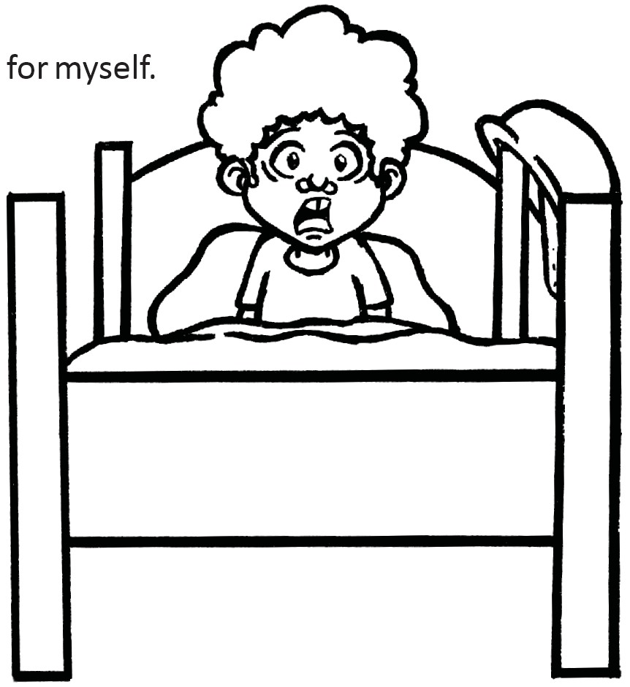

for myself.



**Teboho:** Olwethu and Sonnyboy are not going. **Lerato:** *(Shouts)* Don't tell me about other people! **Japhta:** Teboho is not going to school. End of story!

*(Lerato brings food for Teboho and herself.)*

**Japhta:** Didn't you dish up for me? **Lerato:** You're working with many people at your work… **Japhta:** So?

**Lerato:** Maybe you have Corona… **Japhta:** Lerato, stop with your drama, bring me food! **Lerato:** Aah, Japhta! We'll dish up for you once this Corona thing is over. **Japhta:** We have sanitisers and masks at work.

**Lerato:** Even at school. **Japhta:** Mmm, *(in another world)* …then I will dish up ***Scene 3***

*That night Teboho dreams about himself, infected with the coronavirus.*

**Teboho:** *(Screams. Japhta and Lerato rush to his room.)*

**Japhta:** Boy, what's wrong?

**Teboho:** *(Looks at them, eyes wide open.)* I'm gonna die!

**Lerato:** *(Angrily)* You see your work, Japhta. It's all that negative talk!

**Japhta:** It was just a bad dream my boy, you are not gonna die. *(He puts Teboho back into bed, and goes to his bedroom, where Lerato waits for him, clearly upset!)*

**Lerato:** What kind of man are you? Are you just a man, or a real man? **Japhta:** *(Confused, speaking slowly.)* What do you mean…? No, I am a real man!

**The I-CARE Project LEARNER’S Workbook**

**Grade 6 | Life Skills | Term 3**

17



**Lerato:** You inject death into your child's mind, you need to be a hero – kids need their fathers to be strong.

**Japhta:** I ***am*** his hero!

**Lerato:** He misses his friends. He wants to go to school. You can't take that away from him. I'm going to church tomorrow to pray for you. *(She gets into bed and turns the other way.)*

***Scene 4*** *(Inside the church)*

*Sunday morning is church. Everyone is excited to go back to church after they have reopened after the hard lockdown. We see latecomers rushing into the church. Teboho is happy to see both his friends there with their parents.*

**Priest:** Even thou I walk in the dark, he shall provide the light, even if death knocks on my door he shall kick death to death. He is Alpha and Omega and by His name no sickness shall conquer. Say 'Amen' if you believe

**Congregation:** Amen! *(We see the ladies walking home. The boys are excited.)* **Olwethu:** See you tomorrow!

**Teboho:** Sharp sharp! *(Not knowing what to say, because he fears his father).* ***Scene 5*** *(Back at home)* **Lerato:** *(Opens the door, smells good food)* Japhta, we're home!

**Japhta:** *(Appears after a while. Looks at Teboho with real emotion)* Soldier! Soldier!

**Teboho:** Yes, sir! Yes, sir! *(He stands up, salutes, ready to play soldier as always, an old game they enjoy together.)*

**Japhta:** I have a mission for you! **Teboho:** Yes sir! What's the mission code, sir? **Japhta:** CORONA!!

*(Teboho looks at his father in surprise.)*

**Japhta:** *(Shouts)* Soldier, are you afraid of Corona? **Teboho:** No, sir!

**Japhta:** Tomorrow will be a big day. I want you to carry as many weapons as you can.

**The I-CARE Project LEARNER’S Workbook**

**Grade 6 | Life Skills | Term 3**

18



**Teboho:** Yes, sir!

**Japhta:** Wear your mask at all times, walk and sit 2 metres away from your friends, don't shake anyone's hands and the most important thing ...

**Teboho:** Yes, sir?

**Japhta:** Wash your hands as many times as you can and come straight home after school. Are we clear, soldier?

**Teboho:** Yes, sir! *(Smiles)* Clear, sir! **Japhta:** Go and prepare your weapons, soldier! *(Teboho runs towards his father)* **Teboho:** Love you, papa!

**Lerato:** *(Looks at her man.)* l'm lucky to have you. *(They hug, clearly emotional.)* **Japhta:** Dish up, baby!

**Lerato:** Yes sir, instruction clear, sir! *(She salutes)*

***Scene 6***

*(It's Monday morning and we see the boys coming out and greeting, elbow style. They stand 2 metres away from each other and start singing.)*

**All:** *(With feeling)* Nkosi sikelela i Africa! End

**Reﬂecting on the play**

Do you think playing in the street without masks is the right thing to do?

Why/why not?

Do you think Teboho's mother is cruel to send him back to school?

Would you consider it a form of bullying? Explain:

**The I-CARE Project LEARNER’S Workbook**

**Grade 6 | Life Skills | Term 3**

19

_____________________________________

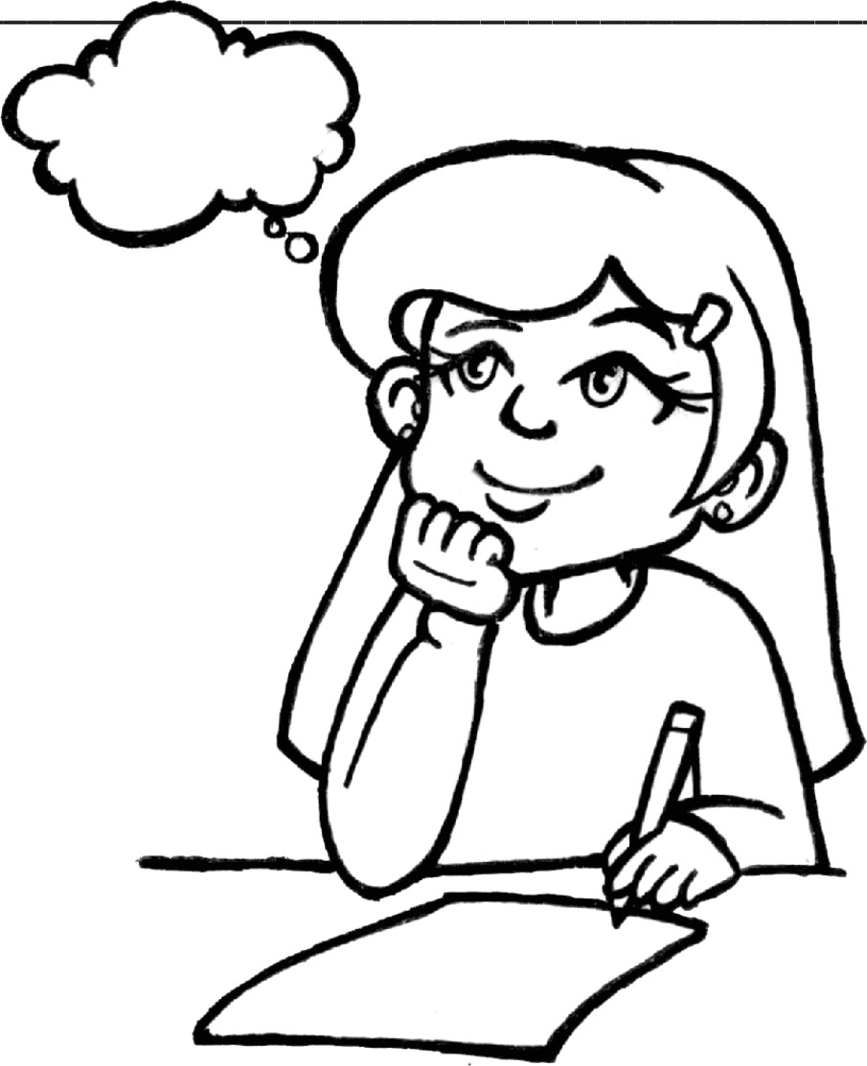

Why/why not?

Why do you think the play is called “The Little Soldier”?

What does it mean to arm yourself?

What types of armour is Teboho using to protect himself at school?

In your opinion, should children attend school during COVID-19?

Why do you think so?

Do you feel safe at school?

What is the reason?

**The I-CARE Project LEARNER’S Workbook**

**Grade 6 | Life Skills | Term 3**

20



**Assessment rubric**

**The I-CARE Project LEARNER’S Workbook**

**Grade 6 | Life Skills | Term 3**

21

**ITEM**

**CRITERIA**

**0**

**NOT ACHIEVED**

**1**

**PARTIALLY ACHIEVED**

**2**

**ACHIEVED**

**3**

**SUPERIOR**

**LEARNER MARK /30**

**Item 1 - Poster**

3 reasons for bullying

No reason given

1 reason given

2 reasons given

3 reasons given

/3

Why people are cruel to animals (3 reasons)

No reason given

1 reason given

2 reasons given

3 reasons given

/3

Where to ﬁnd help clear and striking on poster

Completely left out or minimal info given.

Not very clear or striking.

Some info given.

Clear but not so striking.

Almost all info given.

Very clear and striking. All relevant info given.

/3

Three actions of a bully are clear

Nothing provided

1-2 actions given

2-3 actions given

More than 3 actions given

/3

Layout/design of mind-map

No or very little info which is not clearly displayed.

Basic layout is in place.

Minimum info appears on mind-map.

Quite neat, creative and displays most of the information.

Neatly executed, creative and very clearly displays required information.

/3

**Item 2 - Body armour**

4 ways of protecting yourself clear on shield

No or very little info on self- protection appears on shield

1 way of protecting yourself is clear on the armour

2 ways of protecting yourself are clear on the armour

3 or more ways of protecting yourself are clear on the armour

/3

Where to ﬁnd help clearly marked

No info appears

Some info appears but not clear or complete

Info for ﬁnding help clearly marked but details incomplete

All info for ﬁnding help clear.

Complete set of details

/3

**Item 3 - Bird- feeder or other caring item**

Functional

Does not work/poor functionality

Mostly works

– some design ﬂaws

Works well

Works perfectly

/3

Label has all info

Label has no/one item of info

Label has two or three items of info

Most of the info appears – one item missing

All info appears on the label

/3

Caring and passion are evident

Not handed in or handed in but clearly no caring went into the making

Basic design works but no real eﬀort shown

Good design: workable – some eﬀort and caring shown in ﬁnishes

Has gone extra mile to producing workable bird- feeder/item with creative ﬁnishing touches

/3

**TOTAL:**

**/30**



**Grade 6 Learner’s Library**

Wh

a is bullying?

B

is rep ated

a

g

g

re

ssiv

e

b

eh

avi

r

a

a

in

st

s

o

m

eon

e

els

for

n

o

ap

p

a

ren

t

reaso

n.

S m

etimes a group

o

f

le

ar

ner

s

is

ol

ate o

ne

le

a

r

e

i

n

p

arti

c

ular

to d

is

p

l y

t

h

ir

p

ower

.

Bul

lying c n b phys

al, v

erb

a

l,

or

relat

i

na

l,

in

-p

e

rso

n

o ine. B

u

llie

ar

o

ft

e

rele

ntless, bullying ov

er

a

nd o

v

e

r a

ain

fo

r l

ong

e

io

ds o

f time

. You

m

ay

l

iv

e in

con

stant fear of whe

r

e

a

n

when

the bu

lly

w

i

ll str

ik

e next

.

Typ

es of bul ying

**Physical bullying** –

i

n

c

lu

des

h

it

tin

g, kicking,

or

p

u

s

hi

ng y

o

u (o

r ev

en

jus

t

t

hre

at

eni

ng

to d

o so), as well as

ste

a

ling, h

i

ding

, or r

ui

ni

ng

y

our

th

ings,

and

emb

a

r

rass

ing y

o

u.

**Verbal bullying** – in

c

l

u

de

s na

m

e-c

allin

g,

te

as

ing,

t

a

unting, insultin

g,

oth

erwise

ver

bally abusing you, e.g.

“Coro

n

av

irus! Co

r

ona

virus!”

– inclu

de

s refus

ing to

ta

lk

t

o

y

ou, l

e

avin

g you

out

f

rom

g

roups or

act

ivities, spreading lies about you, making you do things you don’t want to do.

**Relationship bully**

**in**

**g**

Tec

hnology means t

h

t

bullyin

g

is

no long

er

lim

it

e

d

to the

school p

la

y

ground.

It can

**Cyberbullying**

hap

pen anywhere: via sm

artp

hones, em

ails, t

exts, and

soc

ial m

edia, 24 h

o

u

rs a d

ay,

wi

h hundreds of pe

o

p

l

e s

e n

g y

as a

v

ict

im.

Rea

sons for bullying

Bul

lies t d to pick

on

p

eo

ple

w

h

o

are “

di

ﬀe

r

t”

o

r

d

on’t

it in

with

th

e m

a

ins

tream.

Ma

ybe you d ess or

a

c

t

di y te.b ltyh

ﬀer

n

t

, or m

ay

be

yo

ur

r

ac

, or

r

eligio , or the

w

ay yo

u loo

k

set

s you apart. It may

si

m

ply

e

a

t yo

u’re

n

ew

to

e sch

o

ol o

r ne

ig

h

bo

u

rho

o

d

and haven’t made fr

ie

nds

e

Oth

er reasons why k

i

d

s

b

reruojllfvwelyaeeni:lsloppuroobsopwublelleiyremfoduuslt.hemselves.

* To make thems

ular or to gain at ention.

t

* BTBoecloauosketothuegyh’roe be ng

of

●

●

* To escape thei

Where to ind help

1. Go to people you trust for encouragement and support: a parent, teacher,

counsellor, or other trusted adult or even your buddy-guard. It doesn’t mean that

you’re weak or there’s something wrong with you. Share what you are going

through. It can make a huge diﬀerence in the way you feel, even if things do not

change.

2. Boost your conﬁdence**.** Exercise is a great way to boost your self-esteem and reduce

stress. Go for a run or take a kick boxing class to work oﬀ your anger in a healthy

way.

**The I-CARE Project**

**LEARNER’S Workbook**

22

**Grade 6 | Life Skills | Term 3**

https://wwhttps://us.dit[https://ww](http://www.w.chthelabel.orhelpgustopbullyideing.go.orgg/ho/articles/av/bwull-toying/-stbuse/bullyopw-bullyinhat-is-gbullying-others/-anding-cyberbullying.htm)w.w.[chthelabel.orhelpgu](http://www.w.chthelabel.orhelpgustopbullyideing.go.orgg/ho/articles/av/bwull-toying/-stbuse/bullyopw-bullyinhat-is-gbullying-others/-anding-cyberbullying.htm)st[opbullyideing.go](http://www.w.chthelabel.orhelpgustopbullyideing.go.orgg/ho/articles/av/bwull-toying/-stbuse/bullyopw-bullyinhat-is-gbullying-others/-anding-cyberbullying.htm).[or](http://www.w.chthelabel.orhelpgustopbullyideing.go.orgg/ho/articles/av/bwull-toying/-stbuse/bullyopw-bullyinhat-is-gbullying-others/-anding-cyberbullying.htm)g[g/ho/articles/av/bwull-toying/-stbuse/bullyopw-bullyinhat-is-gbullying-others/-anding-cyberbullying.htm](http://www.w.chthelabel.orhelpgustopbullyideing.go.orgg/ho/articles/av/bwull-toying/-stbuse/bullyopw-bullyinhat-is-gbullying-others/-anding-cyberbullying.htm)

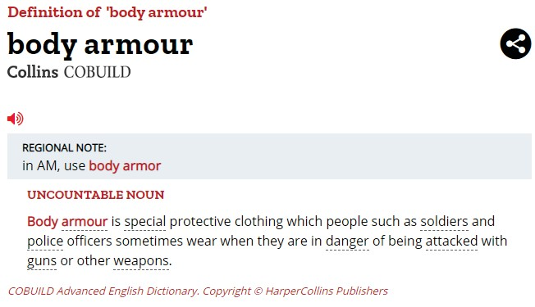

3.

In case of cyberbullying, don’t respond to any messages or posts. Save the evidence

– especially rude messages to be reported to the police and prosecuted by law.

**The I-CARE Project LEARNER’S Workbook**

**Grade 6 | Life Skills | Term 3**

23

H***If*** o***y***w***ou***to***ar***g***e***e***t***t***h***o***e***u***b***t***u***o***l***f***ly***t***:***he bullying habit

1. Stop labelling yourself as a bully. It isn’t productive and will not beneﬁt you. You may be bullying another person, but that does not mean you are a bully.
2. It is a behaviour and not your identity. Bullying is a learned behaviour and is often used as a coping mechanism for a stressful situation.
3. Once you know why you are bullying someone ﬁnd a to solve the problem. Speak to an adult who you trust.
4. Pulling somebody else down will never, ever take you any higher.

**Summarised from the following online sources:**



●

**The I-CARE Project LEARNER’S Workbook**

**Grade 6 | Life Skills | Term 3**

24

ICBpPloPcWpb**H**dSitaofaekeelOu**o**awhrucoaetV**w**neekinlpraIysn-fiDln**t**uogmefr**o**wi -o-rp:emimpw1arht**c**etci9lsuhah**a**cattadtb”hrlkeyo**r**r.sinrtemi**e**es,haisnhintrsalro**f**.gar/spg**o**nuevc,uei**r**saeagomtcpasrnh**y**ria.dea mi**o**atpdimolnci**u**tsorifphadcoa**r**ptwtlalvoltns**p**tyvaeios3**e**ni“dtngitr**t**hiohmets**s**aeconoetnlasatsrsroieilemiiosurcnw,isrkasgow.hlwhconsnftooirhlpolymlegnsietsvn:o,levotyeisirtntdrbhoafiaoenetyuentharnsyhodle,tciueghsaeme-rehneavthaodhaedubkosfnaudktaepm-teruocitaraotekmbzhatftsdietlhe,don.omrseeTngetwaph,iomroctcoiaenfhsavanlr.mt.itmkihadoone–laraemtyp.atnaoa-nirncncwnnioeysctduht.khlphaeuys:eerm,-doyiprwenfiecpcegasato-wubsnys-baeiostnlnseirlobtdadeilnto--eltuaosnoptmnem-emotgieoietasn-nrktt-e,

beutrt●encr-ltifheit-sap-pn:aimn/dahelsecon-1e44a0t1;nht s //a/wwsew.vnd a ea zdele goevntza/c arur pt rsi

**P**Jou**R**s**O**tsa**T**s**E**s**C**o**T**ldf**Y**ioe**O**r**U**s **R**w**S**e**E**al**L**r**F**anr**W**ma**I**o**T**u**H**rot**P**o**E**p**R**r**S**oe**O**tme**N**co**A**ttt**L**h**A**ei**R**rl**M**pthh**O**y**U**sai**R**ctsalwbiothdioeus,rwe can also protect.

Duisdrs yoeoflvtueenksn? orTwhmethmbauetlpyseai oggpeltehnwaditththhebeebrtutelry srkeiioclnlsa,vceosm,riespethteant coifecsoann di **P**c**e**lo**r**s**s**e**on**fbr**a**iee**l** nn**A**d**r**s**m**gr**o**eo**u**te**r**bcutelldiebdy

lRfSaC**A**arnuOe**b**oydmV**u**me-rI**s**mepDsb**e**mrao-ue**a**1rbfvl**n**il9esesi**d**erenHsldt**a**f.ao--**b**Sfbswrhe**a**ucoola**n**lhfmlrv-y**d**atbehins**o**enaog**n**lagieufne**m**-rdr4fdice**e**6ateonh**n**0n:tde**t**7dhh**:**,1wetc**w**yt8roaop**h**upyus**y**r:ew/nao**p**/gep**e**well**t**ediw**s**vwtewi**a**olh**r**la. v**e**monierd**a**casra**t**tkymrwbe**r**ea**i**eye**s**dfo**k**laoelufrf**d**arysm**u**nitoei**r**rinumol**i**yd**n**.na..**g**cglFso.**t**rm**h**liee**i**/s**s**nshd**p**oss**a**awn**n**pfce-r**d**te.o**e**, -**m**ebcu**i**it**c**ilegda-pcshocoitahl-esrkills-

inwikihoi SPCAw.oncom013/Tak932e-Car202e0-o

et

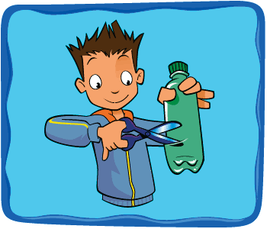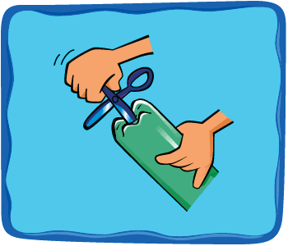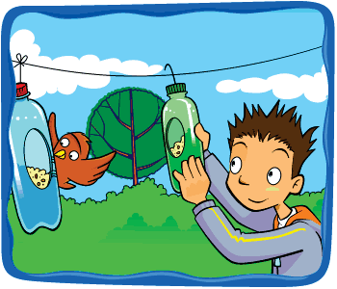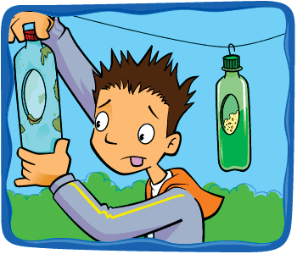

**For more information on the Better Life Campaign, or to report abandoned or**

●

●

**The I-CARE Project LEARNER’S Workbook**

**Grade 6 | Life Skills | Term 3**

25

* NcIfhetavhienrse;btaehrceryuacnealimntogaaelsnt iianmgygaorlseuslrivceeomihfimthtiuennygiattyrheethmaabtouhrsaetvydei.nbgetchoemmeudpanwgiethroruosp, edsoonrot hurt
* them. Call your nearest SPCA for help.

**injured**TCse**a**h**n**w**im**an**a**e**ls**S**,**P**c**C**a**A**ll** o**o**n**ne**01**o**2**f t**8**h**0**e**3**f**5**o**2**ll**1**o**9**w**, **ing numbers:**

* uwrion SPCA on 012 664 5644/5

**M**ht**a**t**k**p**i**s**n**:**g**//K**a**wu**b**nw**ir**gw**d-**.**feeder** f-Your-P

**Step-by-step guide**

1. Cut a hole in the side large enough to allow a free ﬂow of seeds, but in such a way that it won’t all fall out on the ground in the slightest puﬀ of wind, and won’t get wet if it rains.
2. Make a few small holes in the bottom of your feeder to allow any rainwater to drain away. Hang it with wire, or even strong string from a tree or your washing line.
3. If your feeder starts to wear out or the food in it goes mouldy, recycle it and make another one! Remember to keep your feeders well stocked, especially in winter. Birds come to rely on them and will go hungry if you forget.