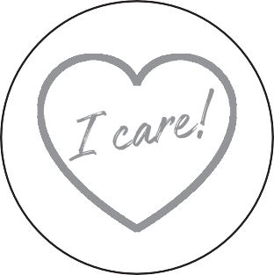

**3 ENTREPRENEURSHIP**

**EMPLOYABILITY**

**Teacher's Project Notes**

**THE I-CARE PROJECT**

**PROJECT-BASED LEARNING I**

**6**

basic education

#

8

Department:

Basic Education

REPUBLIC OF SOUTH AFRICA

,t.,*f*·-t. ;

'A i' i



Dear Teacher

Provided herewith is a **Learner’s Workbook** and a set of **Teacher’s Project Notes for the School- Based Assessment (SBA) Task for Term 3** as per the SBA Plan in Section 4 of the CAPS. These documents are specially created to support you with COVID-19 issues for your subject as per the trimmed Annual Teaching Plan (Section 3) for Term 3.

Most importantly it is envisaged that this will lessen your workload as we come to grips with the disruptions caused by COVID-19.

The Learner’s Workbook and Teacher’s Project Notes were created by DBE-E3, a unit at the National Department of Basic Education which is rolling out Project-Based Learning **(PBL)** in schools, to better prepare learners for a changing world. Although you may not be part of the DBE-E3 Programme as yet, these projects are created to:

1.

Engage learners in processing the pandemic which is aﬀecting their lives and those of their families;

Promote learner self-reliance and independent learning using safety measures; and Encourage social learning in a safe environment.

2.

3.

**Where did this all start?**

**E3: Entrepreneurship, Employability and Education is currently being rolled out in SA schools.** The DBE-E3 Unit, in response to the National Development Plan, has been working in public schools since 2018 to advocate the eventual implementation of Activity-Based Learning, with a special focus on **PBL**. **E3** is part of a DBE programme to introduce *Thinking Skills for a Changing World* into the curriculum in its eﬀort to reduce youth unemployment substantially by 2030.

**How did this work in 2018 and 2019?**

Initially three provinces in 2018, and then all nine provinces in 2019, implemented PBL in Term 3, the term in which the SBA is an actual project. This meant that the projects, written by teachers for teachers were available to select schools by the provinces as part of a pilot re- search project. In this initial phase schools on the programme were provided with projects for Life Skills Grade 4-6, EMS Grade 7-9 and Life Orientation Grade 10 to 11.

*The Learner’s Workbook and Teacher’s Project Notes are a critical resource for you during COVID-19, and the beginning of activity-based learning and PBL as a teaching method the DBE-E3 is consciously promoting.*

**We truly respect your anxiety during this time, and acknowledge your commitment. We appreciate all your hard work.**

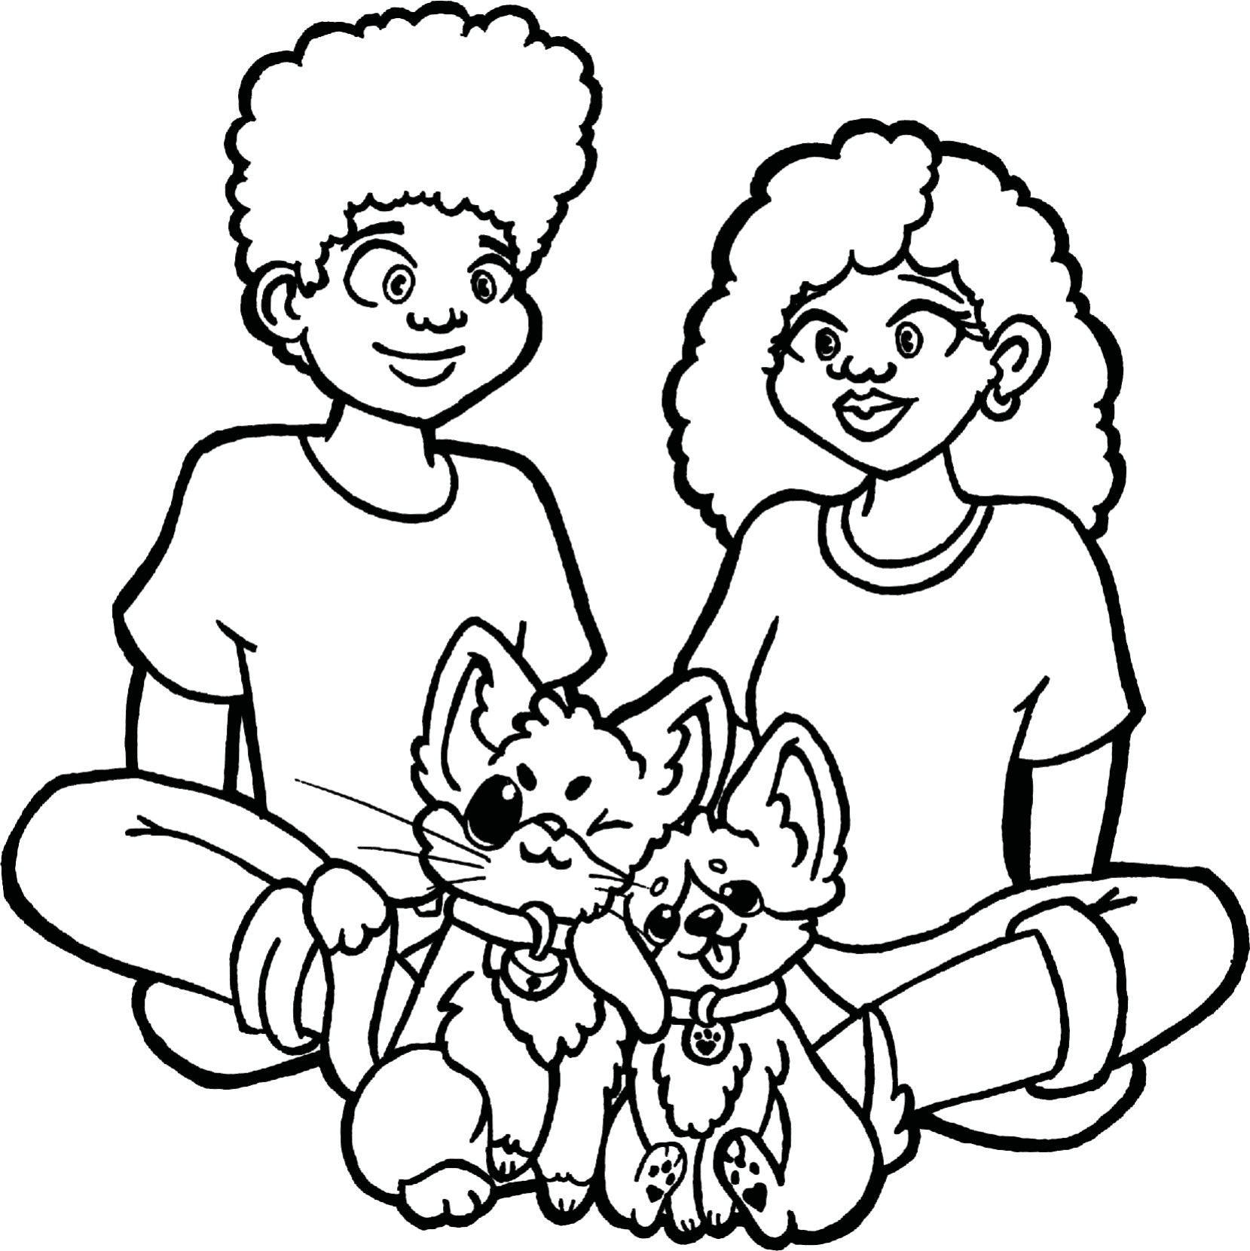



**Teacher’s Project Notes**

**GRADE 6**

**E³ Projects for Trimmed ATP**

**The I-CARE Project**

**The I-CARE Project TEACHER’S Project Notes Grade 6 | Life Skills | Term 3**



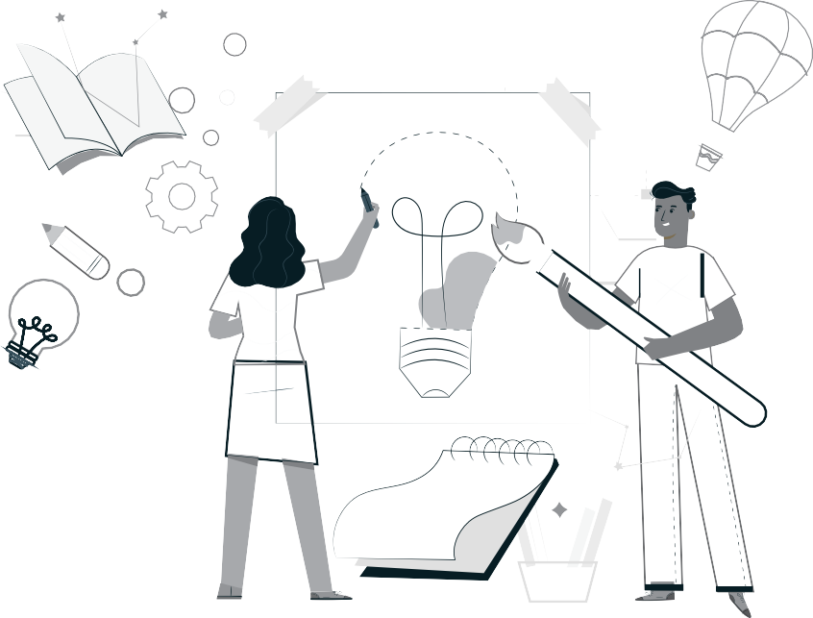

**RECOGNISING SOLUTION-SEEKING TEACHERS**

**ENTER THE TEACHER AGENCY AWARD**

***If it’s going to be, it’s up to me***

**SO WHY?**

To reward you for being awesome! You have shown that you care, that you have found a solution to a problem that helps others and that you have just gone ahead and made it happen.

We want to acknowledge and reward you and tell the world you are our hero! We want to reward you if you can show us that you are

self-motivated, self-directed and want to grow - and if you are driven by purpose and the desire to help others.

**WAIT WHAT?!**

So here’s what you need to show us - you need to be able to tell us that you:

1

2

3

Had the courage to just get going Had belief in yourself to just do it Activated a range of competencies that

makes you THE person that this new crazy

world needs to ﬁx it and solve its problems such as:

* 1. A great character who is self-motivated to be a SA citizen who cares, who is curious about ﬁxing things and who has the energy, enthusiasm and resilience to carry on.
  2. The ability to think and be creative, ﬁgure things out, ﬁnd the information you need and make sense of it.
  3. How you made connections, how you collaborated and communicated with others as you stood in their moccasins to solve problems.

**WHO ME?**

Yes you! Any teacher or school ofﬁcial who is doing something for the greater good.

**WHAT WILL I WIN?**

T&Cs: We will be awarding exciting, signiﬁcant prizes of up to R5000 per prize winner. These will go to worthy recipients from each province whose solutions meet the criteria on the entry form. These will be judged by E³. Awards will be announced in the ﬁrst week of every month starting in August 2020. If no worthy entry is received that merits a prize, E³ reserves the right not to award a prize for that month.

The last winners will announced in the ﬁrst week of October 2020 when this opportunity closes.

Keep an eye of the E³ website to see if you have won and to celebrate the other winners and admire their solutions.

**SO HOW MUST I APPLY?**

It’s really simple - just ﬁll in the form at the back of this book and submit it to us.

Or submit the form on the E3 website:

[**www.e3-dbe.org**](http://www.e3-dbe.org/)[**www.ecubed-dbe.org**](http://www.ecubed-dbe.org/)

**WHEN MUST I HAND IT IN?**

NOW! You can apply anytime whenever. This is an ongoing opportunity that has no deadline. How cool is that?

**CALLING ALL TEACHERS!**

**Think you lead the way in creating solutions to problems?**

**Enter this award and be rewarded and recognised for your unique problem-solving abilities.**



**The I-CARE Project TEACHER’S Project Notes Grade 6 | Life Skills | Term 3**

**RUBRIC TO RATE THE LEVEL OF COMPETENCIES AND E-MINDSET**

**Did your entrepreneurial mindset grow whilst managing this project?**

**Personal rating**

(1=Poor, 4=Excellent)

**Pre-project**

**Post-project**

**COMPETENCIES**

**Character**

Citizenship

I am very committed and involved in various activities in my community and people regard me as someone to follow in my circle of inﬂuence.

Curiosity

I am very curious about everything around me and all my senses are alerted to possibilities which I always put into practice.

Resilience

When I face challenges I am always excited about the possibilities and I always get up after I have been unsuccessful. I am always enthusiastic about what I have learned in the process.

**Thinking**

Creativity

I always use my imagination to come up with original ideas and/or I am always creating new things.

Critical thinking

I always form judgements based on my ability to analyse and evaluate objectively.

Reasoning

I always think about things in a logical and sensible way and I always come up with conclusions easily.

**Collaboration**

Collaboration

I always produce good work / things by working well with people (individuals or a team).

Communication

I am always successful in conveying or sharing ideas or feelings.

Empathy

I have a highly developed ability to understand and share the feelings of others.

**E-MINDSET**

**Agency**

Growth mind-set

I am always open to new information and am always willing to change my beliefs, assumptions and actions as a result.

Motivation

I always do what needs to be done without needing to be inﬂuenced by other people or situations. I always ﬁnd a reason or the strength to complete a task, even when it is challenging, without giving up or needing anyone else to encourage me.

Internal locus of control

I always have control of my life and my work is always my own and it is because of this that I experience success often. I never blame others or circumstances on my lack of success.

Regulation of emotion

I always respond to the demands of a situation with emotions that are socially tolerable and suﬃciently ﬂexible to allow spontaneous or delayed reactions – whichever are appropriate.

**Self-eﬃ**cacy

Tasting success

I have always done things successfully enough to give me “the taste of success” that makes me motivated to want more and to believe that I can get it.

Socially relatable role model

I have always been fortunate to have been exposed to excellent role models that I can relate to and who make me motivated to want to be like them.

Positive support

I have always been fortunate to have had someone who has been a positive support to me and who has encouraged me and seen me as a person.

**Solution- seeking**

Resourceful

I always ﬁnd quick and clever ways to overcome diﬃculties and ﬁnd solutions.

Problem solving

I always ﬁnd solutions to diﬃcult or complex problems.



**Table of contents**

**PART 1 – SETTING THE SCENE**

**1**

1.

The trimmed projects - E³ response to COVID-19

* *The project*
* *Timeframe*
* *Pre-project Planning Phase*

Social learning during Coronavirus Pandemic (COVID-19)

* *The teacher's role*
* WH*-wall*
* *Buddy-guard*
* *The role of the family*

Generic project outline for all projects

* *Step 1: Planning*

1

*1*

*1*

*1*

2

*2*

*2*

*3*

*3*

3

*3*

*3*

*4*

*4*

*4*

*4*

*4*

4

2.

3.

*•*

*•*

*•*

*•*

*•*

*Step 2: Research/Finding out Step 3: Making and showing the evidence Step 4: Getti ð 怀 翾 Ʃttng feedback and changing if you need to Step 5: Finishing oﬀ your project Step 6: Showing oﬀ your project*

*•*

*Step 7: Thinking about it afterwards*

4.

Teacher Toolkit

**PART 2 – THE PROJECT**

**5**

1. Project Summary and CAPS alignment
2. The project in more detail

5

6

**PART 3 – TEACHER TOOLKIT**

**17**

7. Teacher Resources

17

*17*

*18*

*19*

*20*

*22*

*22*

*23*

*24*

*25*

*25*

*26*

*26*

*27*

*•*

*Project resources*

*7.1 Letter to the parents*

*7.2*

*Primary vs Secondary sources*

*7.3*

*The big question in research*

*•*

*Professional Development*

*7.4 Traditional vs Activity-based Learning*

*7.5*

*7.6*

*7.7*

*7.8*

*7.9*

*7.10*

*7.11*

*Project-based Learning Cycle The PBL facilitator*

*The E3 competencies which we are trying to activate The journey to PBL via Enquiry-based and Problem-based Learning Bridging the Unemployment gap through Education The Innovation Cycle*

*Product Development Cycle*

Teacher Agency Award entry form

29

**The I-CARE Project TEACHER’S Project Notes Grade 6 | Life Skills | Term 3**





**PART 1**

**Setti 汨 砠怀础怀础怀팁怀ng the scene**

**1. The trimmed projects - E3 respose to COVID-19**

E3 have been asked by the DBE to create projects for the new trimmed curriculum. In the past, lead teachers would gather and projects would be created during a writers’ workshop. A similar process is being followed now, but remotely.

In Grade 6 we shall be working on one larger project, in three parts. Learners research types of bullying, how do deal with bullies and synthesise information into a mind-map on a poster; they create body armour (a shield) with labels of attributes that will shield them from bullies. In the third part, they will look at caring for pets and create a self- feeder or any other item which will show how much they care for pets.

**Time frame for project completion**

The assessment for Term 3 is a project. As a teacher, you will know your learners and their context best, so adjust the project as necessary. We have included an MS Word version so you can edit the projects to suit your learners.

Please note that learners will be working on their own for the most part of the project. Your role is to support the learner wherever possible. Remember to promote the *WH*- wall because there will be questions unrelated to the project, personal issues, traumatic events, etc. (See *WH*-wall below.)

Use this opportunity to press learners to do as much research and investigating as is possible – if we plan this well, we shall succeed. This is an excellent chance to develop learner agency and self-reliance.

**2. Social Learning during COVID-19 (coronavirus)**

Individual learners will be “scientists” and go through a process (including elements of design thinking, problem-based learning, etc.) which will guide them to solve a problem. Learners will not have groups to work with, but the social learning can be facilitated by:

**The teacher's role**

Notes/WhatsApp/face-to-face questions to teachers (give them a contact number or place a box for queries at the door of your classroom).

***WH*-wall**

Create a *WH*-wall for *Who? Why? What?* (and also *How?*) questions that are posted on the wall. Learners write their open-ended question in large letters on pages that can be stuck on the wall, anonymously if learners wish. You could review all the questions once a week (after they have been on the wall for at least 48 hours) and answer the important questions. The questions need not be about the project – it is a great opportunity to allay general fears about the “new normal” of living and going to school during the pandemic and to encourage questioning techniques.

**The I-CARE Project TEACHER’S Project Notes Grade 6 | Life Skills | Term 3**

1

**TRIMMED PROJECT**

**SBA - Term 3**

**MS Word for editing**

**SOCIAL LEARNING**

**Be available**

**Question wall**

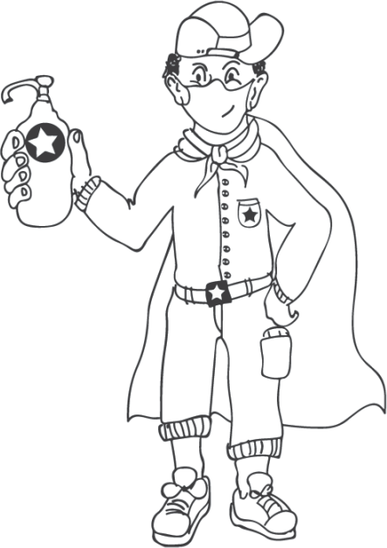



***Buddy-guard***

Have learners appoint a buddy-guard - a safe critical friend whom s/he identiﬁed before the project has started. The pair will agree that they give each other support and feedback at school with social distancing and via text and WhatsApp messages.

***The role of the family***

The family or caregivers will also have a letter sent to them to explain their role.

**3. Generic Project outline for all Projects**

**PLANNING**

1.

Learners brainstorm the problem that needs to be solved on their own, or with their buddy-guard, teacher or family. The brainstorm could also be a class activity done by the entire class.

Learners list questions that will help them think of the Big Question that will guide them in solving the problem.

2.

**RESEARCH / FINDING OUT**

1.

They note down sources of information from the following that they are planning to use to gather information:

* People they could interview
* Articles they could read
* Textbooks they could consult

They identify someone who might help them if they need information whilst stuck at home.

2.

**The I-CARE Project TEACHER’S Project Notes Grade 6 | Life Skills | Term 3**

2

**PLEASE NOTE**

* Part 1 and Part 2 of this booklet must be printed and are the minimum project resources you as teacher will need. However, the rest of the booklet contains valuable tools for personal development, as well as very good sources in support of the project. The rest of the resources can be found in the Learner's Workbook.
* Don't forget to enter the Teacher's Agency Awards. The entry form is at the back of this booklet.
* This programme is accompanied by podcasts, audio recordings and videos. You will ﬁnd them at the following URL: https://learn.ecubed-dbe.org/resources/
* Please complete the Teacher's Mindset Rubric before you start, and also after the project.

**Critical, safe partner.**

A buddy-guard is a special friend who cares about you and wants to support and look out for you.

**Family**

**PROJECT OUTLINE**

**Step 1: Project topic guided by a big question**

**Step 2: Plan research sources**





**MAKING AND SHOWING THE EVIDENCE**

1.

2.

3.

What equipment will be needed to create the project item? Where will information on how to make the item be found? How many times did they try before they got it right?

**GETTING FEEDBACK AND CHANGING IF THEY NEED TO**

1.

2.

3.

Learners get feedback from their buddy-guard, parents or caregivers or teacher. They use information they have gathered to improve their product.

They note what they changed, when they made changes and why.

**FINISHING OFF THE PROJECT**

Using all the feedback and what was learned after trying to improve their product, learners ﬁnish oﬀ their project item and the writing that goes with it.

**SHOWING OFF THEIR PROJECT**

1.

2.

They show oﬀ their project to as many people as it is safe to show it to.

People who view the projects (even those at home) write down their feedback or leave notes or send voice notes. Learners ensure that their WhatsApp number is on the project item and notes.

The ﬁnal item is taken to school and the teacher and learners arrange that the projects are shown to the rest of the school.

3.

**THINKING ABOUT IT AFTERWARDS**

Reﬂection:

1. What did I love about working on this project?

2.

3.

4.

What made this project hard for me? What did I learn by working on this project? About myself? About COVID-19? What would I do diﬀerently if I did a project like this again?

**The I-CARE Project TEACHER’S Project Notes Grade 6 | Life Skills | Term 3**

3

**Step 3: Making creative project item and documenting the process**

**Step 4: Feedback and changes eﬀected**

**Step 5: Finishing oﬀ**

**Step 6: Showing oﬀ projects**

**Step 7: Reﬂection**





**4. Teacher Toolkit**

See the Teacher Toolkit at the end of these notes to help you manage the project and to help you save time. Included you will ﬁnd:

**1. Project Resources:**

A letter to the parents and caregivers and notes on bullying, etc. Tools to assist with the Project, e.g.: *The diﬀerence between Primary and Secondary Resources; How to formulate the big question, etc.*

**2. Professional Development, e.g.:**

Project-based learning is a new pedagogy for teachers. We've included the E³ model and a variety of interesting articles to develop your PBL skills.

*The Project-based Learning (PBL) Cycle and your role as a Project Manager; The journey to Project- based Learning which starts with Enquiry-based Learning and Problem-based Learning, etc.*

**Resources in the Learner's Workbook**

The Learner's Project Workbook is enriched with many resources to help the learner complete the project independently. We are aware that learners will not have access to primary and secondary sources, so we've tried to address this obstacle.

And now, for a summary of the Grade 6 project.

**The I-CARE Project TEACHER’S Project Notes Grade 6 | Life Skills | Term 3**

4

**PLEASE NOTE**

* After introducing the CAPS topic in class, learners are orientated towards the project and then left to deal with the project independently with access to all their resources.
* The number of weeks allocated to a topic in the CAPS does not mean that the length of the project is limited. Remember: the project is a tool to allow deeper investigation into a serious problem that impacts learners.
* We recommend that a learner be given 3 to 4 weeks to complete a project.



**PART 2**

**The Project**

**5.**

**Project Summary and CAPS alignment**

**The I-CARE Project TEACHER’S Project Notes Grade 6 | Life Skills | Term 3**

5

**ALIGNMENT CAPS (TRIMMED ATP)**

**DESCRIPTION OF PROJECT**

Week: 1-4

Address contemporary health issues, e.g. COVID-19, and develop strategies to mitigate challenges caused by the disease/s.

**Development of self: Bullying.** Reasons for bullying; where to ﬁnd help.

**Reading skills:** Reading with understanding and ﬂuency.

**Reading about how to get out of the habit of bullying:** Interpret/explain and relate what has been studied. Get out of the bullying habit.

**Social responsibility**

Basic hygiene principles (issues of COVID-19)

**Caring for animals** Acts of cruelty to animals. Taking care of and protecting animals. Places of safety for animals.

**Reading skills:** Reading with understanding and ﬂuency.

**Reading about ways of taking care of animals and places of safety for animals:** Interpret/explain and relate what has been studied.

***I-CARE Project***

*Learners investigate the diﬀerent forms of bullying, reasons for bullying and how to get out of the bullying habit.*

1. *Learners complete a questionnaire on bullying.*
2. *They research bullying and make a poster / mind-map to analyze bullying. They also create body armour to protect them from bullying.*
3. *Learners complete the questions in the Learner's Workbook.*

*Learners investigate how to look after pets.*

1. *Learners answer question about caring for pets.*
2. *Learners make a bird-feeder or any other item to show caring for animals.*

Learners get the opportunity to display their body armour and their self-feeders. Don't leave out this step. Public displays motivate learners to give of their best work.



**6. The Project in more detail**

The following step-by-step unpacking of the project explains the teacher's role in the roll-out of the project.

***Items marked with (*) can be found in the Teacher’s Toolkit at the back of this booklet, or in the Learner’s Library at the back of the Learner’s Workbook.***

The column on the right is for you to mark/underline which competencies you think you touched on in each step.

**THE I-CARE PROJECT**

**The I-CARE Project TEACHER’S Project Notes Grade 6 | Life Skills | Term 3**

6

**STEP 2: Research / Finding out**

**TASK**

**TEACHER’S ROLE**

**RESOURCES**

**COMPETENCIES**

***(Underline which ones were developed)***

Learners start their research. They complete the table to show sources that they will be using for each item of the project.

1. Ask learners to research bullying.
2. Discuss primary and secondary sources of information.
3. Explain international referencing systems – this is an excellent opportunity to introduce learners to correct referencing. Ask learners to deepen their research by doing interviews with families.

Step 2 in Learner's Workbook.

* Primary and Secondary sources

Textbook Learner's Workbook

**Character** Citizenship Curiosity Resilience Mindset **Connection** Collaboration Communication Empathy **Thinking** Creativity Critical thinking Reasoning

**STEP 1: Planning**

**TASK**

**TEACHER’S ROLE**

**RESOURCES**

**COMPETENCIES**

***(Underline which ones were developed)***

Complete the questionnaire about bullying.

1. Manage the ice breaker. Speak in general about bullying and the types of bullying.
2. Learners complete the questionnaire in their workbook.
3. Learners generate questions that they will try to research.

Step 1 in Learner's Workbook.

*Articles on bullying. You can use this video h[ttps://www](http://www.youtube.co/).y[outube.c](http://www.youtube.co/)o m/watch?v=TeHUYuX1u 4Y

Textbook Learner's Workbook

**Character** Citizenship Curiosity Resilience Mindset **Connection** Collaboration Communication Empathy **Thinking** Creativity Critical thinking Reasoning



**The I-CARE Project TEACHER’S Project Notes Grade 6 | Life Skills | Term 3**

7

**STEP 4: Getti ng feedback and changing if you need**

**TASK**

**TEACHER’S ROLE**

**RESOURCES**

**COMPETENCIES**

***(Underline which ones were developed)***

Learners show their feeders to classmates, family, buddy- guard and other people (via safe channels like WhatsApp and social distancing, etc.)

Learners collect feedback from all sources.

Learners implement changes suggested by feedback.

1. Ask learners to show their feeders to family members, members of the community and their buddy-guard for feedback.
2. Ask learners to implement the changes suggested by feedback.
3. Explain why feedback is important. Learners must realise that it will never be perfect the ﬁrst time. They must learn to keep on improving and pushing the standard.
4. Learners complete Step 4 in Learner's Workbook and get as much feedback as possible on their ideas. They consider making changes.

Learner's feeder designs Learner's Workbook

**Character** Citizenship Curiosity Resilience Mindset **Connection** Collaboration Communication Empathy **Thinking** Creativity Critical thinking Reasoning

**STEP 3: Making and showing the evidence**

**TASK**

**TEACHER’S ROLE**

**RESOURCES**

**COMPETENCIES**

***(Underline which ones were developed)***

Learners make their Body Armour to protect them from bullying.

Learners complete the questions on caring for animals.

Plan and start creating a self- feeder for a pet.

1. Assist learners in managing their time by planning the resources they will need for the 3 items in their project.
2. Explain mind-mapping as a tool for summarising information visually. They plan the mind-map in their workbook.
3. On strips of paper learners write down “weapons” with which to arm themselves against bullying.
4. They make their shield at home and stick the labels on.

Give learners opportunity to present their Body Armour. Allow for further discussion. Encourage class to ask questions.

1. Give them time to start planning their self-feeders.
2. Learners now work independently on their self-feeders.
3. Learners ﬁnish their self-feeders for feedback.

Step 3 in Learner's Workbook.

Cardboard, Crayons, Markers, Scissors, Sticky notes (if you are going to use them.)

Recyclable materials for self-feeder: plastic bottles, containers, Glue Learner's Workbook

*The product design process

**Character** Citizenship Curiosity Resilience Mindset **Connection** Collaboration Communication Empathy **Thinking** Creativity Critical thinking Reasoning



**The I-CARE Project TEACHER’S Project Notes Grade 6 | Life Skills | Term 3**

8

**STEP 6: Showing oﬀ your project**

**TASK**

**TEACHER’S ROLE**

**RESOURCES**

**COMPETENCIES**

***(Underline which ones were developed)***

Learners present their self-feeders to other classes/rest of the school/parents or members of the community according to plan (and with safety measures in mind).

1. Help learners set up their display.
2. Learners create mini-feedback forms for viewers.
3. Appoint a COVID-19 oﬃcer or two from class. They should see to it that all COVID-19 regulations are followed during any public event.
4. Use rubric to assess the project.

Step 6 in Learner's Workbook

Public area for presentation, Sanitiser, Masks, Gloves or other safety measures,

Rubric (p.10) Learner's Workbook **Extended learning opportunity:**

Display feeders online on school's website, Facebook or a specially created blog.

**Character** Citizenship Curiosity Resilience Mindset **Connection** Collaboration Communication Empathy **Thinking** Creativity Critical thinking Reasoning

**STEP 5: Finishing oﬀ your project**

**TASK**

**TEACHER’S ROLE**

**RESOURCES**

**COMPETENCIES**

***(Underline which ones were developed)***

Learners work at home or in class, ﬁnishing oﬀ their feeders with changes they are considering after the feedback.

Brainstorm ideas on how to plan the ﬁnal showing of their feeders at school – to the rest of the community or the rest of the school in a safe way.

Talk about safety measures for their public display according to COVID-19

regulations.

1. Guide learners through the process of changing and improving their feeders, and the reason for these changes. Explain the importance of reviewing a project as part of the improvement of the ﬁnal quality.
2. Brainstorm ideas with learners for the public display of their feeders. (In class? In the school hall? Safety measures?)
3. Learners prepare feeders for display. They help with the set-up for the public display.

Step 5 in Learner's Workbook

Learner's Workbook

**Character** Citizenship Curiosity Resilience Mindset **Connection** Collaboration Communication Empathy **Thinking** Creativity Critical thinking Reasoning



**The I-CARE Project TEACHER’S Project Notes Grade 6 | Life Skills | Term 3**

9

**POST-PROJECT READING ACTIVITY**

**TASK**

**TEACHER’S ROLE**

**RESOURCES**

**COMPETENCIES**

***(Underline which ones were developed)***

Class reads the play called “The Little Soldier” – a link to COVID-19 and learner trauma.

The play can be used in various ways. Learners could sit at their desks and volunteers read certain characters.

Learners could read the play and write one of their own. Learners could act out the play keeping to social distancing rules.

**Extended Learning Opportunity:** Learners could write their own plays.

**Character** Citizenship Curiosity Resilience Mindset **Connection** Collaboration Communication Empathy **Thinking** Creativity Critical thinking Reasoning

**STEP 7: Thinking about it afterwards**

**TASK**

**TEACHER’S ROLE**

**RESOURCES**

**COMPETENCIES**

***(Underline which ones were developed)***

Reﬂection on success or failure of the project and lessons learned.

1. Please don't skip this step.
2. Give learners time in class to reﬂect on the success of their project.
3. Do the teacher's reﬂection rubric.

Teacher's Reﬂection rubric. (Same as Learner’s Reﬂection, p. 14 Step 7 in the Learner’s Workbook.)

Learner's Workbook

**Character** Citizenship Curiosity Resilience Mindset **Connection** Collaboration Communication Empathy **Thinking** Creativity Critical thinking Reasoning



**Assessment rubric**

**The I-CARE Project TEACHER’S Project Notes Grade 6 | Life Skills | Term 3**

10

**ITEM**

**CRITERIA**

**0**

**NOT ACHIEVED**

**1**

**PARTIALLY ACHIEVED**

**2**

**ACHIEVED**

**3**

**SUPERIOR**

**LEARNER MARK /30**

**Item 1 - Poster**

3 reasons for bullying

No reason given

1 reason given

2 reasons given

3 reasons given

/3

Why people are cruel to animals (3 reasons)

No reason given

1 reason given

2 reasons given

3 reasons given

/3

Where to ﬁnd help clear and striking on poster

Completely left out or minimal info given.

Not very clear or striking.

Some info given.

Clear but not so striking.

Almost all info given.

Very clear and striking. All relevant info given.

/3

Three actions of a bully are clear

Nothing provided

1-2 actions given

2-3 actions given

More than 3 actions given

/3

Layout/design of mind-map

No or very little info which is not clearly displayed.

Basic layout is in place.

Minimum info appears on mind-map.

Quite neat, creative and displays most of the information.

Neatly executed, creative and very clearly displays required information.

/3

**Item 2 - Body armour**

4 ways of protecting yourself clear on shield

No or very little info on self- protection appears on shield

1 way of protecting yourself is clear on the armour

2 ways of protecting yourself are clear on the armour

3 or more ways of protecting yourself are clear on the armour

/3

Where to ﬁnd help clearly marked

No info appears

Some info appears but not clear or complete

Info for ﬁnding help clearly marked but details incomplete

All info for ﬁnding help clear.

Complete set of details

/3

**Item 3 - Bird- feeder or other caring item**

Functional

Does not work/poor functionality

Mostly works

– some design ﬂaws

Works well

Works perfectly

/3

Label has all info

Label has no/one item of info

Label has two or three items of info

Most of the info appears – one item missing

All info appears on the label

/3

Caring and passion are evident

Not handed in or handed in but clearly no caring went into the making

Basic design works but no real eﬀort shown

Good design: workable – some eﬀort and caring shown in ﬁnishes

Has gone extra mile to producing workable bird- feeder/item with creative ﬁnishing touches

/3

**TOTAL:**

**/30**



**Ice breaker**

**1.**

**Illustration activity**

1.

Learners study the two illustrations and in pairs (with their safe friend, or buddy-guard) they discuss and come up with ideas like:

* Feeling sorry for the boy being bullied verbally.
* Being angry with the old man who is taking out his frustration on a helpless animal.

Learners may laugh nervously at the pictures – initiate a discussion on why.

They have started their journey to understanding cruelty and how they can shield themselves and other victims from the cruelty of others.

If the learner recognises him-/herself as the potential bully, s/he can start reﬂecting on the reasons for this cruel behaviour.

What can learners learn about the causes of the feelings? What can they recommend we do to ﬁx the problem? Their research in this project will help them answer questions like these.

Three questions that they could generate are:

* Why is the old man hitti ng the dog?
* What makes an old man like that so cruel?
* Why is calling someone names (like ''Coronavirus”) harmful to the sneezing child? (Stigmatisation?)

2.

3.

4.

5.

**2.**

**Self-assessment survey**

1.

Learners complete this survey by answering yes or no to the questions. They then interview their buddy-guard and later a member of their family. They have started gathering background data for their investigation into the types, causes and actions against bullying and animal cruelty.

They are beginning to dig into the bullying and caring project and will face the same issues again and again – this is iterative and by the end of the project they should have a deeper understanding of the topic.

Social distancing takes place as they interview. They read the questions to their buddy-guard who answers by showing a thumbs up for “yes” and a thumbs down for “no”. Remember to stay a safe distance away and don't allow pages to be touched.

After that, one of their family members completes the questionnaire.

Sum up by pointing out that acts of cruelty to weaker peers and animals could be the beginning of bullying and need to be curtailed.

Some learners may be emotional – be sensitive and do not pry. Have a look at their emoticons and decide who needs some nurturing.

2.

3.

4.

5.

6.

**The I-CARE Project TEACHER’S Project Notes Grade 6 | Life Skills | Term 3**

11

**Objective:**

To introduce the topic of person-to-person and person-to-animal cruelty visually (this elicits a deeper emotional response)

To engage the learner in reﬂection about his/her own possible bullying habits





**PLANNING**

Learners start generating questions, an excellent language activity, but also the beginnings of research.

Three questions that could come up after viewing the illustrations:

*1.*

*2.*

*3.*

*What makes an old man so angry that he hits the dog? Why is it especially cruel to call someone names like “coronavirus” especially if s/he is sneezing? How can we stop animal cruelty, etc?*

***Your project***

Explain that the project *Understanding bullying and cruelty to animals and making a plan to stamp out cruelty* has three parts to it and that three items need to be created, one for each part project: a poster, a shield of armour cut out of cardboard and a bird-feeder.

Create a mind-map summarizing the answers to these research questions:

* What is bullying?

•

•

•

•

•

Name four types of bullying and what each of them means. Give three reasons why people bully other people.

Three steps people who bully can take to change their ways. Give three reasons why people could be cruel to animals during COVID-19. (The notes in the Learner's Resource Library and their textbook provide the information they need.)

Learners cut out a shape like a shield from old cardboard. (See the Library of Resources for ideas). They cut out strips of paper or sticky notes and write out words or phrases to arm themselves against bullies, e.g. stay calm, courage, faith, walk away, etc. They should have at least 4 labels, but encourage them to ﬁll the shield if they can. They decorate it. Also: they make sure that they indicate clearly where a victim can ﬁnd help.

**The I-CARE Project TEACHER’S Project Notes Grade 6 | Life Skills | Term 3**

12

**Item 2 - Stamping out cruelty**

**Item 1 - Poster: Understanding Bullying**

**Objective:**

To synthesise information from the Learner’s Library into a poster mind-map

To analyse the term *bullying* in order to gain a deeper understanding of the types of bullying, what turns people into bullies and what people can do to protect themselves against bullies To highlight cruelty against animals and to emphasise the importance of caring





(Discussing and then making an item to show caring)

**1.**

**Discussion:**

They start by discussing with their buddy-guard how we can all show kindness during COVID-19 and generally:

* Three ways of being kind to others during COVID-19:
* Three ways of taking care of and protecting animals, also during COVID-19:

**Showing I-CARE**

They make an object to show how much they care for animals. Explain that animals cannot speak for themselves – we have to do things to protect them and teach others how to do so. There is a step-by- step guide on how to make a bird feeder, but allow learners their own suggestions if they have the know-how. Maybe someone in their family can help!

They brainstorm ideas and commit to one. Ensure that the label they will attach to the I-CARE object will also be part of the assessment.

**2.**

**RESEARCH / FINDING OUT**

**Continue the discussion on research and what makes a good researcher:**

* Using various sources (both primary and secondary – see the notes in the Learner's Library
* Referencing the research the way the professionals do so all over the world.

***Types of sources of information***

•

People they could interview How to reference: Morobe, M. 29 July 2020. Johannesburg.

Articles they could read in the Library at the back of their workbook (from the internet if they have access. The Library in the Learner's Workbook provides some sources, but do not be limited by them) How to reference website articles: Gordon, S. 2019, *7 ways to build social skills and prevent bullying,* viewed 2 June 2020, <https://[www.verywellfamily.com/how-to-build-social-skills-and-prevent-](http://www.verywellfamily.com/how-to-build-social-skills-and-prevent-) bullying-460718>

Textbook How to reference: Mohapi, J (2019). *Life Skills for All* Cape Town, Alpha Publishers.

They then list their own sources (or the sources they have chosen for their project for each item in the project)

•

•

**The I-CARE Project TEACHER’S Project Notes Grade 6 | Life Skills | Term 3**

13

**Objective:** To introduce the concept of research and how to gather data in three diﬀerent ways To encourage learners to reference correctly and to know why this is important

**Item 3 – Caring for Animals**

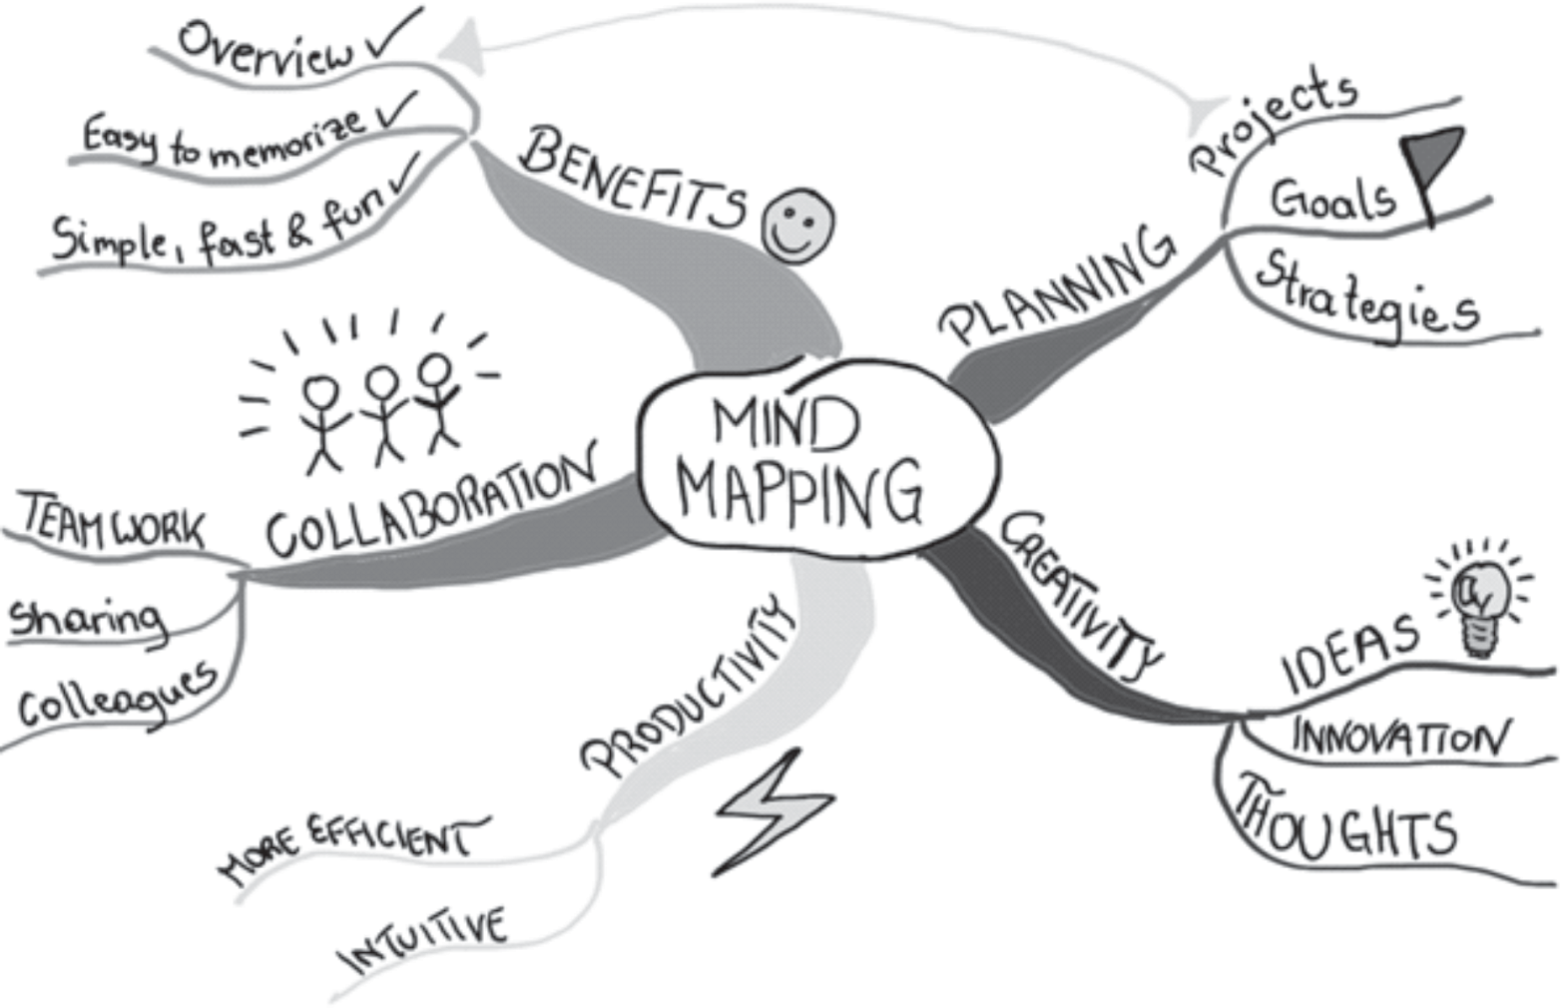



**MAKING AND SHOWING THE EVIDENCE**

**Item 1:** Making a poster: **Understanding bullying**

Learners now list all the resources they need to ensure that they can proceed without any interruptions. Ensure that they have listed everything: poster paper. A4 pages for pictures to be drawn and cut out for the poster. Koki's, glue, etc.

Explain what a mind-map is: a tool for organising information in a visual and fun way. Pictures and colour make it more attractive and help with the sorting of information.

The thicker lines are the main points while the thinner branches are points that explain the main points. They have to organise this information on their own poster:

•

Thick branch - What is bullying? Thin branch - Answer/s (could be more than 1)

•

Thick branch

- 4 Types of bullying

4 Thin branches

- Each branch has a type (verbal, relationship, cyberbullying, etc.)

Thinnest branches - what each entails/means

•

Thick branch Thin branch (3)

Thick branch Thin branch

Thick branch Thin branch

* Reasons why people bully
* Answer/s (could be more than 3)
* Steps to change their way
* Answer/s (could be more than 3)
* Cruelty to animals during COVID-19
* Answer/s (could be more than 3)

•

•

**The I-CARE Project TEACHER’S Project Notes Grade 6 | Life Skills | Term 3**

14

**Objective:** To plan ahead by collecting resources To start understanding how time can be managed





**Item 2:** Making a shield, body armour called **Stamp out bullying!**

Learners now list all the resources they need to ensure that they can proceed without any interruptions. Ensure that they have listed everything: scissors or a paper knife (please emphasise safety as these shields will be cut out at home); recycled cardboard, foil if available, strips if paper, Koki's, Pritt.

**Item 3:** Making an **I-CARE** object to show you care about animals

Learners list and collect everything before the time:

Resources: See Learner Library for feeder resources, e.g. old 2-litre plastic bottles, etc.

**GETTING FEEDBACK AND CHANGING IF YOU NEED TO**

Ensure that they have all the contact details needed. They complete the table providing evidence that they have engaged with others. They also reﬂect on each suggested change and document their decision to change or not.

**FINISHING OFF THE PROJECT**

Using all the feedback and what they learned from all the engagement, the products are ﬁnished oﬀ. Ensure that the written part forms part of the ﬁnal project.

*What did you change?*

*Did it improve your I-CARE object? Explain:*

**The I-CARE Project TEACHER’S Project Notes Grade 6 | Life Skills | Term 3**

15

**Objective:**

To iterate and redesign the product until a better product is produced To encourage resilience and a deep understanding that making mistakes should not be seen as failure

**Objective:**

To introduce social learning within the constraints of COVID-19 To encourage learners to reﬂect on selecting and working with the best people for social learning





**SHOWING OFF YOUR PROJECT**

The public display is an important element. Try your best despite COVID-19 restrictions to arrange some viewing of the bird-feeders, posters and armour (shields). Also encourage feedback (see feedback form below) from those viewing (probably the rest of the school as visitors will probably not be allowed into the school grounds soon).

Name of visitor: Date:

**THINKING ABOUT IT AFTERWARDS**

A very important step – do not underplay its importance.

**Post-project reading**

***The Little Soldier***

At the end of the Learner's Book is a short play about arming yourself (it is theme-related) against COVID- 19, which may also be considered a type of bully. Learners can act it out or read from their desks and those who do not have a reading part can form a chorus to emphasise certain important mantras around COVID-19, e.g. Care for your family, care for yourself! Be brave! This is a good activity for reading and comprehension and a great way to reinforce safety rules, and to build courage.

**The I-CARE Project TEACHER’S Project Notes Grade 6 | Life Skills | Term 3**

16

**Objective:** To allow the learner to reﬂect on learning and whether the process was positive: *“Learning without reﬂection is not learning.”*

**ITEM**

**RATING**

**COMMENT / FEEDBACK**

I-CARE item shows care in the making

Project maker showed passion

**Objective:**

To allow the learner to exhibit his/her work – this is what makes many work hard for, an appreciative audience.

To give the learner feedback from people s/he does not necessarily know



**PART 3**

**TEACHER TOOLKIT**

This section oﬀers you all the resources you might need in launching your project (Project Resources) reﬂecting on your personal development as an active learning facilitator and Project-based Learning Project Manager, practical thinking and other tools to help you in carrying out the project.

**7. Teacher resources**

**Project Resources**

***7.1 Letter to the parents***

A copy of the letter to copy and print is available on the following page.

**The I-CARE Project TEACHER’S Project Notes Grade 6 | Life Skills | Term 3**

17



*Date:*

*Getti 䀰Cng Ready*

***Dear Parents, Siblings and Caregivers***

*The Grade 6 learner in your care will be doing a project or two during the next few weeks.*

*A large part of the project will be done at school, but an important part will be done after school, at home.*

***How can you help?***

*•*

*The project plan is quite structured with dates for each step clearly set out. Check the deadlines and help your child understand the importance of keeping to a schedule.*

*•*

*The project asks learners to share information with the family at home and to ask for feedback and advice. Please set aside some time to help when needed. Perhaps you can ask one member of the family to be the “Advisor” for the family. Your child will have to note the feedback/advice as part of the project, so this is a serious matter for your child.*

*•*

*The Project Pack has all the information resources your child needs, but you may be asked for advice on how to do something. Your experience as an adult will give your child the support needed.*

*Good luck! Let's learn from each other and oﬀer our children support, empathy and care.*

***Teacher***



***7.2 Primary and Secondary Resources***

Sources of information are often categorised as primary or secondary depending upon their originality.

***Primary Sources***

1. Direct or ﬁrst-hand evidence about an event, object, person, or work of art
2. Published materials written or produced by someone with ﬁrst-hand experience of the event.
3. Individual viewpoint of a participant or observer.

*Examples of primary sources:*

•

•

•

•

•

•

•

•

•

•

•

•

•

Interviews, surveys, and ﬁeldwork Diaries, personal letters, and correspondence Internet communications on email, blogs, and newsgroups Photographs, drawings, and posters Books, magazine and newspaper articles, and ads published at the time Public opinion polls

Speeches Original documents (birth certiﬁcates, property deeds, trial transcripts) Research data, such as census statistics Oﬃcial and unoﬃcial records of organisations and government agencies Radio interviews, DVDs, and video recordings Government documents (COVID-19 pamphlets, reports, etc.) Scientiﬁc journal articles reporting experimental research results

***Secondary Sources***

1.

2.

3.

4.

5.

Describe, discuss, interpret, comment upon, analyse, evaluate, summarise, and process primary sources.

Written or produced after the fact with the beneﬁt of hindsight. Lack the freshness and immediacy of the original material.

Collect, organise, and repackage primary source information to increase usability and speed of delivery, such as an online encyclopaedia.

Can be written or non-written (sound, pictures, movies, etc.).

*Examples of secondary sources:*

•

•

•

•

•

•

•

•

•

•

Bibliographies Biographical works

Reference books, including dictionaries, encyclopaedias, and atlases Articles from magazines, journals, and newspapers after the event Literature reviews and review articles (e.g., movie reviews, book reviews) History books and other popular or scholarly books Works of criticism and interpretation

Commentaries and treatises Textbooks Indexes and abstracts

**The I-CARE Project TEACHER’S Project Notes Grade 6 | Life Skills | Term 3**

19

**Source:** Staﬀ writer, date unknown. *Identifying primary and secondary source,* viewed on 2 June 2020,

<https://sccollege.edu/Library/Pages/primarysources.aspx>





***7.3 The big question in research***

Essential questions, or driving questions, are a key element of project-based learning, so we've outlined 14 essential question stems to help you craft the most engaging PBL essential questions.

***1. How can improve ?***

*How can studying diﬀerent cultures improve our understanding of our community? How can robotics improve the healthcare industry?*

*How can access to clean water improve communities, especially during coronavirus?*

1. ***How can be applied to ?***

*How can entrepreneurship skills be applied to subjects like science and geography? How can entrepreneurship skills be applied in our daily lives?*

*How can ethics be applied to solve environmental problems?*

1. ***How can change ?*** *How can individuals change their communities? How can kindness change bullying?*

*How can the human behaviour change the environment?*

1. ***How would you design a new ?***

*How would you design a new school?*

*How would you design a new system to purify water? How would you design a new ﬂag for your community?*

***5. How does aﬀect ?***

*How do poor eating habits aﬀect communities around the world? How does bullying aﬀect our community?*

*How does violence aﬀect our daily lives?*

1. ***What impact did/does have on ?***

*What impact does climate change have on the environment during the 21st century? What impact does coronavirus have on children's sense of security?*

*What impact does social media have on our understanding of the facts surrounding the coronavirus pandemic*

1. ***What makes a good/eﬀective ?***

*What makes a good library? What makes an eﬀective school? What makes a happy classroom?*

1. ***How do/does impact my community?***

*How does racism impact my community?*

*How does the food grown in our region impact what people eat? How does bullying and violence impact my community?*

1. ***What is the relationship between and ?***

*What is the relationship between maths and everyday life? What is the relationship between science and entrepreneurship? What is the relationship between transportation and trade?*

**The I-CARE Project TEACHER’S Project Notes Grade 6 | Life Skills | Term 3**

20



***10. What would be without ?***

*What would our school be without classrooms?*

*What would the Earth's climate be like without the atmosphere? What would the world be without art?*

***11. If you were in charge of , what would you change?***

*If you were in charge of our school, what would you change?*

*If you were in charge of our community, what would you change? If you were in charge of Facebook, what would you change?*

1. ***How can you use to inspire ?***

*How can you use poetry to inspire change?*

*How can you use storytelling to inspire people to take better care of the environment? How can you use science to inspire people to eat healthier food?*

1. ***What if ?***

*What if you could go back in time, what would you change? What if South Africa did not have schools?*

*What if the world lost the internet for one year?*

1. ***How might your community change if ?***

*How might your community change if it were twice as big?*

*How might your community change if it rained every day for a year? How might your community change if every person were given R1 million?*

Seeing the diﬀerent ways learners approach an essential question is one of the most rewarding parts of project-based learning, and you'll get to learn a lot about the learners in your class! Engage students through project-based learning by providing them with great PBL essential questions, then watch them dive in and take control of their own learning.

**The I-CARE Project TEACHER’S Project Notes Grade 6 | Life Skills | Term 3**

21

**Source:** Staﬀ Writer, 2020. *PBL: Easy essential stems for project based learning,* viewed on 2 June 2020,

<h[ttps://www.penpalschools.c](http://www.penpalschools.com/blog/easy-project-based-learning-question-stems-for-essential-)om/blog[/easy-project-based-learning-question-stems-for-essential-](http://www.penpalschools.com/blog/easy-project-based-learning-question-stems-for-essential-) questions>

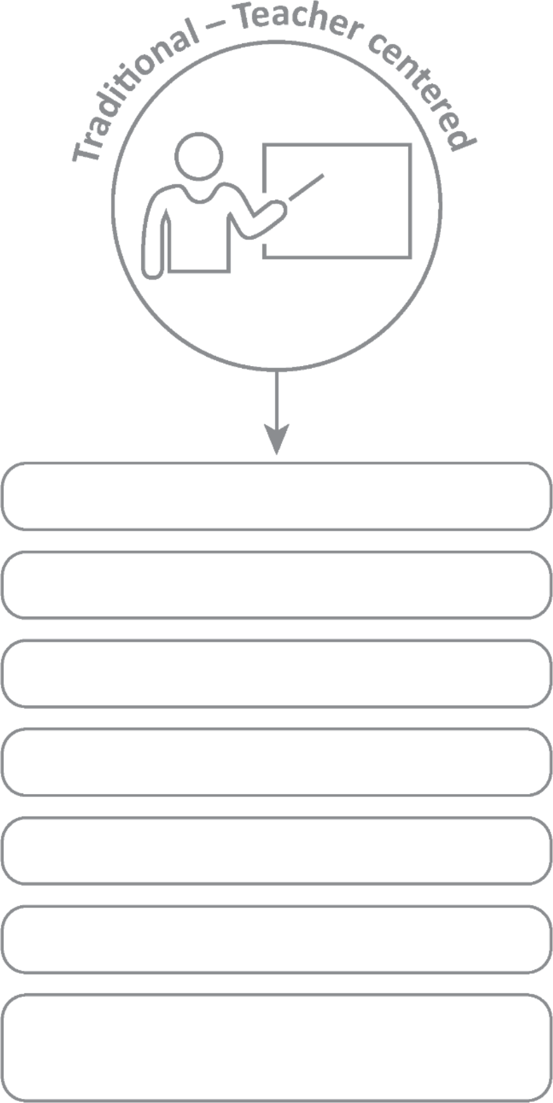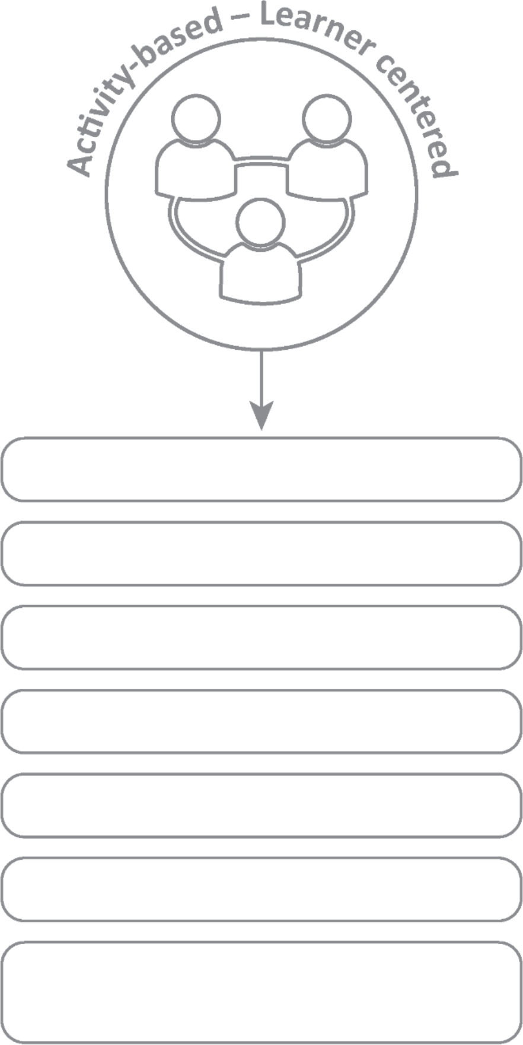



**Professional Development**

***7.4 Traditional vs Activity-based learning***

**Basic Learning**

**In-depth learning**

**Smaller groups within class**

**Bigger class size**

**Integrated/interdisciplinary subjects**

**Isolated subjects**

**Process-oriented**

**Product-oriented**

**Learning through active involvement**

**Learning by repetition**

**Concepts questions to be investigated**

**Concepts are facts to memorize**

**Quantitative evaluation (numerical testing)**

**Authentic assessment (competencies, integrated, mindset)**

**The I-CARE Project TEACHER’S Project Notes Grade 6 | Life Skills | Term 3**

22



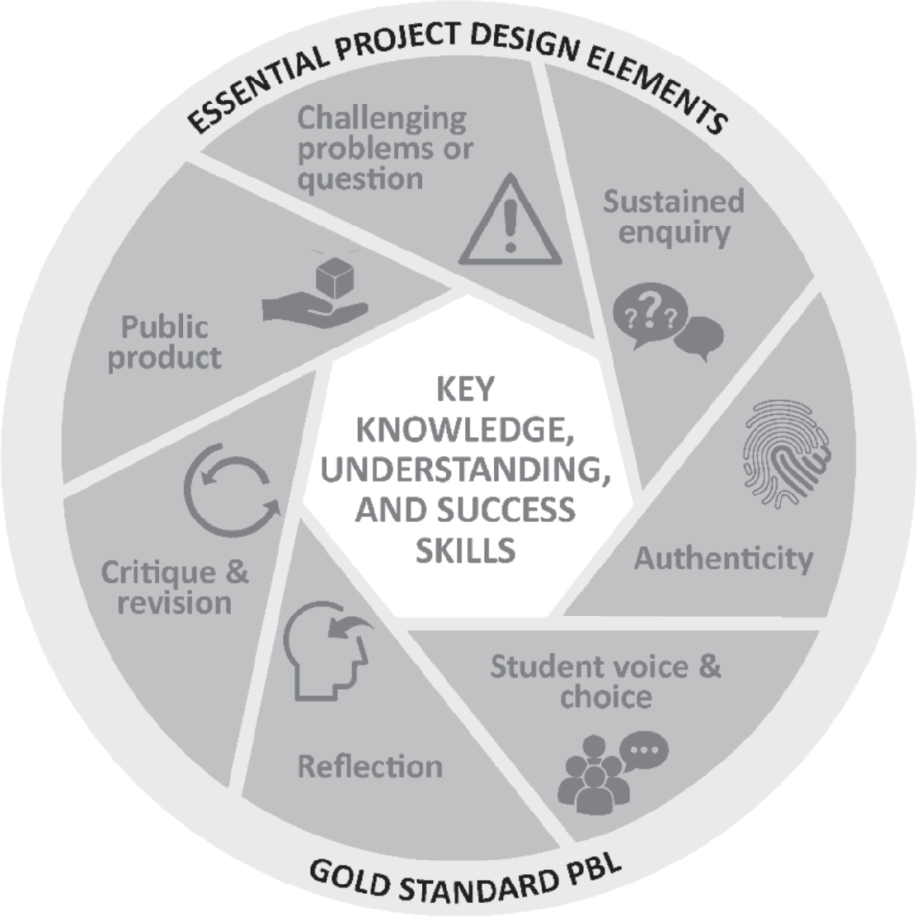

***7.5 The Project-based Learning Cycle***

Below please ﬁnd the *Key Knowledge, Understanding* and *Success Skills* to help you manage the project.

**Challenging problem or question:** Why is this project critical? What is the problem in society and at school being addressed in this project? Keep talking about how this project

will solve a local or global problem.

**Sustained enquiry:** Are learners being “researchers”?

Are they doing the research and getti 耰߻ng deeper and deeper into the problem or are you doing all the talking? Look at the second circle overleaf to remind you of your role: manage activities and scaﬀold student learning. Learners must not be allowed to give up – you must “build a culture” of getti 耰߻ng to the bottom of the problem and

coach them when they lose their way. With time E3 will be developing thinking tools to ensure that you are equipped with strategies to take the enquiry to a new level. (See overleaf for the

current PBL learning cycle with a built-in innovation cycle.)

**Authenticity:** Keep the project real by referring to learners' own lives – this is about them and their world.

**Student Voice and Choice:** Although learners did not choose this project, make it fun and real, and applicable to their own world, so that they own it. Their voices and opinions are what your deeper goal is – encourage their views and applaud each contribution.

**Reﬂection:** To truly embed learning, learners should be able to reﬂect on what they have learned and be able to think of better ways of doing things. The reﬂection activities in the worksheets are not just for fun. Encourage learners to spend time on them as this will deepen their learning.

**Critique and Revision:** This process is to help learners experiment with their innovation and learn how to improve their work and thinking. As you assess and evaluate their products (not them!) learners will see that there are diﬀerent ways of solving problems. It is important that learners hone their curiosity and learn how to “stick it out” and keep trying, not giving up when it doesn't work ﬁrst time round.

**Public Product:** At the end of the project what does the learner have to show or to brag about? Ensure that there is a Project Culmination Week in which each grade displays their products during a week selected by the management team to ensure that as many parents and other stakeholders as possible attend.

**The I-CARE Project TEACHER’S Project Notes Grade 6 | Life Skills | Term 3**

23

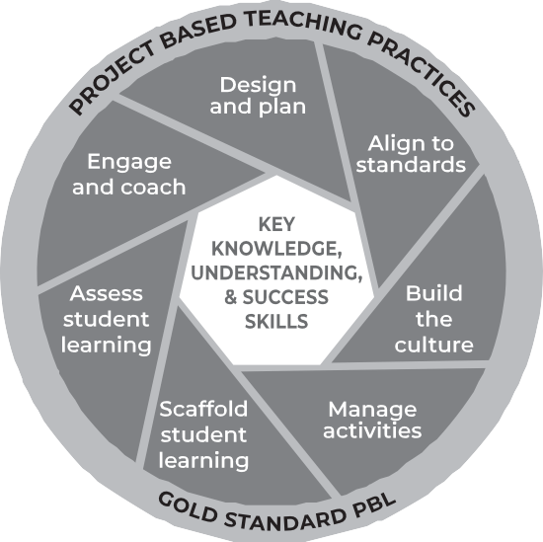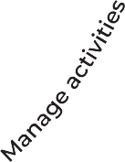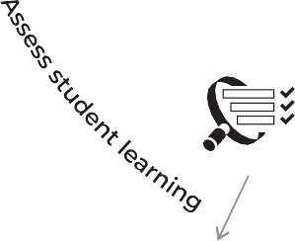

***7.6 The PBL facilitator***

***Project-based Learning: The teacher’s role as project manager***

We as teachers need to reassess our roles. The time for good lecturing has passed. The time has come to put learner needs and their problems at the centre of the lesson and to do everything in our power to make school useful for life after school, to help learners know and believe in themselves and to give them space to become problem solvers themselves... and, of course, to have fun.

Learners go to school not to WORK, but to LEARN!

**A problem arises in the learners’ world and a lesson is created around it. She knows her curriculum and this will help her to link the problem to relevant CAPS information / knowledge transfer.**

**She knows the CAPS and links her lesson to outcomes and expectations from the CAPS.**

**Her role is to pay attention to the needs of every learner and to offer them support, not via formal teaching, but by one-on-one coaching especially as they work in groups.**

**She understands that school culture plays a huge role in modeling appropriate and meaningful relationships.**

**In her classroom, there are 3 types of assessment and each is treated differently and has a different purpose.**

**She creates an authentic project, designed around practical real-life solutions. There is very little transmission teaching.**

**She understands that all learners are different in a variety of ways. She sees her role as that of supporter as each individual learner is helped to climb to the next level through her one-on-one coaching.**

**Learners are given a task with clear instructions and the teacher observes learners and helps them as and when needed. She is a classroom site and activity manager.**

**Baseline - where should we start? Formative - How are we doing, every little step of the way?**

**Summative - How did we do when tested on a chunk of work?**

**She also does not do all the marking herself - she knows that learner self and peer assessment can be powerful learning opportunities if well-managed.**

**The I-CARE Project TEACHER’S Project Notes Grade 6 | Life Skills | Term 3**

24

**En**

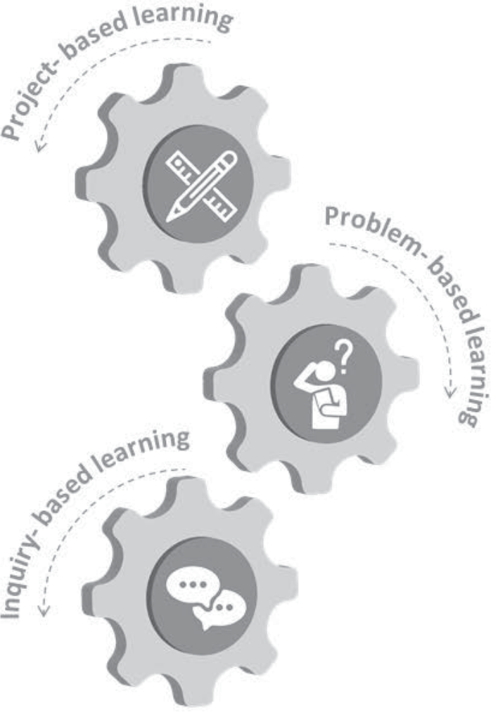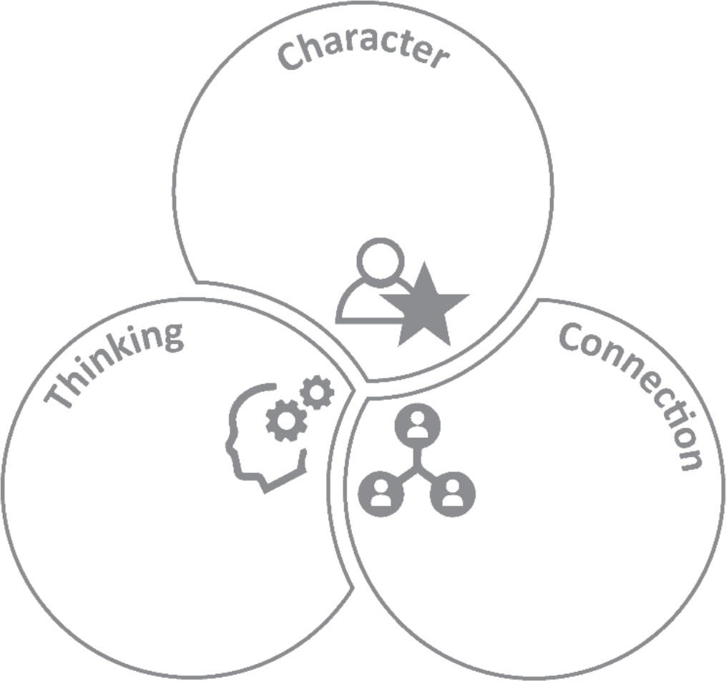



***7.7 The E competencies which we are trying to achieve***

These appear in the competencies column of your planning. Please highlight each competency that was addressed during the lesson.

***The E competencies model within the CAPS***

Citizenship Curiosity Resilience Mindset

Creativity Critical Thinking

Collaboration Communication Empathy

***7.8 The journey to PBL via Enquiry-based and Problem-based Learning***

* Learning by designing and building innovative products to solve complex real-world problems
* Building systems and design thinking abilities and mindsets
* Learn by engaging in complex real-world problems and developing plausible solutions
* Building critical and creative thinking and problem-solving abilities
* Learning by asking questions and engaging a topic, mastering concepts, models and theories - seeking answers
* Developing conceptual thinking and multi-literacies
* Working in groups developing communication and coordination skills

**The I-CARE Project TEACHER’S Project Notes Grade 6 | Life Skills | Term 3**

25

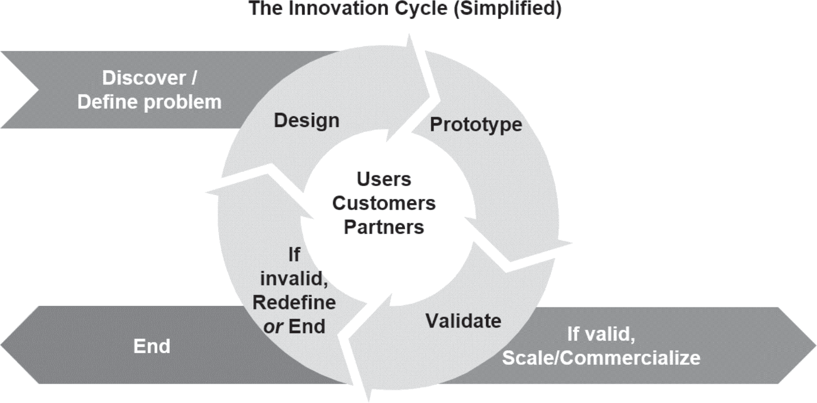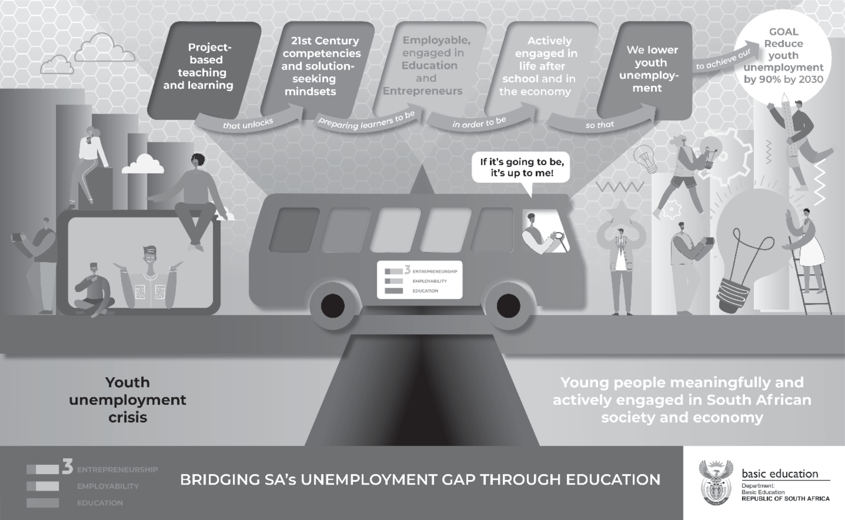



***7.9 Bridging the Unemployment gap through Education***

***7.10 Innovation Cycle***

**The I-CARE Project TEACHER’S Project Notes Grade 6 | Life Skills | Term 3**

26

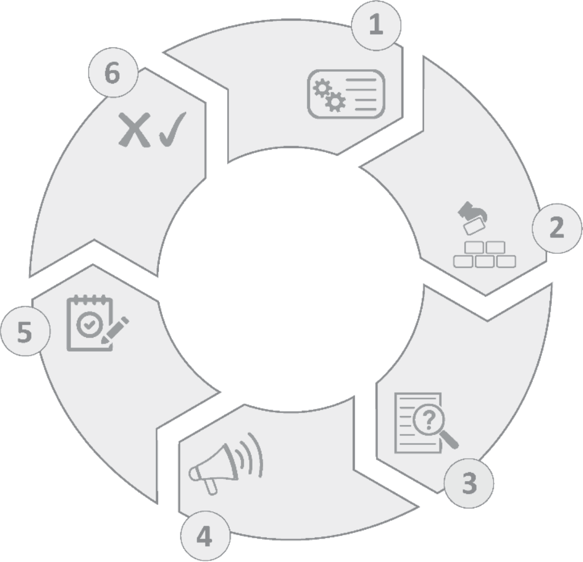



***7.11 Product Development Cycle***

The product development cycle consists of the following stages: Plan, Develop, Evaluate, Launch, Assess, Iterate or Kill.

**Plan**

**Develop**

**Iterate or Kill**

**Product Development Cycle**

**Evaluate**

**Assess**

**Launch**

**Plan**

The planning stage consists of work that needs to be done before any development commences. You want to make sure you have a valid business case for the product and a solid strategic plan to give your startup the best chance of success.

To begin Market Research and Competitive Analysis should be carried out, to get an understanding of the market, and the key players in them. This research will need to answer questions such as:

* Who is your target audience?

•

•

Is there a need for the product? Can it be validated by thing like surveys, customer interview or consumer spending ﬁgures?

Who are the competitors in the market and how will the product be able to compete with them? What is the potential market share for the product?

**Develop**

Simply put this is when the product or service business is built. The ﬁrst release is likely to be an MVP (minimum viable product) containing the core features necessary for the product to be of use to your customers and succeed in the market.

**Evaluate**

Early feedback is key to test the assumption made during the Plan stage. There is no need to wait until the product is completed to perfection before you start evaluating its features, the sooner features can be validated the better. If the feedback from the evaluation says that some features need changing, then tweak them.

**The I-CARE Project TEACHER’S Project Notes Grade 6 | Life Skills | Term 3**

27





**Launch**

Launching the product involves letti Ҁ怀༰怀Ꮀ怀 S뾀ng your target audience know the product is live. This can be done with Press Announcement & Interviews, advertising, creating public launch events, etc.

**Assess**

Similarly to the Evaluation stage, each feature of the product will need to be tested and evaluated to see if a feature worth keeping and iterated on or being dropped from the product completely.

During the assessment stage you will also need to support marketing & sales eﬀorts. This is done by assessing what eﬀect advertising, social media and CRM (Customer relationship management) campaigns have on product engagement and revenue.

**Iterate and Kill**

Once assessment and evaluation of the product features is complete, a decision needs to be made on which features to keep and upgrade and which to remove.

For the features that prove not useful for the customer, and don't generate engagement or revenue, those should be removed. For the features that are kept, they will need to be iterated on and upgraded, to ensure competitiveness. This involves starting the Product Development Cycle all over again.

**The I-CARE Project TEACHER’S Project Notes Grade 6 | Life Skills | Term 3**

28

**Source:** Farbey, Y, 2016. *The product life cycle and product development cycle,* viewed on 2 June 2020,

<https://deﬁneproducts.com/product-life-cycle-product-development-cycle-bccb9c5aabf2>



Email your completed form to [info@ecubed-dbe.org](mailto:info@ecubed-dbe.org) with the subject line “Teacher Agency Award submission”

[**info@ecubed-dbe.org**](mailto:info@ecubed-dbe.org)

Name of your solution:

Why did you choose this name?

Identifying the problem: *(Maximum 200 words)*

*I identiﬁed the following problem in my school/community/at home:*

E3 Teacher Agency Award Form | Page 1 of 5

Name:

Position: (e.g. Teacher, SMT, etc.)

**If teacher:**

Subject taught:

Grade:

School name:

District:

Province:

**Your contact details:**

Email:

Cell number:

WhatsApp number:

**TEACHER AGENCY AWARD FORM**

Trying, adapting the process until problem was solved:*(Maximum 200 words)*

*Initially I …. Then …. Eventually I could solve the problem in this way: ……*

E3 Teacher Agency Award Form | Page 2 of 5

Collaboration and access to information: *(Maximum 200 words)*

*I collaborated with …. And accessed information f rom …. which helped me in the following ways…*

Creativity and innovation: *(Maximum 200 words)*

*My solution was very creative because I …. My solution was unique and innovative because …*

E3 Teacher Agency Award Form | Page 3 of 5

Meeting E3 standards: *(Maximum 200 words)*

Explain why you are an E3 ambassador and tribe member. Use phrases like the following in your explanation:

*I care and want to help others: ………………………………………………………...*

*I am a problem-solver:……………………………………………………………………….*

*I am awesome: …………………………………………………………………………………...*

*I am driven by purpose:……………………………………………………………………….*

*I have courage and self belief:……………………………………………………………….*

*I can keep going, despite challenges:………………………………………………………*

E3 Teacher Agency Award Form | Page 4 of 5

Provide us with each of the following (please include clear notes on the pictures and videos):

•

•

•

•

Your 4 best pictures (2 in portrait and 2 in landscape)

A VoiceNote of not more than a minute reﬂecting on your growth in this project A short video that shows an important episode in the project

If minors appear in the photos and video, please submit permission from parents or caregiv- ers that these photos appear on E3 platforms.

E3 Teacher Agency Award Form | Page 5 of 5