

**Learner’s Workbook**

**CREATING AN INTERCULTURAL RECIPE OR STORY BOOK**

**PROJECT-BASED LEARNING | LIFE SKILLS**

**GRADE**

**4**

**Read to Lead**

A Reading Nation is a Leading Nation

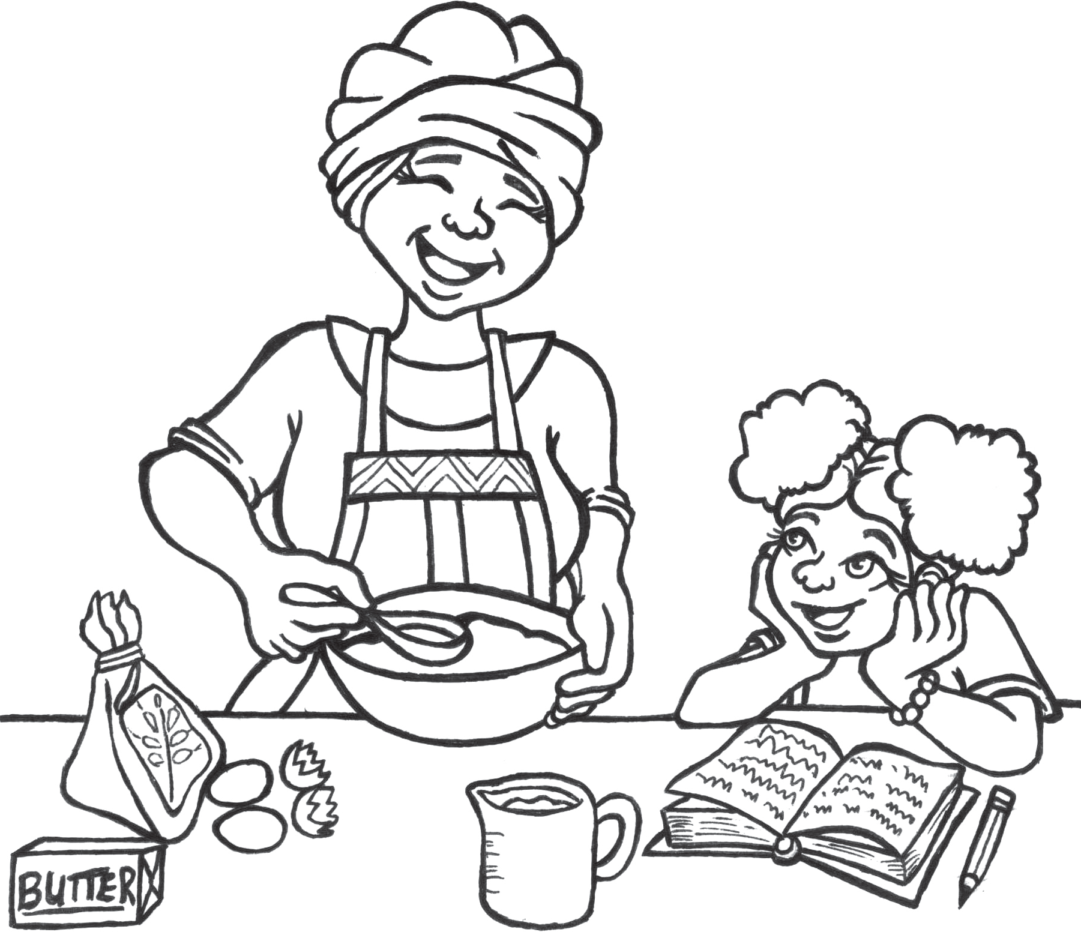

**Name:**

**Educator: Gr 4**

**Creating an intercultural recipe or story book**

**1**

**E³ LEARNER'S BOOK | GRADE 4 | LIFE SKILLS | TERM 3**





**Dear learner**

We are so excited to see your project and we would like you to share it with us so that we can proﬁle it on our website and possibly on Facebook or Instagram. To do that, please follow these instructions very carefully.

**A. Tell us about your project:**

1. *Name of project:*
2. *Name of learner:*
3. *School:*
4. *Grade:*
5. *Describe your project in 50 – 100 words.*
6. *Describe the biggest challenge you had doing this project. (50 – 100 words)*
7. *Describe what you would do better next time. (50 – 100 words)*

**B. Choose the right photographs to tell the story of your project:**

1. *Choose three photographs that tell the story and progress of your project.*
2. *Make sure that no-one's face is clearly visible unless they are wearing masks.*
3. *Make sure the picture is in focus and clear.*

**C. How to send your submission:**

1. *All submissions must be in a word document and the pictures must be in the document.*
2. *You can send it to us on email.*
3. *You can email it yourself, or you can ask your parent / caregiver or teacher to do this for you. must use this heading on the email: Learner Portfolio: Grade 4 Life Skills*

*You*

Email address: [**info@ecubed-dbe.org**](mailto:info@ecubed-dbe.org)

*If needed, we might ask you to make some changes to your submission in order to make it ready for uploading onto our website.*

**2**

**HOW TO COLLECT YOUR INFORMATION**

**SEND YOUR PICTURES AND VIDEOS**

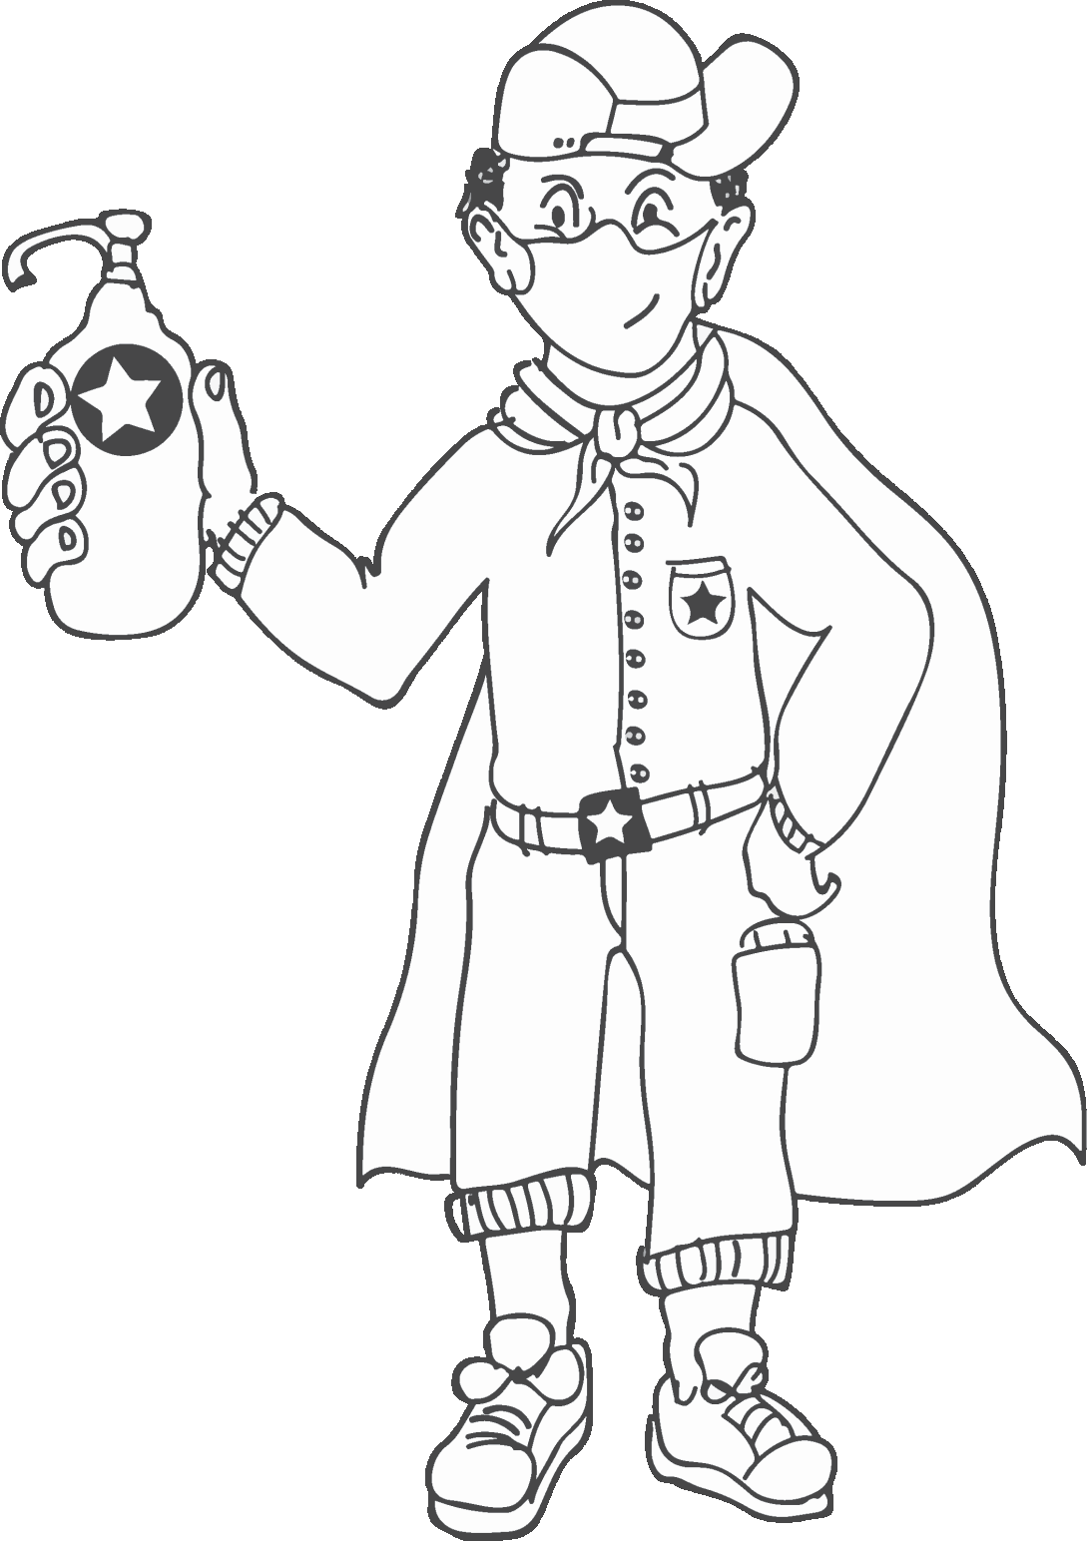



Dear Grade 4 learner

Because of the COVID-19 coronavirus pandemic, you were at home for a long time. We hope you enjoyed it and hope that you are all healthy, and that you had fun with your family, who are normally often too busy. Now it is time to start doing exciting projects with your fresh brain and rested body. School is a very diﬀerent place now: you cannot hug or high ﬁve your friends or share lunchboxes. A lot has changed, not only on the playground, but also in the classroom: no more group work for a while and less role-play and games.

•

Choose one buddy-guard, someone with whom you can discuss everything in class. Agree before the time that you will be partners and do all the activities together.

Don't forget that your family at home is also a good sounding board – to share ideas and help with your project.

A one-on-one discussion with your teacher, either face-to-face or using WhatsApp is also a good way to get feedback.

•

•

This project will turn you into a writer or illustrator! You and your classmates will create cultural awareness through a culturally-rich recipe or story book. Let's go!

***A buddy-guard is a safe friend.***

**3**

**INTRODUCTION**

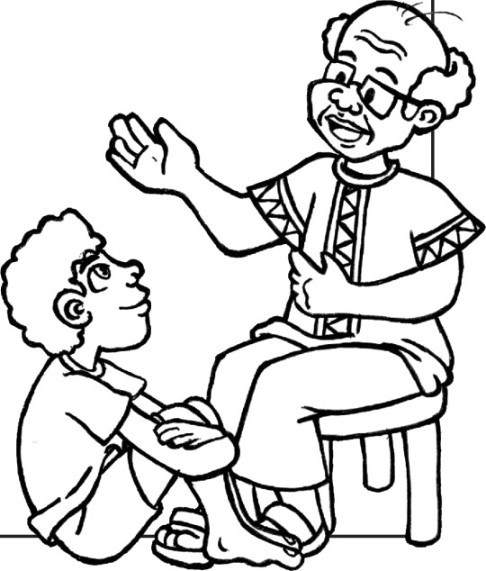

Today your teacher will read you a story about Elihle Mogwe. Try to form pictures in your mind and draw these on Worksheet 1.1.

**4**

**HOW ARE YOU FEELING?**

**LISTENING SKILLS**

5) Great

* Eyes looking
* Ears listening
* Mind thinking
* Hands down and still
* Feet still
* Mouth quiet, masks up!
* Heart caring
* Body calm and still

4) Pretty good

3) Okay

2) Not too good

1) Bad

**WHY ARE YOU FEELING THIS WAY?**

**VOCABULARY LIST**

**WORKSHEET 1.1** Date:

**ACTIVITY 1: LISTENING TO A CULTURAL STORY**

**SESSION 1 – STORIES AND RECIPES FROM ALL CULTURES 1**

English name for

is .......

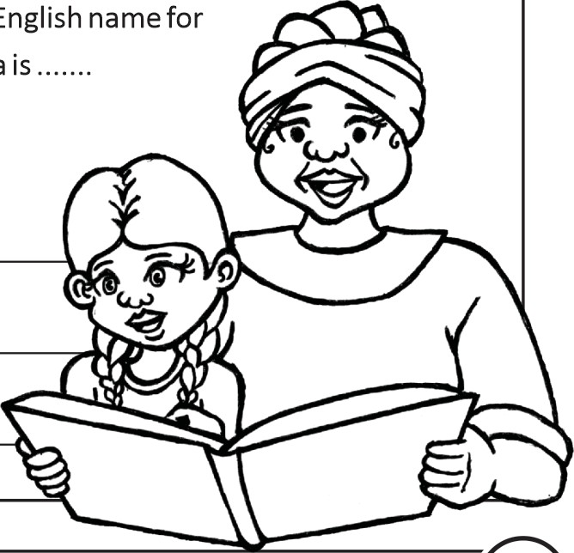

**5**

**HOW ARE YOU FEELING?**

5) Great

4) Pretty good

3) Okay

2) Not too good

1) Bad

**WHY ARE YOU FEELING THIS WAY?**

**VOCABULARY LIST**

**WORKSHEET 1.2** Date:

After completing Worksheet 1.1, complete the COVID-19 crossword puzzle below.

**1 2**

**3 4**

**6 ACROSS**

1. Elihle was living with her Gogo during the COVID-19 .......
2. We need to wash our often and for at least 20

seconds.

**7 6.** Iboza is a traditional remedy to help .......

1. You may not be able to engage in sport, but you can still smile and .......
2. A popular healthy food made from African Spinach is

**9** called .......

1. We should protect ourselves by wearing a .......
2. Grade 4 has just compiled a wonderful cultural .......
3. Remember to cough or sneeze into your .......
4. We also need to remember to self .......

**11**

**DOWN**

1. **1.** Elihle’s home country is .......

**2.** Another medicinal ﬂower that will help a sore throat is .......

1. **5.** Washing hands under a is a clever idea

for schools with limited water.

**9.** The Iboza

What is the moral lesson? (What can you learn from the story?)

**5**

**8**

**10**

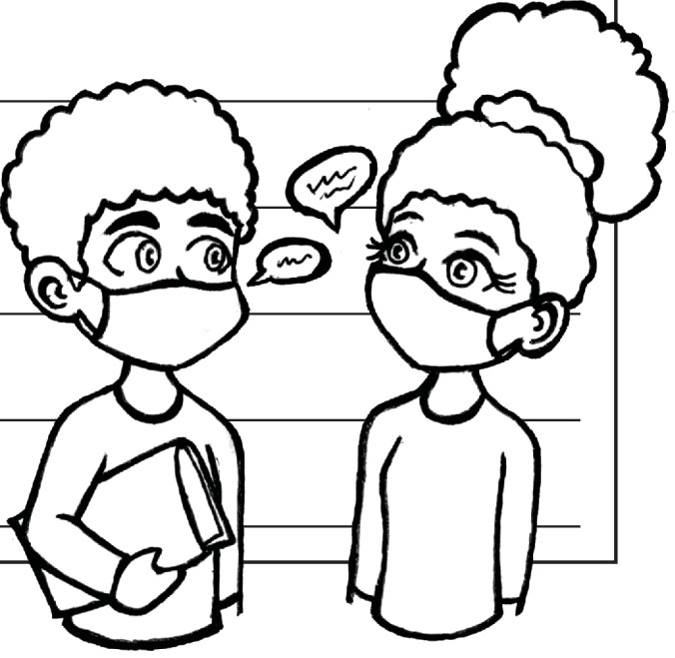

Share your cultural heritage with the teacher and the rest of the class. Ask friends (or your buddy-guard) what culture they represent. Remember to keep your distance!

**6**

**HOW ARE YOU FEELING?**

5) Great

4) Pretty good

3) Okay

2) Not too good

1) Bad

**WHY ARE YOU FEELING THIS WAY?**

**VOCABULARY LIST**

**HOMEWORK**

Ask your parents or caregivers to

1. tell you a story from your culture which you can change into a short oral presentation

**OR**

1. give you a cultural recipe you can bring to school to present as an oral

Write your cultural story or recipe on an A4 paper that your teacher will give to you and bring it to the next lesson.

***Please don't bring food to school. It is best not to share food at school – you care too much about your friends to take a chance!***

**WORKSHEET 2** Date:

My cultural heritage:

My friend's cultural heritage:

**ACTIVITY 2: SPEAKING ABOUT MY CULTURE**



Today you are doing an oral presentation on your cultural recipe or story. Your oral must be no longer than 2 - 3 minutes. Write your oral in the space below.

**7**

**HOW ARE YOU FEELING?**

5) Great

4) Pretty good

3) Okay

2) Not too good

1) Bad

**WHY ARE YOU FEELING THIS WAY?**

**VOCABULARY LIST**

**WORKSHEET 3** Date:

**ACTIVITY 3: MY CULTURAL STORY / MY RECIPE**

**SESSION 2 – MINI SPEECH 2**

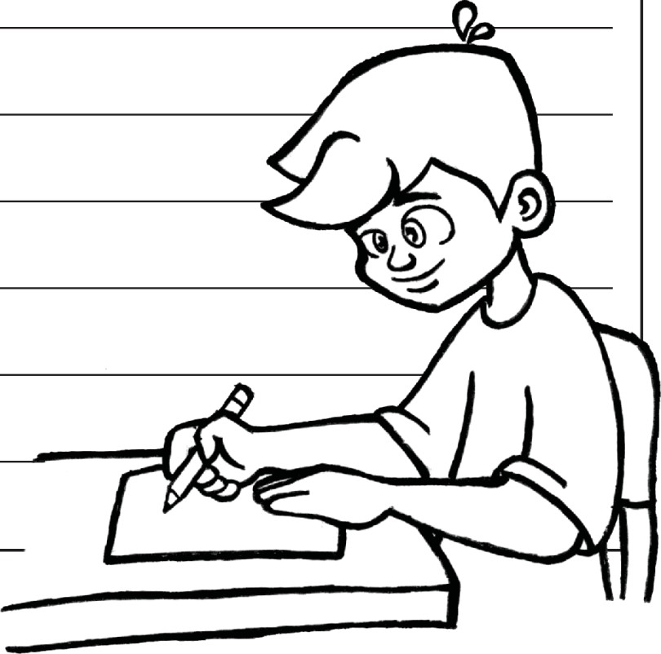

While your friends are presenting their oral, please open Worksheet 4 and start writing a letter of thanks to public servants (police person, nurse, doctor, cashier, banker etc.) in your community for their hard work in keeping us all safe. You must write an informal letter, no longer than ±60 words.

**8**

**HOW ARE YOU FEELING?**

5) Great

4) Pretty good

3) Okay

2) Not too good

1) Bad

**WHY ARE YOU FEELING THIS WAY?**

**VOCABULARY LIST**

**HOMEWORK**

Now that you have presented your cultural story or recipe, illustrate your work (draw pictures) on the A4 page your teacher will hand out. Remember to add your name at the bottom of the page. Remember that your artwork should be original.

**WORKSHEET 4** Date:

**ACTIVITY 4: A LETTER OF THANKS TO A PUBLIC SERVANT**

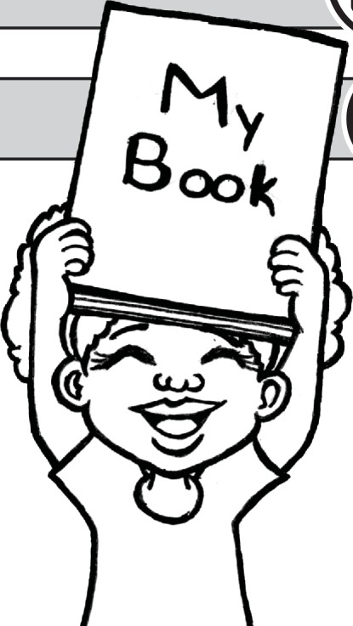

Please hand in your recipe or story, as well as the illustrations you completed for homework. Remember to write your name at the bottom.

Your teacher will give you a strip of paper on which you must write down your name, as well as the title of your cultural story or recipe.

Help your teacher to group all the cultural stories / recipes together. Then use this information to write a table of contents for the book of Cultural stories and Recipes. Use Worksheet 5. Remember to work alphabetically!

**9**

**HOW ARE YOU FEELING?**

5) Great

4) Pretty good

3) Okay

2) Not too good

1) Bad

**WHY ARE YOU FEELING THIS WAY?**

**VOCABULARY LIST**

**HOMEWORK**

Do you have any great ideas for the front page or back page design of your class's recipe or story book? Brainstorm your ideas with your buddy-guard using WhatsApp, if you can.

**WORKSHEET 5** Date:

**TABLE OF CONTENTS**

**NUMBER**

**TITLE**

**AUTHOR**

**PAGE**

**STORIES / RECIPES IN ALPHABETICAL ORDER**

**ACTIVITY 5: WRITE A TABLE OF CONTENTS**

**SESSION 3 – ORGANISING OUR BOOK OF CULTURAL STORIES AND RECIPES 3**

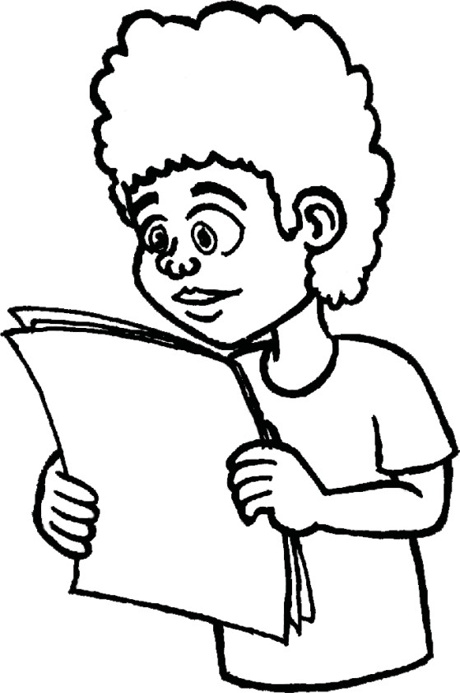

Share your ideas for the front page or back page design of your class's book.

Share your ideas for keeping everybody safe when going to public places. Write these on strips of paper that your teacher will provide. These will become your Golden rules for COVID-19. Display your rules proudly in the classroom. You can even add a list of Golden rules to your book!

Have a look at the ﬁnal recipe/story book. Is everything correct? Do you need to change anything? Write down a list of possible buyers from your family or community on Worksheet 6, as well as reasons for selling the book.

How will you get your caring letters to the nurses and other public servants? Discuss this with your buddy-guard but remember to keep your distance.

Remember to ask family and members of the community (call them or keep your distance!) if they would like to buy a cultural recipe book.

Help your teacher to put up the display pages of your recipe or story book in a place where the whole school can view them. Maybe the passage outside your classroom would be a good place. Ask your parents if they would like to put the pages up at work or at the oﬃce for others to see.

**10**

**HOW ARE YOU FEELING?**

5) Great

4) Pretty good

3) Okay

2) Not too good

1) Bad

**WHY ARE YOU FEELING THIS WAY?**

**VOCABULARY LIST**

**WORKSHEET 6** Date:

**REASONS FOR SELLING THE RECIPE BOOK**

**LIST OF POSSIBLE BUYERS**

**ACTIVITY 6: FINALISE RECIPE OR STORY BOOK CONTENTS**

**SESSION 4 – FINISHING THE BOOK 4**

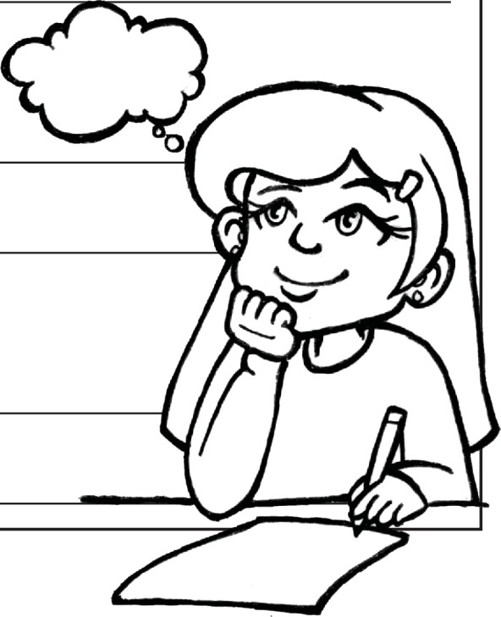

Please complete Worksheet 7. Remember to take copies of the recipe / story book to deliver to buyers (if possible). Copy or print your letter to a public servant and decide how you are going to send or deliver it. Keep your distance!

**11**

**HOW ARE YOU FEELING?**

5) Great

4) Pretty good

3) Okay

2) Not too good

1) Bad

**WHY ARE YOU FEELING THIS WAY?**

**VOCABULARY LIST**

**WORKSHEET 7** Date:

1. What did you enjoy about the project (making the book)?
2. What do you like about your book?
3. What could you have done better?
4. How many diﬀerent cultures are presented in your class?
5. What do you like about your own culture?
6. What do you like about your friends' cultures?
7. How will you stay optimistic during COVID-19 times?
8. What are you grateful for today?

**ACTIVITY 7: THINKING ABOUT WHAT I LEARNT**

**SESSION 5 – REFLECTION 5**