

**Teacher’s Project Notes**

**CREATING AN INTERCULTURAL RECIPE OR STORY BOOK**

**PROJECT-BASED LEARNING | LIFE SKILLS**

**GRADE**

**4**

**Read to Lead**

A Reading Nation is a Leading Nation



Dear Teacher

Provided herewith is a **Learner’s Workbook** and a set of **Teacher’s Project Notes for the School- Based Assessment (SBA) Task for Term 3** as per the SBA Plan in Section 4 of the CAPS. These documents are specially created to support you with COVID-19 issues for your subject as per the trimmed Annual Teaching Plan (Section 3) for Term 3.

Most importantly it is envisaged that this will lessen your workload as we come to grips with the disruptions caused by COVID-19.

The Learner’s Workbook and Teacher’s Project Notes were created by DBE-E3, a unit at the National Department of Basic Education which is rolling out Project-Based Learning **(PBL)** in schools, to better prepare learners for a changing world. Although you may not be part of the DBE-E3 Programme as yet, these projects are created to:

1.

Engage learners in processing the pandemic which is aﬀecting their lives and those of their families;

Promote learner self-reliance and independent learning using safety measures; and Encourage social learning in a safe environment.

2.

3.

**Where did this all start?**

**E3: Entrepreneurship, Employability and Education is currently being rolled out in SA schools.** The DBE-E3 Unit, in response to the National Development Plan, has been working in public schools since 2018 to advocate the eventual implementation of Activity-Based Learning, with a special focus on **PBL**. **E3** is part of a DBE programme to introduce *Thinking Skills for a Changing World* into the curriculum in its eﬀort to reduce youth unemployment substantially by 2030.

**How did this work in 2018 and 2019?**

Initially three provinces in 2018, and then all nine provinces in 2019, implemented PBL in Term 3, the term in which the SBA is an actual project. This meant that the projects, written by teachers for teachers were available to select schools by the provinces as part of a pilot re- search project. In this initial phase schools on the programme were provided with projects for Life Skills Grade 4-6, EMS Grade 7-9 and Life Orientation Grade 10 to 11.

*The Learner’s Workbook and Teacher’s Project Notes are a critical resource for you during COVID-19, and the beginning of activity-based learning and PBL as a teaching method the DBE-E3 is consciously promoting.*

**We truly respect your anxiety during this time, and acknowledge your commitment. We appreciate all your hard work.**

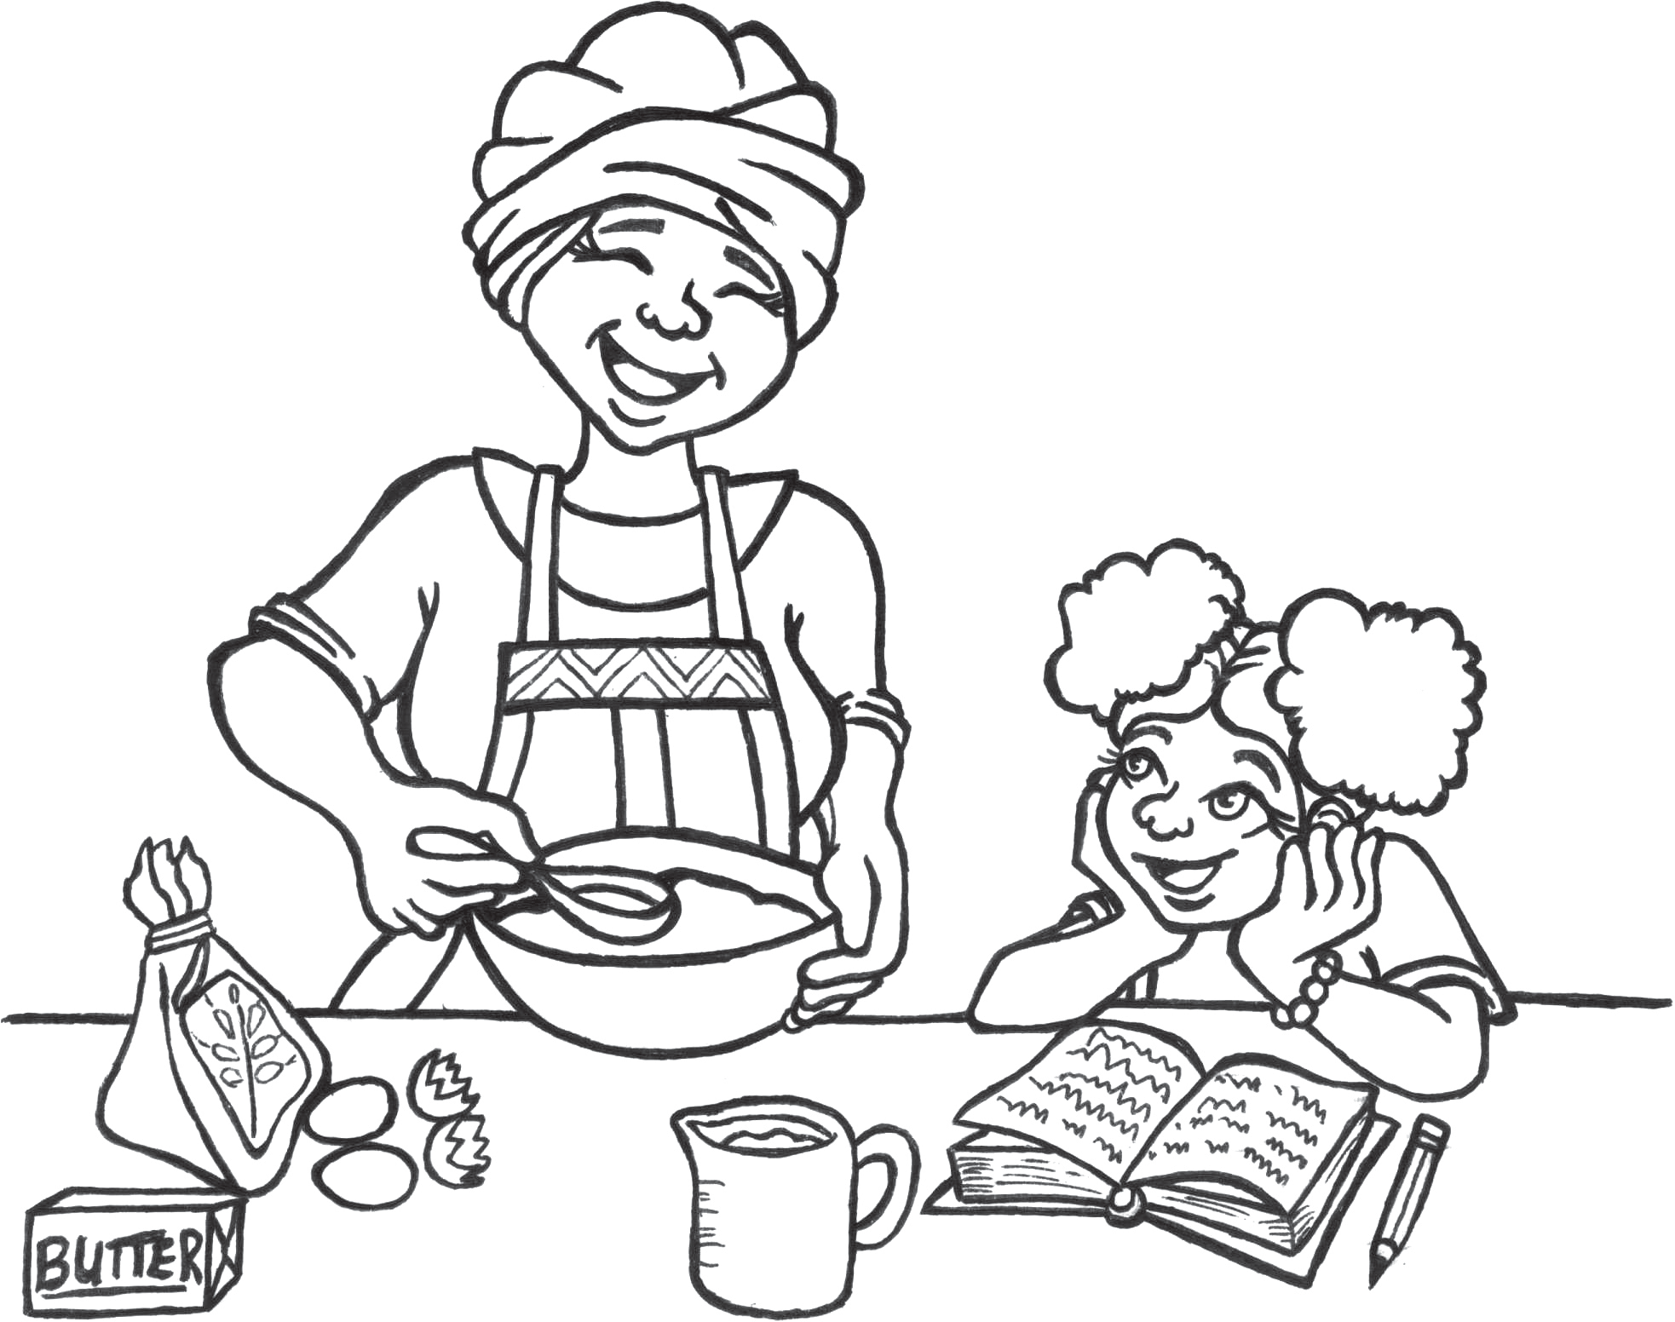



**E³ LEARNER'S BOOK | GRADE 4 | LIFE SKILLS | TERM 3**

**Creating an intercultural recipe or story book**

**Read to Lead**

A Reading Nation is a Leading Nation



**TABLE OF CONTENTS**

Teacher Agency Award information

2

A. Introduction

3

B. The Project-based Learning cycle

3

C. Your role in managing the project

5

Rubric to rate the level of competencies and e-mindset

6

D. Summary of the project

7

Session 1 planner

9

Important notes for Session 1

10

Session 2 planner

11

Important notes for Session 2

12

Session 3 planner

13

Important notes for Session 3

14

Session 4 planner

15

Important notes for Session 4

16

Session 5 planner

17

Important notes for Session 5

18

How to use the self-regulating scale

18

COVID-19 crossword answer sheet

19

Rubrics

20

Cultural story: Elihle Mogwe ant the COVID-19 virus by Scilla Edmonds

24

Vocabulary list from the story

27

Teacher’s reﬂection on Project-based Learning sessions

28

Teacher Agency Award entry form

29

**Creating an intercultural recipe or story book TEACHER’S Project Notes**

**Grade 4 | Life Skills | Term 3**

1





**RECOGNISING SOLUTION-SEEKING TEACHERS**

**ENTER THE TEACHER AGENCY AWARD**

***If it’s going to be, it’s up to me***

**SO WHY?**

To reward you for being awesome! You have shown that you care, that you have found a solution to a problem that helps others and that you have just gone ahead and made it happen.

We want to acknowledge and reward you and tell the world you are our hero! We want to reward you if you can show us that you are

self-motivated, self-directed and want to grow - and if you are driven by purpose and the desire to help others.

**WAIT WHAT?!**

So here’s what you need to show us - you need to be able to tell us that you:

1

2

3

Had the courage to just get going Had belief in yourself to just do it Activated a range of competencies that

makes you THE person that this new crazy

world needs to ﬁx it and solve its problems such as:

* 1. A great character who is self-motivated to be a SA citizen who cares, who is curious about ﬁxing things and who has the energy, enthusiasm and resilience to carry on.
  2. The ability to think and be creative, ﬁgure things out, ﬁnd the information you need and make sense of it.
  3. How you made connections, how you collaborated and communicated with others as you stood in their moccasins to solve problems.

**WHO ME?**

Yes you! Any teacher or school ofﬁcial who is doing something for the greater good.

**WHAT WILL I WIN?**

T&Cs: We will be awarding exciting, signiﬁcant prizes of up to R5000 per prize winner. These will go to worthy recipients from each province whose solutions meet the criteria on the entry form. These will be judged by E³. Awards will be announced in the ﬁrst week of every month starting in August 2020. If no worthy entry is received that merits a prize, E³ reserves the right not to award a prize for that month.

The last winners will announced in the ﬁrst week of October 2020 when this opportunity closes.

Keep an eye of the E³ website to see if you have won and to celebrate the other winners and admire their solutions.

**SO HOW MUST I APPLY?**

It’s really simple - just ﬁll in the form at the back of this book and submit it to us.

Or submit the form on the E3 website:

[**www.e3-dbe.org**](http://www.e3-dbe.org/)[**www.ecubed-dbe.org**](http://www.ecubed-dbe.org/)

**WHEN MUST I HAND IT IN?**

NOW! You can apply anytime whenever. This is an ongoing opportunity that has no deadline. How cool is that?

**CALLING ALL TEACHERS!**

**Think you lead the way in creating solutions to problems?**

**Enter this award and be rewarded and recognised for your unique problem-solving abilities.**



**A.**

**INTRODUCTION**

Dear teacher

Due to the advent of COVID-19, and the consequent lockdown periods, we have lost a substantial amount of teaching time with learners. All is not lost, though. These times have given all of us a reason to upskill ourselves, our learners and their parents or guardians and also to show we care, for ourselves, the learners and the community and this is the message we should be sending out.

It has also taught us to recognise what is important and what is not. Since we have to focus all our energy in achieving the outcomes of the trimmed ATP, or the so-called trimmed curriculum, it has become important for everyone involved in education to be able to work smarter and faster.

At E³ we've had our own sets of challenges. Direct teacher training has been replaced with online coaching and teacher seminars with video conferencing. Similarly, we've had to rework our projects per grade to not only ﬁt them into fewer teaching hours with the same outcomes, but also with consideration for the safety of all learners and teachers.

Project-based Learning (PBL) is still at the heart of it all, and we are passionate about the evolution it will bring about in the learning process. You are the project manager and have the great responsibility of instilling a new culture at your school. These times call for unequalled creativity.

**B.**

**THE PROJECT-BASED LEARNING CYCLE**

Below please ﬁnd the *Key Knowledge, Understanding* and *Success Skills* to help you manage the project.

**Challenging problem or question:** Why is this project critical? What is the problem in society and at school being addressed in this project? How has COVID-19 made this problem more real? Keep talking about how this project will solve a local or global problem, and how COVID-19 is an opportunity to help learners explore their emotions?

**Sustained enquiry:** Are learners being “researchers”? Are they doing the research and getti 遐Y ng deeper and deeper into the problem or are you doing all the talking? Look at the second circle overleaf to remind you of your role: manage activities and scaﬀold student learning. Learners must not be allowed to give up – you must “build a culture” of getti 遐Y ng to the bottom of the problem and coach them when they lose their way. With time E³ will be developing thinking tools to ensure that you are equipped with strategies to take the enquiry to a new level. (See overleaf for the current PBL learning cycle.)

**Authenticity:** Keep the project real by referring to learners' own lives – this is about them and their world and their own challenges particularly in a COVID-19 environment.

**Creating an intercultural recipe or story book TEACHER’S Project Notes**

**Grade 4 | Life Skills | Term 3**

3

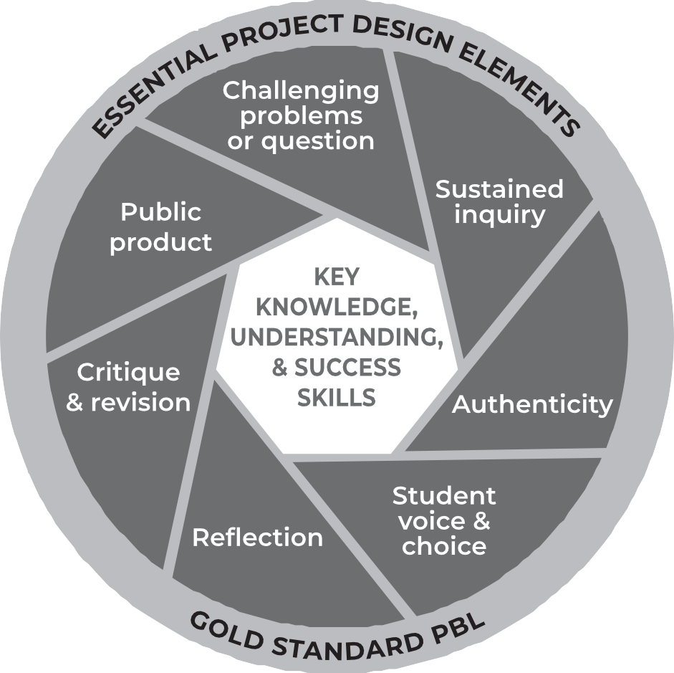



**Student Voice and Choice:** Although learners did not choose this project, make it fun and real, and applicable to their own world, so that they own it. Their voices and opinions are what your deeper goal is

– encourage their views and applaud each contribution. Create a safe space for learners to share concerns. Create a space on the wall where learners can pose random anonymous questions which you can discuss in the last period of every week.

**Reﬂection:** To truly embed learning, learners should be able to reﬂect on what they have learned and be able to think of better ways of doing things. The reﬂection activities in the worksheets are not just for fun. Encourage learners to spend time on them as this will deepen their learning.

**Critique and Revision:** This process is to help learners experiment with their innovation and learn how to improve their work and thinking. As you assess and evaluate their products (not them!) learners will see that there are diﬀerent ways of solving problems. It is important that learners hone their curiosity and learn how to “stick it out” and keep trying, not giving up when it doesn't work ﬁrst time round.

**Public Product:** At the end of the project what does the learner have to show or to brag about? Ensure that there is a Project Culmination Week in which each grade displays their products during a week selected by the management team to ensure that it is safe for the school community many parents and other stakeholders as possible attend.

**Creating an intercultural recipe or story book TEACHER’S Project Notes**

**Grade 4 | Life Skills | Term 3**

4

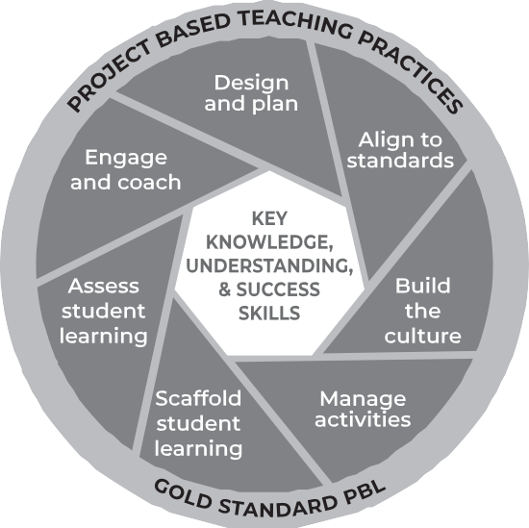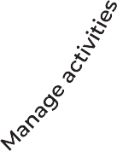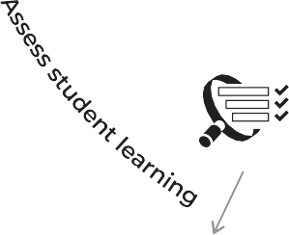

**C.**

**YOUR ROLE IN MANAGING THE PROJECT**

We as teachers need to reassess our roles. The time for good lecturing has passed. The time has come to put learner needs and their problems at the centre of the lesson and to do everything in our power to make school useful for life after school, to help learners know and believe in themselves and to give them space to become problem solvers themselves... and, of course, to have fun.

Learners go to school not to WORK, but to LEARN!

**A problem arises in the learners’ world and a lesson is created around it. She knows her curriculum and this will help her to link the problem to relevant CAPS information / knowledge transfer.**

**She knows the CAPS and links her lesson to outcomes and expectations from the CAPS.**

**Her role is to pay attention to the needs of every learner and to offer them support, not via formal teaching, but by one-on-one coaching especially as they work in groups.**

**She understands that school culture plays a huge role in modeling appropriate and meaningful relationships.**

**In her classroom, there are 3 types of assessment and each is treated differently and has a different purpose.**

**She creates an authentic project, designed around practical real-life solutions. There is very little transmission teaching.**

**She understands that all learners are different in a variety of ways. She sees her role as that of supporter as each individual learner is helped to climb to the next level through her one-on-one coaching.**

**Learners are given a task with clear instructions and the teacher observes learners and helps them as and when needed. She is a classroom site and activity manager.**

**Baseline - where should we start? Formative - How are we doing, every little step of the way?**

**Summative - How did we do when tested on a chunk of work?**

**She also does not do all the marking herself - she knows that learner self and peer assessment can be powerful learning opportunities if well-managed.**

**Creating an intercultural recipe or story book TEACHER’S Project Notes**

**Grade 4 | Life Skills | Term 3**

5

**En**

Test your PBL mindset on the rubric on the next page before you start the project and then do a post-project self-assessment.



**Creating an intercultural recipe or story book TEACHER’S Project Notes**

**Grade 4 | Life Skills | Term 3**

6

**RUBRIC TO RATE THE LEVEL OF COMPETENCIES AND E-MINDSET**

**Did your entrepreneurial mindset grow whilst managing this project?**

**Personal rating**

(1=Poor, 4=Excellent)

**Pre-project**

**Post-project**

**COMPETENCIES**

**Character**

Citizenship

I am very committed and involved in various activities in my community and people regard me as someone to follow in my circle of inﬂuence.

Curiosity

I am very curious about everything around me and all my senses are alerted to possibilities which I always put into practice.

Resilience

When I face challenges I am always excited about the possibilities and I always get up after I have been unsuccessful. I am always enthusiastic about what I have learned in the process.

**Thinking**

Creativity

I always use my imagination to come up with original ideas and/or I am always creating new things.

Critical thinking

I always form judgements based on my ability to analyse and evaluate objectively.

Reasoning

I always think about things in a logical and sensible way and I always come up with conclusions easily.

**Collaboration**

Collaboration

I always produce good work / things by working well with people (individuals or a team).

Communication

I am always successful in conveying or sharing ideas or feelings.

Empathy

I have a highly developed ability to understand and share the feelings of others.

**E-MINDSET**

**Agency**

Growth mind-set

I am always open to new information and am always willing to change my beliefs, assumptions and actions as a result.

Motivation

I always do what needs to be done without needing to be inﬂuenced by other people or situations. I always ﬁnd a reason or the strength to complete a task, even when it is challenging, without giving up or needing anyone else to encourage me.

Internal locus of control

I always have control of my life and my work is always my own and it is because of this that I experience success often. I never blame others or circumstances on my lack of success.

Regulation of emotion

I always respond to the demands of a situation with emotions that are socially tolerable and suﬃciently ﬂexible to allow spontaneous or delayed reactions – whichever are appropriate.

**Self-eﬃ**cacy

Tasting success

I have always done things successfully enough to give me “the taste of success” that makes me motivated to want more and to believe that I can get it.

Socially relatable role model

I have always been fortunate to have been exposed to excellent role models that I can relate to and who make me motivated to want to be like them.

Positive support

I have always been fortunate to have had someone who has been a positive support to me and who has encouraged me and seen me as a person.

**Solution- seeking**

Resourceful

I always ﬁnd quick and clever ways to overcome diﬃculties and ﬁnd solutions.

Problem solving

I always ﬁnd solutions to diﬃcult or complex problems.



**D**

**SUMMARY OF THE PROJECT**

The aim of the project is for every learner in the class to contribute to the creation (writing and illustration) of a book of cultural stories or a book of recipes. You, as the teacher, decide which of these will be the focus. You could choose one; either the recipe book or the story book. Or you could do both by letti ng the learners choose which of the two to focus on. Children work on their recipe or story and keep on improving it until they have their ﬁnal product ready for “publication”.

At that point, the learners prepare their ﬁnal product on an A4 sheet of paper – the story or recipe and illustration – and these are put up for the ﬁnal public display that is viewed by parents and the school community. It is very important that this viewing is a public event (or display if COVID-19 rules still prohibits gatherings) that is advertised openly and widely. After this you could, if you so choose, take all the products, and compile a class or grade recipe / story book that is then either printed and circulated (this could be digital), or it could even be used as a fundraising opportunity.

All the lesson steps have been set out in the planners, including the introduction of COVID-19 issues that need to be addressed. You will also ﬁnd the rubrics at the end of this booklet.

This set of notes is available in MS Word as well should you wish to change anything or translate the content or part thereof.

**Burning Issue / Critical Question:** Learners come to Grade 4 with a lack of cultural identity and pride.

Create cultural awareness through a culturally-rich recipe and story book produced by the class. Integrate basic hygiene principles (COVID-19 issues), address fear, anxiety and anger of losing loved ones. Promote positive living, boosting the immune system, public servants as heroes, and behavioural changes to protect self/others. The key message is not fear, but caring for oneself and your friends.

**CAPS Outcomes Life Skills Term 3:**

Cultures and moral lessons, menus from diﬀerent cultures, moral lessons selected from narratives of cultural groups in SA, reading about moral lessons found in narratives of diﬀerent cultures.

This trimmed project includes very important learner messages for coping with **COVID-19** by focusing on what can be done and how to be positive, rather than instilling fear and anxiety around possible losses and emotional stress.

Learners need to protect themselves not because of a fear of death but rather because they care about themselves, their families and their friends, and they want to be healthy. By the same token social distancing is not practised to avoid catching a friend's virus but rather to demonstrate that they care for

**Creating an intercultural recipe or story book TEACHER’S Project Notes**

**Grade 4 | Life Skills | Term 3**

7



their friend and about the safety of all people. This includes people in the front line, e.g. nurses, doctors and other service industry personnel.

**How to navigate Covid-19 issues**

Please ask each learner in class to choose a 'buddy-guard', a friend with whom they can discuss the project and share ideas with. These two “stick” together throughout the term. This might lessen exposure to other learners, but also prevent learners from feeling isolated. This will additionally, improve communication and allow for much needed collaboration to ensure the success of the project.

Social learning is essential. Instead of doing discussion in groups in class, ask learners to take the debate home to parent or caregivers and siblings. Ask them how discussions with members of their families went.

**Creating an intercultural recipe or story book TEACHER’S Project Notes**

**Grade 4 | Life Skills | Term 3**

8

**•**

**WEEK**

**ACTIVITY NUMBER**

**WORKSHEET**

**ACTIVITY DESCRIPTION**

**1 - Stories and recipes from all cultures**

**Teacher decides: Recipe book or cultural stories or both**

**1**

**1.1**

Listen to a cultural story.

Draw a picture about the cultural story.

**1.2**

Complete a crossword puzzle.

**2**

**2**

Speak about culture.

**Homework**

Research and write a cultural story / recipe.

**2 - Oral presentations**

**3**

**3**

Plan and present oral presentation.

**4**

**4**

Write letter to a public servant.

**Homework**

Illustrate a cultural story / recipe.

**3 - Organising our book of cultural stories and recipes**

**5**

**5**

Write a table of contents. Submission of cultural recipes / stories

**Homework**

Design the “look of the book” for the culturally-rich recipe and story book.

**4 - Finalising our book of cultural stories and recipes**

**6**

**6**

Collaborate design ideas. Establish COVID-19 Golden Rules. Determine the product market.

Public display of the product

**5 - Reﬂection**

**7**

**7**

Reﬂection Consolidation

Distribution of the product

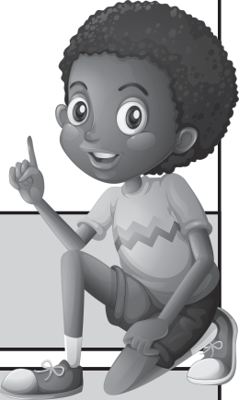

**Creating an intercultural recipe or story book TEACHER’S Project Notes**

**Grade 4 | Life Skills | Term 3**

**WHAT**

**HOW**

**WHY**

9

**POSSIBLE EXPANDED LEARNING-OPPORTUNITY FOR THIS PROJECT**

**CLASSROOM MANAGEMENT AND LAYOUT**

Distancing important Limit groupwork and group discussions - explain buddy-guard concept.

**RESOURCES YOU WILL NEED FOR THIS LESSON**

Cultural story (Elihle Mogwe) Worksheet 1.1 and Worksheet 1.2 Worksheet 2

Coloured pencils / pens or crayons

**COMPETENCIES TO LOOK FOR IN THIS LESSON**

Listening

Evaluate moral lesson Synthesize information Comprehension Creativity

Empathy, respect

**TEACHING TOOLS TO USE IN THIS LESSON (PROCESSES)**

Cultural story / recording Rubrics

**WHAT ARE THE LEARNERS DOING?**

Learners are doing active listening by drawing pictures that correspond to the story. Identify the moral lesson, complete crossword about story. Learn about each other’s cultures. Discussions about COVID-19.

**CAPS ALIGNMENT AND ASSESSMENT AND OTHER SUBJECT INTEGRATION**

Cultural and moral lessons. Moral lessons selected from narratives of cultural groups.

**ENRICHMENT ACTIVITIES**

Ask volunteer to read part of story. Create a short drama with main characters.

**OUTCOMES TO ACHIEVE THIS LESSON**

* Learners listen to story.
* They draw illustrations for the story.
* Grasp the moral of story / comprehension.
* Develop critical thinking skills.
* Learners acquire information about own culture and culture of others, discuss.
* Think about where COVID-19 issues had impact on cultural celebrations.
* Recognise creative ways to celebrate cultural days, and keep a safe distance.
* Respect for own and other’s cultures.
* Celebrating diversity

**TEACHER ACTIVITIES FOR THIS WEEK**

* Read a cultural story (attached at back) or listen to the podcast of the cultural story.
* Test comprehension - *Wh*-questions.
* Open conversation about cultures in SA and who are presented in the class.
* Touch on COVID-19 inﬂuence on cultural celebrations.
* **Homework:** Ask learners to bring cultural recipe or story to class.
* **Homework:** Unpack presentation rubric on 2 minute oral about recipe or story.
* Share outcome of project: Display of recipe and story book or actual self-publication.

Issues regarding lack of conﬁdence linked to **cultural identity** are addressed. Learners produce a culturally rich item (recipe and story book) and organise a public display of the book.

Learners work on a project for an extended period of time that engages them in solving real- world problems. They develop a public product and presentation.

Students develop deep content knowledge, critical thinking, creativity and communication skills doing an authentic, meaningful project.

**1**

**PROJECT-BASED LEARNING | GRADE 4 PLANNER**



**1**

1. Read the **Elihle story *(inserted at the end of this booklet)*** OR play the recording that has been made available to teachers. **LINK REQUIRED** Ask learners to draw a picture from a part of the story on Worksheet 1.1 in their Learner books. This is an excellent opportunity to unpack the story and the moral lessons from the story. E.g. *Why did you draw that picture? Why did you do….? Wh*-questions are a key method for developing critical thinking skills. It is also a way for learners to process trauma and learn to identify and express their feelings.

2. If it is better in your context, you could give the learners play dough or clay to model parts of the story to reach the same critical thinking and emotional expression outcomes. Once the learners have completed their drawings, allow them the opportunity to complete the crossword puzzle based on the story of Elihle (Worksheet 1.2).

***(Crossword puzzle solution at the back of booklet)***

3. How did COVID-19 inﬂuence their cultural celebrations and events (marriages, funerals, and birthdays) in recent times? What creative alternatives did their families come up with to go ahead with celebrations while keeping everyone safe? This can be used to stimulate critical thinking in Activity 2: Speaking about Culture which learners will complete on Worksheet 2.

4. **Homework:** Unpack the oral presentation rubric (at back of booklet) so that learners know what makes a good presentation and they understand how to prepare their oral. This will be a great tool for their parents / caregivers to use as they help them get ready. Provide the learners with an A4 page so that they can write/type out their cultural story and recipe that they wish to present.

5. You are welcome to use these same tasks as the assessments in ENG HL or ENG FAL for integration of subjects. Use the Creative writing rubric for the Cultural story. Use the transactional text rubric for the Recipe and the letter. There is also another rubric that can be used for both Intermediate and Senior phase, for both ENG HL and ENG FAL. These can also be used for the Listening and Speaking mark in ENG HL and ENG FAL.

***(Please see rubrics at the back of the booklet)***

**Creating an intercultural recipe or story book TEACHER’S Project Notes**

**Grade 4 | Life Skills | Term 3**

10

During every week, learners post random anonymous questions on a wall reserved for this purpose. Teacher discusses questions in the last 15 minutes of the week. Ensure that strips of paper and thick pens are available so that learners can quietly and anonymously post their fears on the Question Wall. This intervention will help learners who do not communicate easily to share their trauma. This is also an opportunity to help learners create Wh- questions, a language activity in itself, but also an opportunity for student voice.

**IMPORTANT NOTES FOR SESSION 1**



**Creating an intercultural recipe or story book TEACHER’S Project Notes**

**Grade 4 | Life Skills | Term 3**

**WHAT**

**HOW**

**WHY**

11

**POSSIBLE EXPANDED LEARNING-OPPORTUNITY FOR THIS PROJECT**

**CLASSROOM MANAGEMENT AND LAYOUT**

Distancing important Limit groupwork and group discussions Ensure that buddy-guards understand each other non-verbally

**RESOURCES YOU WILL NEED FOR THIS LESSON**

Worksheet 3 Worksheet 4

A4 page for every learner to take home

Writing paper for every learner to rewrite letter Pens

Learners' oral presentations

**COMPETENCIES TO LOOK FOR IN THIS LESSON**

**Character** Citizenship, Curiosity, Resilience Mindset **Connection** Collaboration Communication Empathy

**Thinking**

Critical thinking Creativity, Reasoning

Underline which were developed in this lesson

**TEACHING TOOLS TO USE IN THIS LESSON (PROCESSES)**

Rubric for oral presentation

Length of Informal Letter Eng. HL Content 60-80 words)

Length of Informal Letter Eng FAL (Content only 40- 60 words)

**WHAT ARE THE LEARNERS DOING?**

Learners are doing oral presentations. They are also writing letters to public servants.

**CAPS ALIGNMENT AND ASSESSMENT AND OTHER SUBJECT INTEGRATION**

Cultural and moral lessons. Moral lessons selected from narratives of cultural groups.

**ENRICHMENT ACTIVITIES**

If current COVID-19 circumstances allow gatherings, learners can create a cultural event with tastings / book readings.

**OUTCOMES TO ACHIEVE THIS LESSON**

* Oral presentation
* Letter writing, write a letter of thanks to a public servant.
* Start planning their one-page recipe/story with illustrations.

**TEACHER ACTIVITIES FOR THIS WEEK**

* Listen to oral presentations.
* Ask them to start working on letter to a local hero (public servants).
* Hand out the A4 pages for illustrations.
* **Homework:** learners must illustrate their cultural recipe or story on ONE A4 page.
* These pages will go on display at school for parents and teachers/learners to view the pages of the book.
* If the time/budget/circumstances allow, these will go into a book format for self publication.

Issues regarding lack of conﬁdence linked to **cultural identity** are addressed. Learners produce a culturally rich item (recipe and story book) and organise a public display of their book.

Learners work on a project for an extended period of time that engages them in solving real- world problems. They develop a public product and presentation.

Students develop deep content knowledge, critical thinking, creativity and communication skills doing an authentic, meaningful project.

**2**

**PROJECT-BASED LEARNING | GRADE 4 PLANNER**



**2**

1. Ensure that the learners plan their oral on Worksheet 3. During a normal school week learners from diﬀerent groups could be selected to present a story or recipe from their group. During social distancing protocols, you could draw names from a hat and give learners the option to present – this will allow for sensitivity towards any learner who has experienced trauma. Keep all names drawn out of the hat aside so that during the course of the year each learner has had the opportunity to present. This will also give shy learners time to develop conﬁdence as they will probably be the last to present and so that no learner presents twice during the year. Every learner also knows that their turn will come up at some point in the year.

**COVID CARE:** To prohibit moving and the possible transferral of COVID-19, ask the learners to present from their desk or allocate a “safe space” in the classroom that will be used for presentations. Provide sanitisation products for the learners so that they can practise good hygiene.

2. Before learners start with their oral presentations, ask those who are not presenting to open Worksheet 4. They should write a letter to a local hero (public servants at the forefront of the pandemic like police, doctors or nurses) to convey their thanks for keeping us all safe. Ask learners to put these up on the walls of the classroom or in any other “safe space” identiﬁed by the teacher.

3. Ask learners to illustrate the recipes or cultural stories. Ensure this by providing them with an A4 paper on which they can illustrate their work. Please make sure that the learners add their names to their work.

**Creating an intercultural recipe or story book TEACHER’S Project Notes**

**Grade 4 | Life Skills | Term 3**

12

**IMPORTANT NOTES FOR SESSION 2**



**Creating an intercultural recipe or story book TEACHER’S Project Notes**

**Grade 4 | Life Skills | Term 3**

**WHAT**

**HOW**

**WHY**

13

**POSSIBLE EXPANDED LEARNING-OPPORTUNITY FOR THIS PROJECT**

Instead of physical publication, invite someone to explain online publishing. Let learners take the lead and go ahead with publication online.

**CLASSROOM MANAGEMENT AND LAYOUT**

Distancing important Limit groupwork and group discussions Ensure that buddy-guards understand each other non-verbally

**RESOURCES YOU WILL NEED FOR THIS LESSON**

Worksheet 5 Blackboard/whiteboard to jot down ideas

Pens Learners' oral presentations

**COMPETENCIES TO LOOK FOR IN THIS LESSON**

**Character** Citizenship, Curiosity, Resilience Mindset **Connection** Collaboration Communication Empathy

**Thinking**

Critical thinking Creativity, Reasoning

Underline which were developed in this lesson

**TEACHING TOOLS TO USE IN THIS LESSON (PROCESSES)**

Rubric for oral presentation Information or research on physical publication and online publication, ISBN numbering, etc.

**WHAT ARE THE LEARNERS DOING?**

Learners are doing oral presentations. They ﬁnish their one-page recipe or story with illustrations. They start work on the table of contents. They share ideas on public display/publication of book.

**CAPS ALIGNMENT AND ASSESSMENT AND OTHER SUBJECT INTEGRATION**

Cultural and moral lessons. Moral lessons selected from narratives of cultural groups.

**ENRICHMENT ACTIVITIES**

If socioeconomic circumstances allow, (and it is COVID- 19 safe) go ahead with publication of book.

**OUTCOMES TO ACHIEVE THIS LESSON**

* Learners present their prepared oral on recipe or cultural story.
* They ﬁnish the one-page stories/recipes and illustrations in class.
* Brainstorm ideas for publication of book.
* Brainstorm ideas for the display of the pages of the book at school.
* Practise skill of organisation of information and data.

**TEACHER ACTIVITIES FOR THIS WEEK**

* Ask learners to hand in or ﬁnish recipes or stories with illustrations on their A4 pages.
* Make sure to add names of learners on pages for display.
* Listen to the rest of the oral presentations.
* **Homework:** Brainstorm ideas for the title of book, front page cover and back page with learners.
* Help learners to create a table of contents for their book on Worksheet 5. Learners don't have to complete the whole table of contents, perhaps only ten spaces so that they can practise the skill.

Issues regarding lack of conﬁdence linked to **cultural identity** are addressed. Learners produce a culturally rich item (recipe or story book) and organise a public display of their project.

Learners work on a project for an extended period of time that engages them in solving real- world problems. They develop a public product and presentation.

Students develop deep content knowledge, critical thinking, creativity and communication skills doing an authentic, meaningful project.

**3**

**PROJECT-BASED LEARNING | GRADE 4 PLANNER**



**3**

1. Now that the learners have completed their oral presentations, ask them to hand in or ﬁnish their recipe or cultural story and illustrations for the book in class. Please make sure to add the names of learners to their recipes or story illustration pages.

2. Assist the learners to create a table of contents for their book. They should complete the activity on Worksheet 5. This will allow their learners to practise the skill of organising information/data and will also ensure that they practise collaboration, despite COVID-19.

3. **Homework activity:** Brainstorm ideas for the title, front page and back page of the book. Ask the learners to start with the design process. The learners can do this on the front and back of their learner books so that they can practise the skill of what goes on the front of a book and what goes on the back. Provide 2 A4 pages to each learner for this purpose.

**Creating an intercultural recipe or story book TEACHER’S Project Notes**

**Grade 4 | Life Skills | Term 3**

14

**IMPORTANT NOTES FOR SESSION 3**



**Creating an intercultural recipe or story book TEACHER’S Project Notes**

**Grade 4 | Life Skills | Term 3**

**WHAT**

**HOW**

**WHY**

15

**POSSIBLE EXPANDED LEARNING-OPPORTUNITY FOR THIS PROJECT**

Talk to parents who are willing to display the pages of the recipe book at work or in their shops (if possible) for public viewing.

**CLASSROOM MANAGEMENT AND LAYOUT**

Distancing important Limit groupwork and group discussions Ensure that buddy-guards understand each other non-verbally

**RESOURCES YOU WILL NEED FOR THIS LESSON**

Worksheet 6 Blackboard/whiteboard to jot down ideas

Pens

Strips of paper

All the pages of the recipe book

**COMPETENCIES TO LOOK FOR IN THIS LESSON**

**Character:** Citizenship, Curiosity, Resilience, Mindset **Connection:**

Collaboration, Empathy, Communication **Thinking:** Creativity, Critical thinking, Reasoning

Underline which were developed in this lesson

**TEACHING TOOLS TO USE IN THIS LESSON (PROCESSES)**

Rubrics

**WHAT ARE THE LEARNERS DOING?**

Learners share ideas for front/back page plus ideas on public display/publication of book. They help with the ﬁnal proof reading of the book's pages. They list possible buyers of book for fundraising.

**CAPS ALIGNMENT AND ASSESSMENT AND OTHER SUBJECT INTEGRATION**

Cultural and moral lessons. Moral lessons selected from narratives of cultural groups.

**ENRICHMENT ACTIVITIES**

If it is COVID-19 safe, go ahead with publication of book and launch at a cultural event.

**OUTCOMES TO ACHIEVE THIS LESSON**

* Learners brainstorm ideas for the front/back page of book.
* Learners write ideas for preventing COVID-19 infections on paper strips .
* Learners help teacher to proof read and check ﬁnal pages of the book for display.
* Learners brainstorm ideas for the public display of their book pages at school.
* Learners list possible buyers and reasons for selling book (ideas for a fundraiser).

**TEACHER ACTIVITIES FOR THIS WEEK**

* Ask volunteers to come forward and share ideas for front/back page of book.
* Brainstorm ideas to copy, reproduce and bind this book.
* Ask learners to list precautions when moving around in public places to prevent COVID-19 infections. Incorporate in the book if possible.
* Check the ﬁnal pages of the book and ask learners to list possible buyers.

Issues regarding lack of conﬁdence linked to **cultural identity** are addressed. Learners produce a culturally rich item (recipe and story book) and organise a public display of their book.

Learners work on a project for an extended period of time that engages them in solving real- world problems. They develop a public product and presentation.

Students develop deep content knowledge, critical thinking, creativity and communication skills doing an authentic, meaningful project.

**4**

**PROJECT-BASED LEARNING | GRADE 4 PLANNER**



**4**

1. Allow the learners to share their ideas for the title, front page and back page of the book. Also brainstorm ways to copy, reproduce and bind this book. Where/to whom will we sell it? How can we aﬀord to each take one copy home? Start a conversation about publishing, ISBN numbering, etc.

2. Ask learners to recite a list of precautions we should take when we move around in public places to prevent the spread of COVID-19. These precautions will become the COVID-19 Golden Rules and can be added to the book produced by the learners. Let them write these on strips of writing paper and put up on the wall next to their letter to public servants.

3. **EXPANDED LEARNING OPPORTUNITY:** If circumstances allow, you can go ahead with publication/self-publishing of the recipe book. Show learners the ﬁnal book before copying and ask them to write a list of possible buyers on Worksheet 6. Also ask them to list reasons for the selling of the book.

4. **PUBLIC DISPLAY:** Put all the recipes or stories with their illustrations up in a public place for display. At school this can be in a speciﬁc hallway, outside a class, in the library, etc. Also ask parents of learners in class if they can display the pages at work or at their businesses for a week or two. If it is possible, encourage the learners to start incorporating technology and share their work on virtual platforms, like Class website, School Facebook page, etc.

**Creating an intercultural recipe or story book TEACHER’S Project Notes**

**Grade 4 | Life Skills | Term 3**

16

**IMPORTANT NOTES FOR SESSION 4**



**Creating an intercultural recipe or story book TEACHER’S Project Notes**

**Grade 4 | Life Skills | Term 3**

**WHAT**

**HOW**

**WHY**

17

**POSSIBLE EXPANDED LEARNING-OPPORTUNITY FOR THIS PROJECT**

Talk to parents who are willing to display the pages of the recipe book at work or in their shops (if possible) for public viewing.

**CLASSROOM MANAGEMENT AND LAYOUT**

Distancing important Limit groupwork and group discussions Ensure that buddy-guards understand each other non-verbally

**RESOURCES YOU WILL NEED FOR THIS LESSON**

Worksheet 7 Blackboard/whiteboard to jot down ideas

Pens

Copied and bound recipe books

Teacher’s reﬂection sheet at the end of this project

**COMPETENCIES TO LOOK FOR IN THIS LESSON**

**Character:** Curiosity, Citizenship, Resilience, Mindset **Connection:** Empathy, Collaboration, Communication **Thinking:** Creativity, Critical thinking, Reasoning Underline which were

developed in this lesson

**TEACHING TOOLS TO USE IN THIS LESSON (PROCESSES)**

Story (Elihle) for unpacking positive atti 技æ怀怀 e၀tudes.

**WHAT ARE THE LEARNERS DOING?**

Learners complete Worksheet 7. They think of ways to stay positive. They reﬂect on the project and take letters to public servants to deliver.

**CAPS ALIGNMENT AND ASSESSMENT AND OTHER SUBJECT INTEGRATION**

Cultural and moral lessons. Moral lessons selected from narratives of cultural groups.

**ENRICHMENT ACTIVITIES**

If it is COVID-19 safe, go ahead with publication of book and launch at a cultural event.

**OUTCOMES TO ACHIEVE THIS LESSON**

* Learners must reﬂect on the success/challenges in the project.
* They recall story and think of ways to stay positive during COVID-19 times.
* Learners take copies that sold to family and friends home to distribute.
* Put letters to public servants in envelopes and learners deliver to people they know.

**TEACHER ACTIVITIES FOR THIS WEEK**

* Ask learners to reﬂect on the project using Worksheet 7.
* How can we stay positive during COVID-19 times?
* Distribute copies of book bought by family or friends (if rules allow)
* Take down letters to public servants and post or deliver, if possible.

Issues regarding lack of conﬁdence linked to **cultural identity** are addressed. Learners produce a culturally rich item (recipe and story book) and organise a public display of their book.

Learners work on a project for an extended period of time that engages them in solving real- world problems. They develop a public product and presentation.

Students develop deep content knowledge, critical thinking, creativity and communication skills doing an authentic, meaningful project.

**5**

**PROJECT-BASED LEARNING | GRADE 4 PLANNER**



**5**

1. This is a very important step. Ask learners to reﬂect on the project, on what they have learned and what they have enjoyed/not enjoyed about the project.

2. Unpack the story of Elihle once again to ask: How can we stay positive during times of uncertainty? Does it help to stay busy and do something concrete/creative?

3. Ask the principal to show oﬀ this book to the rest of the school during assembly. Display the pages of the book in a hallway, outside a classroom or in the library. You can also ask parents of learners in class if it would be possible to display the pages of the recipe book at work in a corridor or at their businesses for the public to view (a sort of travelling display).

4. Provide envelopes or paper and a method to make envelopes. Ask learners to take down the letters and put them in envelopes to post/deliver to heroes (public servants) in the community.

**HOW TO USE THE SELF-REGULATING SCALE**

Ask the learners to tick the box next to the emotion they are experiencing the most. This will give the learners a chance to regulate their emotions, as well as develop empathy for each other.

The teacher can then look at the learners' work, whilst looking at the emotion they indicated.

The teacher can also elevate this activity by asking the learners to close their eyes and, by the show of hands, indicate how they are feeling, this can be done on a scale with 1 ﬁnger indicating extreme sadness and 5 ﬁngers indicating extreme happiness.

**Creating an intercultural recipe or story book TEACHER’S Project Notes**

**Grade 4 | Life Skills | Term 3**

18

**HOW ARE YOU FEELING?**

5) Great

4) Pretty good

3) Okay

2) Not too good

1) Bad

**WHY ARE YOU FEELING THIS WAY?**

**IMPORTANT NOTES FOR SESSION 5**



**COVID-19 CROSSWORD ANSWER SHEET**

**1** S

**2** N

**3** L

**4** H

O

C

K

D

O

W

N

A

N

D

S

U

**6** T

S

H

R

O

A

T

H

U

**7** D

A

N

C

E

R

F

T

**9** G

O

R

O

O

I

I

I

U

C

N

M

A

G

**11**R

E

C

I

P

E

B

O

O

K

R

**12**E

L

B

O

W

U

**13**D

I

S

T

A

N

C

E

H

**ACROSS**

**3.**

**4.**

**6.**

**7.**

**8.**

**10.**

**11.**

**12.**

**13.**

Elihle was living with her Gogo during the COVID-19 .......

We need to wash our often and for at least 20 seconds.

Iboza is a traditional remedy to help .......

You may not be able to engage in sport, but you can still smile and .......

A popular healthy food made from African Spinach is called .......

We should protect ourselves by wearing a .......

Grade 4 has just compiled a wonderful cultural .......

Remember to cough or sneeze into your .......

We also need to remember to self .......

**DOWN**

**1.**

**2.**

**5.**

**9.**

Elihle’s home country is .......

Another medicinal ﬂower that will help a sore throat is .......

Washing hands under a is a clever idea for schools with limited water.

The English name for Iboza is .......

**Creating an intercultural recipe or story book TEACHER’S Project Notes**

**Grade 4 | Life Skills | Term 3**

19

**5** T

**8**M

I

P

P

Y

T

**10**M

A

S

K

P



**RUBRICS**

Name: Gr 4: Date:

**Creating an intercultural recipe or story book TEACHER’S Project Notes**

**Grade 4 | Life Skills | Term 3**

20

**FORMAL ASSESSMENT RUBRIC / CONTROL LIST**

**CRITERIA**

**LEARNER MARK**

**TOTAL MARK**

**1**

**WORKSHEET 1.1: CREATIVELY RESPOND TO A CULTURAL STORY *(Individual Listening Activity)*** Interprets the story and responds in a creative way, whilst highlighting important information from the story.

*(Award 1-2 marks for appropriateness,1-2 marks for creativity, 1-2 marks for colour)*

**[6]**

**WORKSHEET 1.2: CROSSWORD PUZZLE *(Individual Comprehension Activity)***

Answer questions pertaining to the story.

**[10]**

**WORKSHEET 2: SPEAKING ABOUT CULTURE *(Small group/pair Speaking Activity)***

Learners are able to communicate eﬀectively and participate actively in conversation.

**2**

**SELECTS AND WRITES A RECIPE OR STORY *(Individual Writing Activity)*** Selects a unique recipe, identiﬁes ingredients and writes the method. **OR** Selects a unique a cultural story and writes it down .

*(Use the rubric Creative Writing for the story/ Transactional text for the Recipe)*

**[40]**

**WORKSHEET 3: PLANNING MY ORAL *(Individual Writing Activity)***

Learners eﬃciently plan their oral presentation.

**ORAL PRESENTATION: Do an oral presentation on a cultural recipe or story**

Learner adequately and conﬁdently presents the oral. Learner focuses on using the Global Language of Communication to convey the information of the presentation.

*(Use the rubric Prepared Speech for the oral presentation)*

**[30]**

**WORKSHEET 4: WRITE A LETTER *(Individual Writing Activity)***

Writing a letter of thanks to a public servant.

*(Use the rubric Transactional text for the Letter)*

**[40]**

**ILLUSTRATES A RECIPE OR STORY *(Individual Creative Activity)***

The learner draws a suitable illustration the recipe or cultural story they wrote.

*(Award 1-2 marks for appropriateness,1-2 marks for creativity, 1-2 marks for colour)*

**[6]**

**3**

**WORKSHEET 5: ESTABLISH A TABLE OF CONTENTS *(Large group Writing Activity)*** The learner collaborates with others to write a table of contents for the book *(Award 1 mark each appropriate answer)*

**[10]**

**4**

**WORKSHEET 6: LIST OF REASONS FOR SELLING AND POSSIBLE BUYERS *(Individual Writing Activity)***

Creates a list of valid reasons for sale of recipe/story books and a list of at least four possible buyers in the family or community.

*(Award 1 mark each appropriate answer)*

**[10]**

**HOW TO STAY SAFE FROM COVID-19 *(Individual Activity)***

Brainstorms and selects creative ways to prevent infections from COVID-19 in public places, including schools, shopping centres, public transport, etc.

**5**

**WORKSHEET 5: EVALUATION AND REFLECTION *(Individual Writing Activity)***

Evaluates as well as reﬂects on personal participation during the project. Suggests way in which to improve the project.

*(Award 1 mark each appropriate answer)*

**[8]**

Educator:

**TOTAL [160/4 = 40]:**

**/ [40]**



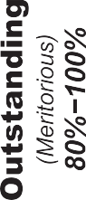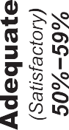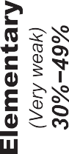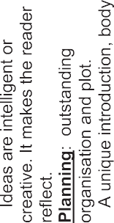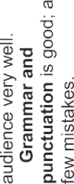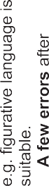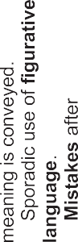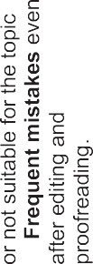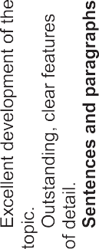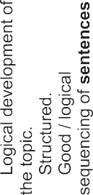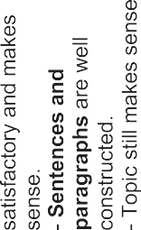

**Creating an intercultural recipe or story book TEACHER’S Project Notes**

**Grade 4 | Life Skills | Term 3**

21



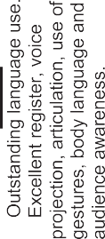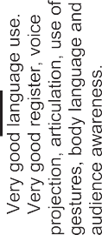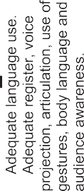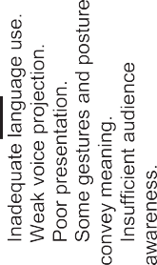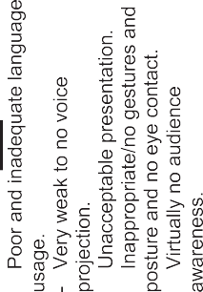

**Creating an intercultural recipe or story book TEACHER’S Project Notes**

**Grade 4 | Life Skills | Term 3**

22



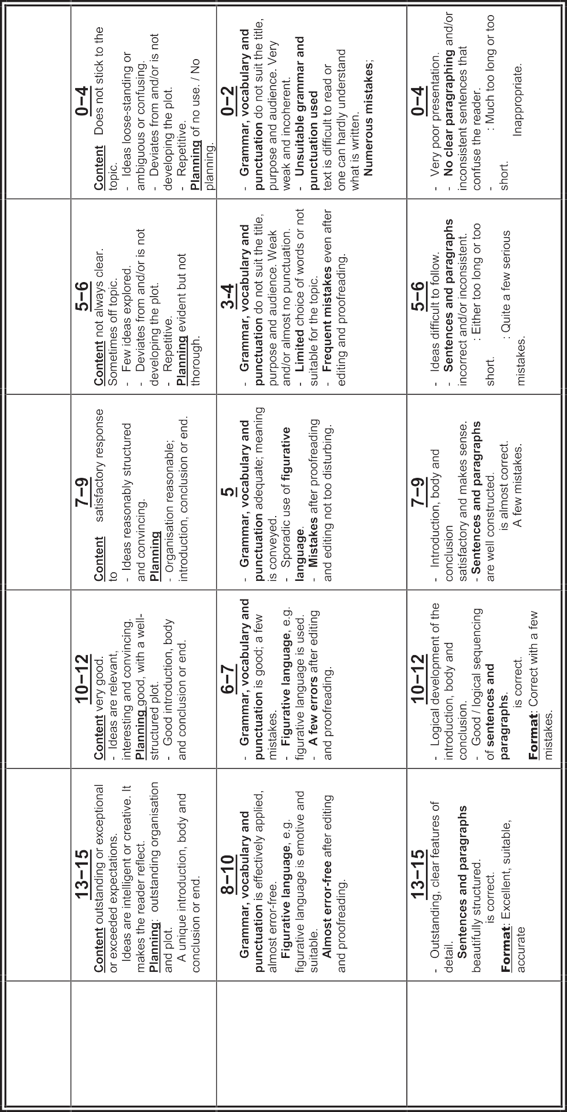

**Creating an intercultural recipe or story book TEACHER’S Project Notes**

**Grade 4 | Life Skills | Term 3**

23

**Length**

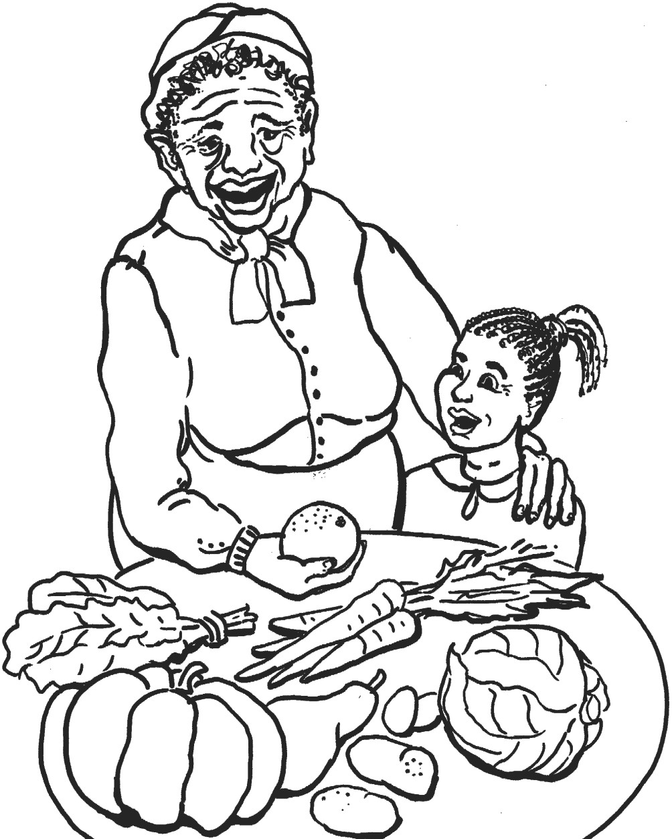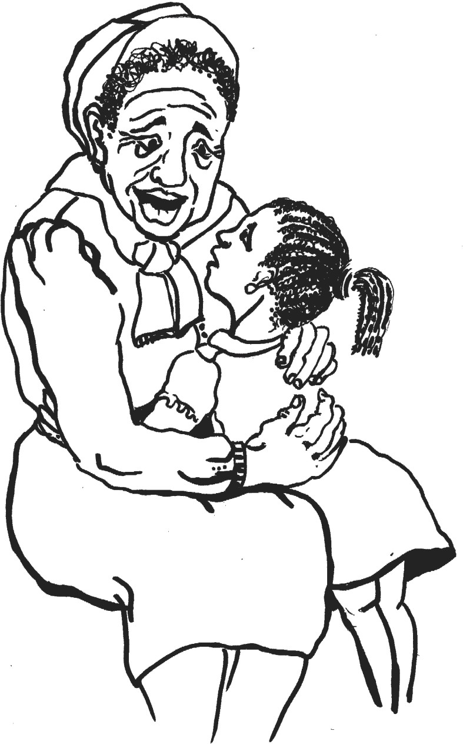



**ELIHLE MOGWE AND THE COVID-19 VIRUS BY SCILLA EDMONDS**

‘Hhawu, Elihle! Why are you looking so sad? Are you missing your Mother today?’

‘No, Gogo. I am just very worried!’

'But why, little one … Why are you so worried?’

‘Gogo, I am worried about the virus – everyone is talking about it and how we are all going to get sick and die! Gogo, I want to go home now, I want to go back to school and see my friends.’

Elihle's eyes began to tear and she put her head in her gogo's lap. She was sad and frightened.

'My precious girl – come. Let us sit down together and talk. 'Yes, you are worrying about many things you do not understand. It is hard for a little girl – to hear all these stories. You know what,

Elihle – you come and help me in the kitchen to prepare the

morogo. It always helps me to keep busy when I am worried. Before we talk about the virus, is morogo a recipe in the recipe book you made at school? What a lovely dish made from African Spinach! An important weapon against any virus is to eat healthy food! My child, you chop - and I will boil the water so long for a good cup of Rooibos Tea!’

Elihle dried her tears and began to help her gogo to prepare the evening meal. She also put her cup of Rooibos tea next to her as she sat on a stool and chopped the leaves and shoots.

'So, Elihle! Tell me now what is worrying you?' Gogo sat down and they worked together and spoke. Elihle was feeling better already.

'Gogo, everyone says there is no medicine for the virus and people like you will die before they ﬁnd a cure.' Elihle stopped and looked at her.

'Hhawu, Elihle – please understand. This is not the ﬁrst disease people in the world have had to worry

**Creating an intercultural recipe or story book TEACHER’S Project Notes**

**Grade 4 | Life Skills | Term 3**

24

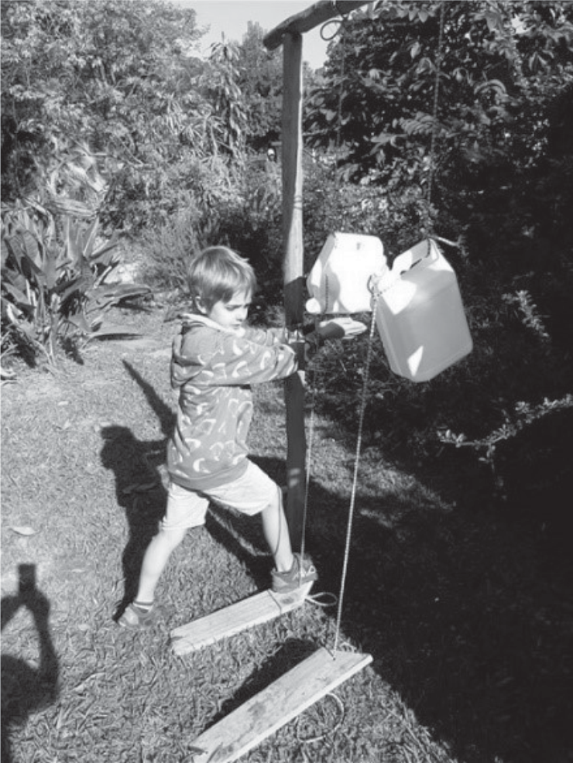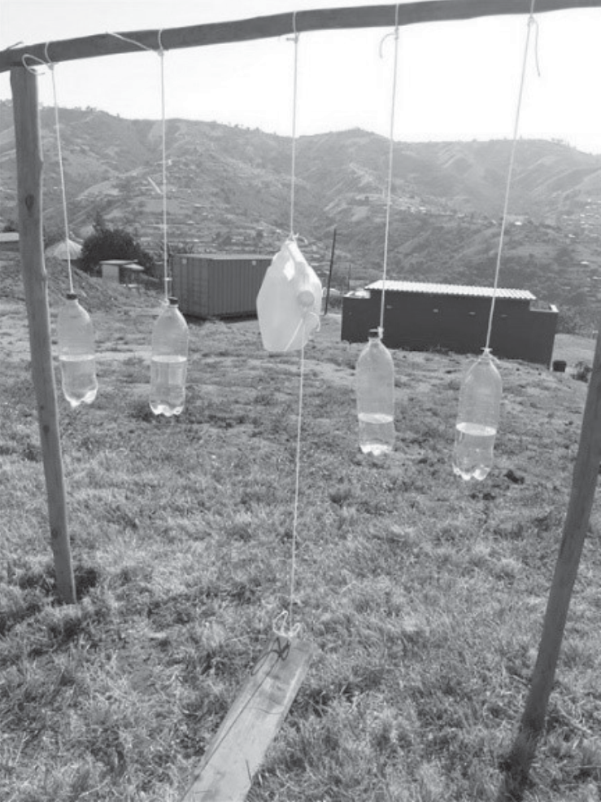

about. When you are as old as me – you know many things! Long before I was a little girl, there were diseases like Smallpox that killed many people. One day, a very clever man called Edward Jenner developed a vaccine that fought the disease - and now it is completely eradicated. I even remember that there was Polio - but now that is also not a problem anymore. Doctors are so clever! Precious child, we need to do things now - to keep us safe - until this disease is controlled. Come, tell me what you know about it already!’

Elihle told her granny that she knew that wearing a mask when they left home would help - and she must not touch her face – because that is how it could be spread. She also knew she needed to wash her hands often - and well - using soap for a long time. Gogo reminded her of the lovely song that the Ndlovu Choir sang about washing hands. Just for fun they went to the basin and sang while they washed.

'Gogo … I have another worry', said Elihle. 'Our school has running water to wash hands but what about the schools that don't have water to do that?’

'Elihle … There are some very clever people! Just yesterday I heard that there were schools that had put in Tippy Taps. This works very well when there is no running water and they are simple to set up.

***Tippy Taps are made from recyclable materials and operated by foot.***

Elihle laughed … 'Can we make one here then you won't have to go inside to wash your hands when you are gardening!' They both laughed and agreed it was a good idea.

'Now, Elihle – did your teachers tell you about coughing or sneezing into your elbow so the germs in the little droplets from your mouth don't get onto your hands?' Elihle nodded. 'She did? Good. Now come - let me show you some of the medicines we can use to stop us getti ng sick!' Gogo led Elihle outside and together they walked to the corner of their road.

**Creating an intercultural recipe or story book TEACHER’S Project Notes**

**Grade 4 | Life Skills | Term 3**

25

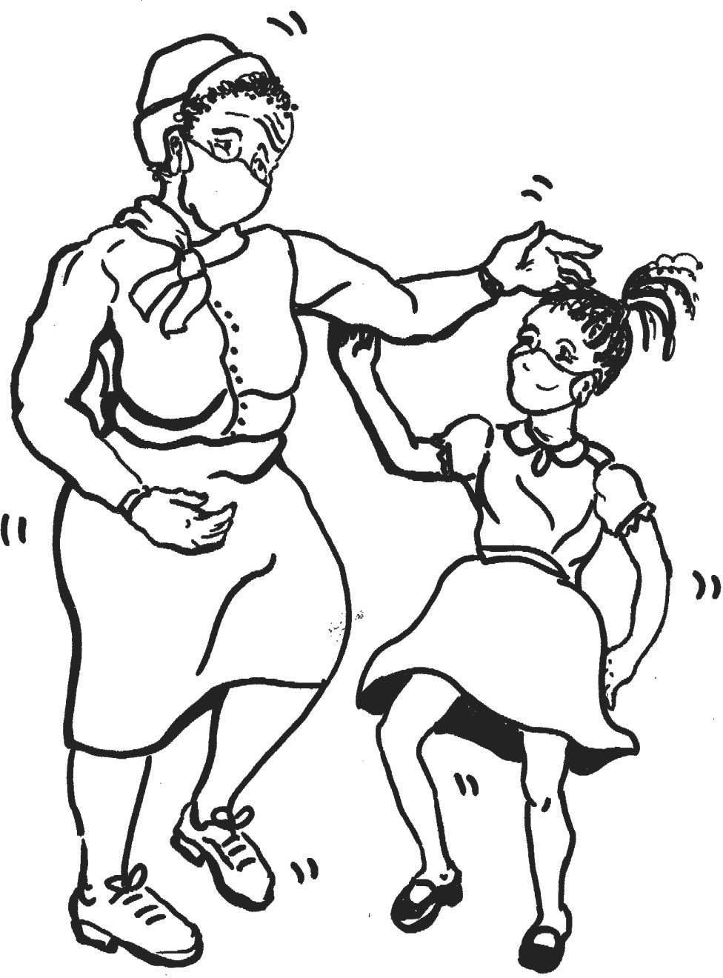

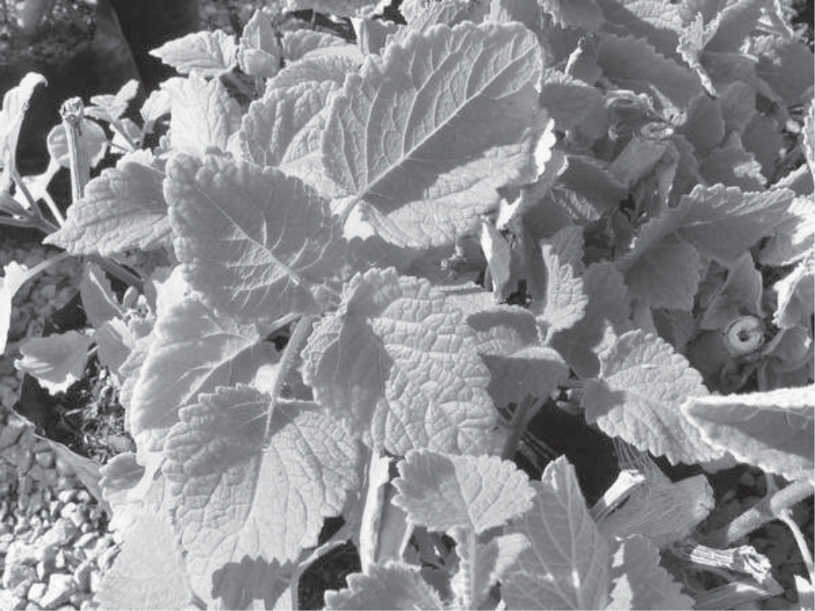

‘Look here, little girl, and learn. This bush is one of the medicines our South African people have been using for a long time – when they get sick. This bush is called Iboza. Pick some leaves and we will make our own medicine for a sore throat and ﬂu. Nasturtium also helps.’ Elihle helped her Gogo and they walked back to the kitchen. Gogo boiled a kettle of water and poured it over the leaves in a cup. She stirred the mixture gently for a while then took the leaves out. She then let the cup of Iboza water cool a little before giving it to Elihle to drink.

Elihle took a sip. 'Whe`…. this is horrible to taste, Gogo!' Gogo laughed but reminded her that lots of medicines that were good for you did not taste nice. She also told Elihle how diﬀerent cultures had diﬀerent remedies and one day they would ﬁnd the right one to kill COVID-19.

'Hhawu, now I understand! Gogo, please tell me

what is safe distancing?' confused.

Elihle was really

'That means that when you play – you must not touch or hold one another. Keep a safe distance! No more shaking hands and hugging! We should always be at least a broomstick apart.' said Gogo.

'Yes, Gogo. I know that – but how will I greet my friends … How will they know I like them? Besides, it is no fun to play spread out. We can't play catching, netball or soccer anymore. This is not fun!’

'No, my child,' said her Gogo. 'You will have to have fun diﬀerently now. Your friends will know you like them - when you smile - and when you wave! I have a good idea! We can dance! Gogo stood up, started clapping her hands and moving her body. She swayed and she moved to the rhythm.

Elihle stood up too and she began to dance. They laughed and she felt so much better! She knew it was going to be ok. COVID-19 was a serious disease but she knew now that this time would pass. In the meantime she would ﬁnd ways of staying healthy but doing things that made her happy.

**Creating an intercultural recipe or story book TEACHER’S Project Notes**

**Grade 4 | Life Skills | Term 3**

26

***The Iboza Bush or Ginger Bush produces lovely purple ﬂowers.***



**VOCABULARY LIST FROM THE STORY**

**Hhawu: Gogo:**

**Virus: Morogo:**

**Leaves and shoots: Smallpox: Medicine: Disease: Vaccine: Eradicate(d): Polio:**

**Mask: Droplets: Iboza:**

**Whe`:**

Wow (An exclamation used to show excitement) Grandmother/ Granny/ Ouma A small infective agent, usually unseen to the naked eye A traditional dish made with African spinach Vegetables such as spinach, cabbage, lettuce, broccoli and bean sprouts A contagious viral disease that causes fever and blisters Used to treat or prevent disease

Sickness A measure (usually an injection) to prevent disease Get rid oﬀ/ make go away/ disappear An infectious viral disease that causes paralysis Used to cover the mouth and nose A very small drop of liquid

Also known as the Ginger bush (English) gemmerbos (Afrikaans)

Gross (An exclamation used to show disgust)

**Creating an intercultural recipe or story book TEACHER’S Project Notes**

**Grade 4 | Life Skills | Term 3**

27



**TEACHER’S REFLECTION ON PROJECT-BASED LEARNING SESSIONS**

1. What worked well and why?

2. What did not work well and why?

3. What can be improved and how?

**Creating an intercultural recipe or story book TEACHER’S Project Notes**

**Grade 4 | Life Skills | Term 3**

28



Email your completed form to [info@ecubed-dbe.org](mailto:info@ecubed-dbe.org) with the subject line “Teacher Agency Award submission

[**info@ecubed-dbe.org**](mailto:info@ecubed-dbe.org)

Name of your solution:

Why did you choose this name?

Identifying the problem: *(Maximum 200 words)*

*I identiﬁed the following problem in my school/community/at home:*

E3 Teacher Agency Award Form | Page 1 of 5

Name:

Position: (e.g. Teacher, SMT, etc.)

**If teacher:**

Subject taught:

Grade:

School name:

District:

Province:

**Your contact details:**

Email:

Cell number:

WhatsApp number:

**TEACHER AGENCY AWARD FORM**

Trying, adapting the process until problem was solved:*(Maximum 200 words)*

*Initially I …. Then …. Eventually I could solve the problem in this way: ……*

E3 Teacher Agency Award Form | Page 2 of 5

Collaboration and access to information: *(Maximum 200 words)*

*I collaborated with …. And accessed information f rom …. which helped me in the following ways…*

Creativity and innovation: *(Maximum 200 words)*

*My solution was very creative because I …. My solution was unique and innovative because …*

E3 Teacher Agency Award Form | Page 3 of 5

Meeting E3 standards: *(Maximum 200 words)*

Explain why you are an E3 ambassador and tribe member. Use phrases like the following in your explanation:

*I care and want to help others: ………………………………………………………...*

*I am a problem-solver:……………………………………………………………………….*

*I am awesome: …………………………………………………………………………………...*

*I am driven by purpose:……………………………………………………………………….*

*I have courage and self belief:……………………………………………………………….*

*I can keep going, despite challenges:………………………………………………………*

E3 Teacher Agency Award Form | Page 4 of 5

Provide us with each of the following (please include clear notes on the pictures and videos):

•

•

•

•

Your 4 best pictures (2 in portrait and 2 in landscape)

A VoiceNote of not more than a minute reﬂecting on your growth in this project A short video that shows an important episode in the project

If minors appear in the photos and video, please submit permission from parents or caregiv- ers that these photos appear on E3 platforms.

E3 Teacher Agency Award Form | Page 5 of 5