Learner’s
Workbook

GRADE 7

E³ Projects for
Trimmed ATP
PROJECT:
Solving a COVID-19 problem

Table of Contents
Please send us photographs/videos for our Facebook/Website 2
Introduction 3
Ice-breaker 5
The Project 7
1. PLANNING 7
2. RESEARCH/ FINDING OUT 8
3. MAKING AND SHOWING THE EVIDENCE 9
4. GETTING FEEDBACK AND CHANGING IF YOU NEED TO 12
5. FINISHING OFF YOUR PROJECT 14
6. SHOWING OFF YOUR PROJECT 16
7. THINKING ABOUT IT AFTERWARDS 17
Assessment Rubric for Project 18
Resource Library 19
1. The big question in research 19
2. COVID-19 business ideas 21
3. Primary vs Secondary sources 22
4. Product Development Cycle 23
5. How to prepare a budget for your new business 25
6. How to prepare a great presentation 26
How to make a Tippy Tap 28
How to make a bandana-style face mask 29

LEARNER'S WORKBOOK
GRADE 7
ECONOMIC MANAGEMENT SCIENCES

E³ PROJECT FOR TRIMMED ATP
Assessment Rubric /50
A positive response to COVID-19

Send your photographs and videos!

Please send us photographs/videos for our Facebook/ Website

Dear learner
After you have completed your project we would love to see it so please send it to us by following these instructions.
How to put together your information:
Tell us about your project:
- Product or service you created:
- Name of learner:
- School:
- Grade:
- Describe your project. (50 – 100 words)
- Describe the biggest challenge you had doing this project. (50 – 100 words)
- Describe what you would do better next time. (50 – 100 words)

Choose the right photographs to tell the story of your project
- Choose three photographs that tell the story and progress of your project.
- Make sure that no-one’s face is clearly visible unless they are wearing masks.
- Make sure the photographs is in focus and clear.

How to send your submission:
- All submissions must be in a word document and the photographs must be in the document.
- You can send it to us on email.
- You can email it yourself, or you can ask your parent/caregiver or teacher to do this for you. You must use this heading on the email: Learner Project Grade 7 EMS.

Email | info@ecubed-dbe.org

If needed, we might ask you to make some changes to your submission in order to make it ready for uploading onto our website.

Introduction

Dear Grade 7 learner

Due to the COVID-19 pandemic, you were at home for a long time. We hope you enjoyed it and you are all healthy, and that you reconnected with your family, something you did not always have time to do because everyone was so busy! Now it is time to start doing exciting projects with your fresh brain and rested body. School is a very different place now: you cannot hug or high five your friends or share lunchboxes. A lot has changed, not only on the playground but also in the classroom: no more group work for a while and less role-play and games.

Because you have to work and communicate with your friends for really deep learning to take place, you have to start thinking of safe ways to communicate with other people who you can share your ideas with and who can give you feedback.
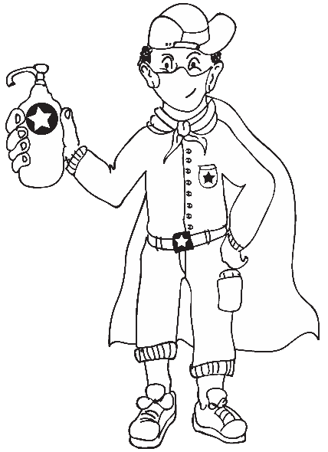 | Here are some ideas:
1
Choose one buddy-guard, someone with whom you can discuss everything in class. Agree before the time that you will be partners and do all the activities together.
2
Don’t forget that your family at home is also a good sounding board – to share ideas and help with your project.
3
A one-on-one discussion with your teacher, either face-to-face or using WhatsApp is also a good way to get feedback.

Become a problem-solver and make a future for yourself

This project has one clear goal, to reduce youth unemployment which is one of our country’s biggest problems.

Can you as a Grade 7 learner solve this gigantic problem?

Yes, you can!
Start thinking of your future,
of yourself as an entrepreneur, or
in a job that suits your personality.
In this project, you are going to start thinking about whether you could be an entrepreneur one day, because entrepreneurs are great
problem solvers.

Look at brands like Uber and Airbnb. These are companies that have physically transformed how we will travel for the rest of our lives.
Solution

What is important when you look at these and other great companies, is that they have found very simple solutions for quite complex problems. They train themselves to focus on results by finding simple solutions for the problems we face in society. In this project you will be working to find simple solutions for creating work for yourself and others by thinking of money-making products and services to sell during the COVID-19 pandemic.

This is how entrepreneurs make a lasting impact on the world as we know it.
Entrepreneurs are problem-solvers at their core, but they are different from the rest of the world’s problem-solvers. This is because they look for cool and unique solutions that often bring about great change in different industries and transform the world we live in.
Don’t become one of those South Africans
who are forced to sit at home after school because they have no future and no hope
…your future in is your hands.
Start now!

THERE ARE MANY USEFUL RESOURCES AT THE BACK OF THIS BOOKLET IN THE RESOURCE LIBRARY. PLEASE USE THEM!

Vocabulary list | Discussion – chat  Solutions – answers  Complex – difficult | Transform – change  Gigantic – huge/big  Reduce – lesson/lower | Transform – change  Core – centre/middle  Unique – special/individual
PROJECT:
Solving a
COVID-19
problem

Ice-breaker

- Play the entrepreneurial profile game with your buddy-guard ensuring that you maintain social distance.
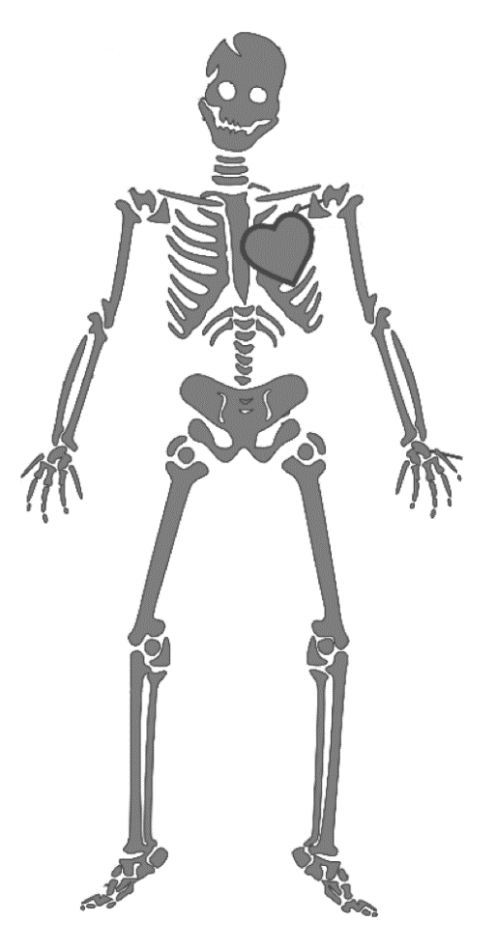
Instructions on how to play the game: Link a body part in the skeleton below to entrepreneurial knowledge, skills, competencies or mindset, e.g. eyes for spotting opportunities in the market.

Vocabulary list | Skills - abilities  Competencies – capabilities  Mindset - Your mindset is your collection of thoughts and beliefs that shape your thought habits | Entrepreneurials - (those with an entrepreneurial mindset) are those who take it upon themselves  to solve problems for others.
- List 4 skills that you have that would make YOU great for entrepreneurship.

What is your own definition of an entrepreneur?
________________________________________________________________________________
________________________________________________________________________________
________________________________________________________________________________

After discussion with the class and teacher, what is your final definition of an entrepreneur?
________________________________________________________________________________
________________________________________________________________________________
________________________________________________________________________________

Share your plan for maintaining social distancing during this game:
________________________________________________________________________________
________________________________________________________________________________
________________________________________________________________________________

Vocabulary list | Profile – description/portrait

The Project

PLANNING

Before a researcher starts an investigation s/he should think of what the problem is that needs to be solved. Starting by asking questions about the problem is a good way to start. (Go to the Resource 1: The Big Question in Research in the Resource Library in these notes.)
Choose a big question about doing business during COVID-19 around a problem that needs to be solved during the coronavirus pandemic. Start off by listing 3 Who? Why? What? How? questions that need to be answered in dealing with problems around the pandemic.
Who?
Why?
What?
How?

Read through your questions and choose 1 that could become the topic of your project. Write down the topic of your research – the BIG question that you need to answer by doing your project.
The topic of
your research
Business
Idea

What will you be making/preparing to show? Draw a circle around your choice:
Product | OR | Service

(Go to the Resource 2: Ideas for COVID-19 in the Resource Library in these notes. But please try to generate ideas on your own first – see if your idea is better than those in the list!)
Vocabulary list | Pandemic – universal/widespread epidemic  Epidemic – outbreak/plague  Topic – subject/theme

RESEARCH/ FINDING OUT

You need to research the viability of your Business Idea. Write down five sources of information from the following that you are planning to use to gather information for your business idea. (Go to the Resource 3: Primary versus Secondary Sources in the Resource Library in these notes.)
Types of sources
 | People you could interview  Articles you could read (see the resource pack at the back of this workbook) |  |  |  | Websites you could visit  Your textbook or a library book
Source number |  | Type of source, e.g. interview, textbook | Reference  Name of interviewee, Detail of book/article/URL |  |  | Notes
1
2
3
4
5

Who will help you if you need information? Write down a name and a contact number:

Will your product or service serve a WANT or a NEED with your customers? Explain the product or need to make sure it truly answers the big question/topic of your research study.
_________________________________________________________________________________
_________________________________________________________________________________

Vocabulary list | Research – investigate/study  Viability – possible/workable  Gather – collect  Interview – talk to | URL (Uniform Resource Locator) – web address  Information – details/facts/data  Customers – clients/shoppers/buyers

MAKING AND SHOWING THE EVIDENCE

Developing your business idea

What are the goals you will be setting for your product or service? Name 3 primary goals:

Your teacher will explain how to do a SWOT (Strengths, Weaknesses, Opportunities and Threats) analysis on your business idea to find out if your product or service is viable for starting a small business.

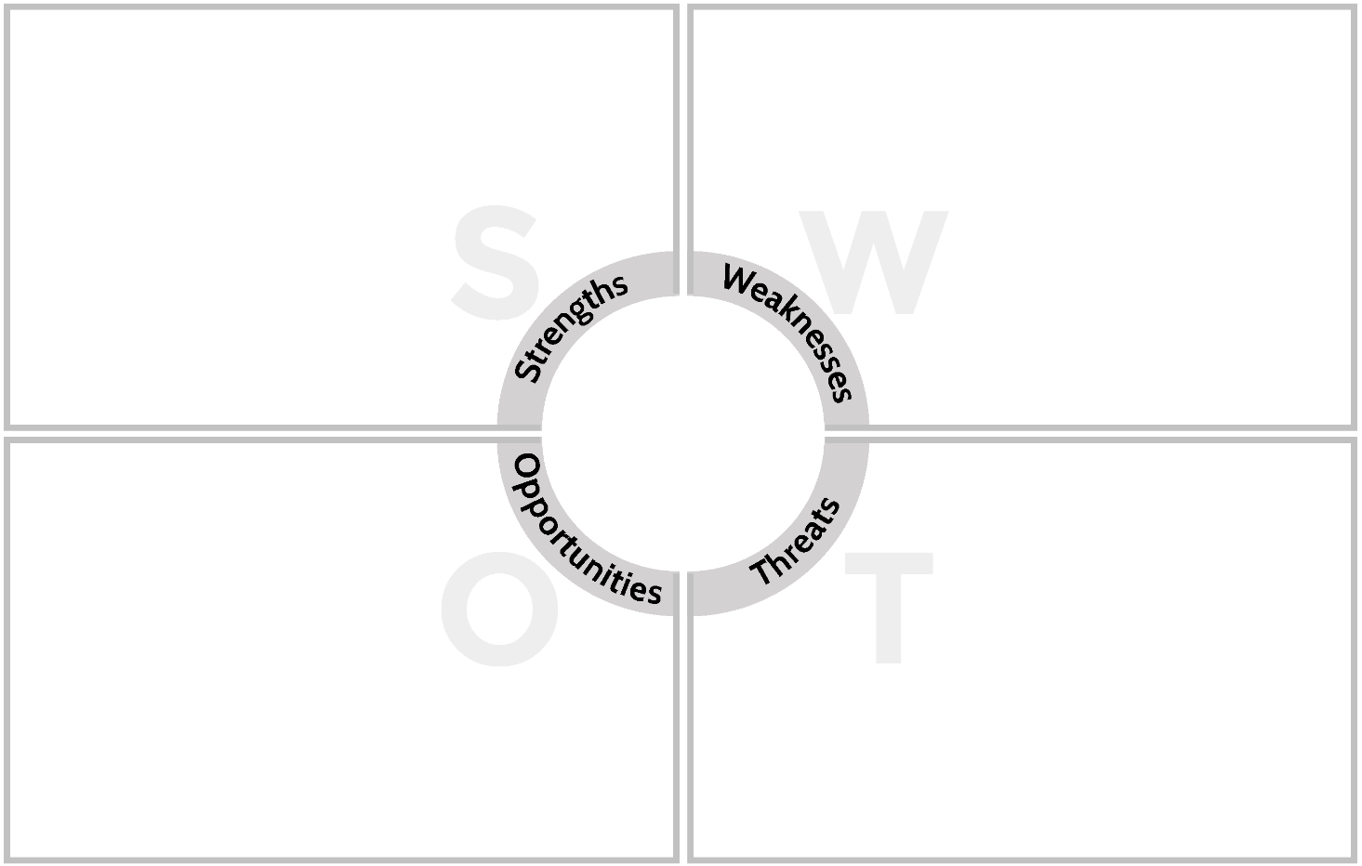
Write down 3 of each:
Business Strengths
Business Weaknesses
Business Opportunities
Business Threats
Your
Business Idea

Vocabulary list | Goals – aims/targets/intents  Primary – first/most important  Analysis – study/investigation | Opportunity – good chance  Threats – warnings/that which can harm your business
What is the process you will be following to develop your business idea?
Complete these questions to show how your product or service was planned (the first step in the Product Development Cycle – see Resource 4):
Plan: What were your first three steps? (use words like target market, competitors, testing the need/needs analysis)
________________________________________________________________________________________________________________________________________________________________________________________________________________________________

Setting a budget for your business

Fill in the following table. How much money do you need for a prototype (Example) of a product or service?
Item | Price per one | Quantity needed | Sub total
SUM TOTAL |  |  | R

If you are struggling, go to Resource 5 BUDGET COVID PTY (LTD). Month 1 in the Resource Library in these notes.

Vocabulary list | Prototype – working example  Budget – to set money aside

Solving the budget problem/Alternatives to hard cash

Can you think of 3 or 4 great alternatives to get hold of the seed money you need to get your business started (sponsors, second hand equipment, home-made items, re-using something, repurposing something else)?
Alternatives to money

Creating your product or service business idea

What equipment do you need to create your product or service? | Where will you get the information on how to make your product/put together your service?

Provide 5 photographs of the process (use a cell phone to take the photographs, or draw three rough sketches)
Your photographs should have the following information:
- Stage of the making process (beginning, middle, end)
- What is happening in the photographs?
- What you learned that we can see in the photographs?

Vocabulary list | Alternatives – other/replacements Sponsors – supporters  Repurpose – to reuse something  Equipment – tools | Seed money – money needed to start the business (which may come from other sources)  Stage – phase  Process – tasks in order

How many times did you try before you got it right?

I tried ____________ times. I kept doing this wrong:
________________________________________________________________________________________________________________________________________________________________________

GETTING FEEDBACK AND CHANGING IF YOU NEED TO

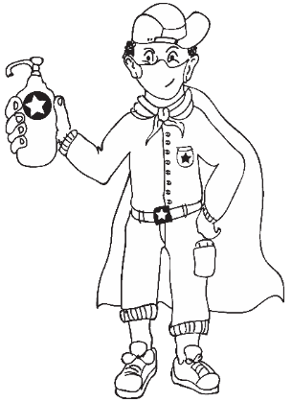 | Who is your buddy-guard?
 | What is your buddy-guard’s address or cell number?
 | Why did you choose him/her as a buddy-guard?

Who at home is your advisor?
How will you get hold of your teacher if you need him/her?

Listen to useful information to improve your product. Say what they advised and what you did. Get at least 3 people to give you feedback.

Date of advice | Who gave feedback | What they said I should do

Write down what you changed, when you made changes and why.
WHAT YOU CHANGED?

WHEN YOU CHANGED IT?

WHY YOU CHANGED IT?

Vocabulary list | Advisor – mentor/guide  Feedback – comment/criticism  Improve – make better

FINISHING OFF YOUR PROJECT

Using all the feedback and what you have learned after trying to improve your product, finish off your project item and the writing that goes with it.
THE PROBLEM

THE SOLUTION

The steps I went through to reach/make the solution

MY CHALLENGES

I rate my final product as _______/ 7
Because:__________________________________________________________________________
_________________________________________________________________________________

Vocabulary list | Problem – issue  Solution – answer  Challenges – opposition  Rate – assess/judge

Prepare well to present your business idea to your teacher and class.

(Go to Resource 6: How to prepare a great presentation in the Resource Library in these notes.)

Here are some notes to prepare for the presentation:

1 | Show your passion and connect with the audience
2 | Focus on the audience’s needs for information
3 | Keep it simple
4 | Smile and make eye contact
5 | Start strong! Use a quote or a statistic
6 | Tell a story
7 | Use props (demo your service or product)
8 | Include the budget and SWOT analysis

Practise in front of your buddy-guard.
Ask for honest feedback.
Take turns.
While listening to each other’s presentations, tick the above table and share areas for improvement.

Vocabulary list | Presentation – talk  Passion – excitement  Quote – saying  Audience – spectators/viewers/listeners | Statistic – facts or researched data  Props – items to support speech and capture audience interest

SHOWING OFF YOUR PROJECT

Your teacher will discuss ways of showing off your project to the rest of the school or to visitors when they are allowed. Make sure you are ready to listen to feedback.

Who saw your project and what did they say about it? Ask at least 4 people.

Write down their views or ask them to leave notes or send voice-notes.

Who gave feedback? | Score ____/7 | The reason

THINKING ABOUT IT AFTERWARDS

1. What did you love about working on this project?

2. What made this project hard for you?

3. What did you learn by working on this project?
- About yourself?
___________________________________________________________________________
___________________________________________________________________________

- About entrepreneurship?
___________________________________________________________________________
___________________________________________________________________________

- About learning during COVID-19?
___________________________________________________________________________
___________________________________________________________________________

4. What would you do differently if you did a project like this again?

Assessment Rubric for Project

 | Not achieved  (1-2) | Partially Achieved  (3-5) | Achieved  (6-7) | Fully Achieved  (8-10) | Learner Mark
1.  Product or service solves a critical COVID-19 problem/or is a viable buss idea during COVID-19 times | Product or service choice does not meet the criteria. | Product or service choice partially meets the criteria. | Product or service choice meets the criteria. | Product or service exceeds the criteria. Creative problem solving.
2.  SWOT analysis: Look at both the internal and external factors that may influence the business’s ability to compete in the market | Response excludes essential components and/or does not address the requirements indicated in the instruction. | Responses includes only one or two of the requirements in the instruction. | Response includes most of the components and meets the requirements in the instruction. | Response includes all components and meets or exceeds all requirements indicated in the instruction.
3.  Creative budgeting – product or service is affordable to manufacture and uses other resources than money | No creative budgeting, no use or alternative sources or resources. | Some creative budgeting. | Creative budgeting, uses many alternative resources like recycling, repurposing, etc. | Incredible creativity in the use of alternative resources to make or create the business.
4.  Project demonstrates both originality & creativity | Project does not demonstrate originality & creativity. | Project demonstrated a little bit of originality & creativity. | Good work, but based on existing ideas. | Very creative and unique project.
5.  Presentation of product to teacher and class | Presentation unsatisfactory, unprepared. | Presentation not ideal, somewhat unprepared. | Presentation good, well prepared. | Great presentation, excellent preparation.
 |  |  |  |  | /50

Resource Library

The big question in research

Essential questions, or driving questions, are a key element of project-based learning, so we’ve outlined 14 essential question stems to help you craft the most engaging PBL essential questions.

1. How can ______ improve _______?
How can studying different cultures improve our understanding of our community?
How can robotics improve the healthcare industry?
How can access to clean water improve communities, especially during the coronavirus pandemic?
2. How can _______ be applied to ________?
How can entrepreneurship skills be applied to subjects like science and geography?
How can entrepreneurship skills be applied in our daily lives?
How can ethics be applied to solve environmental problems?
3. How can _______ change ________?
How can individuals change their communities?
How can kindness change bullying?
How can the human behaviour change the environment?
4. How would you design a new _______?
How would you design a new school?
How would you design a new system to purify water?
How would you design a new flag for your community?
5. How does _________ affect __________?
How do poor eating habits affect communities around the world?
How does bullying affect our community?
How does violence affect our daily lives?
6. What impact did/does __________ have on ________?
What impact does climate change have on the environment during the 21st century?
What impact does coronavirus have on children’s sense of security?
What impact does social media have on our understanding of the facts surrounding the coronavirus pandemic
7. What makes a good/effective _________?
What makes a good library?
What makes an effective school?
What makes a happy classroom?
8. How do/does __________ impact my community?
How does racism impact my community?
How does the food grown in our region impact what people eat?
How does bullying and violence impact my community?
9. What is the relationship between _________ and ___________?
What is the relationship between maths and everyday life?
What is the relationship between science and entrepreneurship?
What is the relationship between transportation and trade?
10. What would __________ be without __________?
What would our school be without classrooms?
What would the Earth’s climate be like without the atmosphere?
What would the world be without art?
11. If you were in charge of ____________, what would you change?
If you were in charge of our school, what would you change?
If you were in charge of our community, what would you change?
If you were in charge of Facebook, what would you change?
12. How can you use __________ to inspire ________?
How can you use poetry to inspire change?
How can you use storytelling to inspire people take better care of the environment?
How can you use science to inspire people to eat healthier food?
13. What if _______________?
What if you could go back in time, what would you change?
What if South Africa did not have schools?
What if the world lost the internet for one year?
14. How might your community change if ______________?
How might your community change if it were twice as big?
How might your community change if it rained every day for a year?
How might your community change if every person were given R1 million?
SOURCE | https://www.penpalschools.com/blog/easy-project-based-learning-question-stems-for-essential-questions

COVID-19 business ideas

During the COVID-19 pandemic, while most people were forced to stay home, some entrepreneurs saw many opportunities in the uncertain times and even profited from it.

Below are some business ideas that took off:

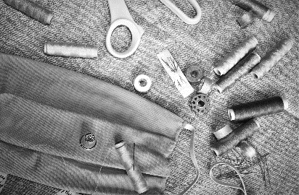  Making masks for businesses and schools | 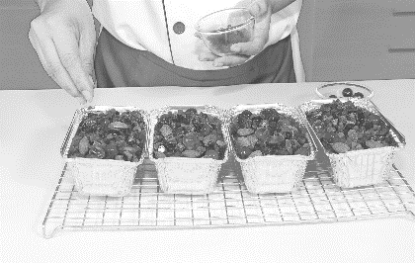  Making and delivering frozen meals to families
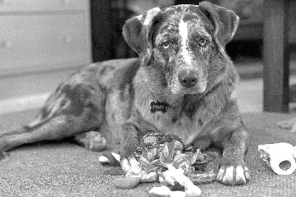  Pet toys to keep your pets quiet | Online brow shaping tutorials
Making and delivering warm foods  Creating and delivering party goods for lockdown birthdays  Cleaning and sanitising office spaces  Cleaning and sanitising schools  Making designer masks for government and big businesses  Delivering and selling cleaning products and safety masks to small businesses  Making and selling stands for electronic devices  Making and selling standing desks for working from home  Grocery shopping and delivery to your doorstep – no contact  Home improvement goodies  Online coaching or tutoring for different subjects  Online story reading for younger children  Hobby sets to keep the family busy  Home gym equipment to rent or to buy  Salon products with how-to brochures for home treatments | Online gym instruction  Online cooking classes  Making and selling of sanitisers and other cleaning products  Graphic design  Printing and delivering printed items  Online consultancy (use your special insight to help others)  Social media marketing for small businesses  Digital campaigns for charity  Web design  Blog writing  Hyperlocal Delivery Company (in your area)  Make-up tutorials using products that also sell online  Create a cloud fashion show  Create a cloud play/music show  Create a cloud choir performance  Sell board games online and make video tutorials (chess, backgammon, etc.)  3D printing of visors and masks for medical personnel

Primary vs Secondary sources

Sources of information are often categorized as primary or secondary depending upon their originality.

Primary Sources
- Direct or first-hand evidence about an event, object, person, or work of art
- Published materials written or produced by someone with first-hand experience of the event.
- Individual viewpoint of a participant or observer.

Examples of primary sources:
- Interviews, surveys, and fieldwork
- Diaries, personal letters, and correspondence
- Internet communications on email, blogs, and newsgroups
- Photographs, drawings, and posters
- Books, magazine and newspaper articles and ads published at the time
- Public opinion polls
- Speeches
- Original documents (birth certificates, property deeds, trial transcripts)
- Research data, such as census statistics
- Official and unofficial records of organizations and government agencies
- Radio interviews, DVDs, and video recordings
- Government documents (COVID-19 pamphlets, reports, etc.)
- Scientific journal articles reporting experimental research results

Secondary Sources
- Describe, discuss, interpret, comment upon, analyse, evaluate, summarize, and process primary sources
- Written or produced after the fact with the benefit of hindsight
- Lack the freshness and immediacy of the original material
- Collect, organize, and repackage primary source information to increase usability and speed of delivery, such as an online encyclopaedia.
- Can be written or non-written (sound, pictures, movies, etc.).

Examples of secondary sources:
- Bibliographies
- Biographical works
- Reference books, including dictionaries, encyclopaedias, and atlases
- Articles from magazines, journals, and newspapers after the event
- Literature reviews and review articles (e.g., movie reviews, book reviews)
- History books and other popular or scholarly books
- Works of criticism and interpretation
- Commentaries and treatises
- Textbooks
- Indexes and abstracts

SOURCE | https://sccollege.edu/Library/Pages/primarysources.aspx

Product Development Cycle

The product development cycle consist of the following stages:
Plan, Develop, Evaluate, Launch, Assess, Iterate or Kill.
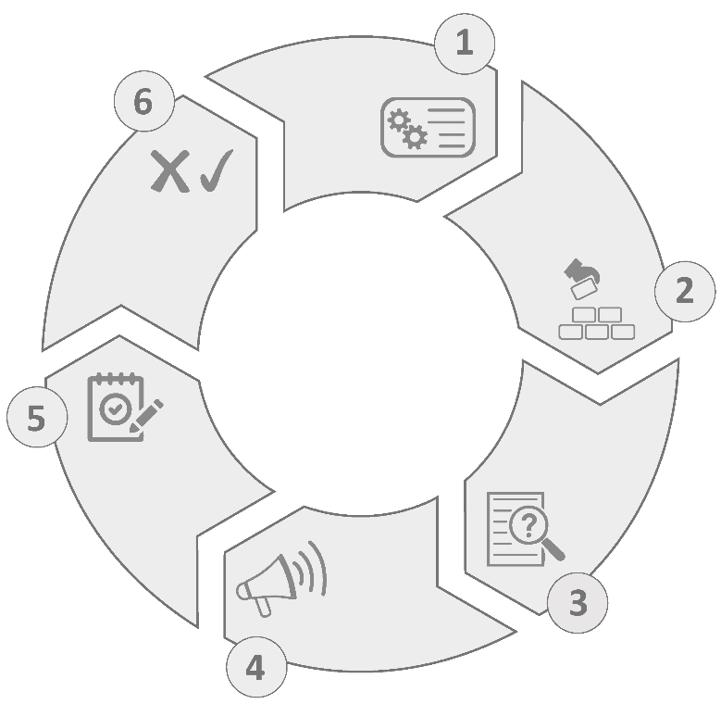
Plan
Develop
Evaluate
Launch
Assess
Iterate or Kill
Product Development Cycle

Plan

The planning stage consist of work that needs to be done before any development commences. You want to make sure you have a valid business case for the product and a solid strategic plan to give your startup the best chance of success.

To begin Market Research and Competitive Analysis should be carried out, to get an understanding of the market, and the key players in them. This research will need to answer questions such as:

- Who are your target audience?
- Is there a need for the product? Can it be validated by things like surveys, customer interview or consumer spending figures?
- Who are the competitors in the market and how will the product be able to compete with them? What is the potential market share for the product?

Develop
Simply put this is when the product or service business is built.
The first release is likely to be an MVP (minimum viable product) containing the core features necessary for the product to be of use to your customers and succeed in the market.

Evaluate
Early feedback is key to test the assumption made during the Plan stage. There is no need to wait until the product is completed to perfection before you start evaluating its features, the sooner features can be validated the better. If the feedback from the evaluation says that some features need changing, then tweak them.

Launch
Launching the product involves letting your target audience know the product is live. This can be done with Press Announcement & Interviews, advertising, creating public launch events, etc.

Assess

Similarly to the Evaluation stage, each feature of the product will need to be tested and evaluated to see if a feature worth keeping and iterated on or being dropped from the product completely.

During the assessment stage you will also need to support marketing & sales efforts. This is done by assessing what effect advertising, social media and CRM (Customer relationship management) campaigns have on product engagement and revenue.

Iterate and Kill
Once assessment and evaluation of the product features is complete, a decision needs to be made on which features to keep and upgrade and which to remove.
For the features that prove not useful for the customer, and don’t generate engagement or revenue, those should be removed. For the features that are kept, they will need to be iterated on and upgraded, to ensure competitiveness. This involves starting the Product Development Cycle all over again.

SOURCE | <https://defineproducts.com/product-life-cycle-product-development-cycle-bccb9c5aabf2 >

How to prepare a budget for your new business
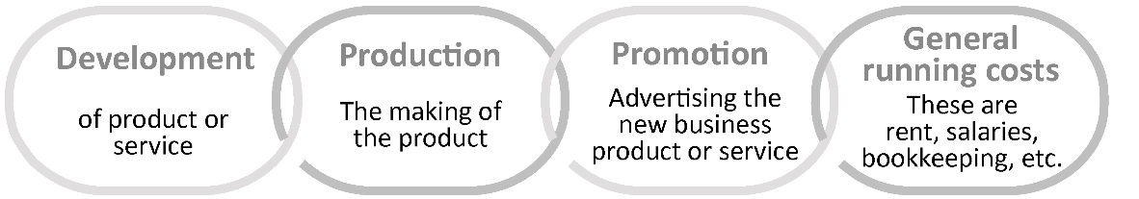
There are mainly four things that you should budget for when you start a new budget:

Here is an example of a simple budget for a new service business:
BUDGET COVID CLEANING (PTY) LTD. Month 1:
Item | Cost per one | Amount needed | Subtotal
Microfiber Cleaning cloths | 13.00 | 10 | 130.00
85% Alcohol Sanitizer 1 litre | 130.00 | 10 | 1300.00
Protective clothing – overall | 250.00 | 3 | 750.00
Protective clothing – masks | 5.00 | 100 | 500.00
Protective clothing – gloves box 100 | 135.00 | 1 | 135.00
Telephone usage | 600.00 | 1 | 600.00
Rent office | 1500.00 | 1 | 1500.00
Advertising Facebook/Instagram | R155.00 | 2 | 310.00
Salaries 3 workers | 2000.00 | 3 | 6000.00
Total |  |  | 11225.00

As a business owner, you must either lend the start-up capital to the business, or find enough clients to cover the costs. Many businesses take a few months to bring in enough capital to cover all the monthly costs. COVID CLEANING (PTY) LTD. started strong and signed 2 clients in their first month.

INCOME STATEMENT COVID CLEANING (PTY) LTD.

Item | Income | Expense
Petunia school cleaning | 5000.00
Dinako taxi cleaning | 6500.00
TOTAL REVENUE | 11500.00
TOTAL EXPENSE (from above) |  | 11225.00
PROFIT |  | 275.00

How to prepare a great presentation

1
Show your Passion and Connect with your Audience

It’s hard to be relaxed and be yourself when you’re nervous.

But time and again, the great presenters say that the most important thing is to connect with your audience, and the best way to do that is to let your passion for the subject shine through. Be honest with the audience about what is important to you and why it matters. Be enthusiastic and honest, and the audience will respond.

2
Focus on your Audience’s Needs

Your presentation needs to be built around what your audience is going to get out of the presentation.

As you prepare the presentation, you always need to bear in mind what the audience needs and wants to know, not what you can tell them. While you’re giving the presentation, you also need to remain focused on your audience’s response, and react to that. You need to make it easy for your audience to understand and respond.

3
Keep it Simple: Concentrate on your Core Message

When planning your presentation, you should always keep in mind the question:

What is the key message (or three key points) for my audience to take away? You should be able to communicate that key message very briefly. Some experts recommend a 30-second ‘elevator summary’, others that you can write it on the back of a business card, or say it in no more than 15 words. Whichever rule you choose, the important thing is to keep your core message focused and brief. And if what you are planning to say doesn’t contribute to that core message, don’t say it.

4
Smile and Make Eye Contact with your Audience

This sounds very easy, but a surprisingly large number of presenters fail to do it.

If you smile and make eye contact, you are building rapport, which helps the audience to connect with you and your subject. It also helps you to feel less nervous, because you are talking to individuals, not to a great mass of unknown people. To help you with this, make sure that you don’t turn down all the lights so that only the slide screen is visible. Your audience needs to see you as well as your slides.

5
Start Strongly

The beginning of your presentation is crucial. You need to grab your audience’s attention and hold it.

They will give you a few minutes’ grace in which to entertain them, before they start to switch off if you’re dull. So don’t waste that on explaining who you are. Start by entertaining them. Try a story (see tip 7 below), or an attention-grabbing (but useful) image on a slide.

6
Tell Stories

Human beings are programmed to respond to stories.

Stories help us to pay attention, and also to remember things. If you can use stories in your presentation, your audience is more likely to engage and to remember your points afterwards. It is a good idea to start with a story, but there is a wider point too: you need your presentation to act like a story. Think about what story you are trying to tell your audience, and create your presentation to tell it.

SOURCE | https://www.skillsyouneed.com/present/presentation-tips.html

How to make a Tippy Tap

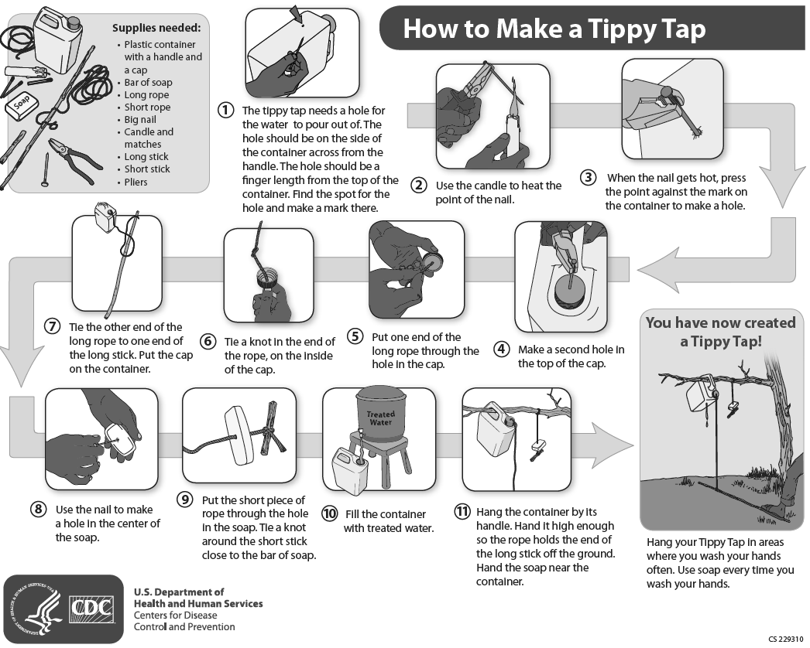

How to make a bandana-style face mask

You will need:
- A bandana or scarf
- 2 x elastic or rubber bands, or hair ties
- A coffee filter, paper towel or kitchen roll (optional)

The easiest method for making your own face mask involves folding a bandana or a scarf. Note that you need to choose the right bandana or scarf. Hold it up to the light to see how much you can see through it. The less you can see, the better; if the material is too thin then your face mask won't be as effective. Tightly woven, 100 percent cotton is best.  Fold your bandana in half, then fold it again twice – lengthways from both the top and the bottom. At this point, you can also add a square piece of coffee filter, paper towel or kitchen roll to your mask – which you can change.  Then, place your rubber bands or hair ties around your strip of material, and fold the material in towards the middle, tucking the ends into each other if possible. | 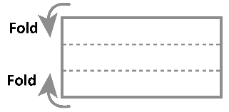  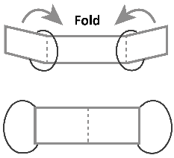  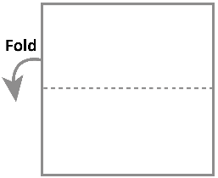

SOURCE | www. Creativebloq.com

