Cover outer (page number 00):
Teacher’s
Project Notes

GRADE 7

E³ Projects for
Trimmed ATP
A positive response
to COVID-19

Table of Contents

Letter from the DBE- E³ 0
Teacher Agency Award 2
Mindset Rubric for Teachers………………………………………………………………………………………………………………3
PART 1: Setting the scene 4
1. The trimmed projects - E³ response to COVID-19 4
2. Social Learning during COVID-19 (Coronavirus) 5
3. Generic Project outline for all Projects (directed at the learner) 6
1. PLANNING 6
2. RESEARCH/ FINDING OUT 6
3. MAKING AND SHOWING THE EVIDENCE 6
4. GETTING FEEDBACK AND CHANGING IF THEY NEED TO 6
5. FINISHING OFF THEIR PROJECT 7
6. SHOWING OFF THEIR PROJECT 7
7. THINKING ABOUT IT AFTERWARDS 7
4. Resource Pack 7
PART 2: The Project/s 8
5. Project Summary and CAPS alignment. 8
6. The Project in more detail 9
7. Assessment rubric for project and presentation of project solution 13
8. Memo and Tips 14
PART 3: TEACHER RESOURCES 21
9. Tools to assist with the Project 21
9.1 Letter to the parents/caregivers 21
9.2 Primary vs Secondary sources 22
9.3 The Big Question in research 23
10. Professional Development 25
10.1 Traditional vs Activity-based Learning 25
10.2 The Project-based Learning Cycle 26
10.3 The Project-Based Learning facilitator 27
10.4 The E³ Competencies model within the CAPS 28
10.5 The journey to PBL via Enquiry-based and Problem-based Learning 28
10.6 Bridging the Unemployment gap through Education 29
Teacher Agency Award Entry Form……………………………………………………………………………………………...30

PLEASE NOTE

Part 1 and 2 of this booklet must be printed and are the minimum project resources you as the teacher will need. However, the rest of the booklet contains valuable tools for personal development, as well as very good sources in support of the project. You don't have to look anywhere else.

Don’t forget to enter the Teacher’s Agency Awards (see page 2)

This programme is accompanied by podcasts, audio recordings and videos.
We will send out the links shortly.

Before you start, please complete the Teacher’s Mindset Rubric on page 3.

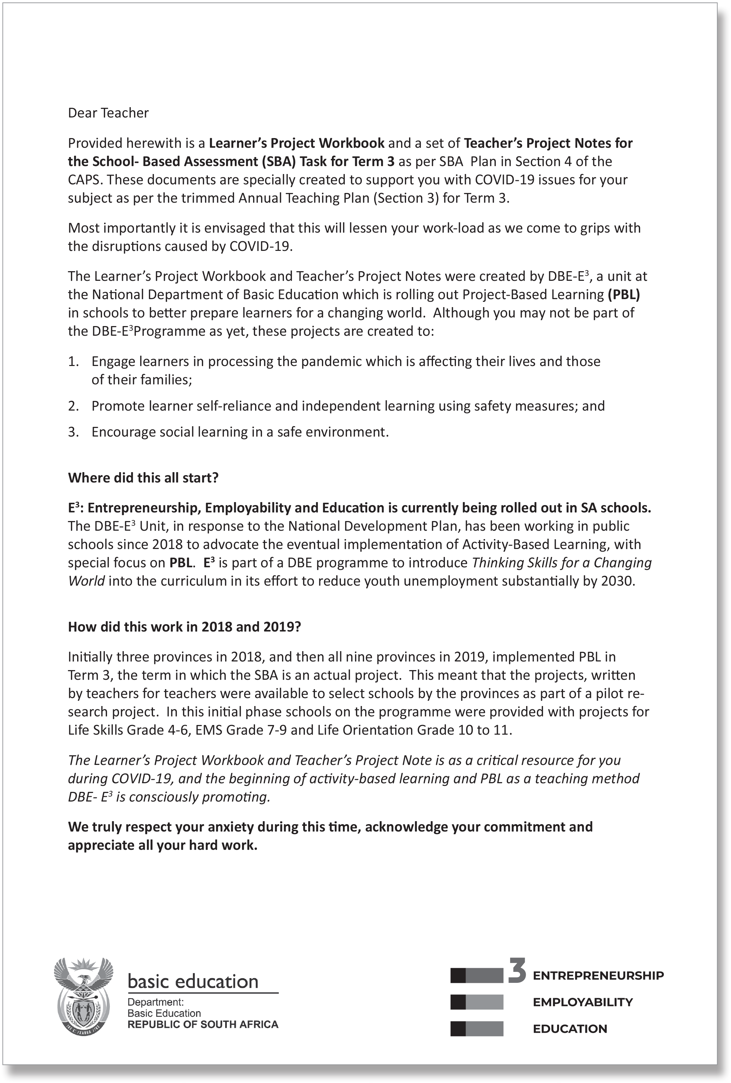

TEACHER’S PROJECT NOTES
GRADE 7
ECONOMIC MANAGEMENT SCIENCES

E³ PROJECT FOR TRIMMED ATP
A positive response to COVID-19

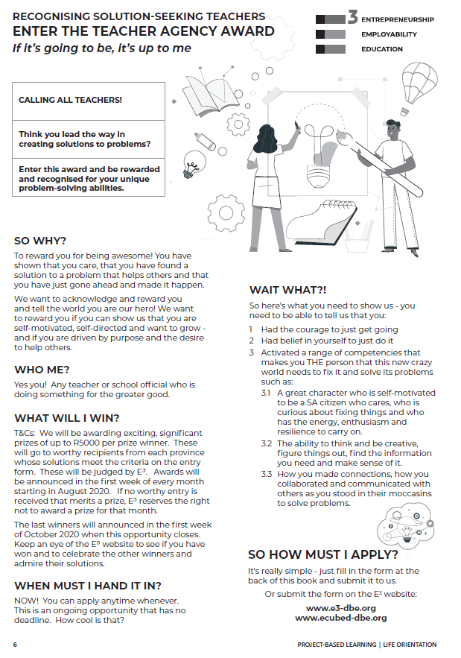
Teacher Agency Award
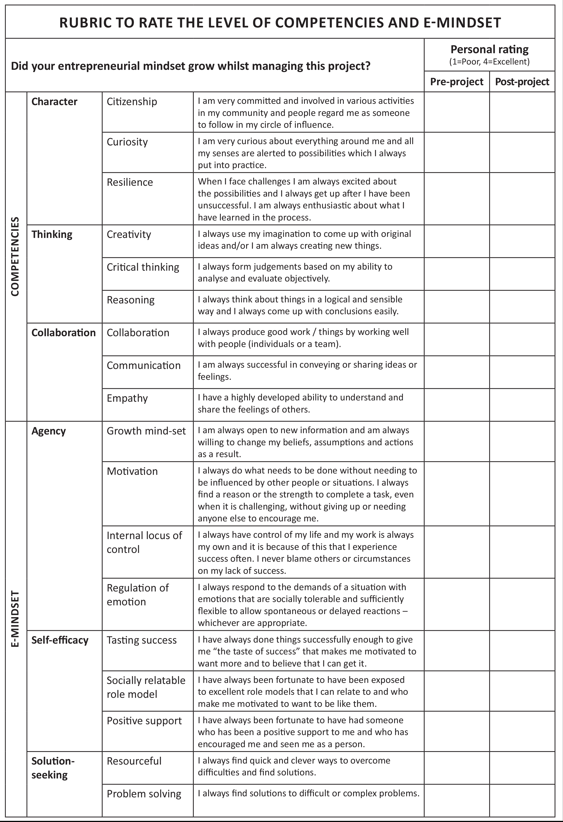

PART 1: Setting the scene

The trimmed projects - E³ response to COVID-19

In collaboration with the DBE we have created projects for the new trimmed curriculum. In the past, lead teachers would gather and projects would be created during a writers’ workshop. A similar process is being followed now, but the trimming of the curriculum has made it difficult to create one solid, clear project anchored by a community/learner problem because Term 3, the project term, now has to cover a number of themes very superficially.

We have tried to create a coherent project which follows internationally-accepted standards in that it is research-based and includes enquiry-based learning and problem-based learning as part of the Project-based Learning process whilst adhering to the CAPS requirements of the trimmed ATP.

Time frame for project completion - assessment

The assessment for Term 3 is a project. Do not use the number of hours allocated to determine which project/s you feel will be useful for your learners (e.g. Week 1). As long as there is one project mark by the end of the term for the SBA (50 marks), the CAPS requirement will have been achieved.

However, we do encourage you to use this opportunity to press learners to do as much research and investigating as is possible – if we plan this well we shall succeed.

Encourage learners to keep visual evidence of the process of their projects: E³ has invited learners to submit evidence of their project to the URLS/contact details in the Learner Workbook – we would love to showcase your school!

Ideas for planning:
Pre-plan
- Write a letter to the caregivers, parents, family and siblings (a letter is part of the Resource Pack at the end of these notes) explaining the need for their support.
- Break up the project (each could be 3-4 weeks long) into small deadlines that you will check.
- Help learners manage some social learning. (See social learning below)

Social Learning during COVID-19 (Coronavirus)

Individual learners will be “scientists” and go through a process (including elements of design thinking, problem-based learning, etc.) which will guide them to solve a problem. Learners will not have groups to work with, but the social learning can be facilitated by:
Be available

The teacher’s role

Notes/WhatsApps/face-to-face questions to teachers (give them a contact number or place a box for queries at the door of your classroom);

Wh-wall

A WH-wall for Who? Why? What? (and also How?) questions that are posted on the wall.

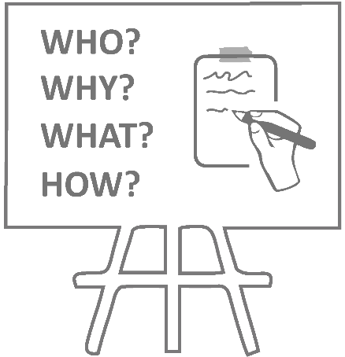
Learners write their open-ended question in large letters on pages that can be stuck on the wall, anonymously if learners wish. You could review all the questions once a week (after they have been on the wall for at least 48 hours) and answer the important questions.

The questions need not be about the project – it is a great opportunity to allay general fears about the “new normal” of living and going to school during the pandemic and also to encourage questioning techniques and so strengthen the fundamentals (especially language).

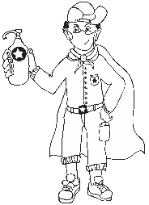
Critical, safe partner.

A buddy-guard is a special friend who cares about you and wants to support and look out for you.
Buddy-guard

A buddy-guard (a safe critical friend whom s/he has identified before the project has started) is the learner’s primary sounding board. The pair will agree that they give each other support and feedback at school with social distancing and via text and WhatsApp messages).

The role of the family

The family (care-givers will also have a letter sent to them to explain their role).

Generic Project outline for all Projects (directed at the learner)

Step 1:
Project topic guided by a big question
Step 2:
Plan research sources
Step 4: Feedback
Step 3:
Making creative project item and documenting the process

PLANNING

- Learners brainstorm the problem that needs to be solved on their own, or with their buddy-guard, teacher or family. The brainstorm could also be a class activity done by the entire class.
- Learners list questions that will help them think of the BIG question that will guide them in solving the problem.
- They write down the topic of their research – the BIG question.

RESEARCH/ FINDING OUT

- They note down five sources of information from the following that they are planning to use to gather information:
- People they could interview
- Articles they could read
- Websites they could go visit
- They identify someone who might help them if they need information whilst stuck at home.

MAKING AND SHOWING THE EVIDENCE

- What equipment will be needed to create the project item?
- Where will information on how to make the item be found?
- How many times did they try before they got it right?

GETTING FEEDBACK AND CHANGING IF THEY NEED TO

- Learners get feedback from their buddy-guard, parents or caregivers or teacher.
- They use information they have gathered to improve their product.
- They note what they changed, when they made changes and why.

FINISHING OFF THEIR PROJECT

Step 5: Finishing off
Step 6: Showing off projects
Step 7: Reflection

Using all the feedback and what was learned after trying to improve their product, learners finish off their project item and the writing that goes with it.

SHOWING OFF THEIR PROJECT

- They show their project to as many people as can be done safely.
- People who view the projects (even those at home) write down their feedback or leave notes or send voice notes. Learners ensure that their WhatsApp number is on the project item and notes.
- The final item is taken to school and the teacher and learners arrange show the projects to the rest of the school.

THINKING ABOUT IT AFTERWARDS

- What did they love about working on this project?
- What made this project hard for them?
- What did they learn by working on this project?
- What would they do differently if they did a project like this again?

Resource Pack

See the Resource Pack at the end of these notes to help you manage the project and to help you save time. Included you will find:

Resources in the Teacher’s Project Notes

- Practical Assistance, e.g.:
A letter to the parents and caregivers.
- Professional Development, e.g.:
The Project-based Learning (PBL) Cycle and your role as a Project Manager; The journey to Project-based Learning which starts with Enquiry-based Learning and Problem-based Learning, etc.

Resources in the Learner’s Workbook

The Learner’s Project Workbook is enriched with many resources to help the learner complete the project independently. There are rich resources to help you explain concepts more easily too!

Please Note
  - After discussing the CAPS topic with your class, learners are orientated towards the project and then left to deal with the project independently with access to all their resources.
  - The number of weeks allocated to a topic in the CAPS does not mean that the length of the project is limited. Remember: the project is a tool to allow deeper investigation into a serious problem that impacts learners.
  - We recommend that a learner be given 3 to 4 weeks to complete a project.

PART 2: The Project/s

Project Summary and CAPS alignment.

Alignment CAPS trimmed ATP | Description of Project
Week: 1-4  Definition of an entrepreneur;  Characteristics of an entrepreneur;  Skills of an entrepreneur;  Entrepreneurial actions of buying, selling producing and making a profit;  Needs and wants of consumers;  SWOT analysis;  COVID-19 problem solving  Effect of health epidemics on formal and informal businesses | Learners look at a problem created by the COVID-19 pandemic and create a product or service as a solution to this problem.

The Project in more detail

The following step-by-step unpacking of the project explains the teacher’s role in the step-by-step roll-out of the project, the PBL cycle and Enquiry-based and Problem-based Learning. Items marked with (*) can be found in the Resource Library in the Learner’s Workbook.

Solving a COVID-19 problem

STEP 1: Planning

Task | Teacher’s role | Resources | Competencies  Underline what you think has been achieved.
Play the Entrepreneurial Profile game:  Learners draw a picture of a human skeleton on paper and label the body parts with entrepreneurial qualities, e.g. eyes – for seeing or recognising opportunities  Come up with a definition of an entrepreneur  Identify the skills, characteristics of an entrepreneur | - Hand out A3 paper and koki’s to buddy pairs in class.  - Ask learners to draw a human skeleton. Guide learners to label all the parts with entrepreneurial qualities.  - Give time for each pair to present their ideas.  - Summarise these ideas on the board and sort according to entrepreneurial a) knowledge,  b) skills and competencies  c) attitudes and mindsets.  Discuss the differences.  - Lead discussion in the formulation of a definition for an entrepreneur. Let each learner write his/her idea down in Learner book. Then put a final definition together using the textbook as an anchor.  - Discuss the idea of a BIG question in research.  - Homework (HW): Learners independently do Step 1 in Learner books. They choose a big question to research and solve. | Flipchart or A3 paper  (Learners work in pairs with their buddy-guard.)  Coloured kokis  Black-/Whiteboard to collate ideas  Skeleton picture in Tips and Memos section  *Big question in research  Textbook  Learner Workbook | Character  Citizenship  Curiosity  Resilience  Mindset  Connection  Collaboration  Communication  Empathy  Thinking  Creativity  Critical thinking  Reasoning

STEP 2: Research/ Finding Out

Task | Teacher’s role | Resources | Competencies  Underline what you think has been achieved.
Identify a business idea that creates an opportunity or solves a problem during the COVID-19 pandemic | - Discuss the needs and wants of consumers with learners.  - Explain the product cycle a template and ask learners to identify a product/service that can be successful during COVID-19.  - Explain the difference between primary and secondary sources, and how they should go ahead with independent research.  - HW: Do step 2 in Learner’s Workbook.  - HW: Bring business idea to next class. | Pens  *See Primary and Secondary sources in Resource Library (Learner’s Workbook)  *Product development cycle  Textbook  Learner’s Workbook | Character  Citizenship  Curiosity  Resilience  Mindset  Connection  Collaboration  Communication  Empathy  Thinking  Creativity  Critical thinking  Reasoning

STEP 3: Making and showing the evidence

Task | Teacher’s role | Resources | Competencies  Underline what you think has been achieved.
Setting goals for the business;  Doing a SWOT analysis on the business;  Drawing up or creating a prototype of the product or service. | - Discuss goal setting for business with learners.  - Demonstrate SWOT analysis on a volunteer business.  - Learners now independently work on putting their product/service together.  - They might need guidance through process.  - HW: Step 3 covering SWOT, budget and goal setting. Independent work on product creation process. | *Product creation process  Learner’s Workbook  NOTE: Extended learning opportunity. Videos: Nabira and Sally. (Show examples of an informal and a formal small business).  Formal vs. Informal business plus SWOT analysis | Character  Citizenship  Curiosity  Resilience  Mindset  Connection  Collaboration  Communication  Empathy  Thinking  Creativity  Critical thinking  Reasoning

STEP 4: Getting feedback and changing if you need

Task | Teacher’s role | Resources | Competencies  Underline what you think has been achieved.
Setting a budget for the business  Getting feedback from discussion groups (family) or buddy-guard, even possible clients (keep social distance)  - Will they pay for the product/ service?  - What are they prepared to pay for the product/ service?  - Is the produce/ service a viable idea?  - CHANGE what needs to be changed or adapted | - Look at budgets for business startup and prototype creation. Let learners compare with budget they set for homework.  - Guide learners in setting up a budget for their business  - Explain buying, selling, producing and making a profit.  - Ask feedback on alternative sources to money (e.g. sponsors, reusable items, repurposing, recycling etc.)  - Explain why feedback is important for the viability of the business prototype or service idea.  - HW: Learners do step 4 in Learner Workbook and get as much feedback as possible on their ideas. They consider making changes. | *Example of a business budget and income and expenditure statement.  *How to make a profit.  Learner’s Workbook | Character  Citizenship  Curiosity  Resilience  Mindset  Connection  Collaboration  Communication  Empathy  Thinking  Creativity  Critical thinking  Reasoning

STEP 5: Finishing off your project

Task | Teacher’s role | Resources | Competencies  Underline what you think has been achieved.
Learners work at home or in class, polishing their product idea or service according to feedback from family and possible clients. | - Guide learners through the process of change and adaptation, and the reason for it.  - Share principles of a good presentation for the presentation of their product or service in class.  - HW: Learners finish their products and services. Prepare a presentation for the class. Complete Step 5 in Learner Workbook. | *Guide on good Presentation  Learner’s Workbook | Character  Citizenship  Curiosity  Resilience  Mindset  Connection  Collaboration  Communication  Empathy  Thinking  Creativity  Critical thinking  Reasoning
STEP 6: Showing off your project

Task | Teacher’s role | Resources | Competencies  Underline what you think has been achieved.
Learners present their product or service to the class and the teacher | - Give learners each a few minutes to present their products or services to the class.  - Allow feedback by other learners.  - HW: Learners do Step 6 in Learner’s books | Rubric for presentation and product/service design idea  Learner’s Workbook | Character  Citizenship  Curiosity  Resilience  Mindset  Connection  Collaboration  Communication  Empathy  Thinking  Creativity  Critical thinking  Reasoning

STEP 7: Thinking about it afterwards

Task | Teacher’s role | Resources | Competencies  Underline what you think has been achieved.
Reflection on success or failure of the project and lessons learned | - Please don’t skip this step.  - Give learners time in class to reflect on the success of their project.  - Do the teacher’s reflection rubric | *Teacher’s Reflection rubric;  Learner’s Workbook | Character  Citizenship  Curiosity  Resilience  Mindset  Connection  Collaboration  Communication  Empathy  Thinking  Creativity  Critical thinking  Reasoning

Assessment rubric for project and presentation of project solution

 | Not achieved  (1-2) | Partially Achieved  (3-5) | Achieved  (6-7) | Fully Achieved  (8-10) | Learner Mark
1.  Product or service solves a critical COVID-19 problem/or is a viable buss idea during COVID-19 times | Product or service choice does not meet the criteria. | Product or service choice partially meets the criteria. | Product or service choice meets the criteria. | Product or service exceeds the criteria. Creative problem solving.
2.  SWOT analysis: Look at both the internal and external factors that may influence the business’s ability to compete in the market | Response excludes essential components and/or does not address the requirements indicated in the instruction. | Responses includes only one or two of the requirements in the instruction. | Response includes most of the components and meets the requirements in the instruction. | Response includes all components and meets or exceeds all requirements indicated in the instruction.
3.  Creative budgeting – product or service is affordable to manufacture and uses other resources than money | No creative budgeting, no use or alternative sources or resources. | Some creative budgeting. | Creative budgeting, uses many alternative resources like recycling, repurposing, etc. | Incredible creativity in the use of alternative resources to make or create the business.
4.  Project demonstrates both originality & creativity | Project does not demonstrate originality & creativity. | Project demonstrated a little bit of originality & creativity. | Good work, but based on existing ideas. | Very creative and unique project.
5.  Presentation of product to teacher and class | Presentation unsatisfactory, unprepared. | Presentation not ideal, somewhat unprepared. | Presentation good, well prepared. | Great presentation, excellent preparation.
 |  |  |  |  | /50

Memo and Tips

Ice-breaker

Objective:
To introduce entrepreneurship and the profile of an entrepreneur in a playful and defocused manner. This encourages learners to start reflecting on their own entrepreneurial characteristics, whilst playing a fun-filled game.

- Learners play the Entrepreneurial Profile Game with their buddy-guards. The game gets quite exciting so ensure that they you maintain social distance. Playing the game outside might help. They study the skeleton and then link a body part to an entrepreneurial competency, skill or mindset, e.g. shoulders – for carrying the burden of the responsibility.

- This activity encourages creative thinking – learners have to use metaphors to unpack the profile of an entrepreneur.

- To create excitement and stimulate creativity even more, create a competition in which the buddy-pair who generate the most links between body parts and entrepreneurial characteristics within a set period of time, are the winners.

- As learners give feedback on their entrepreneurial characteristics, create a mind-map on the board as you sort the class feedback into knowledge, skills and competencies, and mindset.

- They now complete the questions in the ice-breaker before the class goes to your mind-map.

- Using the information on the mind-map and their own self-reflection, together the class create a comprehensive definition of an entrepreneur:

Use your textbook definition to guide you as this is the set of notes learners will be using to study for their tests.

- Learners were asked to think of their own plans for social distancing during the game. What creative solutions did they come up with?
  - If outside, they could merely speak loudly with one person writing down ideas.
  - They could hold up a large sheet of paper with ideas clearly visible.
  - They could WhatsApp each other if cell phones are allowed in class.

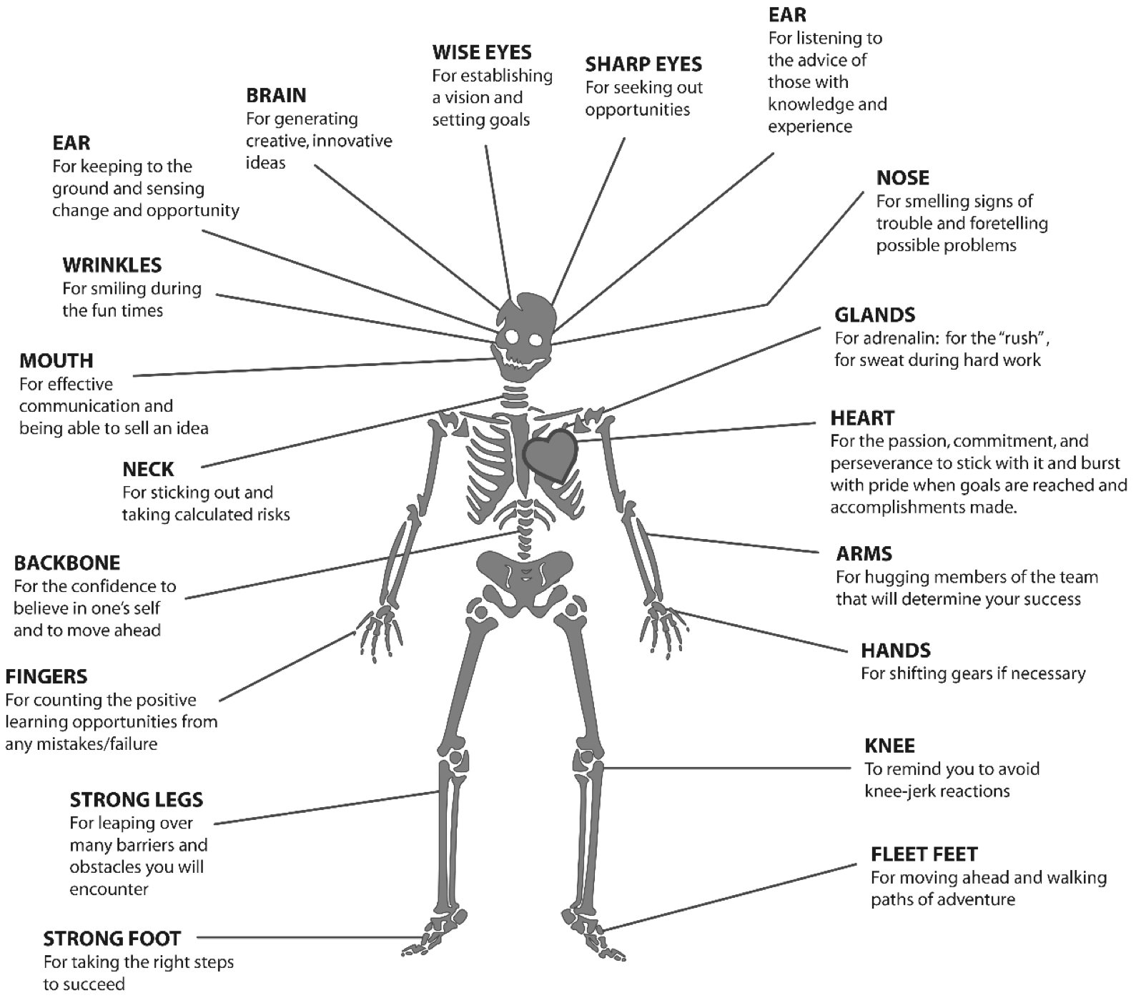

The project

Objective:
To introduce Project-based Learning as a process which starts with enquiry and problem-solving and reaction to a local need and then moves through various phases including product design, testing and iterating until a MVP (minimum viable product) is achieved. The steps are not always clear cut, but there is a logical development from step to step.

PLANNING

Explain to learners that an entrepreneur needs to do a great deal of thinking and research before deciding on a business idea and a product or service. Planning is critical and a research-based project like this, starts with generating so called “big questions”. Because some learners may struggle with English, we have framed the questions to assist their thinking process. The problem is COVID-19 and the challenge for an entrepreneur is exploiting the opportunity to provide a product or service whilst generating an income and even providing jobs for others.

Initiate the discussion by explaining the above, and kicking off with big questions like:
What are the problems faced by people during COVID-19? (Elderly cannot go shopping, businesses and schools need to sanitise, etc.)

Who can help with services? What services can be provided, etc. Learners generate their own big questions, sort them until they have one and then decide on a business idea and the title of their project:

Example:

One question: How can we help old people that cannot fetch their medicines or go shopping?
Title of the project: Creating a service to assist the elderly with tasks that they cannot undertake as a result of isolation.

If learners are struggling, they can refer to Resource 2 in their Resource Library: Ideas for COVID-19.
Ensure that they are clear on whether their business is a product, or a service, or both. Also: decide whether the project will done in pairs or that each learner will complete the project on his/her own, even though the buddies do occasionally engage in “discussion”.

RESEARCH/ FINDING OUT

- Learners need to research the viability of their Business Idea. Encourage them to plan the search for information and to try to include both primary and secondary sources. (Go to the Learner Library Resource 3: Primary versus Secondary Sources for more information and examples of each type.)
- Explain the importance of good references. Each source in the learner’s Resource Library is referenced.
- Make sure that learners have a good understanding of why they need sources (a good researcher produces solid information that is based on evidence) and how to reference these sources. It would be a good idea to help learners identify one person in their circle who could answer questions around research processes – alternatively, that person will be their teacher!
- Check that they understand that a service is also a business “product”. Learners need to understand that both services and products are viable as business ideas.
- Check that the final business idea aligns with the title of their research – all the steps need to be trying to achieve the project goal.

MAKING AND SHOWING THE EVIDENCE

- Learners have now selected a business idea and planned the steps. They now need to set goals, at least 3, for their product or service?
- Explain how to do a SWOT (Strengths, Weaknesses, Opportunities, Threats) analysis on their business ideas to find out if their product or service is viable for starting a small
- What is the process businesses follow to develop a business idea?

The product development cycle is not part of the trimmed ATP, but share the importance of a step-by-step process in developing a business idea. Learners answer the question on the planning step: using words like target market, competitors, testing the need, etc.

(See Resource 4: The Product Development Cycle in the Resource Library of the Learner’s Workbook)

Setting a budget for the business
If you are struggling, go to Resource 5 Budgeting (BUDGET COVID PTY (LTD). Month 1) in the Resource Library in the Learner Workbook. Explain budgeting to learners and show them the example of a budget.

Solving the budget problem/Alternatives to hard cash

Most businesses start with loans, donations or other alternatives to get hold of the seed money needed (sponsors, second-hand equipment, home-made items, re-using something, repurposing something else)?

Discuss ideas for generating start-up funds.

Creating your product or service business idea

- Again learners have to plan; “to do” lists are critical
- What equipment will be needed to create their product or service?
- Where will they find it? How will they pay?

They also need a “go to”-person should you not be available to assist. Identify someone with the necessary insight either at school or within the family.

GETTING FEEDBACK AND CHANGING IF THEY NEED TO

- Encourage learners to keep visual evidence of the process, at least 5 pictures with the following information:
  - Stage of the making process (beginning, middle, end)?
  - What is happening in the picture?
  - What was learned that we can see in the picture?

- How many times did they try before getting it right?

Spend some time explaining the importance of iteration (trying and trying again until the product or service is right.) Not only will the business have a quality product or service, but the learner will have grown in resilience and the understanding that the word FAIL merely means First Attempt in Learning!

- It is very important that learners ask for feedback from different people.

The opinions of different people representing different target markets are really important. Explain that as the designer or creator of the business they still have the final say, but a good business person listens carefully and takes she/he can use.

FINISHING OFF THEIR PROJECT

Using all the feedback and what was learned after trying to improve their products, learners finish off the project item and any writing that goes with it. They then reflect on the problem and the solution, also listing challenges.

Finally they rate their product/service/business and explain the score they have given themselves.

The next step is to prepare to present their business idea to the class.

(Go to Resource 6: How to prepare a great presentation in the Resource Library in these notes.)

They practise in front of their buddy-guards, ask for honest feedback and, while listening to each other’s presentations, tick the above table and share areas for improvement.

SHOWING OFF THEIR PROJECT

Discuss ways of showing off your class’s project to the rest of the school or to visitors when they are allowed. Make sure learners have their feedback forms ready.

THINKING ABOUT IT AFTERWARDS

Learners complete their reflection exercise.

Teachers reflection

Now complete the same reflection exercise yourself before going to the second column of the mindset rubric at the beginning on these notes:

1. What did you love about working on this project?

2. What made this project hard for you?

3. What did you learn by working on this project?
- About yourself?
___________________________________________________________________________
___________________________________________________________________________

- About entrepreneurship?
___________________________________________________________________________
___________________________________________________________________________

- About learning during COVID-19?
___________________________________________________________________________
___________________________________________________________________________

4. What would you do differently if you did a project like this again?

PART 3: TEACHER RESOURCES

Tools to assist with the Project

9.1 Letter to the parents/caregivers

See below:

Date:……………………..

Dear Parents, Siblings and Caregivers

The Grade 7 learner in your care will be doing a project or two during the next few weeks.

A large part of the project will be done at school, but an important part will be done after school, at home.

How can you help?
The project plan is quite structured with dates for each step clearly set out. Check the deadlines and help your child understand the importance of keeping to a schedule.

The project asks learners to share information with the family at home and also to ask for feedback and advice. Please set aside some time to help when needed. Perhaps you can ask one member of the family to be the “Advisor” for the family. Your child will have to note the feedback/advice as part of the project, so this is a serious matter for your child.

The Project Pack has all the information resources your child needs, but you may be asked for advice on how to do something. Your experience as an adult will give your child the support needed.

Good luck! Let’s learn from each other and offer our children support, empathy and care.

Good luck!
………………….. (EMS teacher)

9.2 Primary vs Secondary sources

Sources of information are often categorized as primary or secondary depending upon their originality.

Primary Sources
- Direct or first-hand evidence about an event, object, person, or work of art
- Published materials written or produced by someone with first-hand experience of the event.
- Individual viewpoint of a participant or observer.

Examples of primary sources:
- Interviews, surveys, and fieldwork
- Diaries, personal letters, and correspondence
- Internet communications on email, blogs, and newsgroups
- Photographs, drawings, and posters
- Books, magazine and newspaper articles and ads published at the time
- Public opinion polls
- Speeches
- Original documents (birth certificates, property deeds, trial transcripts)
- Research data, such as census statistics
- Official and unofficial records of organizations and government agencies
- Radio interviews, DVDs, and video recordings
- Government documents (COVID-19 pamphlets, reports, etc.)
- Scientific journal articles reporting experimental research results

Secondary Sources
- Describe, discuss, interpret, comment upon, analyse, evaluate, summarize, and process primary sources
- Written or produced after the fact with the benefit of hindsight
- Lack the freshness and immediacy of the original material
- Collect, organize, and repackage primary source information to increase usability and speed of delivery, such as an online encyclopaedia.
- Can be written or non-written (sound, pictures, movies, etc.).

Examples of secondary sources:
- Bibliographies
- Biographical works
- Reference books, including dictionaries, encyclopaedias, and atlases
- Articles from magazines, journals, and newspapers after the event
- Literature reviews and review articles (e.g., movie reviews, book reviews)
- History books and other popular or scholarly books
- Works of criticism and interpretation
- Commentaries and treatises
- Textbooks
- Indexes and abstracts

SOURCE | https://sccollege.edu/Library/Pages/primarysources.aspx

9.3 The Big Question in research

Essential questions, or driving questions, are a key element of project-based learning, so we’ve outlined 14 essential question stems to help you craft the most engaging PBL essential questions.

1. How can ______ improve _______?
How can studying different cultures improve our understanding of our community?
How can robotics improve the healthcare industry?
How can access to clean water improve communities, especially during the coronavirus pandemic?
2. How can _______ be applied to ________?
How can entrepreneurship skills be applied to subjects like science and geography?
How can entrepreneurship skills be applied in our daily lives?
How can ethics be applied to solve environmental problems?
3. How can _______ change ________?
How can individuals change their communities?
How can kindness change bullying?
How can the human behaviour change the environment?
4. How would you design a new _______?
How would you design a new school?
How would you design a new system to purify water?
How would you design a new flag for your community?
5. How does _________ affect __________?
How do poor eating habits affect communities around the world?
How does bullying affect our community?
How does violence affect our daily lives?
6. What impact did/does __________ have on ________?
What impact does climate change have on the environment during the 21st century?
What impact does coronavirus have on children’s sense of security?
What impact does social media have on our understanding of the facts surrounding the coronavirus pandemic
7. What makes a good/effective _________?
What makes a good library?
What makes an effective school?
What makes a happy classroom?
8. How do/does __________ impact my community?
How does racism impact my community?
How does the food grown in our region impact what people eat?
How does bullying and violence impact my community?
9. What is the relationship between _________ and ___________?
What is the relationship between maths and everyday life?
What is the relationship between science and entrepreneurship?
What is the relationship between transportation and trade?
10. What would __________ be without __________?
What would our school be without classrooms?
What would the Earth’s climate be like without the atmosphere?
What would the world be without art?
11. If you were in charge of ____________, what would you change?
If you were in charge of our school, what would you change?
If you were in charge of our community, what would you change?
If you were in charge of Facebook, what would you change?
12. How can you use __________ to inspire ________?
How can you use poetry to inspire change?
How can you use storytelling to inspire people take better care of the environment?
How can you use science to inspire people to eat healthier food?
13. What if _______________?
What if you could go back in time, what would you change?
What if South Africa did not have schools?
What if the world lost the internet for one year?
14. How might your community change if ______________?
How might your community change if it were twice as big?
How might your community change if it rained every day for a year?
How might your community change if every person were given R1 million?
Seeing the different ways learners approach an essential question is one of the most rewarding parts of project-based learning, and you’ll get to learn a lot about the learners in your class! Engage students through project-based learning by providing them with great PBL essential questions, then watch them dive in and take control of their own learning.

SOURCE | https://www.penpalschools.com/blog/easy-project-based-learning-question-stems-for-essential-questions

Professional Development

10.1 Traditional vs Activity-based Learning

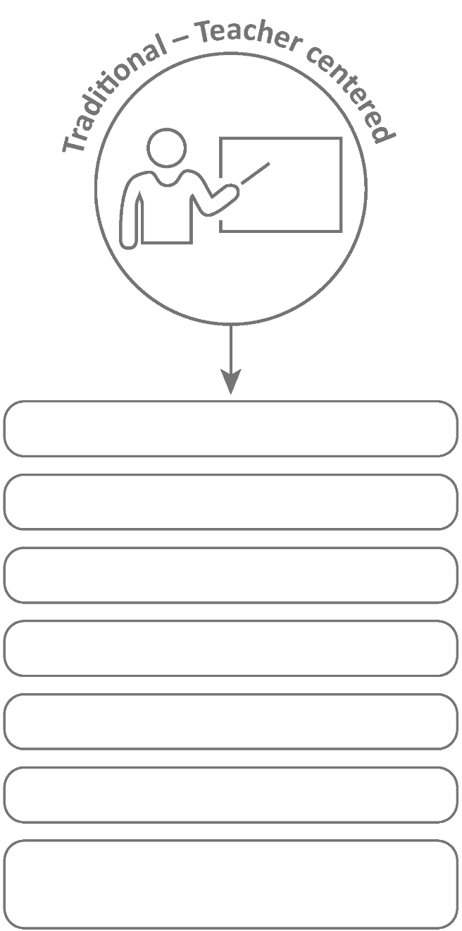
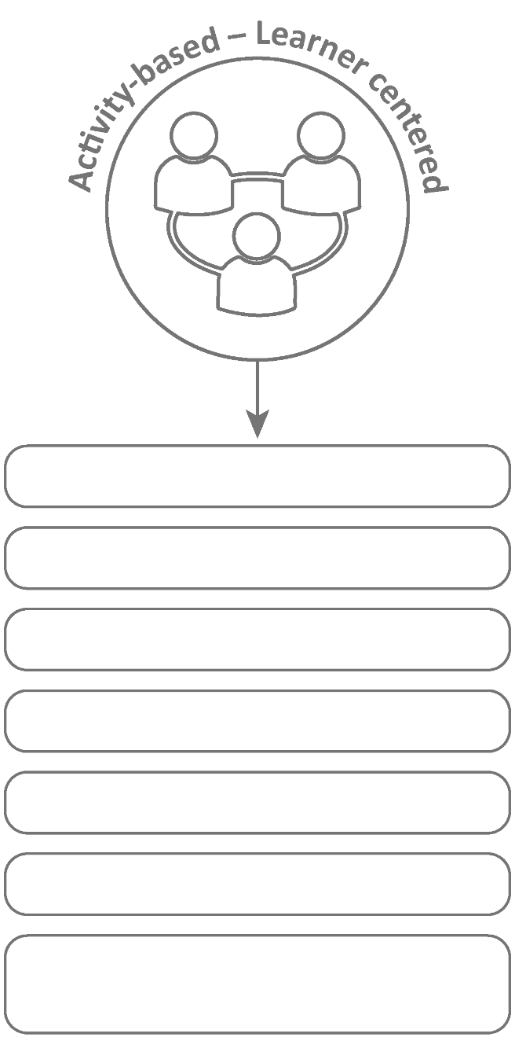
Basic Learning

Bigger class size

Isolated subjects

Product-orientated

Learning by repetition

Concepts are facts to memorize

Quantitative evaluation (numerical testing)

In-depth learning
Smaller groups within class
Integrated/interdisciplinary subjects
Process-oriented
Learning through active involvement
Concepts questions to be investigated
Authentic assessment (competencies, integrated, mindset)

10.2 The Project-based Learning Cycle

Below please find the Key Knowledge, Understanding and Success Skills to help you manage the project.
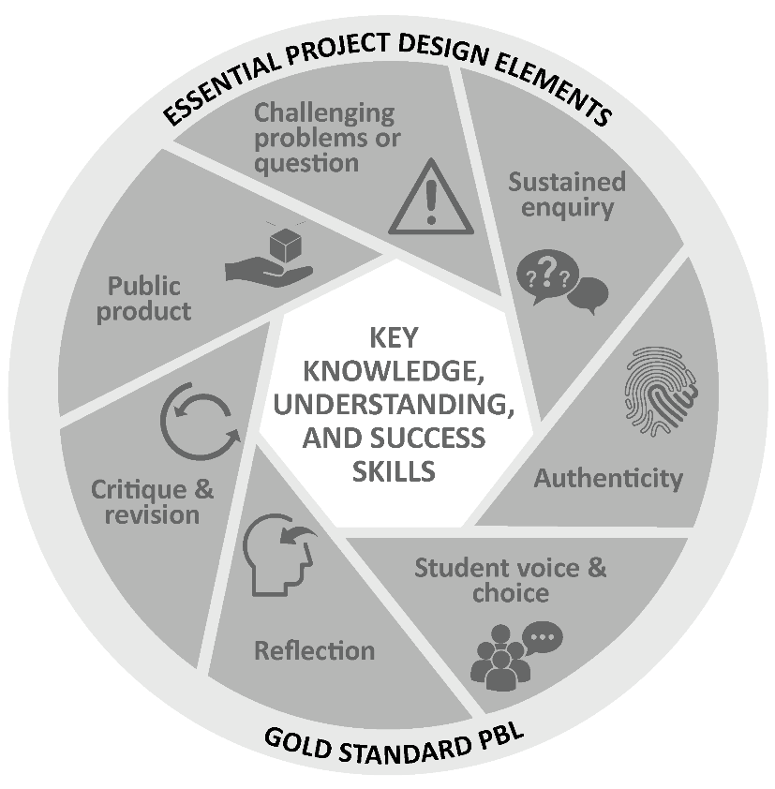
Challenging problem or question: Why is this project critical? What is the problem in society and at school being addressed in this project? Keep talking about how this project will solve a local or global problem.
Sustained enquiry: Are learners being “researchers”? Are they doing the research and getting deeper and deeper into the problem or are you doing all the talking? Look at the second circle overleaf to remind you of your role: manage activities and scaffold student learning. Learners must not be allowed to give up – you must “build a culture” of getting to the bottom of the problem and coach them when they lose their way. With time E³ will be developing thinking tools to ensure that you are equipped with strategies to take the enquiry to a new level. (See overleaf for the current PBL learning cycle with a built-in innovation cycle.)
Authenticity: Keep the project real by referring to learners’ own lives – this is about them and their world.
Student Voice and Choice: Although learners did not choose this project, make it fun and real, and applicable to their own world, so that they own it. Their voices and opinions are what your deeper goal is – encourage their views and applaud each contribution.
Reflection: To truly embed learning, learners should be able to reflect on what they have learned and be able to think of better ways of doing things. The reflection activities in the worksheets are not just for fun. Encourage learners to spend time on them as this will deepen their learning.
Critique and Revision: This process is to help learners experiment with their innovation and learn how to improve their work and thinking. As you assess and evaluate their products (not them!) learners will see that there are different ways of solving problems. It is important that learners hone their curiosity and learn how to “stick it out” and keep trying, not giving up when it doesn’t work first time round.
Public Product: At the end of the project what does the learner have to show or to brag about? Ensure that there is a Project Culmination Week in which each grade displays their products during a week selected by the management team to ensure that as many parents and other stakeholders as possible attend.

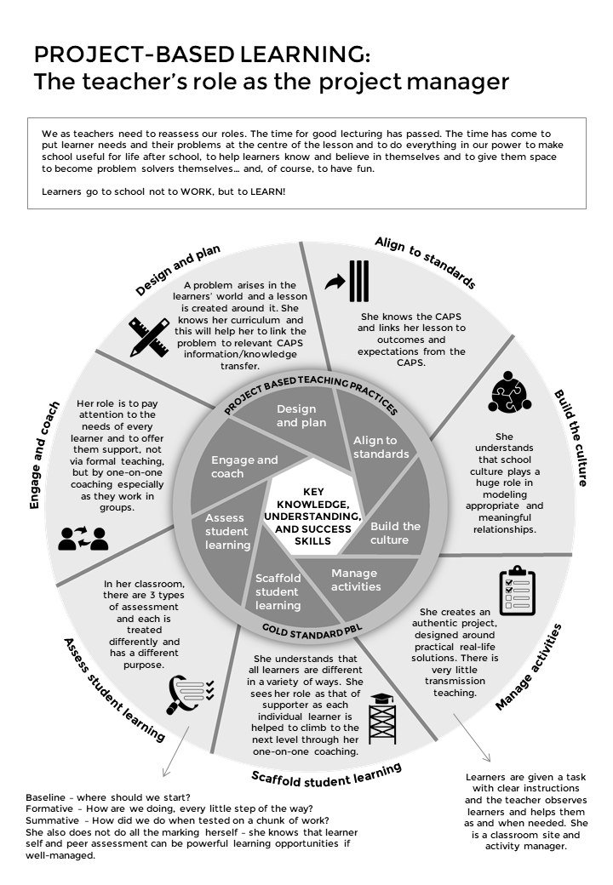
10.3 The Project-Based Learning facilitator

10.4 The E³ Competencies model within the CAPS

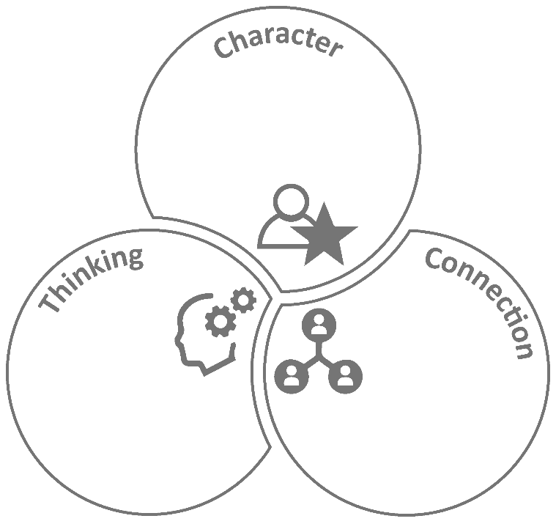
Citizenship
Curiosity
Resilience
Mindset
Collaboration
Communication
Empathy
Creativity
Critical Thinking
Reasoning

10.5 The journey to PBL via Enquiry-based and Problem-based Learning
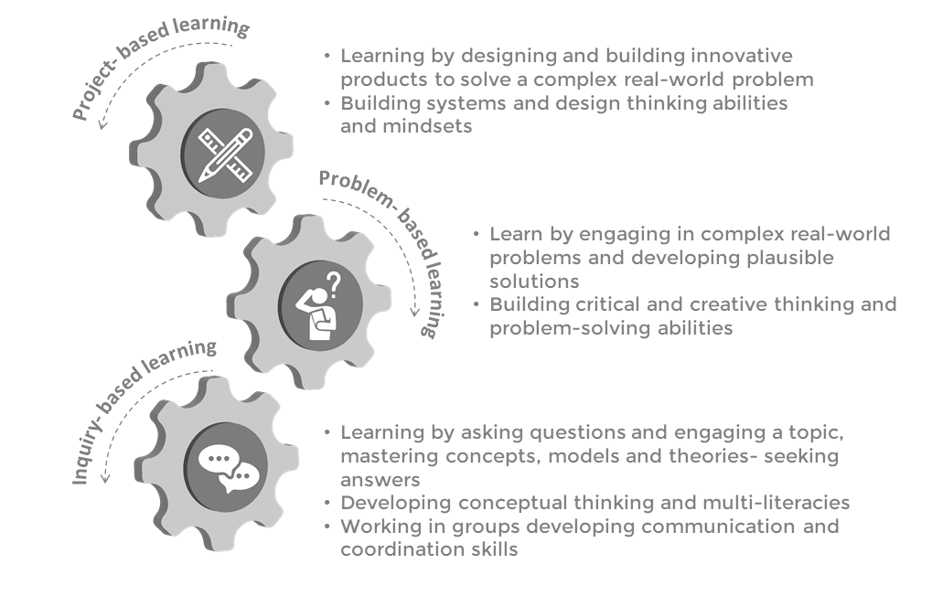

10.6 Bridging the Unemployment gap through Education
