

**Learner’s Workbook**

**A POSITIVE RESPONSE TO COVID-19**

**PROJECT-BASED LEARNING | LIFE ORIENTATION**

**GRADE**

**10**

**COVID-19**

**SERIES**

**Learner’s Workbook**

**GRADE 10 Life Orientation**

**E³ PROJECT FOR TRIMMED ATP**

**A positive response to COVID-19**

COVID-19 SERIES | LEARNER’S WORKBOOK | GRADE 10

3

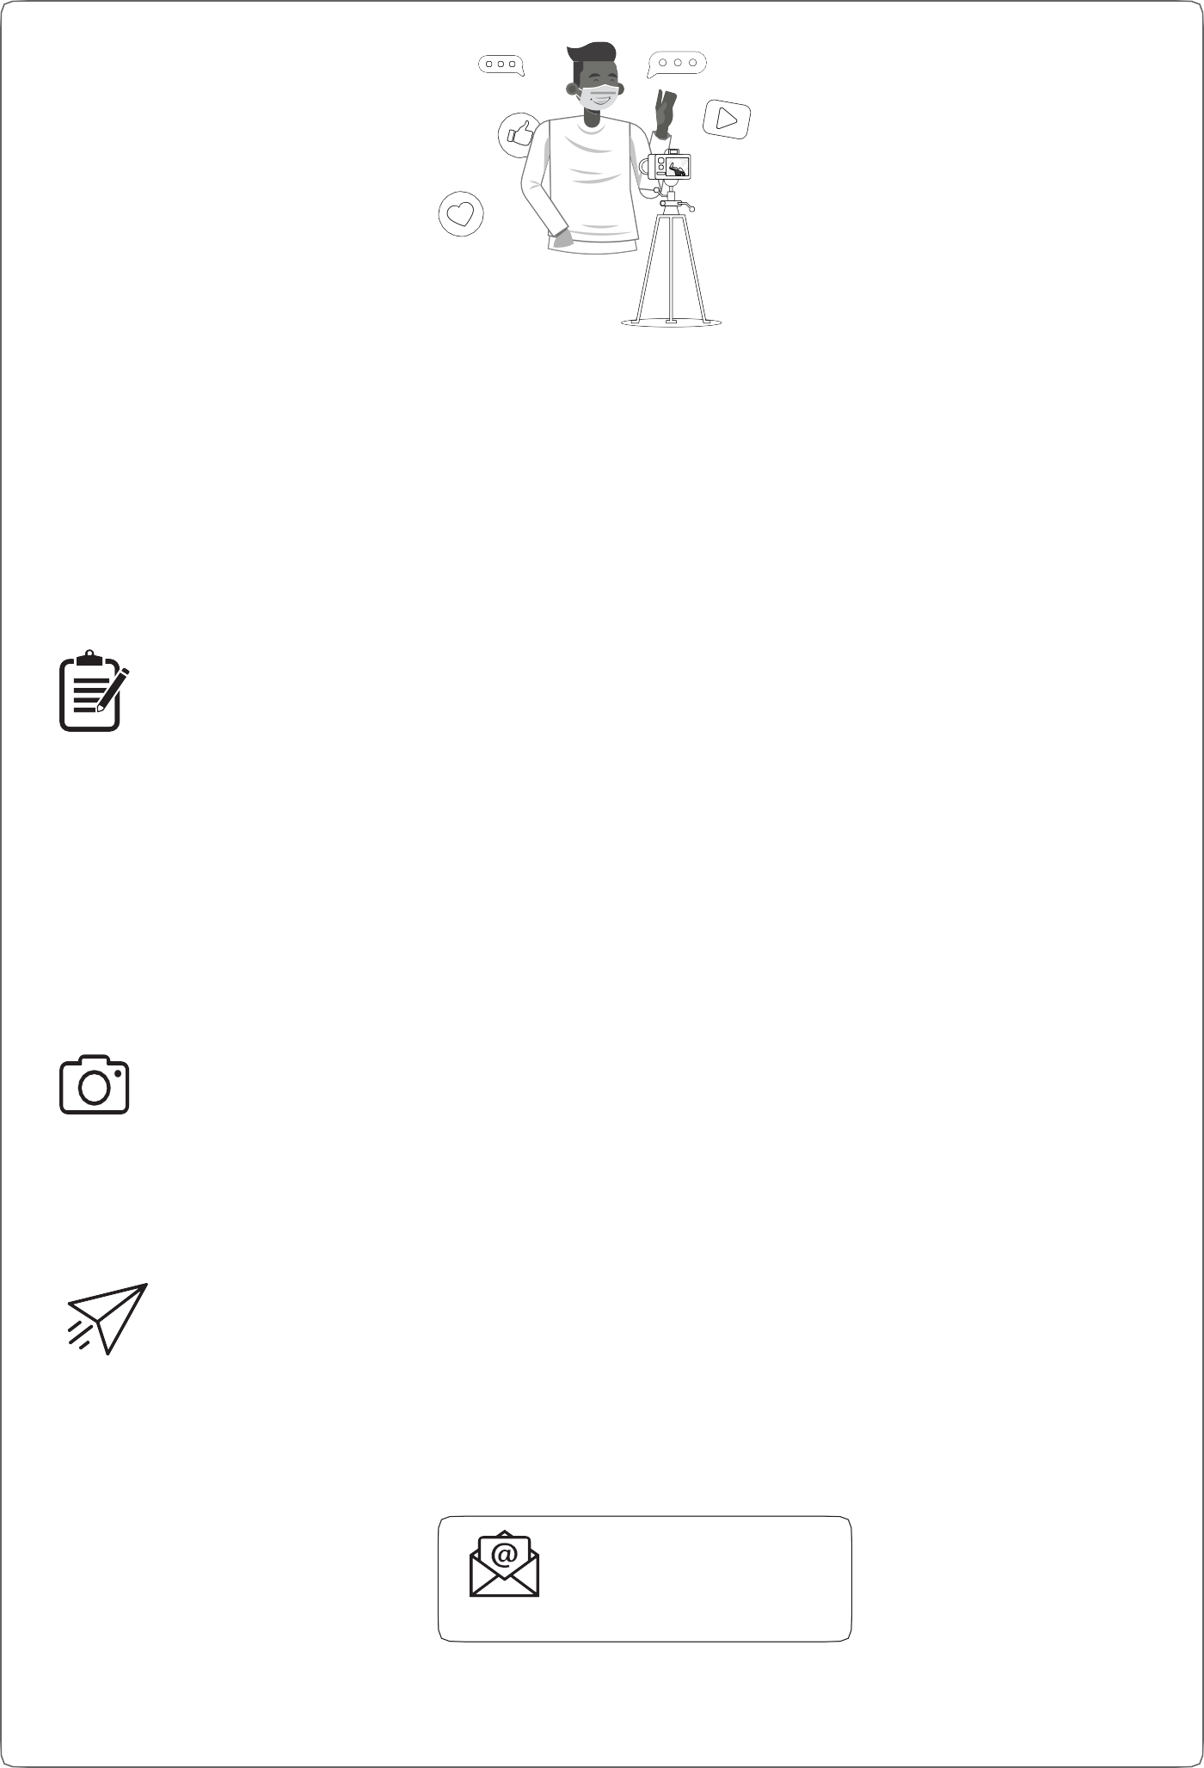

**Please send us pics/videos for our Facebook/Website**

**Send your pictures and videos!**

Dear learner

We are so excited to see your project and we would like you to share it with us so that we can profile it on our website and possibly on Facebook or Instagram. To do that, please follow these instructions very carefully.

**HOW TO PUT TOGETHER YOUR INFORMATION:**

**Tell us about your project:**

1.

2.

3.

4.

5.

6.

7.

Product or service you created:

Name of learner:

School:

Grade:

Describe your project (50 – 100 words).

Describe the biggest challenge you had doing this project (50 – 100 words). Describe what you would do better next time (50 – 100 words).

**Choose the right photographs to tell the story of your project**

1.

2.

3.

Choose three photographs that tell the story and progress of your project. Make sure that no-one’s face is clearly visible unless they are wearing masks.

Make sure the picture is in focus and clear.

**How to send your submission:**

1.

2.

3.

All submissions must be in a word document and the pictures must be in the document. You can send it to us on email.

You can email it yourself, or you can ask your parent/caregiver or teacher to do this for you. You must use this subject line on the email: Learner Project Grade 10 LO.

[info@ecubed-dbe.org](mailto:info@ecubed-dbe.org)

Email

If needed, we might ask you to make some changes to your submission in order to make it ready for uploading onto our website.

4

PROJECT-BASED LEARNING | LIFE ORIENTATION

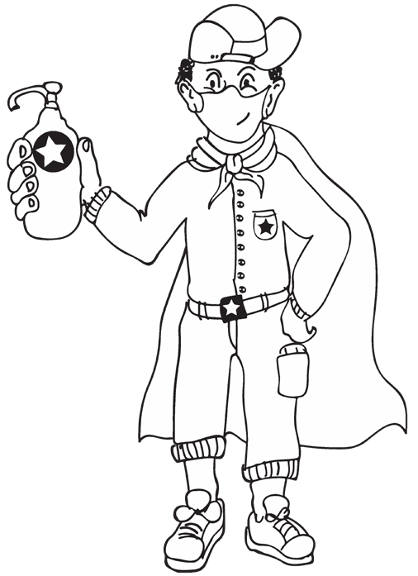

**Introduction**

Dear Grade 10 learner

School and life generally is now a very different place from what it was in March this year. You are proba- bly looking forward to seeing your friends again. Everyone is a little more traumatised than when you last socialised. Let’s work together to share warmth and caring. How can you do this? Not by hugging them or giving them a high five! Rather show your friendship by keeping yourself healthy and by keeping your distance. A great deal of learning happens socially, but because you cannot do group work for a while, we need to think of new ways to team up with friends to complete your project. Here are some ideas:

**Your task: Become a problem-solver and make a future for yourself**

Our country has one huge problem – youth unemployment. How can you as a Grade 10 learner solve this gigantic problem? You can! Start thinking of your future, of yourself as an entrepreneur, or in a career that suits your personality. You may want to embark on studying further or starting a small enterprise to earn an income while deciding.

Whichever path you choose, the following project is for you. You will start by doing an audit on who you are as a person – what you do well and where you can grow; your maturity and courage in facing tough times and your deep understanding that within the new normal of COVID-19 you will find yourself taking more responsibility, not only for those with whom you live, but for your own safety. In this project, you are also going to research various careers that interest you (and the Grade 9 class who have to choose subjects for matric) and contribute towards organising a Career Gallery where you showcase various possible career options that have come about as a result of the COVID-19 pandemic, as well as other fu- ture-focused careers.

According to historical data, many people switch to more career-oriented courses of study during eco- nomic hard times. If the post-COVID-19 workforce follows this trend, degrees in engineering, accounting, business, healthcare and computer-related fields may become increasingly sought after. Traditional careers will not disappear, but will demand different competencies from employees.

According to Prof. Julia Richardson, international careers expert:

**Are you up for the challenge?**

Are you emotionally equipped and ready to take on the challenge of a new world? Do you have the skills and competencies to be a game changer? Do you know what you want to do after

school?

**Resources to help you**

There are many resources at the end of this booklet. Make good use of them. It will help you to work independently. Let’s get going!

**Your support people:**

Choose one **buddy-guard**, a special someone with whom you can discuss everything in class (either by WhatsApp or from a 2-meter distance). Don’t forget that your family at home can also share ideas with you and listen to your views and so help with your project.

COVID-19 SERIES | LEARNER’S WORKBOOK | GRADE 10

5

“I would say it’s more about the career skill sets changing rather than some careers disappearing altogether as a result of COVID-19 - the key to all

this then is ensuring that you are prepared to meet the changing activities/requirements for career holders.”



**GRADE 10 PROJECT: Organising a Career Gallery – COVID-19 impact on career choices.**

In this project you will do research and create items that will answer the following questions:

**PART 1: Who am I? My Personal Journal**

You will complete 8 short entries in a journal. This means thinking deeply about the coronavirus and how it has af- fected you and your family, both in a good and a bad way. Has the pandemic made you think differently about your future?

**PART 2: Where am I going? How will I get there? Researching COVID-19 and future-focused careers**

You will do research on a career path that suits what you have learned about yourself and create a research poster, power point presentation or a video on a career you really think might work for you. You will collect evidence (WhatsApp videos or voice notes or sketches) to show your progress. Grade 9s who need to choose subjects for Matric will really be interested in visiting your career gallery. Imagine a wall of exciting posters and tables with com- puters displaying creative PowerPoint presentations and videos.

**PART 1: Baseline – My personal journal:**

**Who am I?**

✪ **Activity 1: Processing the effects of the coronavirus**

To measure progress, you need to know where you started. This is called a baseline assessment. (See your Library notes at the back of this workbook). Hopefully after this project you will be able to see great growth in your skills and the competencies needed for a future career, and, more importantly, you will have developed emotional muscle as well. No more fear and insecurity!

**Think about** how the Coronavirus is affecting you and all of us right now. In other words, how have things been affected and changed and how have people/ the world/ nature responded?

Complete the mind-map on the next page to capture your thoughts on the topics indicated. Please add more topics if you wish:

6

PROJECT-BASED LEARNING | LIFE ORIENTATION

r

a

po

u

rt

s

a

ff

H

e

om

e

c

fe

t

o

e

e

d

n

e

ra

l

y

ly

o

F

u

t

u

u

r

r

e

Pl

a

l

n

s

i

f

e

S

c

?

h

o

o

l

COVID-19 SERIES | LEARNER’S WORKBOOK | GRADE 10

7

H

y

g

i

e

n

e

H

o

S

o

w

ci

a

l

h

l

y

/

a

F

r

ie

s

n

d

C

s

o

r

o

n

Fo

a

T

od

v

r

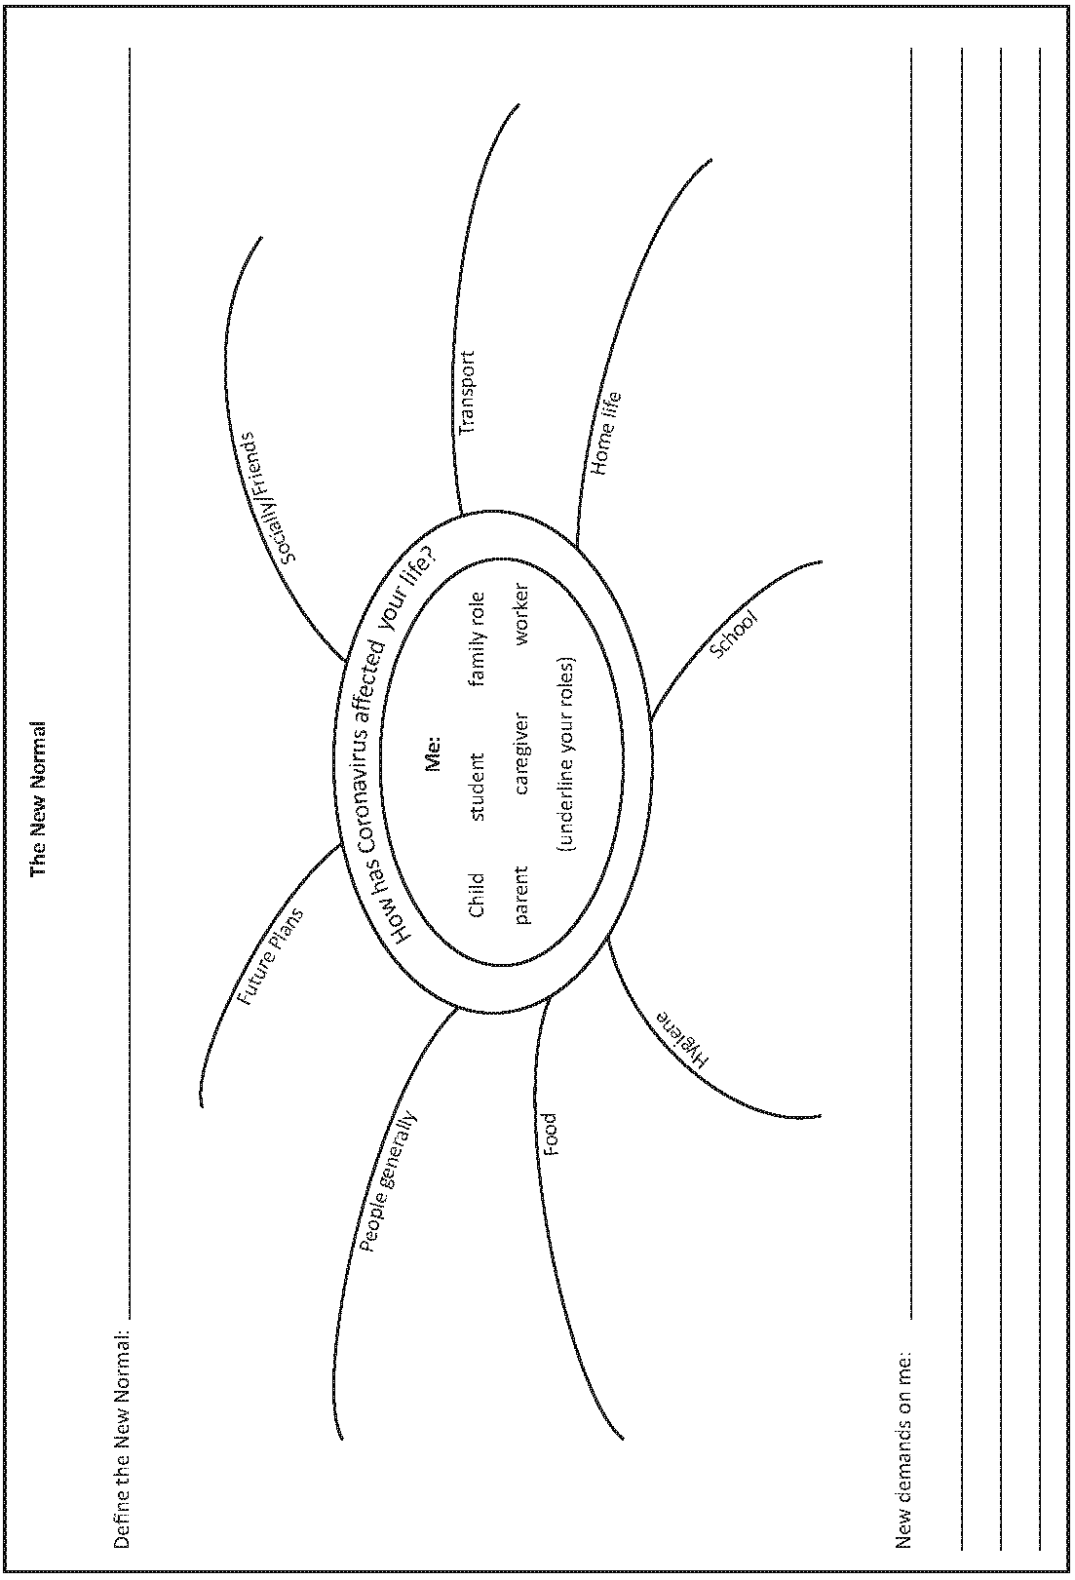



✪ **Activity 2: Keep track of your feelings and ideas in a Journal**

You will be keeping a journal over the next few weeks. The purpose will be to keep track of everything that you are experiencing during the COVID-19 pandemic while planning the Career Gallery.

Eight (8) inserts must be completed. You can decide whether you want to complete the 9th insert. Please date every journal entry.

Œ **What is a Journal?** A journal is a record that can be used to detail everything from your feelings about a particular situation in your social life to your thoughts on a current event in the world. Hence, journals serve a range of purposes. A journal is meant to collect your ideas and observations on any number of things and put the happenings of each day into writing. In this way, you are able to better remember what you did, what you thought, and what was happening when you were younger. Ideas come from all over. They could be stimulated by things you see or hear or read via social media, on the news or during a conversation. Some thoughts are original. They may be in opposition to what is happening or being said.

**Suggested start / process:**

1.

Write whatever is top of mind on that day, e.g. unusual things that happened at school, at home, in your street, etc.

If you are not feeling inspired, use your mind-map on the previous page to remind you of the “new normal”. Then choose one aspect and write a paragraph on it.

2.

3.

The next day pick up where you left off or start on a new aspect or idea. Do this for 8 or 9 days in a row.

* You are learning new things each day. You can reflect on these.
* Many people are fearful of the future. We are getting new statistics and stories each day about COVID-19. You may choose to reflect on these.
* Entries can include pictures, art, photos. Write about these as well.

4.

Date each entry.

If you experience writer’s block, here are some more ideas to inspire journal entries. Please do not feel you have to answer these questions – they are really just ideas.

You will find that once you have answered these questions, you will be able to write about anything in your journal.

1.

2.

3.

4.

5.

6.

7.

8.

*What are you and your family doing for fun?*

*How are you balancing your schoolwork and chores with recreation? Are you managing to get exercise? How?*

*What are you doing that you’ve never done before?*

*How are your relationships with the people you are living with? What are your fears about the virus?*

*Has the virus affected anyone close to you in a serious way?*

*What are you missing? What about school do you miss / not miss?*

8

PROJECT-BASED LEARNING | LIFE ORIENTATION

As long as the world has not found a cure or a vaccine for Covid-19, we may have to adjust to a “new normal”, meaning a new way of living and going about our lives, work and interactions with other people.

http[s://w](http://www.thestar.com.my/lifestyle/health/2020/05/21/covid-19-what-does-the-039new-normal039-mean)ww.[thes](http://www.thestar.com.my/lifestyle/health/2020/05/21/covid-19-what-does-the-039new-normal039-mean)t[ar.com.my/lifestyle/health/2020/05/21/covid-19-what-does-the-039new-normal039-mean](http://www.thestar.com.my/lifestyle/health/2020/05/21/covid-19-what-does-the-039new-normal039-mean)

COVID-19 SERIES | LEARNER’S WORKBOOK | GRADE 10

9

Journal entry topic: Date:

Journal entry topic: Date:

Journal entry topic: Date:

10

PROJECT-BASED LEARNING | LIFE ORIENTATION

Journal entry topic: Date:

Journal entry topic: Date:

Journal entry topic: Date:

COVID-19 SERIES | LEARNER’S WORKBOOK | GRADE 10

11

Journal entry topic: Date:

Journal entry topic: Date:

Journal entry topic: Date:

As you undertake this journey, you may have more and more questions – list them in a safe space and when the opportunity arises, ask someone for their opinion**.**

Œ **NOTE:** Remember to make use of the *Wh*-wall for any question you might have, even if it’s personal. You can post your question on a classroom wall on loose pieces of paper when you are back at school. You may ask an anonymous question – maybe it will help someone else who does not have the courage to do so!

✪ **Activity 3: Take stock of who you are at this moment in time.**

**Think of who you were six months ago (pre-COVID-19) – You may have more than one answer for each role/ responsibility.**

12

PROJECT-BASED LEARNING | LIFE ORIENTATION

**ROLE AND RESPONSIBILITY**

*(select words from this column for the next 2 columns)*

**PRE-COVID 19**

**TODAY**

**HOW THIS HAS AFFECTED MY LIFE IN THE PAST 6 MONTHS? WHAT DEMANDS HAS THIS PLACED ON ME?**

**My life role:** child, learner, adolescent, adult

**My family role:** sibling, partner, mother, father, grandparent, bread- winner, employer, employee, leader, follower

**Responsibility:**

At school, within the family, socially

(partner and friends)

✪ **Activity 4: Rate your COVID-19 armour.**

**Are you strong and able to manage your new world?**

***Build your armour to shield you against a rapidly changing world with new challenges.***

 **Armour:** any defensive covering, esp. that of metal, chain mail, etc., worn by medieval warriors to prevent injury to the body in battle. But it can also refer to emotional and social “weapons”” we use to protect ourselves in difficult times. During COVID-19 we have to strengthen our inner tools so that we can arm and protect ourselves and those we care for.

**4.1 Emotional armour (personal and COVID-related)**

**Rate your “weapons” in dealing with the new NOW, by rating how strong they are right now.**

*(1=Not at all strong; 2=Improving, but not yet strong enough; 3=Fair to fairly strong; 4=Strong and ready for the challenges ahead)*

COVID-19 SERIES | LEARNER’S WORKBOOK | GRADE 10

13

**Weapons to protect me**

**1**

**2**

**3**

**4**

**What I can do to strengthen?**

Maturing personality

Depth and control of emotions

Managing feelings of

insecurity

Managing changing needs

Managing changing

interests

Managing changing feelings and beliefs

Re-assessing my values

Responsible decisions regarding optimising my potential – strategies

Managing social distancing and effect on family and peers

Self-management and coping skills within family life in present situation

**4.2 Social armour**

*(1=Not at all strong; 2=Improving, but not yet strong enough; 3=Fair to fairly strong; 4=Strong and ready for the challenges ahead)*

**4.3 Sexuality/values - armour**

*(1=Not at all strong; 2=Improving, but not yet strong enough; 3=Fair to fairly strong; 4=Strong and ready for the challenges ahead)*

14

PROJECT-BASED LEARNING | LIFE ORIENTATION

**Weapons to protect me**

**1**

**2**

**3**

**4**

**What can I do to strengthen?**

Focused effort to take responsible decisions regarding lifestyle

Plan of action in place for seeking help in taking

decisions around sexuality

and lifestyle

Focused awareness on lifestyle choices that could lead to pregnancy, sexual abuse and rape

Respect for self and others

**Weapons to protect me**

**1**

**2**

**3**

**4**

**What can I do to strengthen?**

Acceptance by all

Relationship with family

Relationship with friends

Independence of peer group

Focused thoughts about moving into study or the workforce

Increased responsibilities towards family

**4.4 Responsibility Monitor**

**Study your self-assessment above and complete the following:**

I feel I am responsible when it comes to:

However, I need to work on taking responsibility in these areas**:**

Why do you think responsibility is such a serious issue, especially during COVID-19?

COVID-19 SERIES | LEARNER’S WORKBOOK | GRADE 10

15

**Weapons to protect me**

**1**

**2**

**3**

**4**

**What can I do to strengthen?**

Self-control

Right to privacy

Abstinence

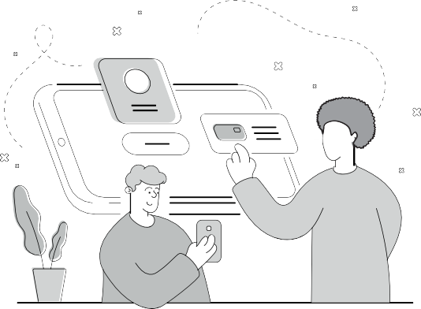



**PART 2: The Career Gallery Where am I going? How will I get there?**

**Researching COVID-19 and future-focussed careers**

You will do research on career paths that suit you and what you have learned about yourself and create a research poster, a power point presentation or a video on a career you really think might work for you. (Choose 1 project item that you can manage).

**STEP 1 – PLANNING**

You are at a crossroad in your life. You probably feel a little uncertain emotionally, and may be worried about your future. This project will give you the opportunity to think about developing emotional strength and selecting a career path that satisfies your unique make up. Brainstorm the current situation on your own by thinking of a few random words to describe how you are feeling right now, or connect with your buddy-guard, teacher or someone at home to share ideas.

1. List a few questions that will direct you as you start your career research. Here are some question words to help you:

What ? Why ? How ? What if ?

When ?

2. Have you considered doing your own thing? Do you have what it takes to be an entrepreneur?

**Play the Perfect Entrepreneur game and find out.**

Games are an excellent way to get information across but also to get to know yourself a bit better. In this game you will partner up with your buddy-guard. Each of you will have 3 minutes to talk about why you think you would be a perfect entrepreneur, then 3 minutes on why you think you would not be a good entrepreneur. Your teacher will keep a timer running. Your buddy-guard will take notes while you are talking and you will do the same for him/her.

A buddy-guard is a special friend who cares about you and wants to support and look out for you

16

PROJECT-BASED LEARNING | LIFE ORIENTATION

3. Answer the following questions:

3.1

Does everyone have the potential characteristics to become an entrepreneur? Explain.

3.2

Is it a bad thing if some people do not possess the characteristics to become an entrepreneur? Explain.

3.3

What have you learned from this exercise?

3.4

Which entrepreneurial characteristics in your own make-up do you think need to be developed to run a busi- ness? Discuss three and list them below.

4.

Complete the WITS analysis on yourself and find out where you need to grow, but also where you shine! WITS is an acronym for Weaknesses, Interests, Talents and Skills. Be very honest with yourself. There is no right or wrong answer. We are all different and that is why we complement each other as business partners or team members.

COVID-19 SERIES | LEARNER’S WORKBOOK | GRADE 10

17

MY TALENTS ARE:

MY INTERESTS ARE:

MY WEAKNESSES ARE:

MY SKILLSET IS:



5. Once you have filled in your WITS table, you should now have a better understanding of yourself. This is a very important aspect to consider when choosing a career. Please also read the article on **“10 things for high school students to remember”** in your Library.

What stands out for you in this article? What really speaks to you?

You are now ready to use what you have learned about yourself to start a focused research study.

**STEP 2 – RESEARCH/FINDING OUT**

Today you start with exciting research on your chosen career. You will design an academic poster, power point pre- sentation or shoot a video that will inform the viewers about the specific career you chose. Your research poster, Power-point presentation or video (choose 1 that you can manage) will include all the information set out below in- cluding any other information you and your teacher deem necessary.

Once you have decided on a career, make sure you keep digging into the research to ensure that these questions are answered (you may even need to phone or interview someone by email). Plan the sources you will use here.

There are many ways of finding information for your project. Please use three different ways to collect information for your project item. Start looking for information and make sure you list your sources and reference each source correctly:

**Types of research sources**

•

•

People you could interview. How to reference? *Morobe, M. 29 July 2020, Johannesburg.*

Articles you could read in Library at the back of this workbook (from the internet).

How to reference? Gordon, S. 2019, *7 ways to build social skills and prevent bullying*, viewed 2 June 2020,

<http[s://w](http://www.verywellfamily.com/how-to-build-social-skills-and-prevent-bullying-460718)ww.v[erywellfamily.com/how-to-build-social-skills-and-prevent-bullying-460718](http://www.verywellfamily.com/how-to-build-social-skills-and-prevent-bullying-460718)>

Your textbook. How to reference? Mohapi, J (2019). *Life Skills for All* Cape Town, Alpha Publishers.

•

1.

Complete the table below to show how you found/or are going to find your information:

18

PROJECT-BASED LEARNING | LIFE ORIENTATION

**Type of source**

**Reference (Check the Library for articles)**

**Rate the source**

**(1=poor, 4= excellent) and say why in one or two words**

Textbook

Articles from the internet in your Library (in this Workbook)

Interview with one other person that you know will give you solid information

The internet if you have

access

Other? E.g. YouTube

1. Your first source was a video (or a transcript of the video if you cannot access the video). View the video link or read the transcript in your library. The video is about possible career paths that have been highlighted. How

many of these are still relevant during a post-COVID world? COVID-19 has changed the world of work drastically. Careers that were previously seen as less glamorous, have now become extremely sought after. There may be an industry that has not been brought to light yet. Maybe you can think of one and base your research on that. Who knows, you may be the first!

* 1. Make notes while you are watching or reading. Select two careers that seem interesting to you. If there are none in the video, list your top two choices here anyway. You can refer to the lists in the Careers section of your Library:

First choice

Second choice

2.2 Did starting your own business feature in your choices? Say why/why not:

* You have thought of sources and selected a possible career. You are now ready to start your research.
* Keep the following in mind when you decide on your **specific career choice** that you would like to showcase. Remember that you need to have an interest in your chosen career as it will show in your final product.
* After watching the video or reading the transcript (you will find it in your Library at the end of these notes), brainstorm with your buddy-guard or someone at home the various job opportunities that you think are more pronounced, due to the COVID-19 pandemic.

2.3 Which career are you thinking of?

2.3.1 Why are you the perfect person for this career?

2.4 How does it fit into the current and post COVID-19 pandemic we find ourselves in?

1. Do research to gather the following information:
   1. What is the work-setting for your chosen career (indoors, outdoors or in different settings)?

COVID-19 SERIES | LEARNER’S WORKBOOK | GRADE 10

19

3.2

What types of activities does it require? (design, handy work, computer work, administration?)

3.3

What skills, competencies and requirements do you need to do the job? Also: what level of education and experi- ence do you need?

3.4

What is the median salary for the job?

3.5

Is it possible to move up in the career? Are there possibilities for promotion?

3.6

What further studies would be available to you?

3.7

What subject choices for Grade 12 do you have to make to enter the field of work/study?

20

PROJECT-BASED LEARNING | LIFE ORIENTATION

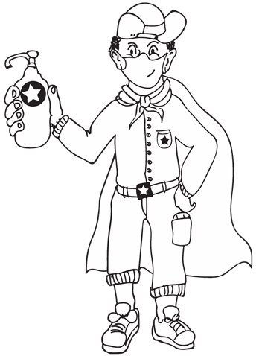



**STEP 3: MAKING AND SHOWING THE EVIDENCE**

What resources do you need to create your project? Which item did you decide on? Poster, PowerPoint presentation or video (encircle your choice).

1.

2.

Where will you get the info on how to make your item?

3.

How many times did you try before you were satisfied with the product? Make notes of all your challenges so that you can give good feedback in the reflection section in Step 7.

Now, do it!

Remember to update your journal.

**STEP 4: GETTING FEEDBACK AND CHANGING IF YOU NEED TO**

Getting feedback

Show the rough draft of your poster, power point presentation or video to family and friends (with social distanc- ing) and ask for feedback. Complete the blocks below:

1.

COVID-19 SERIES | LEARNER’S WORKBOOK | GRADE 10

21

Who is your buddy-guard?

What is your buddy-guard’s address or cell number?

Why did you choose him/her as a buddy-guard?

Things/resources I need:



2.

Analyse the feedback

Listen to useful information to improve your project item. Say what they advised and what you did. Get at least 3 people to give you feedback.

3.

Write down what you changed, and why.

What you changed?

Why you changed it?

22

PROJECT-BASED LEARNING | LIFE ORIENTATION

Date of advice

Who gave feedback?

What they said I should do

Who at home is your advisor?

How will you get hold of your teacher if you need him/her?



1. The importance of feedback
   1. Why is it important to ask for feedback?

4.2 Why did you choose these specific people for their feedback?

4.3 Do you view feedback as constructive or negative? Discuss why.

**STEP 5: FINISHING OFF YOUR PROJECT**

1.

Getting it perfect. Work in class or at home and make the final changes to your poster, power point presentation or video. Ask family members to help you proofread all the copy (written parts).

PLEASE TAKE A PHOTO of yourself and your project item to share on the E3 website, and to keep as evidence.

Brainstorm some ideas for displaying these items at school, in a public space or online with your family, teacher or buddy-guard. What have you decided about the public display? Write your plans in the block below.

Remember that if your choice was a PowerPoint presentation, you need to plan that the presentation is animated and looped so that it runs at the career gallery.

2.

3.

4.

What safety measures should you take with the public display of your project? Please write these down in the block below:

COVID-19 SERIES | LEARNER’S WORKBOOK | GRADE 10

23



**STEP 6: SHOWING OFF YOUR PROJECT**

**Public Display**

•

•

•

Because of COVID-19, this Career Gallery will be very different from any other Expo that you know of. Social distancing is of the utmost importance.

Find a place that allows for social distance where you can stick the poster on a wall, show your power point pres- entation or short video. It should be a place where students can visit one at a time, for more information. (This will be your office for the day.)

Remember to speak clearly and loudly enough for the listener to hear through the mask that you will be wearing. Draw a table and see what your attendance as well as feedback from your visitors are.

Write down their views on your chosen career.

Add your WhatsApp number and name to your work for people to be able to give feedback. If you are not too busy, you could interview some of your visitors for feedback.

•

•

•

•

1.

How many people visited your office?

2.

3.

4.

What percentage of visitors would change their careers to match yours? What percentage of visitors have the same career in mind as you?

Help your classmates and teacher to set up the Career Gallery. Create a Facebook insert or WhatsApp message with pictures to send to your group to tell them about your event when it is eventually safe to show off the Grade 10 projects. This can be a wall in a corridor at school, or you could create this display on a digital platform (blog, website, Facebook, etc.).

4.1 Make a TO-DO list of things you will need for this to happen:

24

PROJECT-BASED LEARNING | LIFE ORIENTATION

**Visitor**

**Grade**

**Current Career Choice**

**Would you change your choice?**

**Why/Why not?**

4.2

Facebook or WhatsApp message wording and pictures (keep the visual evidence of this activity):

4.3

Did you get any feedback on the display? List a few things that people said about your Grade 10 Careers Gallery:

4.4

What item did you create?

How would you rate your own item? And that of your buddy-guard?

COVID-19 SERIES | LEARNER’S WORKBOOK | GRADE 10

25

**My rating /7**

**My buddy-guard rating /7**

Why?

Why?

**Good feedback – What they liked**

**Not-so-good feedback – What they didn’t like**



**STEP 7: THINKING ABOUT IT AFTERWARDS**

Reflection: For deep learning to take place, one should always reflect on the work you have done. Please complete the questionnaire below:

1. What did you love about working on this project?

2. What made this project hard for you?

1. What did you learn by working on this project?
   1. About yourself and your suitability for the career you chose?

3.2 About planning your future?

3.3 About learning and living during COVID-19?

Learning:

Living:

3.4 What advice would you give to the next person that has to do this project?

3.5 What have you learned about COVID-19 effects on career choices?

26

PROJECT-BASED LEARNING | LIFE ORIENTATION

3.6 Do you still want to pursue the same career as before COVID-19?

3.7 Discuss an interesting fact that you learned about another career.

3.8 What skills have you garnered throughout the project?

3.9 How has the COVID-19 pandemic strengthened you?

4. What would you do differently if you did a project like this again?

COVID-19 SERIES | LEARNER’S WORKBOOK | GRADE 10

27

**LEARNER’S RESOURCE LIBRARY**

**BASELINE**

A **baseline study** is an analysis of the current situation to identify the starting points for a programme or project. It looks at what information must be considered and analyzed to establish a **baseline** or starting point, the benchmark against which future progress can be assessed or comparisons made. Dec 4, 2014

*https://ec.europa.eu/eurostat/statistics-explained/index.php/Glossary:Baseline_study*

**PRIMARY VS SECONDARY SOURCES**

Sources of information are often categorized as primary or secondary depending upon their originality.

**Primary Sources**

1.

2.

3.

Direct or first-hand evidence about an event, object, person, or work of art

Published materials written or produced by someone with first-hand experience of the event. Individual viewpoint of a participant or observer.

***Examples of primary sources*:**

Interviews, surveys, and fieldwork

Diaries, personal letters, and correspondence

Internet communications on email, blogs, and newsgroups Photographs, drawings, and posters

Books, magazine and newspaper articles and ads published at the time Public opinion polls

Speeches

Original documents (birth certificates, property deeds, trial transcripts) Research data, such as census statistics

Official and unofficial records of organizations and government agencies Radio interviews, DVDs, and video recordings

Government documents (COVID-19 pamphlets, reports, etc.) Scientific journal articles reporting experimental research results

·

·

·

·

·

·

·

·

·

·

·

·

·

**Secondary Sources**

1.

2.

3.

4.

Describe, discuss, interpret, comment upon, analyse, evaluate, summarize, and process primary sources Written or produced after the fact with the benefit of hindsight

Lack the freshness and immediacy of the original material

Collect, organize, and repackage primary source information to increase usability and speed of delivery, such as an online encyclopaedia.

Can be written or non-written (sound, pictures, movies, etc.).

5.

***Examples of secondary sources:***

Bibliographies Biographical works

Reference books, including dictionaries, encyclopaedias, and atlases Articles from magazines, journals, and newspapers after the event Literature reviews and review articles (e.g., movie reviews, book reviews) History books and other popular or scholarly books

Works of criticism and interpretation Commentaries and treatises Textbooks

Indexes and abstracts

**SOURCE** https://sccollege.edu/Library/Pages/primarysources.aspx

·

·

·

·

·

·

·

·

·

·

28

PROJECT-BASED LEARNING | LIFE ORIENTATION

**WHAT IS A RESEARCH POSTER?**

Posters are widely used in the academic community, and most conferences include poster presentations in their program. Research posters summarize information or research concisely and attractively to help publicize it and generate discussion.

The poster is usually a mixture of a brief text mixed with tables, graphs, pictures, and other presentation formats. At a conference, the researcher stands by the poster display while other participants can come and view the presentation and interact with the author.

What makes a good poster?

* Important information should be readable from about 10 feet away
* Title is short and draws interest
* Word count of about 300 to 800 words
* Text is clear and to the point
* Use of bullets, numbering, and headlines make it easy to read
* Effective use of graphics, colour and fonts
* Consistent and clean layout
* Includes acknowledgments, your name and institutional affiliation

**TRANSCRIPTION OF VIDEO**

***The world is shifting***

The world is shifting. It is developing at a fast pace into a knowledge-based, tech heavy service economy. Ten years ago these jobs did not exist: data scientists, drone operators, influencers, user-experienced designers, social media managers, genetic counselors, SEO specialists, app developers, cloud service specialists. We had never heard of Uber, WhatsApp, iPad, Instagram, crypto currency, air B&B. These have now become part of our daily lives, while new technologies are being invented, new job opportunities are being created.

***New job descriptions***

A recent report by tech giant Dell claims that 85% of the jobs that will be available in 2030 have not even been invent- ed yet. Traditional jobs will soon not exist: retail cashiers, telemarketers, newspaper deliverers, travel agents, postal workers, librarians, assembly line workers, drivers. Drivers? Yes. Drivers … a self-driving delivery vehicle to run errands from picking up groceries to delivering dinner has already been launched. Many jobs will also become rede- fined as opposed to totally eradicated with skills that can be transferable to other roles. Flexibility and a willingness to change careers will be an important attribute in the future job market.

***The Fourth Industrial Revolution is here***

The fourth industrial revolution is here. It is transforming the way we work and it must transform the way we learn. Professor Klaus Schwab, founder and executive chairman of the World Economic Forum, says the changes are so pro- found that from the perspective of human history there has never been a time of greater promise or potential peril.

***Is our education system embracing the changes?***

My concern however, is that decision-makers are caught too often in traditional linear and non-disruptive thinking. Is our education system embracing these changes? By the looks of it our classrooms have not evolved much over the years while we have embraced some of the changes through various initiatives such as developing values, mindsets,

the roll out of E-learning and the expansion of technical and vocational skills. Are we honest enough to admit that not

all our schools are equipping our learners for the 21st century?

COVID-19 SERIES | LEARNER’S WORKBOOK | GRADE 10

29

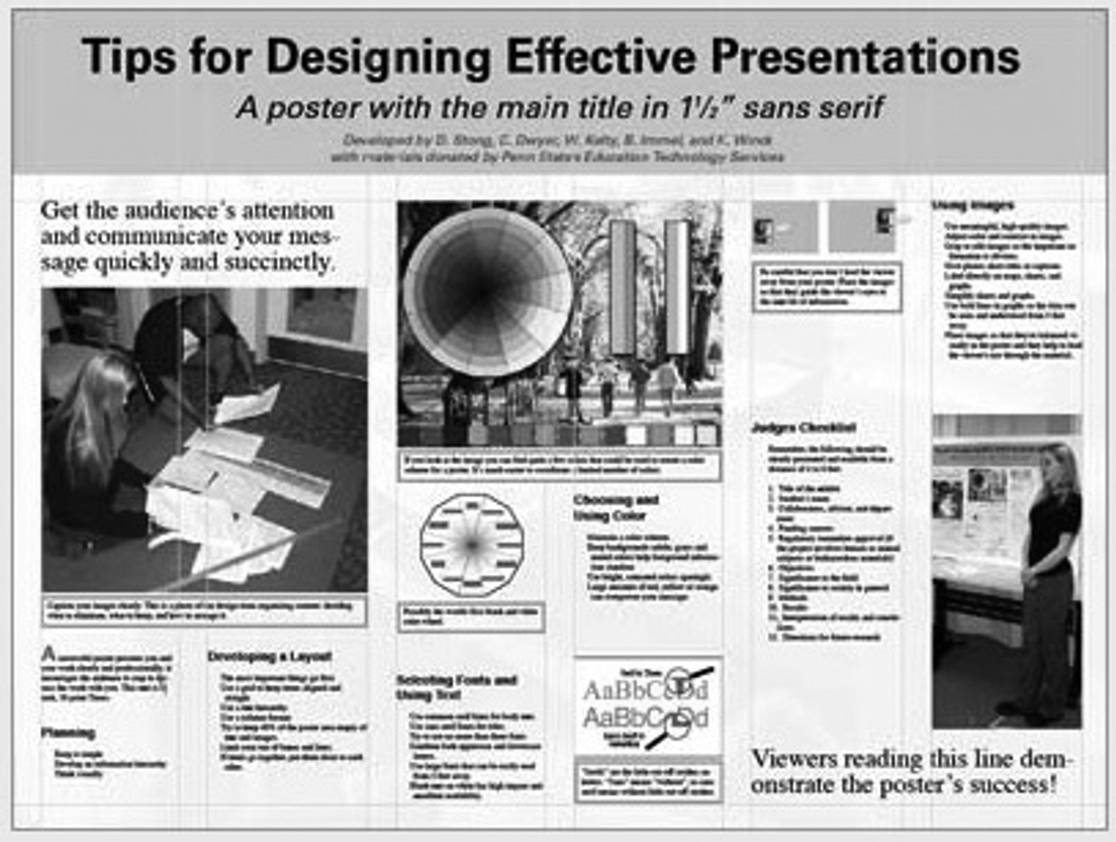

***21st century classrooms and teachers***

Today’s classrooms should be dynamic, creative, interactive, innovative, diverse, exhilarating, fun, tech-rich and cus- tomizable. Today’s teachers must be mentors, entrepreneurs, motivators, illuminators and catalysts of change, because preparing students for the 21st century isn’t just about technology or skills for the global economy. 21st century educa- tion is about innovation, flexibility, creativity, cultural awareness, problem solving, civic engagement, communication, productivity, accountability, collaboration and leadership. These are the skills that learners need to develop.

***Socio-economic challenges are a barrier to visionary education***

We also have to acknowledge that we face many challenges in the Western Cape. Overcrowded classrooms, gangster- ism, drugs, violence, poverty, teacher apathy, poor quality teaching, migration, lack of parental support, poor infra- structure, financial constraints. This means that we are not fulfilling our vision for quality education for every learner in every classroom in every school in the province. If teachers can only provide content, facts, dates, formulas, is their role becoming obsolete?

***Rethinking education – an urgent reality***

We need to rethink the tools we use and the types of problems we ask learners to solve. We need to ask what does it mean to teach in the 21st century and if we are seriously preparing our learners for their future? These are the conver- sations that we should be having. These conversations must start now.

https://youtu.be/PZiTyw34IZQ

**A SAMPLE OF A WELL DESIGNED ACADEMIC POSTER – DIFFERENCE BETWEEN AN ACADEMIC AND ANOTHER POSTER?**

Image credit: Poster Session T[ips by mousejockey@psu.edu,](mailto:mousejockey@psu.edu) via Penn State

30

PROJECT-BASED LEARNING | LIFE ORIENTATION

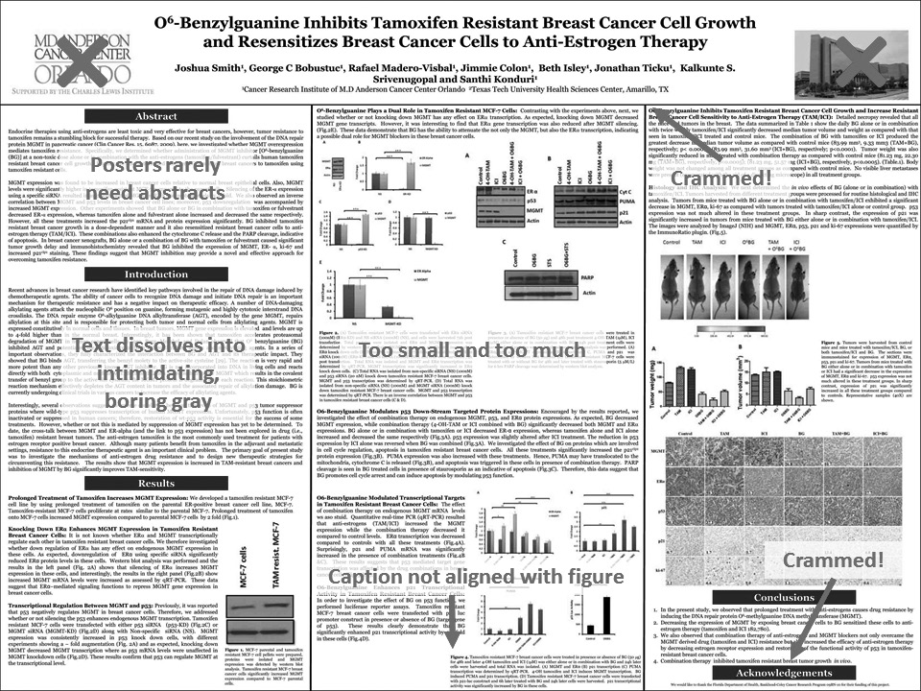

**WHERE DO I BEGIN?**

Answer these three questions:

1.

2.

3.

What is the most important/interesting/astounding finding from my research project?

How can I visually share my research with conference attendees? Should I use charts, graphs, photos, images? What kind of information can I convey during my talk that will complement my poster?

**WHAT SOFTWARE CAN I USE TO MAKE A POSTER?**

**PowerPoint**

A popular, easy-to-use option. It is part of Microsoft Office package.

**Adobe Illustrator, Photoshop and InDesign**

Feature-rich professional software that is good for posters including lots of high-resolution images, but they are more com- plex and expensive.

**Open Source Alternatives**

OpenOffice in the free alternative to MS Office (Impress is its PowerPoint alternative). Inkscape and Gimp are alternatives to Adobe products. For charts and diagrams try Gliffy or Lovely Charts.

**A SAMPLE OF A POORLY DESIGNED POSTER**

Image Credit: Critique by Better Posters Source: https://guides.nyu.edu/posters

**TIPS ON MAKING A POSTER**

[https://www.canva.com/learn/25-ways-to-design-an-awesome-poster-and-create-a-buzz-for](http://www.canva.com/learn/25-ways-to-design-an-awesome-poster-and-create-a-buzz-for-your-next-event/)-your[-next-event/](http://www.canva.com/learn/25-ways-to-design-an-awesome-poster-and-create-a-buzz-for-your-next-event/)

COVID-19 SERIES | LEARNER’S WORKBOOK | GRADE 10

31

**10 THINGS FOR HIGH SCHOOL STUDENTS TO REMEMBER**

*by Randall Hansen Career Advice Expert*

Believe it or not, if you’re in high school right now, you’re at a great point in your life. You have your whole life in front of you. And now is a good time to start thinking about your future, to make some initial plans; just remember that plans can be easily changed. Remember too, that experts predict that the average person will change careers -- not just jobs -- more than five times in his or her lifetime. And as you start thinking about one or more potential educational and career paths, here are 10 things to remember in the days ahead.

**1. Take time to think about what you like to do, and dream and imagine ideal careers.**

There are so many opportunities, so many different types of jobs and careers in a wide variety of industries -- and there are also other career paths that are just emerging. Even if you are fairly sure of a career choice, take the time in high school to explore similar (or even vastly different) careers. Explore all your options. Examine your likes and dislikes and take a few career-assessment tests. Answer the question: if you could have any job right now, what would it be -- and why? Don’t let any barriers hold you back from finding the perfect career.

**2. Challenge yourself in high school, but don’t overwhelm yourself.**

Do get the most out of high school as possible. When you can, take the tough and challenging schedule of classes; you’ll learn more -- and it will look good on your CV. Obviously, you need to stay focused on getting good marks, but don’t over- load your schedule -- or yourself -- so that it makes you sick or burnt out.

**3. Work, volunteer, or otherwise gain some experience.**

As with your education, the more you are exposed to, the more options will open to you as you search out careers. There are even a growing number of job shadowing opportunities for high-school students. Seek work and volunteer experiences in and out of school. Work experience looks good on your CV.

**4. Get as much education as you can.**

We are now a society in which many jobs and careers require additional education or training beyond high school. Some ca- reers even require a graduate degree before you can work in the field. Be greedy to know more. Read, read, read…

**5. Talk with as many adults as possible about careers, employment and further study.**

The best way to find out about different careers is to ask people -- family, neighbors, friends, teachers, counselors -- and get them to tell you about their career and university experiences. If you have not already, begin to build a network of adults who know you and are willing to assist you in your educational and career endeavors. And for careers that truly interest you, consider asking each person if you can shadow him/her at work.

**6. Remember that everyone must follow his or her own path in life.**

Don’t spend too much time worrying what other people in your high school are doing -- or letting their opinions about your dreams and ambitions affect your decision. And don’t worry if you leave high school with no clear career path. Everyone develops/matures/grows at their own pace, so don’t feel the need to rush to make a decision now. But don’t use the fact that you have plenty of time to make a decision as an excuse not to at least start learning and researching potential career options!

**7. People change; don’t feel locked into career now.**

It’s great to have an ideal plan for your life, but remember that things happen, and your plans may need to change... so keep an open mind -- and keep your options open. Some of your friends -- or perhaps you -- already know, or think you know, what you want to do in life. If so, that’s fantastic, but don’t become so myopic that you lose sight of other interesting oppor- tunities. There are career paths that have not even started today that may be big in five or more years.

**8. Don’t let anyone control your dreams and ambitions.**

You will be horribly miserable at best if you let a parent or other family member dictate your major or your career. *Students often feel pressure to follow in an adult family member’s career path, especially if s/he is footing the bill for education after school. The worst thing you can do is choose a career to please someone else.*

**9. It’s never too early nor too late to get organized and begin making plans.**

No matter where you are in high school, now is the time to plan the remainder of your high-school years -- as well as your plans after high school. Research your options for after your final exam – TVET, university, internships, a job to start earn-

32

PROJECT-BASED LEARNING | LIFE ORIENTATION

ing until you are ready, etc. Start thinking about teachers who might be willing to write letters of recommendation for you

-- and approach them when the time is near. Finally, make plans to fill any gaps in your plans -- such as striving for better marks, gaining experience, or doing volunteer work in your community – it all helps to develop your emotional muscle.

**10. Never stop learning: read, grow, and expand your mind or start a little business.**

Don’t pass-up opportunities to learn and experience new things. Many teachers offer extra enrichment work. Look at these as opportunities for growth rather than a drag. The more you read, the more you’ll know. It’s a cliché, but knowledge is power.

**Final Thoughts About High School**

High school is a real transition time for teens, as you move into adulthood and the more adult issues of work, careers, and university. It should be a time of growth as well as a time of challenge. Have fun, but get the best education you can so that you are positioned to take advantage of further educational opportunities. And no matter where you go after high school, never stop learning and growing.

[https://www.livecareer.com/resources/careers/recent-grads/high-school-critical-issues](http://www.livecareer.com/resources/careers/recent-grads/high-school-critical-issues)

**COVID-19 AND POST-COVID-19 JOBS AND CAREERS**

Start a business or look for a job in these industries that were not so glamorous pre-COVID-19. Here are some ideas of industries not mentioned in the video:

•

•

•

Masks and medical supplies Cleaning services

Psychologists and other medical or paramedical careers like carers in old aged homes, nurses

Personal life ethics coaches. Lawyers

Drive-in movie theatres

Shopping delivery services

•

•

•

•

•

•

•

Board games and puzzle makers Fitness equipment companies Shipping

Online gaming

Toilet paper, soap sales, hand sanitizer Remote doctor’s services Telecommunications

•

•

•

•

**JOB OPPORTUNITIES** [https://www.google.com/search?q=job+opportunities+during+COVID-19](http://www.google.com/search?q=job%2Bopportunities%2Bduring%2BCOVID-19)

* **Sanitiser Resellers Wanted**

As South Africa has moved to Level 4 of the Lockdown, there is a great opportunity to make money by reselling sanitiser. We are looking for resellers anywhere in South Africa. if you are an enthusiastic and energetic person, you can resell our sanitiser products to your friends, family and businesses around your location. You can start reselling with as little as R1 000 + VAT.

* **More Health Workers Needed to Fight COVID-19**

We are looking for MORE HEALTH WORKERS to join our health industry and assist our nation in fighting against COVID-19. Individuals with ANY health qualification can apply and be willing to undergo medical check & background check before they can sign employment contract. Requirements: Basic health qualification (entry level). Any health qualification will be an advantage. Grade 10/12. Driver’s license not compulsory.

* **Delivery Drivers**

Temporary Due to COVID-19, and South Africa’s shift to level 4, many businesses are relying on delivery of their goods in order to service their customers. This means a demand for Delivery Drivers through the country. ClockWork is an app that allows businesses needing to do deliveries to finding reliable Delivery Drivers. Requirements: • High School Diploma or equivalent. • Valid driver’s license Strong time management and customer service skills

* **Marketers needed for English and Afrikaans Language Study and websites.**

Marketers needed for English and Afrikaans Language Study and websites. Must be willing to market online or via verbal marketing. No qualification needed, but at least 2 years sales experience is required. I pay: R20 commission per confirmed sale, per module on the Language Study and R150 per confirmed e-Commerce website sale.

COVID-19 SERIES | LEARNER’S WORKBOOK | GRADE 10

33

* **Warehouse Supervisor**

Warehouse Supervisor Wanted R 15 500 to R 20 500 per month Job Effectively planning, leading, organizing and controlling the business unit. Requirements: At least 5 years’ extensive operational experience in distribution / warehouse facility Ability to work systematically under pressure Must be able to read, write, speak and understand English and Afrikaans Computer literate: MS Office and Pastel

* **It tecnician needed at Vandolph SA**

Skills needed? Basic IT skills camera installations Alarm installations need to have your own car, South African drivers licence. send Cv to [jackie@vandolph.co.za](mailto:jackie@vandolph.co.za)

* **Call Centre consultant request**

Call Center Representative Responsibilities: Required for Answering or making calls to clients to learn about and address their needs, complaints, or other issues with products or services

* **Professional Estate Agents Wanted**

We are looking for professional estate agents to join our team. We offer Above average commission structures for qualified agents. Join us today to reap the benefits of the property market and investments.

* **Debt Collection Agent**

Experienced debt collectors needed. Vehicle industry. Must have experience in vehicle collection. Field work, not office bound, Clear criminal and credit record. Own transport a must. Valid Certification. CV, ID and License

* **Sales Agent**

The Sales Agent will be responsible for answering incoming sales calls, establishing client needs, up selling to existing customers, and taking new clients through the lead to receipt process. • Matric Certificate • Minimum of 2 years’ experience in the Information Technology Industry • A team player who can positively and productively impact the company • General telephone etiquette and good product knowledge • Exceptional customer service and communication

* **Junior Programmer**

Junior Programmer We are looking for a qualified and experienced Junior Programmer to work with us on a contract basis. Desired candidate must be able to write basic code, fix bugs and assist the Development Manager in all design related tasks. A minimum of 3 years work experience. Please send CVs via email to [admin@shemitah.co.za](mailto:admin@shemitah.co.za) Thank you!!!

* **Sales job**

We are looking for a High-End AV Audio Video Salesman. Research our company and website and make sure you understand our industry please! Must be a Non Smoker. Joining our team would mean that you should be loyal, honest, have integrity and naturally have strong administrative skills, vast knowledge on audio/visual equipment, good communications skills, passionate about AV.

* **Purchase and Delivery**

Shop and Deliver groceries to customers in your area. All Genders can apply. Must adhere to the following criteria: Trustworthy, Honest, Responsible, Easy communicator, must be a people’s person, Over the Age of 18, Access to a trustworthy vehicle and Valid driver’s license. Good track record and references

34

PROJECT-BASED LEARNING | LIFE ORIENTATION

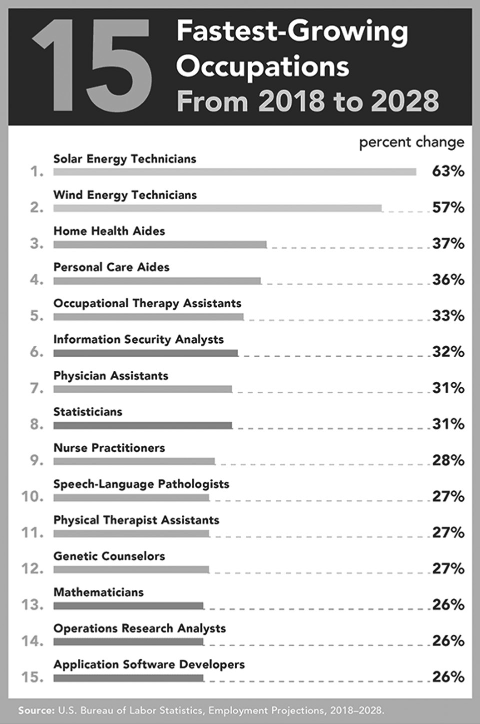

**FUTURE OCCUPATIONS**

**Biomedical Engineer**

Professionals in this field are already starting to revolutionize the health care industry. In fact, biomedical engineering is probably one of the best careers to get into if you want your work to have a positive impact in the years ahead. After all, biomedical engineers are involved in all kinds of cutting-edge research and development. For example, many of them get to design things like sophisticated medical devices, artificial organs, bionic body parts, and biological implants.

**Blockchain Developer**

You’ve probably heard of the digital cryptocurrency called Bitcoin. But how much do you know about the underlying technology that makes it possible? Blockchain technology works as a distributed cryptographic ledger that can make economic and other types of transactions decentralized, faster, and more private. It’s all a bit hard to understand, but many experts believe that blockchain technology will eventually be just as world-changing as the Internet. That’s why professionals who understand how to develop practical services and products with blockchain technology will probably be in high demand well into the future.

**3D-Printing Technician**

Many futurists believe that we’ve only just begun to scratch the surface of what 3D-printing technology (aka additive manufacturing) will ultimately be capable of achieving. Hobbyists, industrial designers, biomedical engineers, and other people are already experimenting with on-demand manufacturing of things like tools, food, clothing, everyday household objects, medical implants, and aviation, automotive, and electronics components. As this technology advances, 3D-printing machines may become just as commonplace as refrigerators and microwaves.

**Remote Health Care Engineer**

As robotics and communications technologies get more advanced, it’s becoming possible for doctors and other health care specialists to consult with patients without being physically present. Technology is even being developed and perfected to allow surgeons to perform remote operations with the assistance of robots. In the future, many more remote health care engineers will develop and coordinate the use of advanced technology that allows patients to get diagnosed and treated by almost any medical specialist in the world, regardless of where he or she is physically located.

COVID-19 SERIES | LEARNER’S WORKBOOK | GRADE 10

35

**Urban Agriculture Specialist**

Here’s a startling fact: Each year, the urban population on Earth grows by the equivalent of about seven Chicago-sized cities. That means, from 2010 to 2050, the global population of city dwellers will double, reaching about 5.2 billion people. In addition, many of today’s industrial farming practices are damaging the natural environment. So in order for cities to be sustainable, they’ll need to grow their own food using sophisticated hydroponics and vertical farming methods. Demand for professional urban farmers will likely grow as more cities and urban dwellers realize that their survival depends on growing food locally.

**Tech Ethicist**

Humanity still hasn’t fully learned that we shouldn’t do something just because we can. Ethicists have the job of trying to help us avoid learning that lesson the hard way. They help us examine hard-to-answer questions in relation to new technologies and their potential consequences. For example, should we allow the creation of “designer babies?” Who has parental rights when a human is conceived, grown, and born in a laboratory, outside of a mother’s womb? Should we grant artificially intelligent robots the same rights we have? How much information are we entitled to know about other people? The questions are almost limitless given how quickly technology is changing our world.

**Virtual Reality Designer**

Most people like to travel and explore places they’ve never been. However, you don’t necessarily have to physically travel anywhere in order to see and experience new places. Whole virtual worlds are being created, and the supporting technology will increasingly allow you to interact with it using all of your senses. A lot of VR users might even form deep relationships with other people’s virtual avatars while having adventures that they would never experience in the real world.

**JOBS THAT DON’T QUITE EXIST YET (But Probably Will)**

**Custom Body Part Manufacturer**

At some point, waiting lists for organ transplants will probably become a thing of the past. Soon, doctors may be able to order up custom organs that are grown or 3D-printed using their patients’ own cells. After all, scientists have already had some success at creating hearts, kidneys, and livers in their labs. They’ve even grown skin, ears, and other external body parts.

**Hyper-Intelligent Transportation Engineer**

We’re quickly moving toward a future in which humans will no longer be the operators of transport vehicles. Self- driving cars are probably only the beginning. With more intelligent machines and several advanced technologies already in place or being developed, a future of fully automated transportation networks may become reality. A new paradigm of smart roads, vacuum-tube tunnels, maglev trains, and many other advanced transportation systems could replace our current one.

**Cyborg Designer**

By combining the best aspects of a natural organism with those of an advanced robot, it may be possible to create a new entity that is superior to the sum of its parts. So, in the future, highly creative cyborg designers might be in demand as humans try to merge themselves with machines in order to transcend their natural limitations. Other non-human cybernetic organisms may also be developed for use in health care, entertainment, sports, space exploration, and many other industries.

**Space Tourism Guide**

Companies like SpaceX and Virgin Galactic already have plans well underway to commercialize space travel for the public. In the relatively near future, space tourists may be going into orbit for family holidays, a little adventure, or even to conduct business. If bases are established on the moon, they may be going there too. Of course, most of us aren’t astronauts. That’s why special guides will be needed to help people prepare for space travel and get adjusted to the new environment once they’re in orbit.

**Extinct Species Revivalist**

Human actions continue to cause the extinction of various plants, animals, and micro- organisms. In many cases, we don’t realize how important those species are to the health of the world’s ecosystems until they’re gone. As zoologists and other scientists learn more about the widespread ecological impacts of extinctions, it’s becoming clear that many species play critical roles in supporting the environments that humans rely on. So conserving threatened species is often essential. But science may also advance to the point that we can actually bring back some of the species that have already gone extinct and reintegrate them into their natural environments.

SOURCE: http[s://w](http://www.trade-schools.net/articles/best-careers-for-the-future)ww.[trade-schools.net/articles/bes](http://www.trade-schools.net/articles/best-careers-for-the-future)t[-careers-for-the-future](http://www.trade-schools.net/articles/best-careers-for-the-future)

36

PROJECT-BASED LEARNING | LIFE ORIENTATION