

**Teacher’s Project Notes**

**A POSITIVE RESPONSE TO COVID-19**

**PROJECT-BASED LEARNING | LIFE ORIENTATION**

**GRADE**

**10**



Dear Teacher

Provided herewith is a **Learner’s Project Workbook** and a set of **Teacher’s Project Notes for the School- Based Assessment (SBA) Task for Term 3** as per the SBA Plan in Section 4 of the CAPS. These documents were specially created to support you with COVID-19 issues for your subject as per the trimmed Annual Teaching Plan (Section 3) for Term 3.

Most importantly, it is envisaged that this will lessen your workload as we come to grips with the disruptions caused by COVID-19.

The Learner’s Workbook and Teacher’s Project Notes were created by DBE-E3, a unit at the National Department of Basic Education which is rolling out Project-Based Learning **(PBL)** in schools, to better prepare learners for a changing world. Although you may not be part of the DBE-E3 Programme as yet, these projects were created to:

1.

Engage learners in processing the pandemic which is affecting their lives and those of their families;

Promote learner self-reliance and independent learning using safety measures; and Encourage social learning in a safe environment.

2.

3.

**Where did this all start?**

**E3: Entrepreneurship, Employability and Education is currently being rolled out in SA schools.** The DBE-E3 Unit, in response to the National Development Plan, has been working in public schools since 2018 to advocate the eventual implementation of Activity-Based Learning, with a special **focus on PBL**. E3 is part of a DBE programme to introduce *Thinking Skills for a Changing World* into the curriculum in its effort to reduce youth unemployment substantially by 2030.

**How did this work in 2018 and 2019?**

Initially three provinces in 2018, and then all nine provinces in 2019, implemented PBL in Term 3, the term in which the SBA is an actual project. This meant that the projects, written by teachers for teachers were available to select schools by the provinces as part of a pilot research project. In this initial phase schools on the programme were provided with projects for Life Skills Grade 4-6, EMS Grade 7-9 and Life Orientation Grade 10 to 11.

*The Learner’s Workbook and Teacher’s Project Notes are provided as a critical resource for you during COVID-19, and the beginning of activity-based learning and PBL as a teaching method the DBE- E3 is consciously promoting.*

**We truly respect your anxiety during this time, and acknowledge your commitment. We appreciate all your hard work.**

**TEACHER’S PROJECT NOTES**

**GRADE 10 Life Orientation**

**E³ PROJECT FOR TRIMMED ATP**

**A positive response to COVID-19**

**CONTENTS**

TEACHER AGENCY AWARD 6

LEARNER PROJECT PORTFOLIO FOR E³ WEBSITE 7

RUBRIC TO RATE THE LEVEL OF COMPETENCIES AND E-MINDSET 8

PART 1 – SETTING THE SCENE 9

1.

2.

3.

4.

The trimmed projects - E³ response to COVID-19 9

Social Learning during COVID-19 (Coronavirus) 9

Generic Project outline for all Projects 10

Teacher’s Resource Pack 11

PART 2 – THE PROJECT 13

5.

6.

Project Summary and CAPS alignment. 13

The Project in more detail 15

PART 3 – TEACHER’S RESOURCES 22

PROJECT RESOURCES

7.1

7.2

7.3

Letter to parents/caregivers 22

Primary vs Secondary resources 24

The big question in research 25

TEACHER DEVELOPMENT NOTES

7.4

7.5

7.6

7.7

7.8

7.9

7.10

Traditional vs. Activity-based Learning 27

The Project-based Learning Cycle 28

The PBL facilitator 29

The E³ competencies which we are trying to achieve 30

The journey to PBL via Enquiry-based and Problem-based Learning 30

Bridging the unemployment gap through Education 31

The E³ learning cycle 32

TEACHER AGENCY AWARD ENTRY FORM





**RECOGNISING SOLUTION-SEEKING TEACHERS**

**ENTER THE TEACHER AGENCY AWARD**

***If it’s going to be, it’s up to me***

**SO WHY?**

To reward you for being awesome! You have shown that you care, that you have found a solution to a problem that helps others and that you have just gone ahead and made it happen.

We want to acknowledge and reward you and tell the world you are our hero! We want to reward you if you can show us that you are

self-motivated, self-directed and want to grow - and if you are driven by purpose and the desire to help others.

**WHO ME?**

Yes you! Any teacher or school official who is doing something for the greater good.

**WAIT WHAT?!**

So here’s what you need to show us - you need to be able to tell us that you:

1

2

3

Had the courage to just get going Had belief in yourself to just do it

Activated a range of competencies that make you THE person that this new crazy world needs to fix it and solve its problems, competencies such as:

3.1

A great character who is self-motivated to be a SA citizen who cares, who is curious about fixing things and who has the energy, enthusiasm and resilience to carry on.

The ability to think and be creative, figure things out, find the information you need and make sense of it.

How you made connections, how you collaborated and communicated with others as you stood in their moccasins to solve problems.

**WHAT WILL I WIN?**

T&Cs: We will be awarding exciting, significant prizes of up to R5000 per prize winner. These will go to worthy recipients from each province whose solutions meet the criteria on the entry form. These will be judged by E³. Awards will be announced in the first week of every month. If no worthy entry is received that merits a prize, E³ reserves the right not to award a prize for that month.

The last winners will be announced in the first week of October 2020 when this opportunity closes. Keep an eye on the E³ website to see if you have won and to celebrate the other winners and admire their solutions.

3.2

3.3

**SO HOW MUST I APPLY?**

It’s really simple - just fill in the form at the back of this book and submit it to us.

Or submit the form on the E3 website:

[**www.e3-dbe.org**](http://www.e3-dbe.org/)[**www.ecubed-dbe.org**](http://www.ecubed-dbe.org/)

**WHEN MUST I HAND IT IN?**

NOW! You can apply anytime whenever. This is an ongoing opportunity that has no deadline. How cool is that?

6

PROJECT-BASED LEARNING | LIFE ORIENTATION

**CALLING ALL TEACHERS!**

**Think you lead the way in creating solutions to problems?**

**Enter this award and be rewarded and recognised for your unique problem-solving abilities.**



**Please send us pics/videos for our Facebook/Website**

**Send your pictures and videos!**

Dear learner

We are so excited to see your project and we would like you to share it with us so that we can profile it on our website and possibly on Facebook or Instagram. To do that, please follow these instructions very carefully.

**HOW TO PUT TOGETHER YOUR INFORMATION:**

**Tell us about your project:**

1.

2.

3.

4.

5.

6.

7.

Product or service you created:

Name of learner:

School:

Grade:

Describe your project. (50 – 100 words)

Describe the biggest challenge you had doing this project. (50 – 100 words) Describe what you would do better next time. (50 – 100 words)

**Choose the right photographs to tell the story of your project**

1.

2.

3.

Choose three photographs that tell the story and progress of your project. Make sure that no-one’s face is clearly visible unless they are wearing masks.

Make sure the picture is in focus and clear.

**How to send your submission:**

1.

2.

3.

All submissions must be in a word document and the pictures must be in the document. You can send it to us on email.

You can email it yourself, or you can ask your parent/caregiver or teacher to do this for you. You must use this subject line on the email: *Learner Project Grade 10 LO*.

[info@ecubed-dbe.org](mailto:info@ecubed-dbe.org)

Email

If needed, we might ask you to make some changes to your submission in order to make it ready for uploading onto our website.

COVID-19 SERIES | Teacher’s Project Notes | GRADE 10

7

8

PROJECT-BASED LEARNING | LIFE ORIENTATION

**RUBRIC TO RATE THE LEVEL OF COMPETENCIES AND E-MINDSET**

**Did your entrepreneurial mindset grow whilst managing this project?**

**Personal rating**

(1=Poor, 4=Excellent)

**Pre-project**

**Post-project**

**COMPETENCIES**

**Character**

Citizenship

I am very committed and involved in various activities in my community and people regard me as someone to follow in my circle of influence.

Curiosity

I am very curious about everything around me and all my senses are alerted to possibilities which I always put into practice.

Resilience

When I face challenges I am always excited about the possibilities and I always get up after I have been unsuccessful. I am always enthusiastic about what I have learned in the process.

**Thinking**

Creativity

I always use my imagination to come up with original ideas and/or I am always creating new things.

Critical thinking

I always form judgements based on my ability to analyse and evaluate objectively.

Reasoning

I always think about things in a logical and sensible way and I always come up with conclusions easily.

**Collaboration**

Collaboration

I always produce good work / things by working well with people (individuals or a team).

Communication

I am always successful in conveying or sharing ideas or feelings.

Empathy

I have a highly developed ability to understand and share the feelings of others.

**E-MINDSET**

**Agency**

Growth mindset

I am always open to new information and am always willing to change my beliefs, assumptions and actions as a result.

Motivation

I always do what needs to be done without needing to be influenced by other people or situations. I always find a reason or the strength to complete a task, even when it is challenging, without giving up or needing anyone else to encourage me.

Internal locus of control

I always have control of my life and my work is always my own and it is because of this that I experience success often. I never blame others or circumstances for my lack of success.

Regulation of emotion

I always respond to the demands of a situation with emotions that are socially tolerable and sufficiently flexible to allow spontaneous or delayed reactions – whichever are appropriate.

**Self-efficacy**

Tasting success

I have always done things successfully enough to give me “the taste of success” that makes me motivated to want more and to believe that I can get it.

Socially relatable role model

I have always been fortunate to have been exposed to excellent role models that I can relate to and who make me motivated to want to be like them.

Positive support

I have always been fortunate to have had someone who has been a positive support to me and who has encouraged me and seen me as a person.

**Solution- seeking**

Resourceful

I always find quick and clever ways to overcome difficulties and find solutions.

Problem solving

I always find solutions to difficult or complex problems.

**PART 1 – SETTING THE SCENE**

**1. THE TRIMMED PROJECTS - E³ RESPONSE TO COVID-19 (CORONAVIRUS)**

DBE and E3 are collaborating to create projects for the new trimmed curriculum. In the past, lead teachers would gather and projects would be created during a writer’s workshop. A similar process is being followed now, but remotely.

In Grade 10 we shall be working on one larger project. Learners will plan a Career Expo and create a poster on a chosen career that has been highlighted due to the current coronavirus pandemic.

**Time frame for project completion**

The assessment for Term 3 is a project. As a teacher, you will know your learners and their context best, so adjust the project as necessary. This is why we have included an MS Word version so you can edit or translate if you’d like to.

Please note that learners will be working on their own for the most part of the project. Your role is to support the learner wherever it is possible. Create a Question-wall and remember to promote the *Wh-wall* because there will be unrelated questions to the project, personal issues, traumatic events, etc.

Use this opportunity to press learners to do as much research and investigating as is possible – if we plan this well we shall succeed. This is an excellent chance to develop learner agency and self-reliance.

**Ideas for planning:**

1.

Write a letter to the caregivers, parents, family and siblings (an exemplar letter is part of this pack for your use) explaining the need for their support.

Break up the projects into small deadlines that you will check regularly.

Help learners manage some social learning. (See social learning on the next page.)

**PLEASE NOTE: Part 1 and Part 2 of this booklet must be printed and are the minimum project resources you as teacher will need.** However, the rest of the booklet contains valuable tools for personal development, as well as very good sources in support of the project. You don’t have to look anywhere else.

**PLEASE NOTE**: Don’t forget to enter the Teacher’s Agency Awards - see page 6. This programme is accompanied by podcasts, audio recordings and videos.

Encourage learners to document the process of their projects (see learner submission instructions in the learner’s workbook) for the E³ website which will provide a space for showcasing learner excellence.

Email: [info@ecubed-dbe.org](mailto:info@ecubed-dbe.org)

2.

3.

4.

5.

6.

7.

**2. SOCIAL LEARNING DURING COVID-19**

Individual learners will be “scientists” and go through a process (including elements of design thinking, problem- based learning, etc.) which will guide them to solve a problem. Learners will not have groups to work with, but the social learning can be facilitated by:

2.1

Notes/WhatsApp/face-to-face questions to teachers (give them a contact number or place a box for queries at the door of your classroom).

A *WH*-wall for *Who? Why? What?* (and also *How?*) questions that are posted on the wall. Learners write their open-ended question in large letters on pages that can be stuck on the wall, anonymously if learners wish.

2.2

COVID-19 SERIES | Teacher’s Project Notes | GRADE 10

9

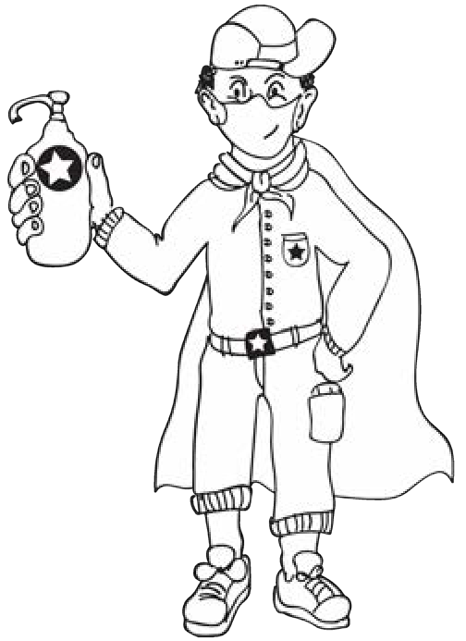



You could review all the questions once a week (after they have been on the wall for at least 48 hours) and answer the important questions. The questions need not be about the project – it is a great opportunity to allay general fears about the “new normal” of living and going to school during the pandemic and also to encourage questioning techniques.

Have learners appoint a buddy-guard

(a safe critical friend whom s/he has iden- tified before the project has started. The pair will agree that they give each other support and feedback at school with social distancing and via

text and WhatsApp messages).

The family care-givers will also have a letter sent to them to explain their role.

2.3

2.4

**3.**

**GENERIC PROJECT OUTLINE FOR ALL PROJECTS**

**STEP 1: Planning**

1.

Learners brainstorm the problem that needs to be solved on their own, or with their buddy-guard, teacher or family. The brainstorm could also be a class activity done by the entire class.

Learners list questions that will help them think of the BIG question that will guide them in solving the problem.

They write down the topic of their research – the BIG question.

2.

3.

**STEP 2: Research/Finding out**

1.

They note down five sources of information from the following that they are planning to use to gather information:

•

•

•

People they could interview Articles they could read Websites they could go onto

2.

They identify someone who might help them if they need information whilst stuck at home.

**STEP 3: Making and showing evidence**

1.

2.

3.

What equipment will be needed to create the project item? Where will information on how to make the item be found? How many times did they try before they got it right?

PROJECT-BASED LEARNING | LIFE ORIENTATION

10

HOW?



**STEP 4: Getting feedback and changing if you need to**

1.

2.

3.

Learners get feedback from their buddy-guard, parents or caregivers or teacher. They use information they have gathered to improve their product.

They note what they changed, when they made changes and why.

**STEP 5: Finishing off the project**

Using all the feedback and what was learned after trying to improve their product, learners finish off their project item and the writing that goes with it.

**STEP 6: Showing off your project**

1.

2.

They show off their project to as many people as it is safe to show it to.

People who view the projects (even those at home) write down their feedback or leave notes or send voice notes. Learners ensure that their WhatsApp number is on the project item and notes.

The final item is taken to school and the teacher and learners arrange that the projects are shown to the rest of the school.

3.

**STEP 7: Thinking about it afterwards (Academic and Personal Reflection)**

**Academic Reflection:**

1.

2.

3.

4.

5.

The problem The solution

Steps I went through to reach the solution My challenges

Rating my final product

**Personal Reflection:**

1.

2.

3.

4.

What did I love about working on this project? What made this project hard for me?

What did I learn by working on this project? About myself? About COVID-19? What would I do differently if I did a project like this again?

COVID-19 SERIES | Teacher’s Project Notes | GRADE 10

11

**4. TEACHER’S RESOURCES**

See the Resource Pack in Part 3 of these notes to help you manage the project and to help you save time. Included you will find:

**Practical Assistance, e.g.:**

1. **PROJECT RESOURCES**

A letter to the parents and caregivers.

*The difference between Primary and Secondary Resources; How to formulate the big question, etc.*

1. **TEACHER DEVELOPMENT NOTES,** e.g.:

Project-based Learning is a new pedagogy for teachers. We’ve included the E³ model and a variety of interesting articles to develop your PBL skills.

*The Project-based Learning (PBL) Cycle and your role as a Project Manager; The journey to Project-based Learning which starts with Enquiry-based Learning and Problem-based Learning, etc.*

**Resources in the Learner’s Workbook**

The Learner’s Project Workbook is enriched with many resources to help the learner complete the project independently. We are aware that learners will not have access to primary and secondary sources, so we’ve tried to address this obstacle.

And now, for a summary of the Grade 10 project.

12

PROJECT-BASED LEARNING | LIFE ORIENTATION

 **PLEASE NOTE:**

* After introducing the CAPS topic in class, learners are orientated towards the project and then left to deal with the project as an individual learner with access to all their resources.
* The number of weeks allocated to a topic in the CAPS does not mean that the length of the project is limited. Remember: the project is a tool to allow deeper investigation into a serious problem that impacts learners.
* We recommend that a learner be given 3 to 4 weeks to complete a project.



**PART 2 – THE PROJECTS**

**5.**

**PROJECT SUMMARY AND CAPS ALIGNMENT**

COVID-19 SERIES | Teacher’s Project Notes | GRADE 10

13

**PROJECT Part 1: Who am I? My Personal Journal**

**Alignment CAPS (trimmed ATP)**

**Description of Project**

**Week: 1-4 Development of Self in Society**

**Life roles: nature and responsibilities**

* Life roles as child, student, adult, role in family, partner, mother, father, grandparent, breadwinner, employee, employer, leader and follower
* Evolving nature of roles and responsibilities inherent in each role; how roles change and affect relationships
* Evolving nature of life-roles as a result of COVID-19

**Handling each role effectively**

* Changes towards adulthood
* Changes associated with development towards adulthood
* Evolving nature of life roles and the demands it puts on children, family members, adults, elderly, etc. as a result of COVID-19

**Development of Self in Society**

* Emotional changes: maturing personality, depth and control of emotions, feelings of insecurity, changing needs, interests, feelings, beliefs, values and sexual interest
* Social changes: relationship with family, interaction with social groups, need for acceptance by and dependence on peer group, moving into the workforce and increased responsibilities
* Coping with change: importance of communication and making friends
* The effects of COVID-19 on established norms of family life

Learners complete 8 short entries in a journal.

This means thinking deeply about the coronavirus and how it has affected them and their families, both in a good and a bad way.

Has the pandemic made them think differently about the future?

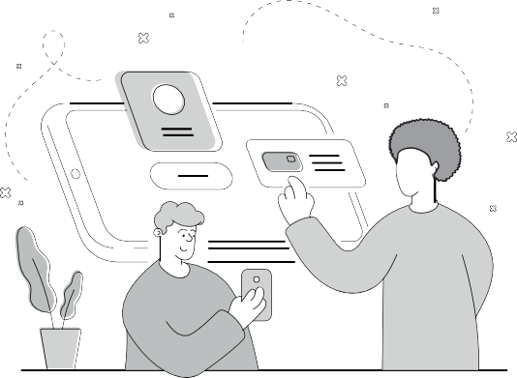

14

PROJECT-BASED LEARNING | LIFE ORIENTATION

**PROJECT Part 2: Career Gallery:**

**Creating a poster/video/PowerPoint presentation on possible career paths post COVID-19.**

**Where am I going? How will I get there?**

**Alignment CAPS (trimmed ATP)**

**Description of Project**

**Week: 5-8**

**Diversity in jobs: Economic sectors: primary (raw materials), secondary (finished products or goods) and tertiary (infrastructure and providing services)**

* Work settings: workplace environment and conditions; indoors and outdoors (laboratory, mine)
* Activities involved in each job: designing, assembling and growing.
* Management and preparation of the workplace to minimize the spread of COVID-19 to employees/ employers
* Safety issues at the workplace The importance of observing the fol- lowing: Fumigation, testing and monitoring
* Provision of information on safety procedures
* Constant monitoring for adherence
* The use of Personal Protective Equipments (PPEs)

**Skills and competencies: information gathering or analysis and instruction**

* Various facets of self and integration into the world of work
* Opportunities within different career fields including work in recrea- tion, fitness and sport industries
* Alignment of personal facets to the new job opportunities that COVID-19 makes available
* Matching personal facets to the new jobs that COVID-19 has made available including those that were not known or common

**Research skills, salary package, promotion, and further study prospects**

* The need for new jobs arising from the advent of COVID-19

**Changing nature of jobs:**

* New jobs
* Redefinition of old jobs
* Changing nature of the workplace, etc.

**Time management**

* Effective use of time to Identify personal abilities and skills required for post COVID-19 challenges

**Project 2:**

Learners research, design and create a poster, PowerPoint presentation or video on careers that have been highlighted during the COVID-19 pandemic and the impact that COVID-19 has had on the choice of careers or a new job that may not have been showcased prior to the advent of COVID-19.

The aim of the project is to involve every learner in class in the creation (researching, writing and illustrating) of an A3 or A2 poster on: COVID-19 careers and what the job market will look like post-COVID -19.

If COVID-19 regulations allow at the time, the posters can be displayed at an open day. The school can invite parents, the whole school communi- ty and members from media houses to be part of this event.

Alternatively the grade 10 project can be on display for enjoyment by the rest of the school, keeping to the regulations.

Do not exclude some kind of public display, if possible. This motivates learners to give of their best work.

Finally, they present their findings at a public event (they might want to introduce their research to younger grades in school) if and should COVID-19 regulations allow.

Alternatively, the display can be digital



**6. THE PROJECT IN MORE DETAIL**

The following step-by-step unpacking of the project explains the tasks and your role in managing the project. Items marked with (*) can be found in PART 3 of this booklet or in the resource pack at the back of the Learner’s Workbook.

**6.1**

**PROJECT: Creating a poster/video/PowerPoint presentation on possible career paths post COVID-19.**

COVID-19 SERIES | Teacher’s Project Notes | GRADE 10

15

**STEP 1 - Planning**

**TASK**

**Teacher’s Role**

**Resources**

**Competencies**

**Part 1: Baseline – My per- sonal journal: Who am I?**

Learners start with a base- line assessment of their feelings and ideas by com- pleting Activities 1 to 4 in the Learner’s Workbook. This is an ongoing process during the project.

**The Career Gallery:**

Learners watch the video or read the video transcription about careers in the 21st century and are asked to

re-assess the career space post COVID-19.

They are introduced to the outcome of the project: A Career Gallery where they will display one of the fol- lowing items to share their research on careers: an academic poster, a power point presentation or a short video.

Learners play the Perfect Entrepreneur game – many never consider starting an enterprise as a career.

Learners are introduced to journaling, do a WITS

analysis on themselves and reflect on how COVID-19 has changed their environments and their futures.

**Baseline – My personal journal: Who am I?**

1. Before the actual project starts, learners start taking stock of their feelings and ideas in the form of a mindmap in which they analyse how the coronavirus has af- fected their lives (Activity 1).
2. Introduce learners to the process and idea of journaling. Ask them to start with their first entries. Explain that there is no right or wrong way to go about it, since it is a very personal way to reflect on your days, happenings and thoughts about it. It should be an ongoing process during the project (Activity 2).
3. Learners now take stock of who they are now and analyse how they have changed especially in terms of their roles and re- sponsibilities. (Activity 3)
4. In Activity 4.1 – 4.4 ideas on how to armour themselves emotionally, socially and in terms of values against the onslaught of COVID-19 are explored.

**The Career Gallery:**

1. Tell learners about the project and the outcomes expected from them and guide them in creating questions to direct their career research.
2. Explain the Perfect Entrepreneur game and keep time while learners play with their buddy-guards.
3. Explain the reason or meaning of a WITS analysis and guide learners to complete it.
4. They read the article in their Library and reflect.

Video on careers URL: https:// youtu.be/ PZiTyw34IZQ

Screen to view video on

* Memo:

The Perfect Entrepreneur game

* What is a journal?

Textbook

Learner’s Workbook

*Articles on careers post COVID-19

**Character** Citizenship Curiosity Resilience Mindset

**Connection** Collaboration Communication Empathy

**Thinking** Creativity Critical thinking Reasoning

 **NOTE: Please track Competencies**

The column on the far right is for you to mark/underline which **competencies** you think you touched on, or were developed, in each step or task. E.g. Citizenship. **You also take stock of your competencies in the pre-project rubric on page 8.**



16

PROJECT-BASED LEARNING | LIFE ORIENTATION

**STEP 2 - Research/ Finding out**

**TASK**

**Teacher’s Role**

**Resources**

**Competencies**

Identify career or entrepre- neurial opportunities created by the COVID-19 Pandemic.

Learners each choose a career they will research.

Learners design a poster, PowerPoint or video with all the information research about this specific career.

Remind learners about keeping their journals updated.

1. Guide learners in doing research on their chosen careers in class or at home..
2. Explain sources and referencing, and show them the video. There is a transcript of the video in the Learner’s Library if video viewing is not possible.
3. Guide them to the careers section of the Library. They then complete questions 1 to 3.
4. Learners start planning the outline of a poster, PowerPoint or video containing all the researched information.
5. Remind learners about the importance of planning so that all important information is included in their final product.
6. Remind learners to update their journals regularly.

Pens Markers A4 Paper

A3 or A2 Paper (for final posters)

Researched information

Textbook

Learner’s Workbook

* Article on careers post COVID-19
* How to create a research poster
* List of Future and COVID-19

Careers

**Character** Citizenship Curiosity Resilience Mindset

**Connection** Collaboration Communication Empathy

**Thinking** Creativity Critical thinking Reasoning

**STEP 3 Making and showing the evidence**

**TASK**

**Teacher’s Role**

**Resources**

**Competencies**

Plan and start creating a colourful, effective poster, PowerPoint presentation or video with important infor- mation on the chosen career path post COVID-19.

1. Learners gather all their research.
2. Give them time to start planning their posters/power point presentations or videos.
3. Learners now independently work on putting their poster, PowerPoint or videos together (rough drafts for feedback).
4. Remind them to also add positive outcomes of the COVID-19 pandemic in the form of career and entrepreneurial opportunities.
5. Learners finish their rough drafts for feedback.
6. Remind learners to update their journals.

* How to create a research poster
* Career day poster, PowerPoint or video project. (Google search).

A4 paper (white and coloured)

A3 or A2 poster paper

Glue stick Scissors Cello tape

Coloured pens for poster design and creation.

Cellphone for video

Computer for PowerPoint

**Character** Citizenship Curiosity Resilience Mindset

**Connection** Collaboration Communication Empathy

**Thinking** Creativity Critical thinking Reasoning



COVID-19 SERIES | Teacher’s Project Notes | GRADE 10

17

**STEP 4 - Getting feedback and changing if you need to**

**TASK**

**Teacher’s Role**

**Resources**

**Competencies**

Learners show their poster, PowerPoint or video to class mates, family, buddy-guard, teacher and other people (via safe channels like WhatsApp and social distancing, etc.)

Learners collect feedback from all sources.

Learners implement changes suggested by feedback.

1. Ask learners to show their poster/power point presentations or videos to family members and members of society for feedback.
2. Ask learners to implement the changes suggested by feedback.
3. Explain why feedback is important. Learners have to realise that it will never be perfect the first time. They must learn to keep on improving and pushing the standard.
4. Learners complete Step 4 in Learner’s Workbook and get as much feedback as possible on their ideas. They can now consider making changes.
5. Remind learners to update their journals.

Learner’s Poster designs, PowerPoint presentation or video

Learner’s Workbook

**Character** Citizenship Curiosity Resilience Mindset

**Connection** Collaboration Communication Empathy

**Thinking** Creativity Critical thinking Reasoning

**STEP 5 - Finishing off your project**

**TASK**

**Teacher’s Role**

**Resources**

**Competencies**

Learners work at home or in class, finishing off their

posters, PowerPoint or video with changes they are con- sidering after the feedback.

Brainstorm ideas on the safety for the final showing of their posters, PowerPoint or video at the Career Expo – to the rest of the community or the rest of the school if it is still unsafe.

Online display is an option.

Talk about safety measures for public display according to COVID-19 regulations.

1. Guide learners through the process of change and adaptation of their posters/ power point presentations or videos and the reason for these changes. Explain importance of iteration and reviewing projects as part of the improvement of the final quality.
2. Give them time to complete or redesign their posters, PowerPoints or videos in class and at home.
3. Brainstorm ideas with learners for the public display of their posters, PowerPoints or videos. (In class? In the school hall? Online? Safety measures?)
4. Learners prepare posters for display. Remember that they should be one-sided. They help with the set-up for the public display.
5. Remind learners to update their journals.

Learner’s Workbook

Learners’ posters, PowerPoint presentations or videos

**Character** Citizenship Curiosity Resilience Mindset

**Connection** Collaboration Communication Empathy

**Thinking** Creativity Critical thinking Reasoning



18

PROJECT-BASED LEARNING | LIFE ORIENTATION

**STEP 6 - Showing off your project**

**TASK**

**Teacher’s Role**

**Resources**

**Competencies**

Learners present their posters to other classes/ rest of the school/parents or members of the community according to plan (and with safety measures in mind)

1. Learners create a visitors’ form (and analyse feedback after the event).
2. Help learners to set up their display. They create a to-do list and script the wording for a Facebook or WhatsApp message to publicise the event.
3. Appoint a COVID-19 officer or two from class. They should see to it that all COVID- 19 regulations are followed during any public event.
4. Use rubric to assess the project.
5. Learners should have their workbook with them to complete the rest of the activities in Step 6.
6. Remind learners to update their journals.

Public area for presentation;

Sanitiser, masks, gloves or other safety measures;

* Rubric

Learner’s Workbook

Extended learn- ing opportunity:

Display posters online on school’s website, Facebook or a specially created blog.

**Character** Citizenship Curiosity Resilience Mindset

**Connection** Collaboration Communication Empathy

**Thinking** Creativity Critical thinking Reasoning

**STEP 7 - Thinking about it afterwards**

**TASK**

**Teacher’s Role**

**Resources**

**Competencies**

Reflection on success or failure of the project and lessons learned by complet- ing Activity 13

1. Please don’t skip this step.
2. Give learners time in class to reflect on the success of their project (academically and personally).
3. Remind learners to update their journal during the reflection process.
4. Do the teacher’s reflection rubric at the beginning of the book (the post-project rubric on page 8).

* Teacher’s Reflection rubric

Learner’s Workbook

**Character** Citizenship Curiosity Resilience Mindset

**Connection** Collaboration Communication Empathy

**Thinking** Creativity Critical thinking Reasoning

**Project Part 1: Journal activities and entries showing development of self – from child to adult**

**6.2**

**RUBRICS**

COVID-19 SERIES | Teacher’s Project Notes | GRADE 10

19

**Criteria**

**Level Descriptors**

**Total Mark**

**Mark obtained**

1. Initial mind-map showing aspects of life affected by Coronavirus

**0**

**1-2**

**3-4**

**5-6**

**7-8**

**9-10**

**10**

No engagement with mind-map/ no attempt to un- derstand the task

Limited engage- ment with mind- map. Very little re- flection and think- ing displayed.

2 issues analysed

Limited en- gagement but an attempt to analyse at least 4 of the issues related to the effect of the Coronavirus on self.

Adequate en- gagement with mind-map – 5 or 6 issues ana- lysed. Evidence of a growing un- derstanding of growth towards adulthood and accompanying responsibility.

Proficient re- sponses. 7 or 8 issues analysed with good insight and evidence

of growing re- sponsibility and maturity.

Excellent comple- tion of mind-map. All issues and some additional issues analysed.

Shows maturity and an accept- ance of changing role and addition- al responsibility

2. Eight Journal entries to collect ideas, experiences and feelings

**0**

**1-2**

**3-4**

**5-6**

**7-8**

**9-10**

**10**

No engagement with journal /no attempt to un- derstand the task or share ideas, experiences and feelings

1-2 journal entries completed, but clearly no deep understanding

of the reasoning behind each

3-4 journal entries completed, but no evidence of deep reflection and awareness of changing role and responsibilities

Adequate en- gagement with journal – 5 or 6 entries. Evidence of a growing un- derstanding of growth towards adulthood and accompanying re- sponsibility

Proficient journal entries. 7 or 8 entries completed showing evidence of self- analysis with good insight and evidence

of growth and maturity.

Excellent com- pletion of all 8 and more journal entries.

Shows maturity and an accept- ance of changing role and addition- al responsibility.

3. Self-analysis worksheet

**0**

**1**

**2**

**3**

**4**

**5**

**5**

No attempt to reflect on growth during COVID-19

Some evidence of analysis of situa- tion and effect on self-development, but very limited.

Some engage- ment in work- sheet. Shows an attempt to reflect and respond realistically

Adequate re- sponses to work- sheet questions. A fair attempt to reflect honestly and with some maturity.

Proficient and mature response to worksheet questions. A good attempt to analyse self re- alistically. Good insights.

Excellent. Completion of all questions and honest analysis

show deep insight and maturity as well as accepting responsibility.

**TOTAL**

**25**

**Project Part 2: Research into career provides an understanding of various elements to create a deep understanding of careers and the world of work**

20

PROJECT-BASED LEARNING | LIFE ORIENTATION

**Criteria**

**Level Descriptors**

**Total Mark**

**Mark obtained**

1. Research component: Skills and competencies in gathering and analysing information

**0**

**1-2**

**3-4**

**5-6**

**7-8**

**9-10**

**10**

No information gathered or analysed. No evidence of skills displayed.

Minimal evidence of information gathered or analysed. Minimal evidence research skills displayed.

2 issues analysed.

Some information gathered and analysed. Some evidence of research skills displayed.

Adequate amount of information gathered and analysed. A fair display of skills in research.

Solid and well-analysed and synthesised information. A good attempt to gather the required information from various

sources.

Excellent and proficient research skills in evidence. Shows mature and deep understanding of processing information.

Rigorous researcher.

2. Research-based understanding of the world of work: 3 sectors, how chosen career fits into sector

**0**

**1-2**

**3-4**

**5-6**

**7-8**

**9-10**

**10**

No evidence of understanding of the 3 sectors and how chosen career fits into the sector.

Minimal understanding of the 3 sectors and how chosen career

fits into the sector. Confuses sector and job fit.

Some evidence of understanding of the 3 sectors and how chosen career fits into the sector.

Adequate evidence of understanding of the 3 sectors but unsure of how chosen career fits into the sector.

Solid understanding of the 3 sectors and how chosen career fits into the sector.

Excellent and proficient research skills evident – excellent grasp of the three sectors and how chosen career fits in.

3. Research-based information of the chosen career: work setting, ac- tivities in career, salary

median, promotion and further study and other opportunities; Safety issues in the chosen career (6 items)

**0**

**1-2**

**3-4**

**5-6**

**7-8**

**9-10**

**10**

No items of required

information gathering in evidence. No attempt made.

Minimal effort made to research required information items. 1-2 items of information gathered.

Some information gathering – 2-3 items in evidence.

Adequate evidence that the required

information was sought. 3-4 items in evidence.

Good information gathering – 4 to 5 items of information in evidence.

Excellent information gathering – all 6 items and more enriched the research.

COVID-19 SERIES | Teacher’s Project Notes | GRADE 10

21

4. Use of appropriate media and skills to communicate the research data (Choice of poster/ power point presentation/ video)

**0**

**1-2**

**3-4**

**5-6**

**7-8**

**9-10**

**10**

No medium to communicate research

data handed in.

Poster/power point presentation/video handed in but little evidence of care in presentation or of the packaging of the data for the chosen medium

Some attempt to use design features and layout and editing to present data. Some attempt shown.

A fair understanding of the medium is displayed in the fairly good attempt to organise information in an appealing and neatly structured manner

A solid and appealing presentation of data showing pride, good planning and a good synthesis of the information gathered

Excellent and highly proficient presentation: well-

organised, appealing and showing evidence of a deep understanding of the information

5. Insight into how management can minimise spread of coronavirus

**0**

**1**

**2**

**3**

**4**

**5**

**5**

No response to how management can minimise spread of coronavirus

Little insight into how management can minimise spread of coronavirus

Some attempt to analyse how

management can minimise spread of coronavirus

Adequate insight into how management can minimise spread of coronavirus

Good insight into how management can minimise spread of coronavirus

Excellent insight and understanding of management’s task in minimising the spread of coronavirus

6. Clear insight into self and how “self” integrates into chosen career

**0**

**1**

**2**

**3**

**4**

**5**

**5**

No attempt to reflect

Little insight into self and how “self”

integrates into chosen career

Some attempt to analyse how “self” integrates into chosen career

Adequate insight into self and how “self” integrates into chosen career

Clear insight into self and how “self”

integrates into chosen career

Mature insight into self and how “self” integrates into chosen career.

Deep understanding of self and career requirements evident.

7. Understanding of doing business using 4IR communication skills (e.g. face book/WhatsApp promotion of Career Gallery)

**0**

**1**

**2**

**3**

**4**

**5**

**5**

No attempt made to com- plete this task.

Minimal understanding of doing business using 4IR communication skills (e.g. social media used but ineffectively and not to promote expo/gallery)

Some understanding of doing business using 4IR communication skills (e.g. face book/ WhatsApp promotion of Career Gallery)

Adequate understand- ing of doing business using 4IR communi- cation skills (e.g. face book/WhatsApp promo- tion of Career Gallery) Adequate message works

Good understanding of doing business using 4IR communication skills – thought went into compiling the message and all infor- mation was present.

Excellent grasp of social media for business. Creative and appealing message ticks all / most boxes.

**TOTAL**

**55**

**PART 3 – TEACHER’S RESOURCES**

**PROJECT RESOURCES**

This section offers you all the resources you might need in launching your project, reflecting on your personal devel- opment as an active learning facilitator and Project-based Learning Project Manager and practical thinking and other tools to help you in carrying out the project, e.g. step-by-step instructions and information sheets and rubrics.

**7.1 LETTER TO THE PARENTS**

You may print the letter on the next page to use.

22

PROJECT-BASED LEARNING | LIFE ORIENTATION

*Date*

***Dear Parents, Siblings and Caregivers***

*The Grade 10 learner in your care will be doing a project or two during the next few weeks.*

*A large part of the project will be done at school, but an important part will be done after school, at home.*

***How can you help?***

* *The project plan is quite structured with dates for each step clearly set out. Check the deadlines and help your child understand the importance of keeping to a schedule.*
* *The project asks learners to share information with the family at home and also to ask for feedback and advice. Please set aside some time to help when needed. Perhaps you can ask one member of the family to be the “Advisor” for the family. Your child will have to note the feedback/advice as part of the project, so this is a serious matter for your child.*
* *The Project Pack has all the information resources your child needs, but you may be asked for advice on how to do something. Your experience as an adult will give your child the support needed.*

*Good luck! Let’s learn from each other and offer our children support, empathy and care.*

*Teacher*

COVID-19 SERIES | Teacher’s Project Notes | GRADE 10

23

**7.2 PRIMARY AND SECONDARY RESOURCES**

Sources of information are often categorized as primary or secondary depending upon their originality.

**Primary Sources**

1.

2.

3.

Direct or first-hand evidence about an event, object, person, or work of art

Published materials written or produced by someone with first-hand experience of the event. Individual viewpoint of a participant or observer.

Examples of primary sources:

•

•

•

•

•

•

•

•

•

•

•

•

•

Interviews, surveys, and fieldwork

Diaries, personal letters, and correspondence

Internet communications on email, blogs, and newsgroups Photographs, drawings, and posters

Books, magazine and newspaper articles and ads published at the time Public opinion polls

Speeches

Original documents (birth certificates, property deeds, trial transcripts) Research data, such as census statistics

Official and unofficial records of organizations and government agencies Radio interviews, DVDs, and video recordings

Government documents (COVID-19 pamphlets, reports, etc.) Scientific journal articles reporting experimental research results

**Secondary Sources**

1.

2.

3.

4.

Describe, discuss, interpret, comment upon, analyse, evaluate, summarize, and process primary sources Written or produced after the fact with the benefit of hindsight

Lack the freshness and immediacy of the original material

Collect, organize, and repackage primary source information to increase usability and speed of delivery, such as an online encyclopaedia.

Can be written or non-written (sound, pictures, movies, etc.).

5.

Examples of secondary sources:

•

•

•

•

•

•

•

•

•

•

Bibliographies Biographical works

Reference books, including dictionaries, encyclopaedias, and atlases Articles from magazines, journals, and newspapers after the event Literature reviews and review articles (e.g., movie reviews, book reviews) History books and other popular or scholarly books

Works of criticism and interpretation Commentaries and treatises Textbooks

Indexes and abstracts

https://sccollege.edu/Library/Pages/primarysources.aspx

24

PROJECT-BASED LEARNING | LIFE ORIENTATION

**How to reference this source:** Staff writer, date unknown. *Identifying primary and secondary source,*

viewed on 2 June 2020, <https://sccollege.edu/Library/Pages/primarysources.aspx>

**7.3 THE BIG QUESTION IN RESEARCH**

Essential questions, or driving questions, are a key element of project-based learning, so we’ve outlined 14 essential question stems to help you craft **the most engaging PBL essential questions**.

**1.**

**How can improve ?**

*How can studying different cultures improve our understanding of our community? How can robotics improve the healthcare industry?*

*How can access to clean water improve communities, especially during coronavirus?*

**2.**

**How can be applied to ?**

*How can entrepreneurship skills be applied to subjects like science and geography? How can entrepreneurship skills be applied in our daily lives?*

*How can ethics be applied to solve environmental problems?*

**3.**

**How can change ?**

*How can individuals change their communities? How can kindness change bullying?*

*How can the human behaviour change the environment?*

**4.**

**How would you design a new ?**

*How would you design a new school?*

*How would you design a new system to purify water? How would you design a new flag for your community?*

**5.**

**How does affect ?**

*How do poor eating habits affect communities around the world? How does bullying affect our community?*

*How does violence affect our daily lives?*

**6.**

**What impact did/does have on ?**

*What impact does climate change have on the environment during the 20th century? What impact does the coronavirus have on children’s sense of security?*

*What impact does social media have on our understanding of the facts surrounding the coronavirus pandemic?*

**7.**

**What makes a good/effective ?**

*What makes a good library? What makes an effective school? What makes a happy classroom?*

**8.**

**How do/does impact my community?**

*How does racism impact my community?*

*How does the food grown in our region impact what people eat? How does bullying and violence impact my community?*

COVID-19 SERIES | Teacher’s Project Notes | GRADE 10

25

**9. What is the relationship between and ?**

*What is the relationship between maths and everyday life? What is the relationship between science and entrepreneurship? What is the relationship between transportation and trade?*

**10. What would be without ?**

*What would our school be without classrooms?*

*What would the Earth’s climate be like without the atmosphere? What would the world be without art?*

**11. If you were in charge of , what would you change?**

*If you were in charge of our school, what would you change?*

*If you were in charge of our community, what would you change? If you were in charge of Facebook, what would you change?*

**12. How can you use to inspire ?**

*How can you use poetry to inspire change?*

*How can you use storytelling to inspire people take better care of the environment? How can you use science to inspire people to eat healthier food?*

1. **What if ?**

*What if you could go back in time, what would you change? What if South Africa did not have schools?*

*What if the world lost the internet for one year?*

1. **How might your community change if ?**

*How might your community change if it were twice as big?*

*How might your community change if it rained every day for a year?*

*How might your community change if every person were given R1 million?*

Seeing the different ways learners approach an essential question is one of the most rewarding parts of project-based learning, and you’ll get to learn a lot about the learners in your class! Engage students through project-based learning by providing them with great PBL essential questions, then watch them dive in and take control of their own learning.

http[s://w](http://www.penpalschools.com/blog/easy-project-based-learning-question-stems-for-essential-questions)ww[.penpalschools.com/blog](http://www.penpalschools.com/blog/easy-project-based-learning-question-stems-for-essential-questions)/[eas](http://www.penpalschools.com/blog/easy-project-based-learning-question-stems-for-essential-questions)y[-project-based-learning-question-stems-for-essential-questions](http://www.penpalschools.com/blog/easy-project-based-learning-question-stems-for-essential-questions)

26

PROJECT-BASED LEARNING | LIFE ORIENTATION

**How to reference this source:** Staff Writer, 2020. PBL: Easy essential stems for project-based learning, viewed on 2 June 2020, <http[s://w](http://www.penpalschools.com/blog/easy-project-based-learning-question-stems-for-essential-)ww[.penpalschools.com/blog](http://www.penpalschools.com/blog/easy-project-based-learning-question-stems-for-essential-)/[eas](http://www.penpalschools.com/blog/easy-project-based-learning-question-stems-for-essential-)y[-project-based-learning-question-stems-for-essential-](http://www.penpalschools.com/blog/easy-project-based-learning-question-stems-for-essential-) questions>



**TEACHER DEVELOPMENT NOTES**

**7.4**

**TRADITIONAL VS. ACTIVITY-BASED LEARNING**

COVID-19 SERIES | Teacher’s Project Notes | GRADE 10

27

**Traditional — teacher centred**

**Activity-based — learner centred,**

**e.g Project-based Learning**

Basic learning

In-depth learning

Bigger class size

Smaller groups within class

Isolated subjects

Integrated/interdisciplinary subjects

Product-oriented

Process-oriented

Learning by repetition

Learning through active involvement

Concepts are facts to memorise

Concepts are questions to be investigated

Quantitative evaluation (numerical testing)

Authentic assessment (competencies, integrated, mindset)



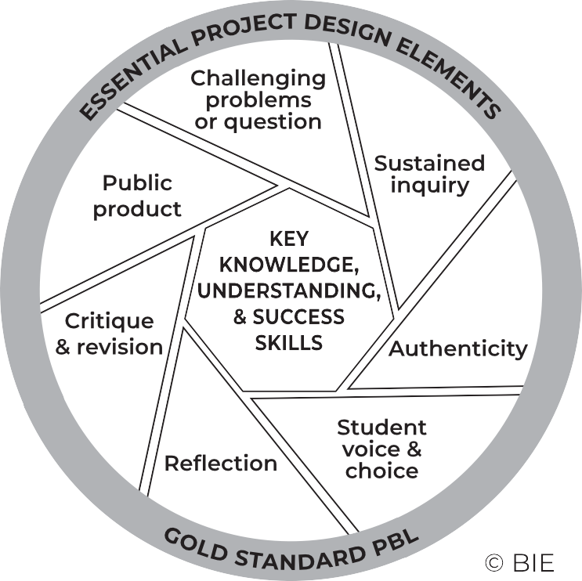

**7.5 THE PROJECT-BASED LEARNING CYCLE**

Below please find the *Key Knowledge*, *Understanding* and *Success Skills* to help you manage the project.

**Challenging problem or question:** Why is this project critical? What is the problem in society and at school being addressed in this project? Keep talking about how this project will solve a local or global problem.

**Sustained enquiry:** Are learners being “researchers”? Are they doing the research and getting deeper and deeper into the problem or are you doing all the talking? Look at the second circle overleaf

to remind you of your role: manage activities and scaffold student learning. Learners must not be allowed to give up – you must “build a culture” of getting to the bottom of the problem and coach them when they lose their way. With time E3 will be developing thinking tools to ensure that you are equipped with strategies to take the enquiry to a new level.

**Authenticity:** Keep the project real by referring to learners’ own lives – this is about them and their world.

**Student Voice and Choice:** Although learners did not choose this project, make it fun and real, and applicable to their own world, so that they own it. Their voices and opinions are what your deeper goal is – encourage their views and applaud each contribution.

**Reflection:** To truly embed learning, learners should be able to reflect on what they have learned and be able to think of better ways of doing things. The reflection activities in the worksheets are not just for fun. Encourage learners to spend time on them as this will deepen their learning.

**Critique and Revision:** This process is to help learners experiment with their innovation and learn how to improve their work and thinking. As you assess and evaluate their products (not them!) learners will see that there are different ways of solving problems. It is important that learners hone their curiosity and learn how to “stick it out” and keep trying, not giving up when it doesn’t work first time round.

**Public Product:** At the end of the project what does the learner have to show or to brag about? Ensure that there is a Project Culmination Week in which each grade displays their products during a week selected by the management team to ensure that many stakeholders attend.

28

PROJECT-BASED LEARNING | LIFE ORIENTATION

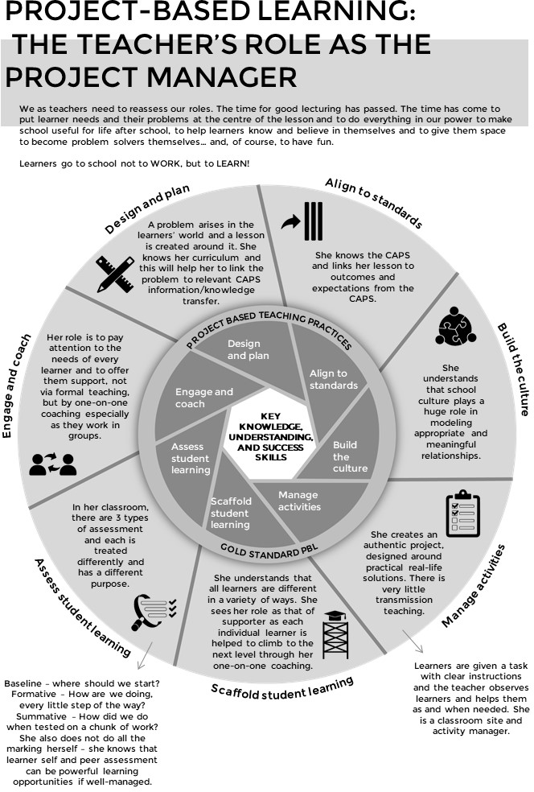

**7.6 THE PBL FACILITATOR**

COVID-19 SERIES | Teacher’s Project Notes | GRADE 10

29

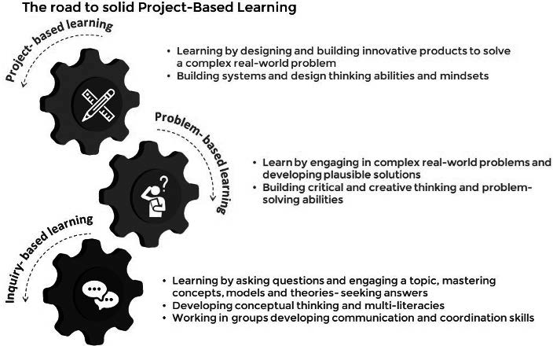

**7.7**

**THE E3 COMPETENCIES WHICH WE ARE TRYING TO ACHIEVE**

**THE E3 COMPETENCIES WITHIN THE CAPS**

**THINKING**

**CHARACTER**

**CONNECTION**

**creativity**

**critical thinking and reasoning**

**citizenship curiosity resilience**

**mindset**

**collaboration communication**

**empathy**

These appear in the competencies column of your planning. Please highlight each competency that was addressed during the lesson.

**7.8**

**THE JOURNEY TO PBL VIA ENQUIRY-BASED AND PROBLEM-BASED LEARNING**

30

PROJECT-BASED LEARNING | LIFE ORIENTATION

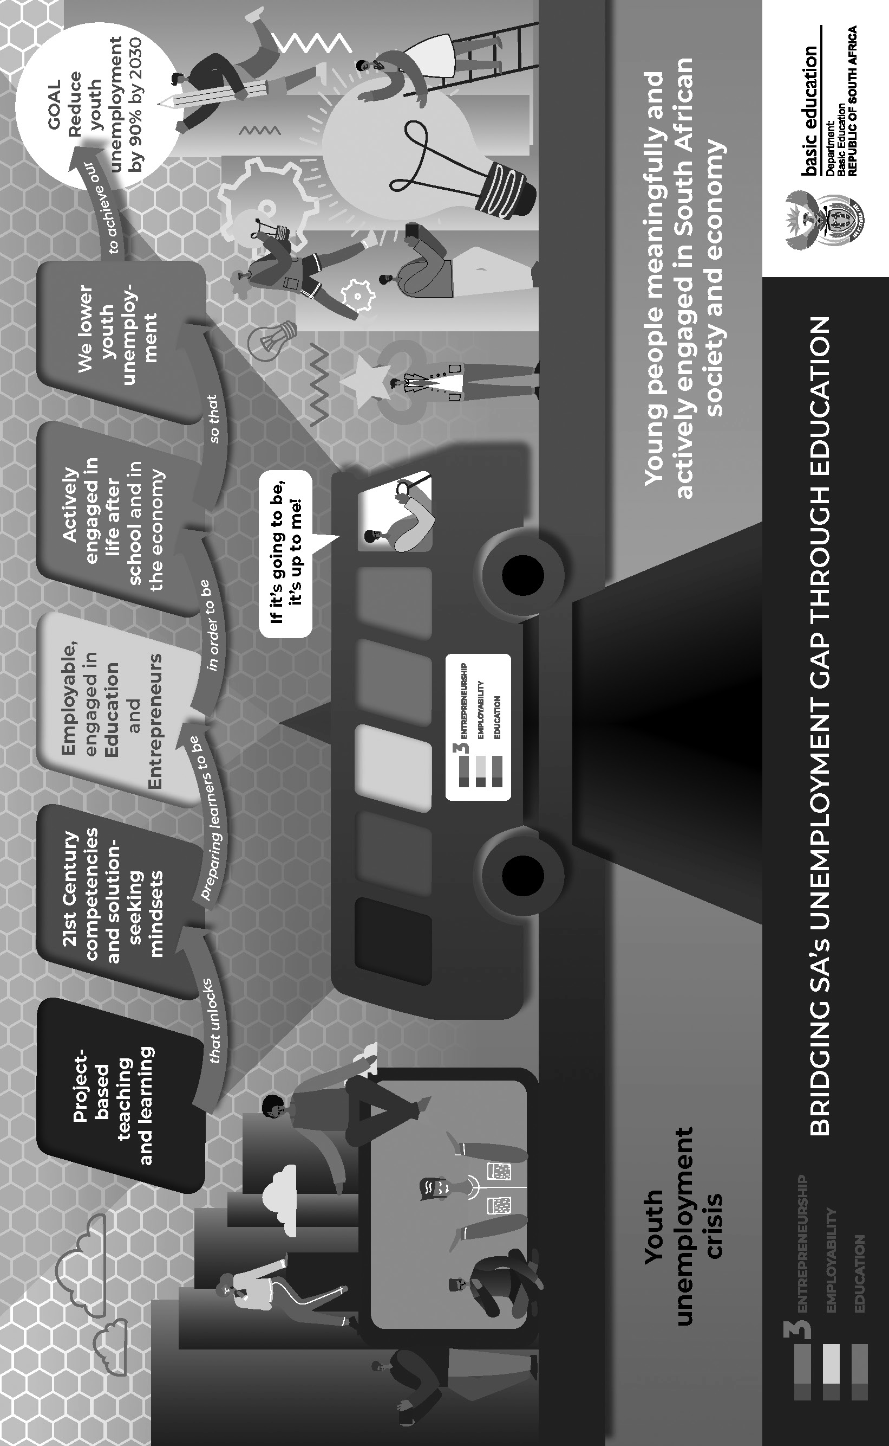

**7.9**

**BRIDGING THE UNEMPLOYMENT GAP THROUGH EDUCATION**

COVID-19 SERIES | Teacher’s Project Notes | GRADE 10

31



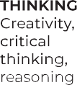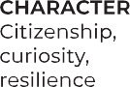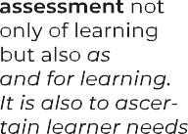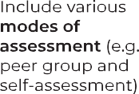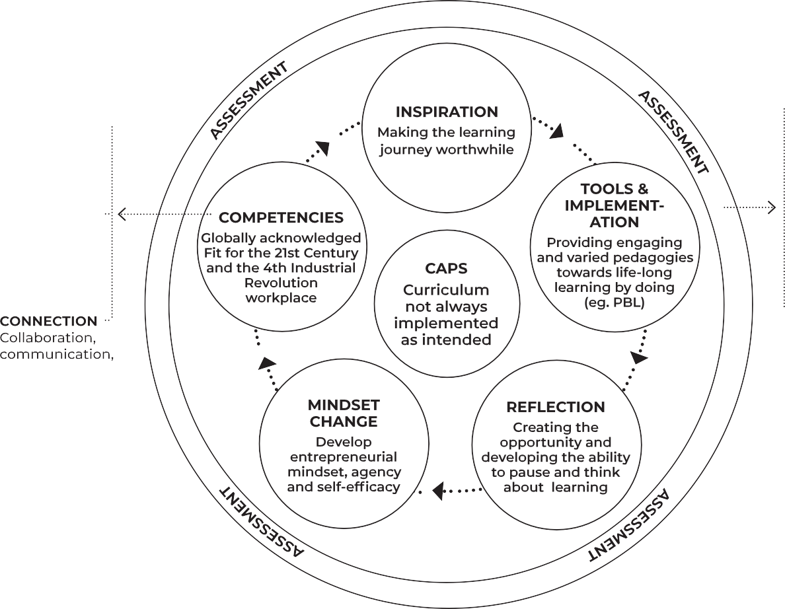

**7.10**

**THE E3 LEARNING CYCLE – PEDAGOGICAL PARADIGMS**

32

PROJECT-BASED LEARNING | LIFE ORIENTATION



Email your completed form to [info@ecubed-dbe.org](mailto:info@ecubed-dbe.org) with the subject line “Teacher Agency Award submission

[**info@ecubed-dbe.org**](mailto:info@ecubed-dbe.org)

Name of your solution:

Why did you choose this name?

Identifying the problem: *(Maximum 200 words)*

*I identified the following problem in my school/community/at home:*

E3 Teacher Agency Award Form | Page 1 of 5

Name:

Position: (e.g. Teacher, SMT, etc.)

**If teacher:**

Subject taught:

Grade:

School name:

District:

Province:

**Your contact details:**

Email:

Cell number:

WhatsApp number:

**TEACHER AGENCY AWARD FORM**

Trying, adapting the process until problem was solved: *(Maximum 200 words)*

*Initially I …. Then …. Eventually I could solve the problem in this way: ……*

E3 Teacher Agency Award Form | Page 2 of 5

Collaboration and access to information: *(Maximum 200 words)*

*I collaborated with …. and accessed information from …. which helped me in the following ways…*

Creativity and innovation: *(Maximum 200 words)*

*My solution was very creative because I …. My solution was unique and innovative because …*

E3 Teacher Agency Award Form | Page 3 of 5

Meeting E3 standards: *(Maximum 200 words)*

Explain why you are an E3 ambassador and tribe member. Use phrases like the following in your explanation:

*I care and want to help others: ………………………………………………………...*

*I am a problem-solver:……………………………………………………………………….*

*I am awesome: …………………………………………………………………………………...*

*I am driven by purpose:……………………………………………………………………….*

*I have courage and self belief:……………………………………………………………….*

*I can keep going, despite challenges:………………………………………………………*

E3 Teacher Agency Award Form | Page 4 of 5

Provide us with each of the following (please include clear notes on the pictures and videos):

Your 4 best pictures (2 in portrait and 2 in landscape)

A VoiceNote of not more than a minute reflecting on your growth in this project A short video that shows an important episode in the project

If minors appear in the photos and video, please submit permission from parents or caregiv- ers that these photos appear on E3 platforms.

•

•

•

•

E3 Teacher Agency Award Form | Page 5 of 5