

**SAVING WATER, SAVING LIVES**

**PROJECT-BASED LEARNING | LIFE SKILLS**

**5**

Step 1 – Planning

Step 2 – Research/Finding out

Step 3 – Making and showing the evidence

Step 4 – Getting feedback and changing if you need to

Step 5 – Finishing oﬀ the project

Step 6 – Showing oﬀ your project

Step 7 – Thinking about it afterwards

Step 1 – Planning

Step 2 – Research/Finding out

Step 3 – Making and showing the evidence

Step 4 – Getting feedback and changing if you need to

Step 5 – Finishing oﬀ the project

Step 6 – Showing oﬀ your project

Step 7 – Thinking about it afterwards



**Learner’s Workbook**

**GRADE 5**

**E³ Projects for Trimmed ATP**

**Saving Water, Saving Lives**

**Table of Contents**

***Appeal to learners for pictures and videos for E3 Facebook and Website***

***2***

**Introduction to the Saving Water, Saving Lives projects**

**4**

**Project 1 - Saving Water**

**5**

•

•

•

•

•

•

•

6

7

9

9

10

11

12

**Project 2 - Saving Lives**

**13**

•

•

•

•

•

•

•

13

14

17

19

20

20

21

Step 1 – Planning

Step 2 – Research/Finding out

Step 3 – Making and showing the evidence

Step 4 – Getting feedback and changing if you need to

Step 5 – Finishing oﬀ the project

Step 6 – Showing oﬀ your project

Step 7 – Thinking about it afterwards

**Project 3 - Healthy Eating**

**22**

•

•

•

•

•

•

•

23

24

25

26

27

27

28

**Learner's Resource Library**

**29**

•

•

•

•

•

•

•

•

•

•

Letter to parents or cargivers

Water conservation How to build a Tippy Tap Build a simple water ﬁlter

Examples of an Infographic

Levels of domestic violence increase globally as COVID-19 pandemic escalates Important Numbers

South African dietary guidelines

Food sources and nutrient value

12 Food Storage Tips to Make Your Groceries Last Longer

COVID-19 and Food

29

31

32

33

35

37

37

38

39

41

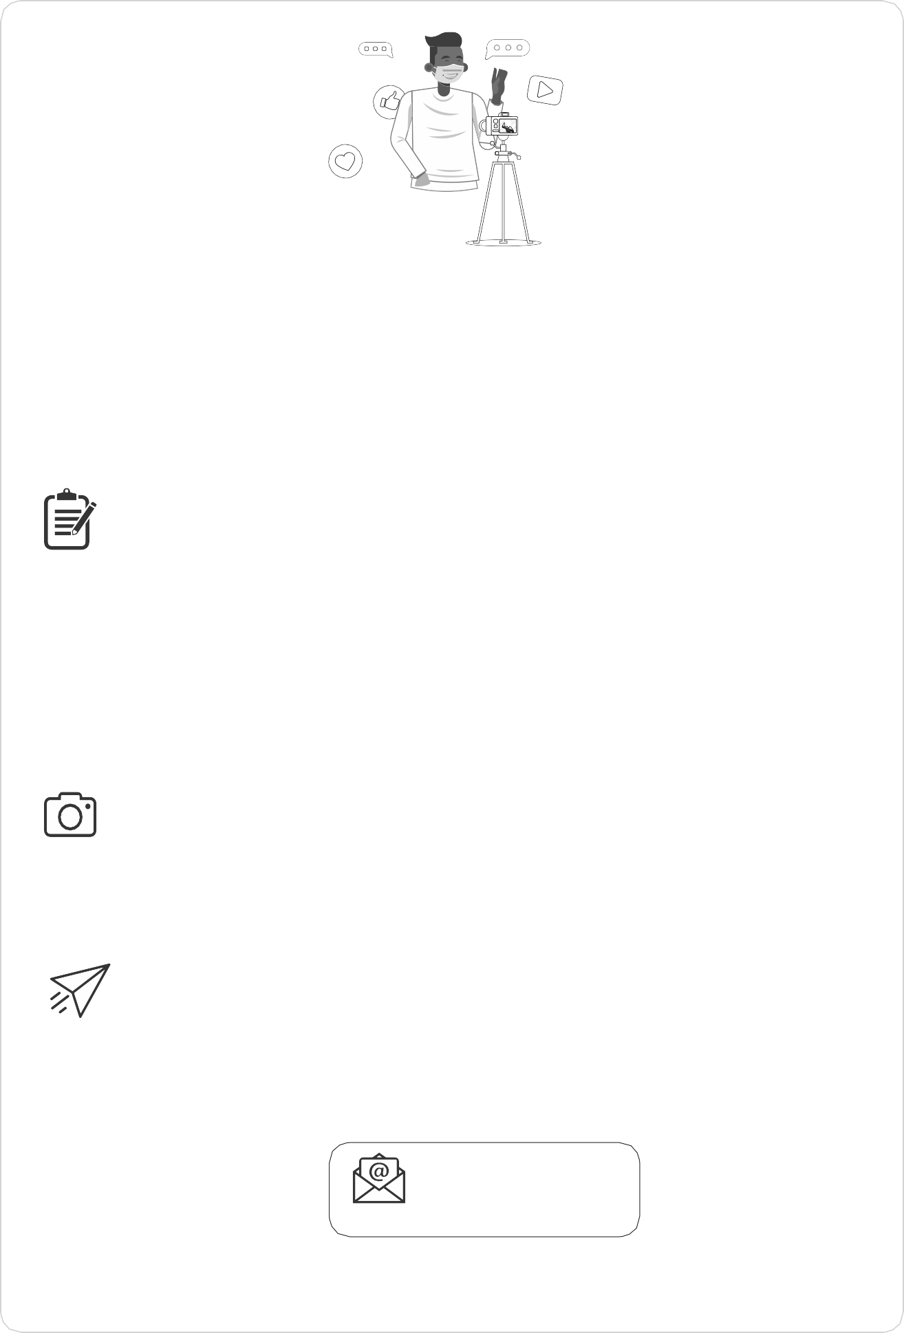

**Please send us pics/videos for our Facebook/Website**

**Send your pictures and videos!**

Dear learner

We are so excited to see your project and we would like you to share it with us so that we can proﬁle it on our website and possibly on Facebook or Instagram. To do that, please follow these instructions very carefully.

**HOW TO PUT TOGETHER YOUR INFORMATION:**

**Tell us about your project:**

1.

2.

3.

4.

5.

6.

7.

Product or service you created:

Name of learner:

School:

Grade:

Describe your project. (50 – 100 words)

Describe the biggest challenge you had doing this project. (50 – 100 words) Describe what you would do better next time. (50 – 100 words)

**Choose the right photographs to tell the story of your project**

1.

2.

3.

Choose three photographs that tell the story and progress of your project. Make sure that no-one’s face is clearly visible unless they are wearing masks.

Make sure the picture is in focus and clear.

**How to send your submission:**

1.

2.

3.

All submissions must be in a word document and the pictures must be in the document. You can send it to us on email.

You can email it yourself, or you can ask your parent/caregiver or teacher to do this for you. You must use this subject line on the email: *Learner Project Grade 10 LO*.

[info@ecubed-dbe.org](mailto:info@ecubed-dbe.org)

Email

If needed, we might ask you to make some changes to your submission in order to make it ready for uploading onto our website.

**Saving Water, Saving Lives LEARNER’S Workbook**

**Grade 5 | LIFE SKILLS | Term 3**

2





**E³ LEARNER’S WORKBOOK | GRADE 5 | LIFE SKILLS | TERM 3**

**Saving Water, Saving Lives**

**Read to Lead**

A Reading Nation is a Leading Nation

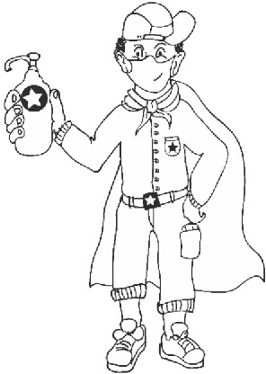



**Introduction**

Dear Grade 5 learner

Due to the COVID-19 pandemic, you have been at home on and oﬀ for a long time. Make the most of this time. We hope you are all healthy, and that you reconnected with your family, something you did not always have time to do because everyone was so busy! Now it is time to start doing exciting projects with your fresh brain and rested body. School is a very diﬀerent place now: you cannot hug or high ﬁve your friends or share lunchboxes. A lot has changed, not only on the playground but also in the classroom: no more group work for a while and fewer role-play games.

Because you have to work and communicate with your friends for really deep learning to take place, you have to start thinking of safe ways to communicate with other people with whom you can share your ideas and who can give you feedback.

**Here are some ideas:**

Choose one **buddy-guard**, someone with whom you can discuss everything in class. Agree before the time that you will be partners and do all the activities together, in a safe way.

Don’t forget that **your family** at home is also a good sounding board – to share ideas and help with your project.

A one-on-one discussion with **your teacher**, either face-to- face or using WhatsApp is also a good way to get feedback.

**1**

**2**

**3**

**Become a problem-solver and make a future for yourself**

This project has one clear goal, to **reduce youth unemployment which is one of our country’s biggest problems.**

Can you as a Grade 5 learner solve this gigantic problem?

**Yes, you can!**

*Start thinking of your future, of yourself as an entrepreneur, or in a job that suits your personality.*

*In this project, you are going to start thinking about whether you could be an entrepreneur one day, because entrepreneurs are great problem solvers.*

**Saving Water, Saving Lives LEARNER’S Workbook**

**Grade 5 | LIFE SKILLS | Term 3**

4

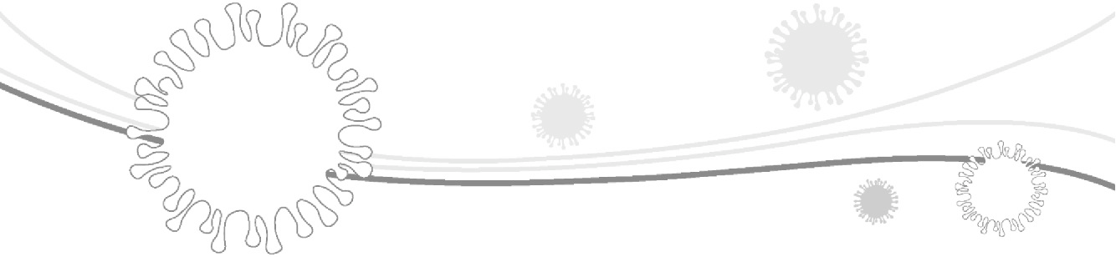



**PROJECT:**

**Saving Water, Saving Lives**

**Project 1 – Saving Water**

***Activity 1 – The Importance of Water***

Start a discussion with your family, siblings, buddy-guard or class mates about the importance of water. Try to answer the questions below:

What living things need water to survive?

What do humans use water for? Name at least 5 things that you can think of:

Running water became very important during COVID-19. Explain why.

Please page to your Learner's Resource Library (at the back of this book) and have a look at the instructions for making a Tippy Tap and a water puriﬁer. Start thinking about which one you will choose to make for this project. What resources (things) do you think you will need to build your puriﬁer or Tippy Tap model?

List of stuﬀ I will need:

**Saving Water, Saving Lives LEARNER’S Workbook**

**Grade 5 | LIFE SKILLS | Term 3**

5



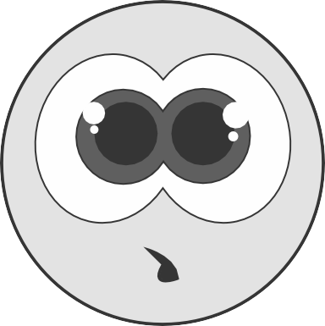

**PLANNING**

***Activity 2 – How to save and protect water***

Since water is such an important resource to all living beings, that we must save and protect it. Please write down 5 ideas for saving water at home, at school or in the community.

1.

2.

3.

4.

5.

We need quality water to drink and to be healthy. How do you think can we protect the quality of our water? In other words, how do we keep our drinking water, rivers, dams, etc. clean? Discuss some ideas with your buddy-guard or family members. Write those brilliant ideas down below:

1.

2.

3.

4.

5.

**Saving Water, Saving Lives LEARNER’S Workbook**

**Grade 5 | LIFE SKILLS | Term 3**

6

***Research Question***

If we do research, we have to start with a BIG question. If you could change the name of the project (Saving water, saving lives) into a big question, what would it be? Please write this BIG question down in the space below. Start oﬀ by creating a few questions about water and the problems of not having enough clean water.

What...

What if...

Why...

How...

I have decided to make a Tippy Tap / water-puriﬁer (encircle your choice) to answer the following big question: (link a question to your choice)





**RESEARCH / FINDING OUT**

***Activity 3 – How we can save water in our school/communities***

With your parents, siblings, teacher or caregiver, take a tour of your home/school/community and see if you can ﬁnd places where there is obvious water wastage. Write your ﬁndings in the table below:

***Activity 4 – How to build a Tippy Tap OR water puriﬁer***

To show how you will be saving or protecting water, you will either build a Tippy Tap or a water puriﬁer (instructions are in the back of this booklet). PLANNING should be your ﬁrst step when you are building something. Start drawing plans for your Tippy Tap model or water puriﬁer below and LABEL the parts clearly.

**Saving Water, Saving Lives LEARNER’S Workbook**

**Grade 5 | LIFE SKILLS | Term 3**

7

**PLACES WE LOOKED**

**WATER WASTAGE FOUND**

**POSSIBLE SOLUTION**



***Activity 5 – My research outcomes***

When we do research, we must share the outcomes with other people. A good way to show your research outcomes, is to put it on a poster. In the space provided below, start planning your research poster. Remember to include the following information:

3 facts stating the importance of water for life 3 ways to save water 3 ways to protect the quality of our water

The importance of water during the COVID-19 pandemic

**Saving Water, Saving Lives LEARNER’S Workbook**

**Grade 5 | LIFE SKILLS | Term 3**

8

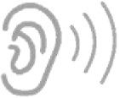



**MAKING AND SHOWING THE EVIDENCE**

***Activity 6 – Making the item of your choice***

It is now time to start making the evidence of your research. You must start work on your Tippy Tap model OR water puriﬁer at home or in class.

Your teacher will also provide you with a big A3 paper to make your ﬁnal poster (or paste two A4 pages together at home to form an A3 size paper).

What did you learn from the process? Please answer the questions below:

1. What do you think will be the most diﬃcult part of making your Tippy Tap/water puriﬁer?

2. How do you plan to overcome that problem?

3. Who can you go to for help when you get stuck?

4. How will you motivate yourself or your friends to go on?

**GETTING FEEDBACK AND CHANGING IF YOU NEED TO**

***Activity 7 – Getting feedback***

Show your Tippy Tap/water puriﬁer and research poster to as many people as possible. Listen carefully to the feedback.

Listen to useful information to improve your item or research poster. Get at least 3 people to give you feedback.

**Saving Water, Saving Lives LEARNER’S Workbook**

**Grade 5 | LIFE SKILLS | Term 3**

9

**DATE OF ADVICE**

**WHO GAVE FEEDBACK**

**WHAT THEY SAID I SHOULD DO**





Write down what you changed, and why.

**WHAT YOU CHANGED?**

**WHY YOU CHANGED IT?**

**FINISHING OFF THE PROJECT**

***Activity 8 – Getting it perfect***

Work in class or at home and make the ﬁnal changes to your Tippy Tap/water puriﬁer and your research poster.

Brainstorm with your teacher, caregiver or family members about the public display of these items.

Where and how will you show your poster if school is not open yet?

IF schools are open and you can show your items and posters to the rest of the school, what would be the best venue (place) and day?

For the public showing, what else might you need?

**Saving Water, Saving Lives LEARNER’S Workbook**

**Grade 5 | LIFE SKILLS | Term 3**

10

*PLEASE NOTE:*

***Always remember to keep everything for assessment when schools open!***





**SHOWING OFF YOUR PROJECT**

***Activity 9 – Public Display***

TODAY is D-day for the public display of your Tippy Tap, water puriﬁer and your research poster. You can be proud of the work you have done!

During the public display, ask for feedback from people who saw your work. Write down what they said in the table below:

If you could assess your own work, what marks would you give yourself?

**Saving Water, Saving Lives LEARNER’S Workbook**

**Grade 5 | LIFE SKILLS | Term 3**

11

**MY TIPPY TAP OR WATER PURIFIER**

**MY RESEARCH POSTER**

Mark out of 5:

Mark out of 5:

Why?

Why?

**GOOD FEEDBACK – WHAT THEY LIKED**

**NOT-SO-GOOD FEEDBACK – WHAT THEY DIDN'T LIKE**





**THINKING ABOUT IT AFTERWARDS**

***Activity 10 – Reﬂection***

For deep learning to take place, one should always reﬂect on the work you have done. Please complete the questionnaire below:

1.

What did you love about working on this project?

2.

What made this project hard for you?

3.

What did you learn by working on this project?

*•*

*About yourself?*

*•*

*About the importance of water?*

*•*

*About learning during COVID-19?*

4.

What would you do diﬀerently if you did a project like this again?

**Saving Water, Saving Lives LEARNER’S Workbook**

**Grade 5 | LIFE SKILLS | Term 3**

12

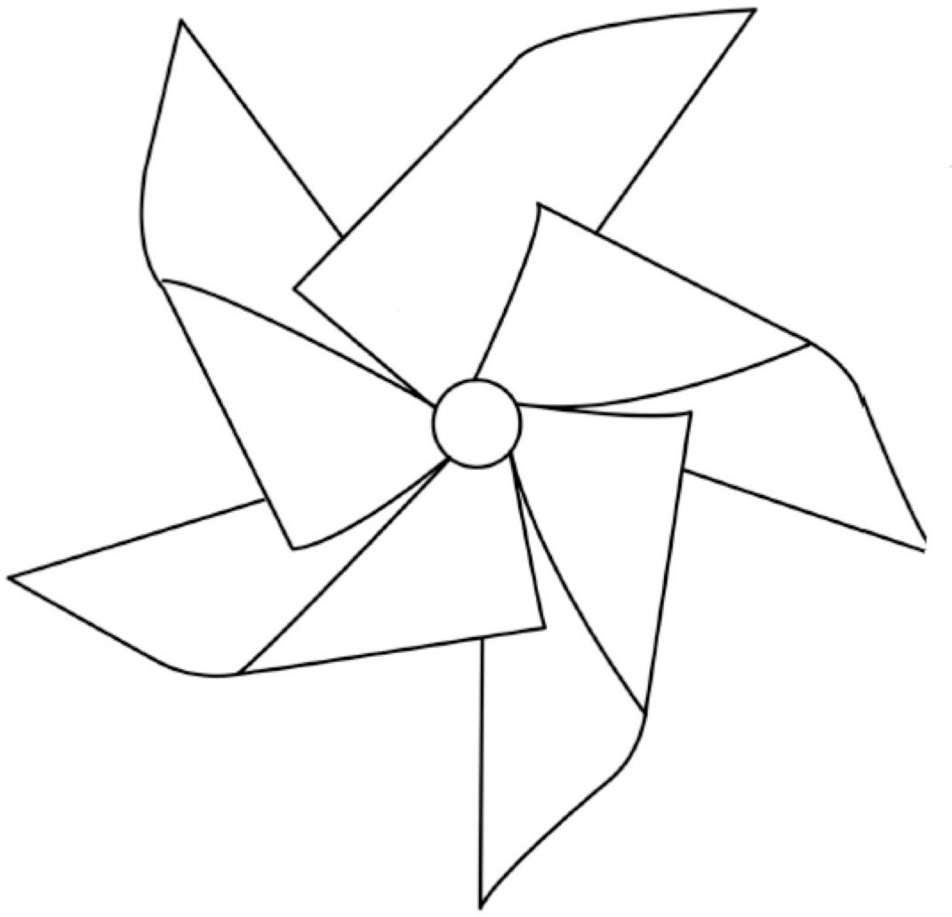



**Project 2 – Saving Lives**

**PLANNING**

***Activity 1 – Forms of child abuse***

During this project you will become an activist for change.

Start a conversation with your teacher, buddy-guard, family members or friends (within COVID-19 rules) on the diﬀerent forms of child abuse. There are typically two forms of abuse: physical and emotional abuse. Can you possibly think of an example of each? Write it in the table below.

To become an activist for change, you have to empower as many people as possible. To do this, we are going to share important information of where to get help within the community or school. This will be done through pinwheels like the one on the image below. We ﬁrst have to gather all the information through research and then add it to the blades of the pinwheel.

**Saving Water, Saving Lives LEARNER’S Workbook**

**Grade 5 | LIFE SKILLS | Term 3**

13

**FORMS OF CHILD ABUSE**

**PHYSICAL**

**EMOTIONAL**

Example:

Example:





**RESEARCH / FINDING OUT**

***Activity 2 – Letter that shouts for help***

Many communities have seen increased incidences of violence during lockdown. Have you noticed any forms of violence lately? Please write down what you have seen or heard:

Why do you think we have increased levels of violence during COVID-19? Discuss with your family or buddy-guard.

Imagine that you can help these people by writing to someone for advice!

Think of an incident that you've seen or heard of and write about your concerns to Aunty Mimi. Ask for her advice on what to do, what to tell your friend, or how to handle the situation. Here is an example. Read it and then write your own letter (about yourself or a friend or family member).

**Saving Water, Saving Lives LEARNER’S Workbook**

**Grade 5 | LIFE SKILLS | Term 3**

14

Dear Aunty Mimi

I write for a friend. My friend's father has lost his job during the coronavirus pandemic.

This made him very mad. He started to drink beer in the mornings – not only in the evenings. If he gets very drunk, he starts cursing and hitting everything and everyone in his way. My friend fears for his life when his father is drunk. In normal times his father is a great guy who tells good jokes and loves his children.

My friend wants to know what he can do about this situation. I hope you can help?

With warm regards

Friend of a friend



Now you must please plan your letter to Aunty Mimi in the block below. Give a *nom de plume* (not your real name).

Your teacher or parent will give you a big paper to rewrite your letter neatly and paste it on the wall when you get back to school. Leave the letter on the wall until it is safe to remove (with COVID-19 regulations you must give it at least 24 hours).

Read all the letters on the wall (if you are in school and your class have all written letters) and discuss possible solutions with adults and your teacher.

MOST IMPORTANTLY, you should research the names and numbers of organisations who can help in times of crisis. Research the names of organisations and their local numbers and write them in the table:

**Saving Water, Saving Lives LEARNER’S Workbook**

**Grade 5 | LIFE SKILLS | Term 3**

15

**PROBLEM THAT NEEDS HELP**

**ORGANISATION THAT CAN HELP**

**NUMBER OR ADDRESS**

E.g. child abuse

Childline

08000 555 66

Dear Aunty Mimi



Now imagine you are Aunty Mimi. Choose someone else's letter to respond to.

Write your response with good advice in the block below. Please ask an adult, teacher or sibling for advice if you get stuck. Remember to share important numbers of organisations to advise people to go to if they need help.

Your teacher or parent will give you another paper to neatly rewrite your reply in time for the re-opening of school.

STICK THE REPLY NEXT TO THE LETTER ON THE WALL WHEN YOU GET BACK TO SCHOOL.

When the time comes, your teacher will summarise all the problems on the wall under diﬀerent headers. Please help him/her to ﬁnd examples of physical abuse, emotional abuse, eﬀects of abuse on mental health, strategies to deal with abuse and where to ﬁnd help.

**Saving Water, Saving Lives LEARNER’S Workbook**

**Grade 5 | LIFE SKILLS | Term 3**

16

Dear

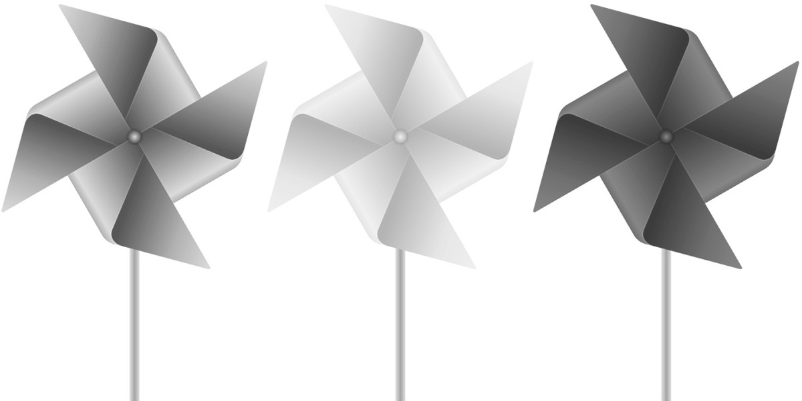



**MAKING AND SHOWING THE EVIDENCE**

***Activity 3 – Pinwheels for change***

Today you start to work on your pinwheel for change which you will hand in with your letter for marks. Before you start, you must ﬁrst plan out the steps:

1. What messages of hope and important numbers will you add on your pinwheel?

2. How will you decorate your pinwheel so that it stands out?

3. What else do you need to complete your pinwheel?

**Saving Water, Saving Lives LEARNER’S Workbook**

**Grade 5 | LIFE SKILLS | Term 3**

17





Use the template of the pinwheel below. Figure out where to write your messages so that they are still visible when you cut, fold and fasten the pinwheel. Please make sure some helpline numbers are clearly visible.

**Saving Water, Saving Lives LEARNER’S Workbook**

**Grade 5 | LIFE SKILLS | Term 3**

18





**GETTING FEEDBACK AND CHANGING IF YOU NEED TO**

***Activity 4 – Following good advice***

Show your pinwheel design and plan to as many people as possible. Gather some feedback and list it in the table.

Listen to useful information to improve your pinwheel. feedback.

Get at least 3 people to give you

Write down what you changed, and why.

**WHAT YOU CHANGED?**

**WHY YOU CHANGED IT?**

**Saving Water, Saving Lives LEARNER’S Workbook**

**Grade 5 | LIFE SKILLS | Term 3**

19

**DATE OF ADVICE**

**WHO GAVE FEEDBACK**

**WHAT THEY SAID I SHOULD DO**





**FINISHING OFF THE PROJECT**

***Activity 5 – Finishing touches***

Do the ﬁnal changes on your pinwheel, cut it out, decorate it, and then see if you can get it to work once you've pinned it to a stick or straw.

Where do you want to aﬀect change? Where do you think you should plant or fasten your pinwheel for people to see? Think of a few good spots where it will have eﬀect and write them down. You will plant your pinwheel after your teacher has assessed it and the letters.

**SHOWING OFF YOUR PROJECT**

***Activity 6 – Planting the pinwheels for public display***

With the help of your teacher, or parents/caregivers at home, fasten the pinwheel in the place that you have planned for the public display. If you are at school, the whole class can plant their pinwheels in the same area for eﬀect, or you can put it somewhere where you think someone will ﬁnd it.

Will it make a diﬀerence? Why do you think so?

**Saving Water, Saving Lives LEARNER’S Workbook**

**Grade 5 | LIFE SKILLS | Term 3**

20





**THINKING ABOUT IT AFTERWARDS**

***Activity 7 – Reﬂection***

For deep learning to take place, one should always reﬂect on the work you have done. Please complete the questionnaire below:

1.

What did you love about working on this project?

2.

What made this project hard for you?

3.

What did you learn by working on this project?

*•*

*About yourself?*

*•*

*About where to go for help?*

*•*

*About learning during COVID-19?*

*•*

*Do you think that there are always practical solutions for people who are suﬀering from abuse? Why do you think so?*

**Saving Water, Saving Lives LEARNER’S Workbook**

**Grade 5 | LIFE SKILLS | Term 3**

21

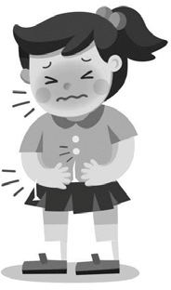



**Project 3 – Healthy Eating *Activity 1 – Introducing Thumi*** Read the story of Thumi with your teacher:

Thumi just turned 11. She had a good birthday. At her birthday party she had cake, chips, toﬀees, cooldrink and lots of ﬁzzers, but she also had these treats the day after, and the next day. If she complains of hunger, grandma cuts her another slice of cake. Now she is not feeling so well.

Lately she has been feeling very sluggish and she has little energy. She used to run around with her friends at break, playing 'Open the Gate', but she doesn't seem to have the energy these days. Her skin is all ﬂaky and she sometimes has terrible toothache at the back of her mouth. But worst of all, her schools dress doesn't ﬁt anymore. The buttons are stretching over her tummy. Grandma struggles on a monthly pension, she cannot ask for new school dresses now.

All grandma ever buys is fast food. She loves pizza, Nando's, cheesy chips and toasted sandwiches. If the money is almost ﬁnished near the middle of the month, she buys vetkoek and white bread. Thumi suspects that their lifestyle is not good for her health. On top of it all, she also worries that she is getting COVID-19 symptoms. She can use a little help from a few friends! Please help!

What are the four main symptoms for COVID-19 that you have heard from the media (television or radio?)

• •

• • Should Thumi be worried? Do you think she has any COVID-19 symptoms? Explain.

What else could be the matter with Thumi?

**Saving Water, Saving Lives LEARNER’S Workbook**

**Grade 5 | LIFE SKILLS | Term 3**

22





As a friend, can you help Thumi make better choices? Discuss healthy eating habits for children with your parents/care givers or teachers. Please WhatsApp Thumi in the space below, giving her advice on healthy eating habits. Be kind. Rather motivate than scold.

**PLANNING**

***Activity 2 – Choosing your research topics***

**The outcome of this project**

During the Healthy Eating project you will do research on healthy eating habits, diﬀerent foods and how to preserve food. You must present all your research in an Infographic Poster. (An infographic is a way of sharing important information using pictures.)

Your Infographic Poster should contain information on 8 food types that you pick at home and research for their dietary value (are they healthy?), ways to preserve them, food safety and value for money during COVID-19.

When you are at home, look at the 8 types of food that you generally have in the house at all times. List the 8 foods you would like to research in this table:

**Saving Water, Saving Lives LEARNER’S Workbook**

**Grade 5 | LIFE SKILLS | Term 3**

23

1.

2.

3.

4.

5.

6.

7.

8.





**RESEARCH / FINDING OUT**

***Activity 3 – Research your choices***

Use the table below to do thorough research on your food choices. Speak to everyone you know and ﬁnd out as much as possible about your food sources by searching magazines, the internet and other sources. There is also information in the Library section of these notes.

**Saving Water, Saving Lives LEARNER’S Workbook**

**Grade 5 | LIFE SKILLS | Term 3**

24

Value for money during COVID-19 pandemic

e.g. beans are high in protein but only Rx per serving

Food safety measures,

e.g. keep chicken in fridge, chicken grow bacteria that can make you very ill

How to store this item,

e.g. rice should be stored in a dry place, with an airtight cover to make it last longer

Nutritional value (protein, vitamins, minerals, etc.)

Food item

1. E.g. rice

2.

3.

4.

5.

6.

7.

8.





**MAKING AND SHOWING THE EVIDENCE**

***Activity 4 – Planning the Infographic Poster***

Look at the research you have done in Activity 3. What is the best way to portray all the information on a poster? Remember – and infographic uses more pictures than words. Do a rough sketch in the space below. Go to the Library for an example of infographic.

Rough sketch of my Infographic Poster

**Saving Water, Saving Lives LEARNER’S Workbook**

**Grade 5 | LIFE SKILLS | Term 3**

25





**GETTING FEEDBACK AND CHANGING IF YOU NEED TO**

***Activity 5 – Following good advice***

Show your rough infographic poster sketch to as many people as possible. Gather some feedback and list it in the table.

Listen to useful information to improve your rough poster sketch. give you feedback.

Get at least 3 people to

Write down what you changed, and why.

**WHAT YOU CHANGED?**

**WHY YOU CHANGED IT?**

**Saving Water, Saving Lives LEARNER’S Workbook**

**Grade 5 | LIFE SKILLS | Term 3**

26

**DATE OF ADVICE**

**WHO GAVE FEEDBACK**

**WHAT THEY SAID I SHOULD DO**





**FINISHING OFF THE PROJECT**

***Activity 6 – Finishing touches***

Use the rough draft of your poster to create the ﬁnal product. Be careful and start in pencil before you put the ﬁnishing touches in pen. Use colour pencils or Koki's to make an visual impact. Use many pictures instead of words.

Are you happy with your ﬁnal Infographic Poster? Why?

Discuss with your teacher and class mates (or if you are still in lockdown, with your family members) where you will be displaying your posters. Write your plans below:

**SHOWING OFF YOUR PROJECT**

***Activity 7 – Public Display of Infographic Posters***

With the help of your teacher, or parents/caregivers at home, put your poster up for a public display. Invite people to have a look (keep to COVID-19 regulations) and give feedback.

During the public display, ask for feedback from people who saw your work. Write down what they said in the table below:

If you could assess your own work, what marks would you give yourself?

I would give myself a mark of out of 5 for my Infographic Poster.

Why did you give yourself this mark?

**Saving Water, Saving Lives LEARNER’S Workbook**

**Grade 5 | LIFE SKILLS | Term 3**

27

**GOOD FEEDBACK – WHAT THEY LIKED**

**NOT-SO-GOOD FEEDBACK – WHAT THEY DIDN'T LIKE**



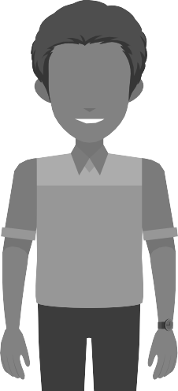

**THINKING ABOUT IT AFTERWARDS**

***Activity 8 – Reﬂection***

For deep learning to take place, one should always reﬂect on the work you have done. Please complete the questionnaire below:

1.

What did you love about working on this project?

2.

What made this project hard for you?

3.

What did you learn by working on this project?

*•*

*About yourself?*

*•*

*About healthy eating habits?*

*•*

*About learning during COVID-19?*

•

Do you think an infographic is a good tool for spreading important information? Why? Why not?

**Saving Water, Saving Lives LEARNER’S Workbook**

**Grade 5 | LIFE SKILLS | Term 3**

28



**Learner’s Resource Library**

***Letter to parents or caregivers - Water conservation***

Dear Parent or Caregiver

Below is a Water Conservation Lesson Plan from WESSA (Wildlife and Environmental Society of South Africa). This is a resource you can use to help your Grade 5 child complete Project 1 independently, should they still be at home due to lockdown. Please improvise and adapt where necessary.

**Aim**

To show how vital water is in our lives and why it’s so important to look after it.

**Time requirements**

Approximately 60 minutes

**Resources**

**Activity 1**

* A container of water
* A cloth
* Paper and pencils

**Activity 2**

* Paper and pencil
* Food colouring

**Learning objectives**

To learn, through discussion and observation, about the importance of water, the many diﬀerent ways we use it, how it can be wasted and the measures we can take to save it.

**Curriculum links**

Science– Water conservation English – Oral language and reading Maths – Numbers and data

**Skills**

Questioning, observing, discussing, investigating, counting and analysing

**Saving Water, Saving Lives LEARNER’S Workbook**

**Grade 5 | LIFE SKILLS | Term 3**

29



**Links to Eco-Schools seven steps**

Environmental Review – conducting leak tests is an essential action Monitoring and Evaluation – documenting leaks and water usage Informing and Involving – publicising results of water diaries and leak tests

**Running the activity:**

1) **Precious water** – To raise awareness about the importance of water:

* Put some water in a container and cover it. Tell the students you have the most important thing in the world under the cloth and ask them to guess what it is.
* Focus on water conservation to explain how important water is.
* Ask the students to name all the ways people use water and write down their answers.
* Ask the students to keep a water diary for a day or two to see how they use water and discuss their results (compare with their original answers).
* Rank the answers showing the most frequent uses of water to the least frequent. You could research how much water each of these activities uses to calculate how much water the class is using.
* Ask the students how they think water is wasted and how they can stop the waste. Write down their answers and stick them up in class to remind students what they can do to reduce waste.

2) **Leak hunt –** To check your school/home/community for leaks:

* Put students into groups, give them a pencil and paper and a place to visit to check for leaks.
* Idea: those looking for leaks in the toilets could put food colouring in the cisterns and leave it there for a few minutes to see if the colouring reaches the bowl. If it does reach the bowl it means your toilet is constantly running.
* Have the students report their ﬁndings and stick them up (in the classroom or at home) to constantly remind learners what to look out for.

**Remember to act on your ﬁndings!**

**Questions Learners should be able to answer at the end of the lesson.**

* Why do you think water is important?
* How do people waste water?
* Name some ways you can save water?

**Saving Water, Saving Lives LEARNER’S Workbook**

**Grade 5 | LIFE SKILLS | Term 3**

30

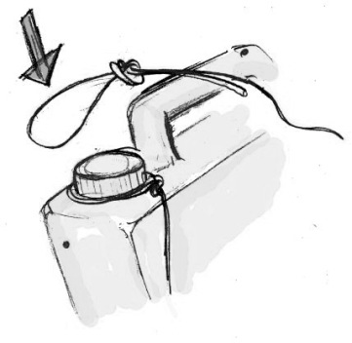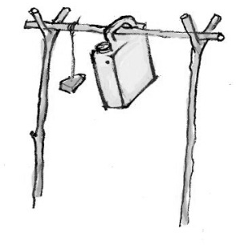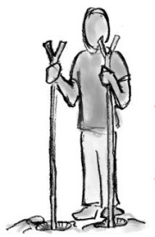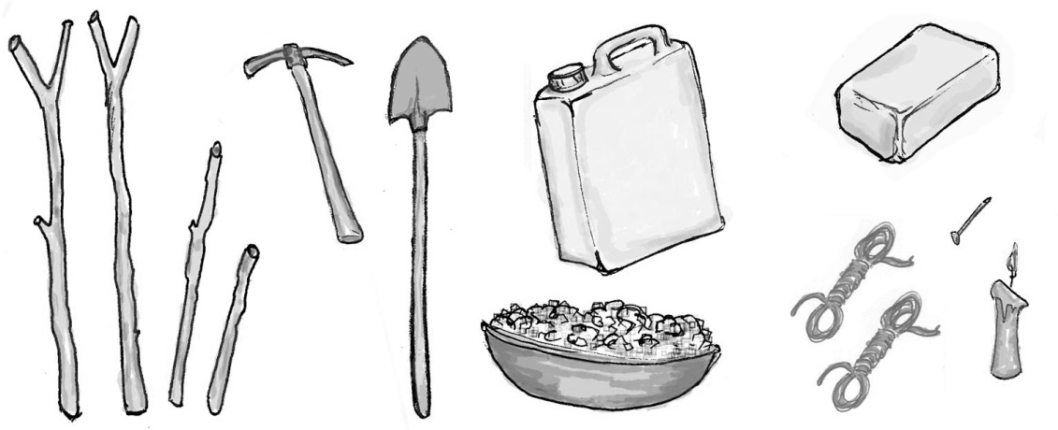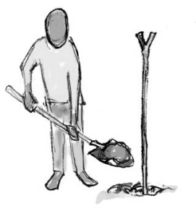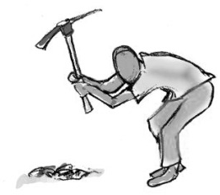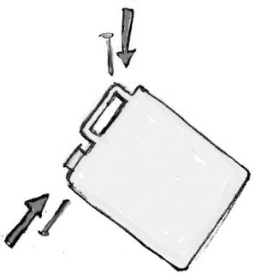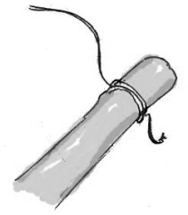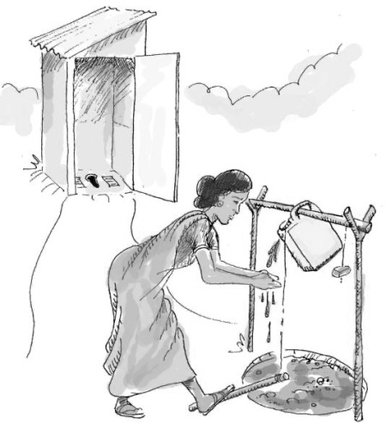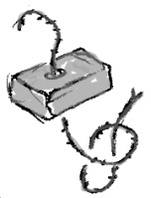

***How to build a Tippy Tap***

*Tippy Tap instructions (Tippy tap.org):* [*http://www.tippytap.org/build-a-tippy-tap-manual*](http://www.tippytap.org/build-a-tippy-tap-manual)

**Saving Water, Saving Lives LEARNER’S Workbook**

**Grade 5 | LIFE SKILLS | Term 3**

31

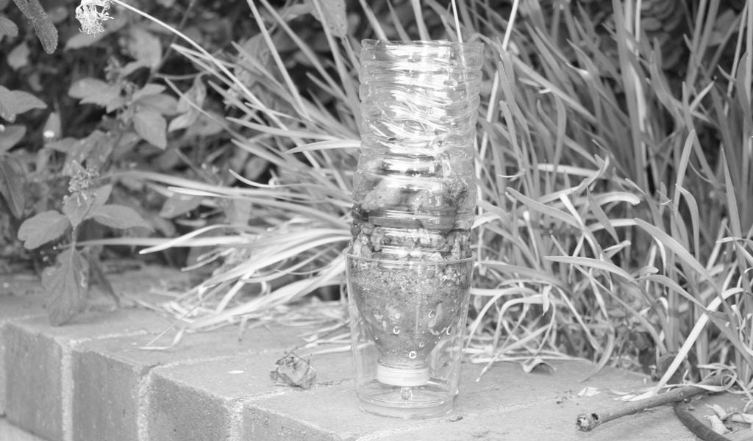



***Build a simple water ﬁlter***

**Image source:** https:/[/www.](http://www.instructables.com/id/Simple-Water-Filter-out-of-a-Waterbottle/)i[nstructables.com/id/Simple-Water-Filter-out-of-a-Waterbottle/](http://www.instructables.com/id/Simple-Water-Filter-out-of-a-Waterbottle/) **You will need:**

2Lt plastic bottle Gravel

Sand Soil Cotton

Pair of scissors Hammer and nail

**Method:**

Using your scissors or knife, cut of the very end of the water bottle

Using the hammer and the nail (or screwdriver), and make a small hole in the center of the cap. Make sure the cap is on tight!

Now stick your cotton balls (or coﬀee ﬁlter or a piece of fabric) through the hole and down by the cap. Use a pen to get it really deep down.

Now add half a cup of sand or crushed charcoal.

Next, add your gravel into the bottle. Around half a cup of gravel should be enough. Finally, add your larger gravel or small rocks (if using) into the bottle.

Your water ﬁlter is now complete! Just put the ﬁlter over your cup for ﬁltered water.

Pour the dirty/muddy water into the ﬁlter and give it time to dam up in a glass.

*Water puriﬁer instructions (Part 3 of water lesson): http*[*s://www.biloxischools.ne*](http://www.biloxischools.net/cms/lib/)*t/*[*cms/lib/*](http://www.biloxischools.net/cms/lib/) *MS01910473/Centricity/Domain/1963/K2%20Understanding%20Clean%20Water%20Make%20a%20 Filtration%20System.pdf*

**Saving Water, Saving Lives LEARNER’S Workbook**

**Grade 5 | LIFE SKILLS | Term 3**

32

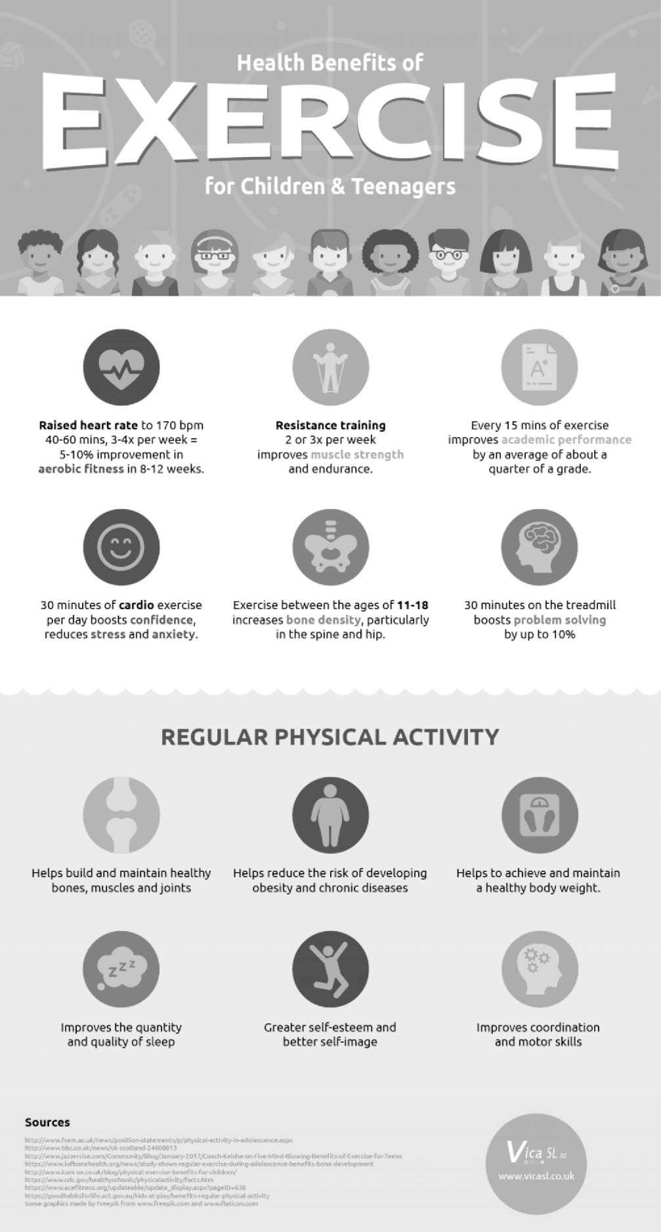



***Examples of an Infographic***

**Saving Water, Saving Lives LEARNER’S Workbook**

**Grade 5 | LIFE SKILLS | Term 3**

33

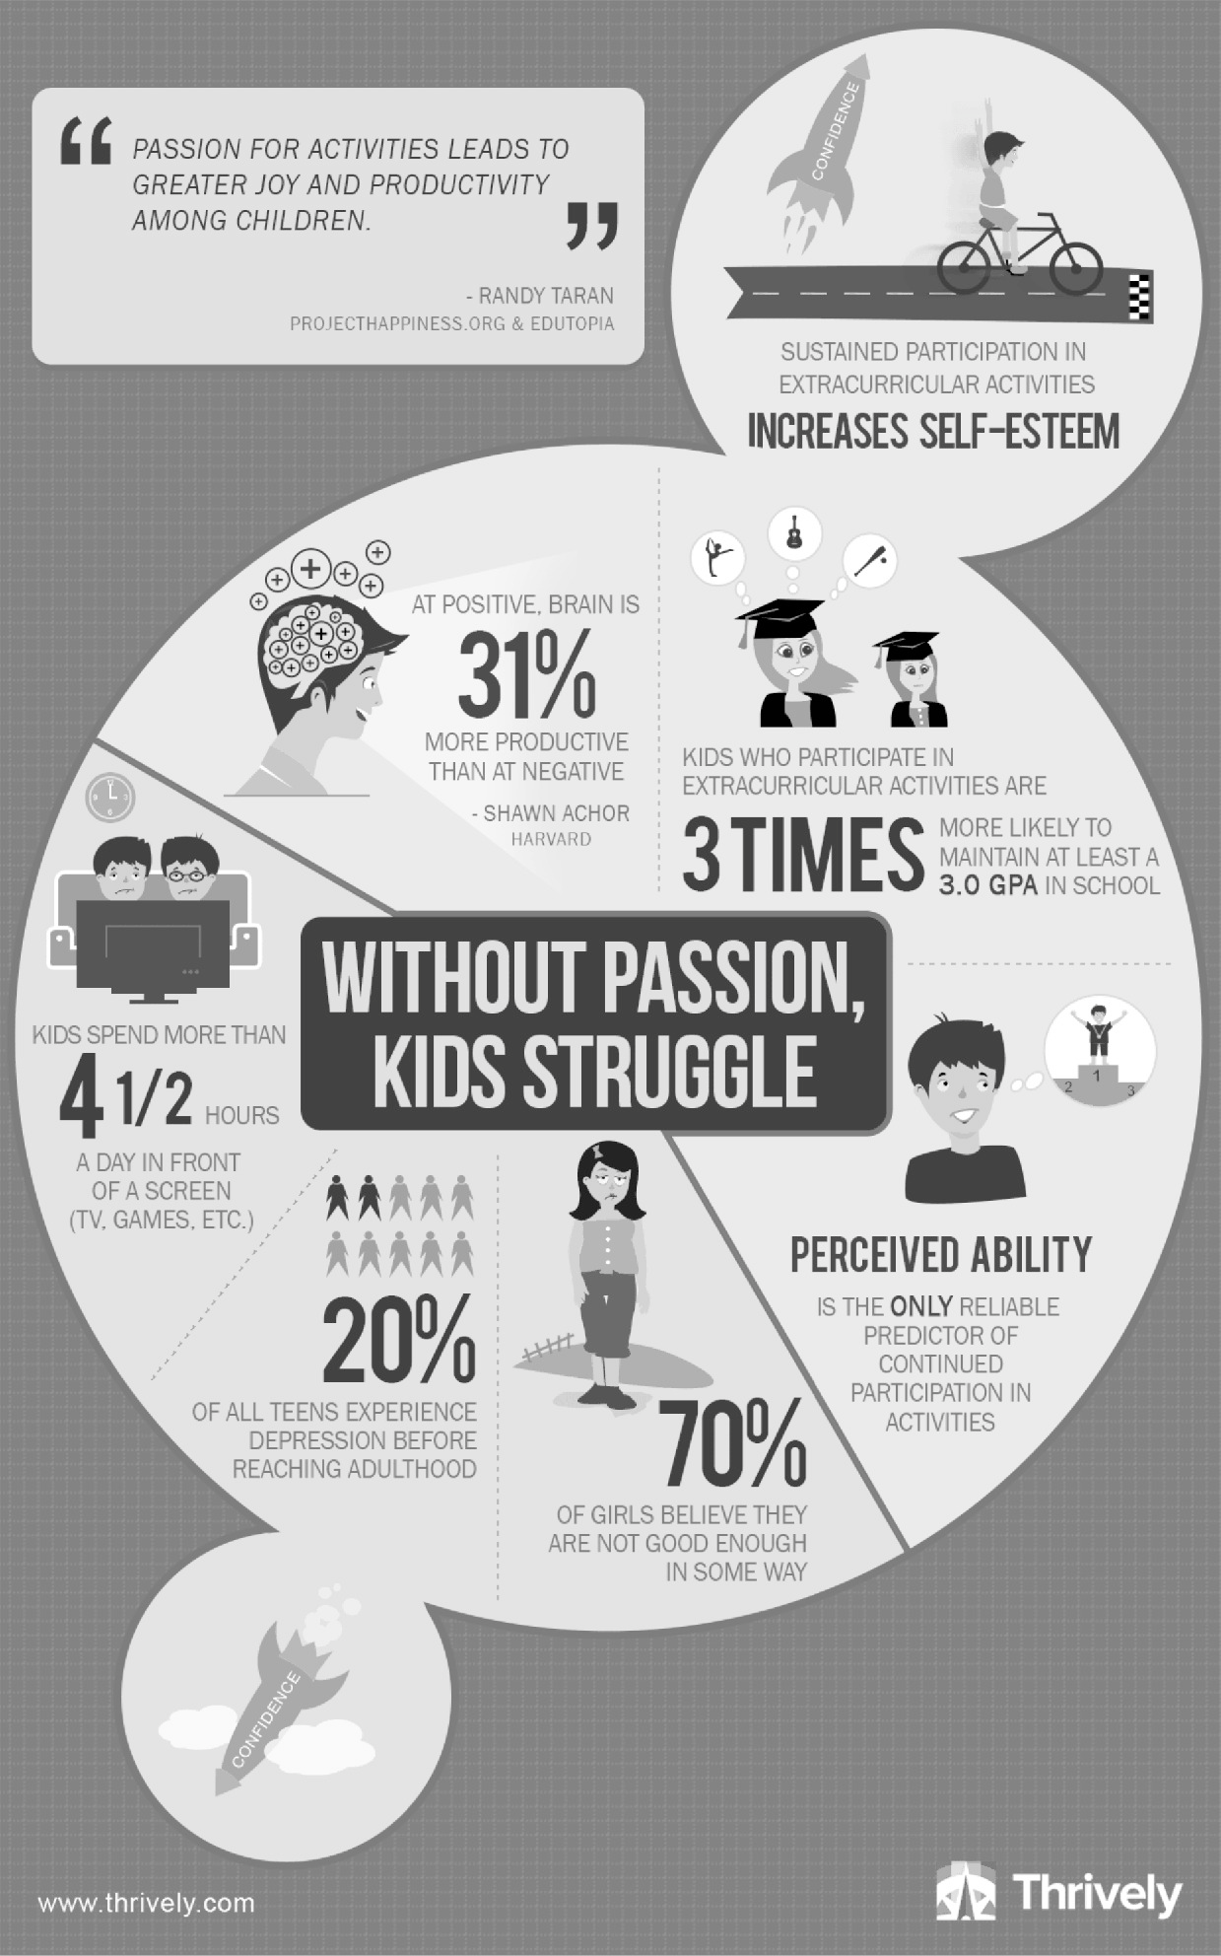



**Saving Water, Saving Lives LEARNER’S Workbook**

**Grade 5 | LIFE SKILLS | Term 3**

34

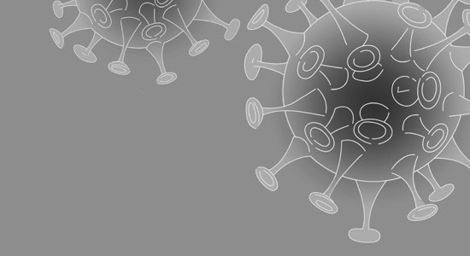



***Levels of domestic violence increase globally as COVID-19 pandemic escalates***

Violence against women tends to increase in any emergency, including epidemics.

Stress, disruption of social and protective networks, increased poverty and decreased access to services can worsen the risk of women and children suﬀering violence.

In the case of COVID-19, isolation, restricted movement and stay-at-home measures to contain the spread of the infection have a particularly severe impact on women.

The chances of women and their children being exposed to violence is dramatically bigger, as family members spend more time in close contact and household stress build up. The risk grows even greater when families also have to cope with job losses.

Health services are overwhelmed by the urgent need to counteract the eﬀect of the pandemic. This can have particularly dramatic outcomes in countries with limited health services and ﬁnancial resources.

Special consideration should be given to more vulnerable groups, including women living with disabilities, who are at increased risk of domestic violence and may face further barriers in reaching the services they need.

**What can be done?**

**Health care facilities** should update counselling services, protection services, hotlines and shelters.

**Health care providers** should watch out for violence against women during this time, so that when survivors reach out to health care facilities (whether or not they have COVID-19, and

**Saving Water, Saving Lives LEARNER’S Workbook**

**Grade 5 | LIFE SKILLS | Term 3**

35

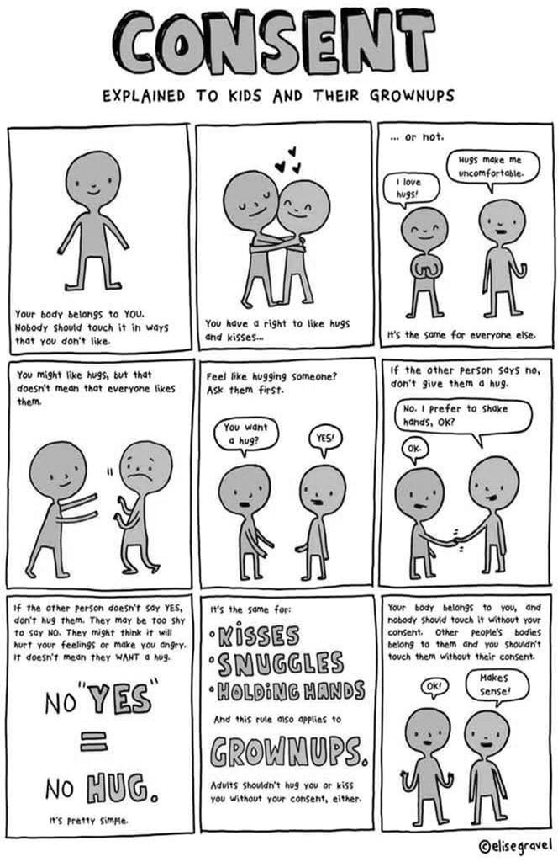



whether or not they disclose the violence), they can receive suitable and sympathetic health

care.

Adapted from SOURCE: <http://www.emro.who.int/violence-injuries-disabilities/violence-> news/levels-of-domestic-violence-increase-as-covid-19-pandemic-escalates.html

**Saving Water, Saving Lives LEARNER’S Workbook**

**Grade 5 | LIFE SKILLS | Term 3**

36

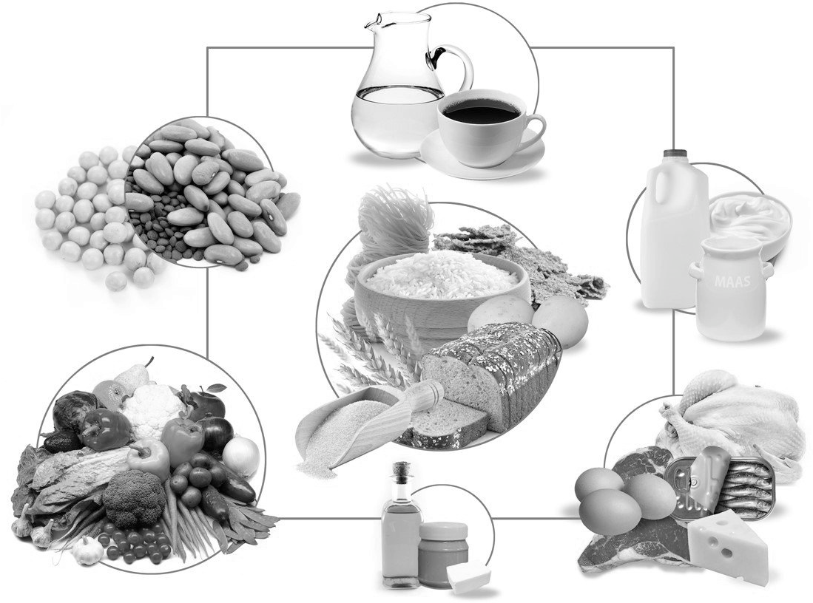



***South African dietary guidelines***

**Enjoy a variety of foods** – select foods from all of the circles and eat these daily. Try to vary

your selection and the colour of food on your plate. e.g. have spinach, carrots, tomatoes and beetroot on your plate.

**Make starchy foods part of most meals** – this is where you get most of your energy for the

day. Choose whole grain starchy foods like whole grain maize meal, bread and pasta’s over reﬁned white grains.

**Saving Water, Saving Lives LEARNER’S Workbook**

**Grade 5 | LIFE SKILLS | Term 3**

37

***Important Numbers***

Lifeline toll-free at 0800 055 555.

The Child Emergency Line can be reached for free at 0800 123 321.

Child Welfare SA provides a hotline for reporting abuse: 0861 4 CHILD (24453) IMPORTANT NOTES ON CHILD ABUSE

1. It is NEVER the child’s fault. Children are naughty and noisy, but abuse is NOT the answer in disciplining a child. Children often feel guilty, ashamed or embarrassed by their circumstances. Please convey the message that it is NEVER their fault.
2. NEGLECT is also a form of child abuse (other than sexual, physical or emotional abuse). This is very diﬃcult to navigate, but cases have been successfully made against parents and caregivers for gross neglect.



**Be active!** – do at least 30 minutes of exercise, 5 days a week. This can include brisk

walking, running, cycling, going to the gym, household chores as well as mowing the lawn.

**Eat plenty of vegetables and fruit every day** – Include 5 vegetables and fruit daily (3

vegetables and 2 fruits).

**Eat dry beans, split peas, lentils and soya regularly** – these can be eaten instead of chicken

and meat products for energy and growth.

**Have milk, maas or yoghurt every day** – these foods are good for your teeth and bones and

help keep them healthy.

**Fish, chicken, lean meat or eggs can be eaten daily** – choose lean cuts of meat, trim oﬀ the

visible fat and remove the skin before cooking.

**Drink lots of clean, safe water** – depending on your activity levels, aim for ± 8 glasses of

water or unsweetened beverages.

**Use fats sparingly, choose vegetable oils rather than hard fats** – avoid adding additional

fat to foods. Use a little soft margarine on bread and avoid cooking with and eating hard fats.

**Use sugar and foods and drinks high in sugar sparingly** – limit your intake of foods that

contain a lot of sugar. Reduce your intake of sweetened drinks, sweets and sugar.

**Use salt and foods high in salt sparingly** – avoid adding salt to your food at the table.

Reduce the amount of salt you add when cooking. Use herbs and lemon to ﬂavour your food.

RESOURCE: https:/[/www.nestl](http://www.nestle-esar.com/nhw/nutritionbasics/sa-food-based-dietary-guidline)e[-esar.com/nhw/nutritionbasics/sa-food-based-dietary-guidline](http://www.nestle-esar.com/nhw/nutritionbasics/sa-food-based-dietary-guidline)

***Food sources and nutrient value***

**Saving Water, Saving Lives LEARNER’S Workbook**

**Grade 5 | LIFE SKILLS | Term 3**

38

**Nutrient**

**Food sources**

Calcium

Non-fat and low-fat dairy, dairy substitutes, broccoli, dark, leafy greens, and sardines

Potassium

Bananas, cantaloupe, raisins, nuts, ﬁsh, and spinach and other dark greens

Fibre

Legumes (dried beans and peas), whole-grain foods and brans, seeds, apples, strawberries, carrots, raspberries, and colourful fruit and vegetables



All of the above foods are good choices.

Source: https://familydoctor.org/changing -your-diet-choosing-nutrient-rich-foods/

***12 Food Storage Tips to Make Your Groceries Last Longer***

**By Paige Smith • Jul 23, 2019**

**141SHARES**

It’s all too easy to forget about your groceries until they start stinking up your kitchen, but here’s the good news: knowing how to store them properly isn’t rocket science.

Not only does proper food storage prevent unnecessary waste (and sudden bouts of frustration), but it also lessens your grocery bill and minimizes the risk of a contracting a food-borne illness.

These 12 simple food storage tips will help ensure your food stays fresh as long as possible.

**Saving Water, Saving Lives LEARNER’S Workbook**

**Grade 5 | LIFE SKILLS | Term 3**

39

Magnesium

Spinach, black beans, peas, and almonds

Vitamin A

Eggs, milk, carrots, sweet potatoes, and cantaloupe

Vitamin C

Oranges, strawberries, tomatoes, kiwi, broccoli, and red and green bell peppers

Vitamin E

Avocados, nuts, seeds, whole-grain foods, and spinach and other dark leafy greens



**Store dairy products at the back of the fridge**

Take your jug of two-percent out of the fridge door. That location might make it easy to grab quickly for your bowl of cereal, but it might make it spoil faster because of the temperature.

**Put meat on the bottom shelf**

Nothing ruins a container of broccoli faster than a soak in pork juice. Meats should be on the bottom shelf so juices don’t drip on other foods. Keep cold cuts like ham separate from other raw meat to prevent cross-contamination.

**Know *where* to store fruits and vegetables**

Not all fruits and veggies need to live in the fridge. Avocados, citrus, bananas, nectarines, pears, peaches, onions, tomatoes, and potatoes can all be stored at room temperature or in a cool pantry. But don’t store onions and potatoes together. Because of ethylene gas that some kinds of produce release, they cause each other to spoil faster.

**Wrap your greens in paper towels**

To prevent slimy residue from accumulating in your bag of lettuce, spinach, or other leafy greens, stick paper towels inside to soak up excess moisture. You can do the same with leftover salad greens in food storage containers.

**Use plastic wrap on bananas**

Cover the crown of a bunch of bananas in plastic wrap to slow the release of ethylene gas. This will prevent them from ripening too quickly.

**Wash produce as you go**

If washing fruits and veggies is the ﬁrst thing you do when you come home from the grocery store, you might want to switch up your routine. Unless you plan on freezing your food, you should only wash things you’re ready to eat right away or soon after. That lessens the chance of mold growing on damp produce.

**Roast veggies**

Roast vegetables such as broccoli and cauliﬂower to extend their shelf life.

**Store grains in air-tight containers**

Buying in bulk is a great way to save money when grocery shopping, but you want to store it correctly so the extra food doesn’t go to waste. If you buy grains in bulk, be sure to transfer them to an airtight container to maintain freshness, as well as keep bugs away.

SOURCE: https://www.openﬁt.com/food-storage-tips

*(For the 12 saving tips document) with thanks to WESSA*

**Saving Water, Saving Lives LEARNER’S Workbook**

**Grade 5 | LIFE SKILLS | Term 3**

40



***COVID-19 and Food***

**Can COVID-19 be passed on through food?**

No reported cases of COVID-19 have been linked to contamination of food. The main risk of

transmission is from close contact with infected people. The advice to food businesses and consumers is to maintain good hygiene practices and to wash your hands regularly. Thorough cooking will kill the virus.

**Does washing-up or using a dishwasher eliminate the virus?**

As with soap, washing-up liquid and dishwasher detergents are likely to inactivate the virus. In

particular, washing and drying dishes in a dishwasher at 60°C or higher is eﬀective at eliminating any risk.

SOURCE: https://[www.fsai.ie/faq/coronavirus.html#covid](http://www.fsai.ie/faq/coronavirus.html#covid)

How to stretch your grocery budget during COVID-19 pandemic

The coronavirus pandemic is causing a lot of people to buy groceries and

eat at home.

The goal right now is to go out as little as possible and while it is important

to support local businesses and spazas, most people probably can’t aﬀord to buy prepared food every day, so here is what you can do.

Try buying some canned meat instead of fresh meat to save some cash and

make it last longer.

Also, when you buy fresh produce try to get what is in season because it will

likely be cheaper.

Stick to your list and don’t buy anything that is not planned.

Make simple meals like soups and vegetable stews that are nutrient rich but

can also be stretched with legumes and other grains. Instead of feeding one person with a can of ﬁsh, make ﬁsh cakes and feed four.

Another piece of advice is to avoid shopping when you are hungry because

that may cause you to spend more.

Pool the family’s resources. Instead of buying for each household, pool the

grocery budget and buy in bulk so everyone can save or get more for their money.

Adapted from Source: https://whnt.com/news/coronavirus/how-to-stretch-your-grocery-

budget-during-covid-19-pandemic/

**Saving Water, Saving Lives LEARNER’S Workbook**

**Grade 5 | LIFE SKILLS | Term 3**

41