

**SAVING WATER, SAVING LIVES**

**PROJECT-BASED LEARNING | LIFE SKILLS**

**5**

*PLANNING*

*RESEARCH / FINDING OUT*

*MAKING AND SHOWING THE EVIDENCE*

*GETTING FEEDBACK AND CHANGING IF THEY NEED TO*

*FINISHING OFF THEIR PROJECT*

*SHOWING OFF THEIR PROJECT*

*THINKING ABOUT IT AFTERWARDS*



**Teacher’s Project Notes**

**GRADE 5**

**E³ Projects for Trimmed ATP**

**Saving water, saving lives**

**Table of Contents**

Letter from the DBE Teacher Agency Award Mindset Rubric for Teachers **PART 1: Setting the Scene**

2

3

**4**

4

5

6

*6*

*6*

*6*

*6*

*7*

*7*

*7*

8

**9**

9

11

*11*

*15*

*18*

1.

2.

3.

The trimmed projects - E3 response to COVID-19 Social Learning during COVID-19 (Coronavirus)

Generic Project outline for all Projects (directed at the learner)

*-*

*-*

*-*

*-*

*-*

*-*

*-*

4.

Resource Pack

**PART 2: The Projects**

5.

6.

Project Summary and CAPS alignment

The Projects in more detail

*6.1*

*6.2*

*6.3*

*Saving water*

*Saving lives - Child abuse, Violence and dealing with violent situations Healthy eating for children - Dietary needs and factors that inﬂuence food intake*

7.

Assessment Rubric

21

**22**

22

*23*

*24*

**PART3: Teacher’s Resources**

9.

Tools to assist with the Project

*9.1*

*9.2*

*Letter to the parents / caregivers The Big Question in research*

10.

Professional Development

26

*26*

*27*

*28*

*29*

*29*

*30*

*10.1*

*10.2*

*10.3*

*10.4*

*10.5*

*10.6*

*Traditional vs Activity-based learning The Project-based Learning Cycle Project-based Learning facilitator*

*The E3 Competencies model within the CAPS*

*The journey to PBL via Enquiry-based and Problem-based Learning Bridging the Unemployment gap through Education*

Teacher Agency Award Entry Form

31

**PLEASE NOTE**

* **Part 1 and Part 2 of this booklet must be printed** and are the minimum project resources you as teacher will need. However, the rest of the booklet contains valuable tools for personal development, as well as very good sources in support of the project. You don’t have to look anywhere else.
* Don't forget to **enter the Teacher's Agency Awards** (see page 2). The entry form is at the back of this booklet (page 31).
* This programme is accompanied by **podcasts, audio recordings and videos**. You will ﬁnd them at the following URL: **https://learn.ecubed-dbe.org/resources/**
* Before you start, please **complete the Pre-project section of the Teacher's Mindset Rubric** on page 3. **Complete the Post-project section** upon completion of the project.



Dear Teacher

Provided herewith is a **Learner’s Project Workbook** and a set of **Teacher’s Project Notes for the School- Based Assessment (SBA) Task for Term 3** as per the SBA Plan in Section 4 of the CAPS. These documents were specially created to support you with COVID-19 issues for your subject as per the trimmed Annual Teaching Plan (Section 3) for Term 3.

Most importantly, it is envisaged that this will lessen your workload as we come to grips with the disruptions caused by COVID-19.

The Learner’s Workbook and Teacher’s Project Notes were created by DBE-E3, a unit at the National Department of Basic Education which is rolling out Project-Based Learning **(PBL)** in schools, to better prepare learners for a changing world. Although you may not be part of the DBE-E3 Programme as yet, these projects were created to:

1.

Engage learners in processing the pandemic which is aﬀecting their lives and those of their families;

Promote learner self-reliance and independent learning using safety measures; and Encourage social learning in a safe environment.

2.

3.

**Where did this all start?**

**E3: Entrepreneurship, Employability and Education is currently being rolled out in SA schools.** The DBE-E3 Unit, in response to the National Development Plan, has been working in public schools since 2018 to advocate the eventual implementation of Activity-Based Learning, with a special **focus on PBL**. E3 is part of a DBE programme to introduce *Thinking Skills for a Changing World* into the curriculum in its eﬀort to reduce youth unemployment substantially by 2030.

**How did this work in 2018 and 2019?**

Initially three provinces in 2018, and then all nine provinces in 2019, implemented PBL in Term 3, the term in which the SBA is an actual project. This meant that the projects, written by teachers for teachers were available to select schools by the provinces as part of a pilot research project. In this initial phase schools on the programme were provided with projects for Life Skills Grade 4-6, EMS Grade 7-9 and Life Orientation Grade 10 to 11.

*The Learner’s Workbook and Teacher’s Project Notes are provided as a critical resource for you during COVID-19, and the beginning of activity-based learning and PBL as a teaching method the DBE- E3 is consciously promoting.*

**We truly respect your anxiety during this time, and acknowledge your commitment. We appreciate all your hard work.**





**E³ TEACHER’S PROJECT NOTES | GRADE 5 | LIFE SKILLS | TERM 3**

**Saving Water, Saving Lives**

**Read to Lead**

A Reading Nation is a Leading Nation



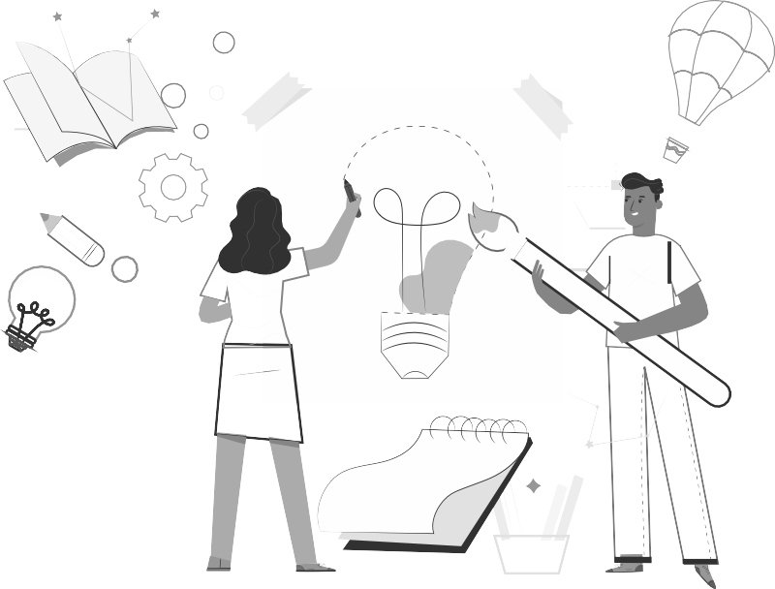

**RECOGNISING SOLUTION-SEEKING TEACHERS**

**ENTER THE TEACHER AGENCY AWARD**

***If it’s going to be, it’s up to me***

**SO WHY?**

To reward you for being awesome! You have shown that you care, that you have found a solution to a problem that helps others and that you have just gone ahead and made it happen.

We want to acknowledge and reward you and tell the world you are our hero! We want to reward you if you can show us that you are

self-motivated, self-directed and want to grow - and if you are driven by purpose and the desire to help others.

**WHO ME?**

Yes you! Any teacher or school ofﬁcial who is doing something for the greater good.

**WAIT WHAT?!**

So here’s what you need to show us - you need to be able to tell us that you:

1. Had the courage to just get going
2. Had belief in yourself to just do it

3

Activated a range of competencies that make you THE person that this new crazy world needs to ﬁx it and solve its problems, competencies such as:

* 1. A great character who is self-motivated to be a SA citizen who cares, who is curious about ﬁxing things and who has the energy, enthusiasm and resilience to carry on.
  2. The ability to think and be creative, ﬁgure things out, ﬁnd the information you need and make sense of it.
  3. How you made connections, how you collaborated and communicated with others as you stood in their moccasins to solve problems.

**WHAT WILL I WIN?**

T&Cs: We will be awarding exciting, signiﬁcant prizes of up to R5000 per prize winner. These will go to worthy recipients from each province whose solutions meet the criteria on the entry form. These will be judged by E³. Awards will be announced in the ﬁrst week of every month.

If no worthy entry is received that merits a prize, E³ reserves the right not to award a prize for that month.

The last winners will be announced in the ﬁrst week of October 2020 when this opportunity closes. Keep an eye on the E³ website to see if you have won and to celebrate the other winners and admire their solutions.

**SO HOW MUST I APPLY?**

It’s really simple - just ﬁll in the form at the back of this book and submit it to us.

Or submit the form on the E3 website:

[**www.e3-dbe.org**](http://www.e3-dbe.org/)[**www.ecubed-dbe.org**](http://www.ecubed-dbe.org/)

**WHEN MUST I HAND IT IN?**

NOW! You can apply anytime whenever. This is an ongoing opportunity that has no deadline. How cool is that?

**Saving water, saving lives TEACHER’S Project Notes Grade 5 | Life Skills | Term 3**

2

**CALLING ALL TEACHERS!**

**Think you lead the way in creating solutions to problems?**

**Enter this award and be rewarded and recognised for your unique problem-solving abilities.**



**Saving water, saving lives TEACHER’S Project Notes Grade 5 | Life Skills | Term 3**

3

**RUBRIC TO RATE THE LEVEL OF COMPETENCIES AND E-MINDSET**

**Did your entrepreneurial mindset grow whilst managing this project?**

**Personal rating**

(1=Poor, 4=Excellent)

**Pre-project**

**Post-project**

**COMPETENCIES**

**Character**

Citizenship

I am very committed and involved in various activities in my community and people regard me as someone to follow in my circle of inﬂuence.

Curiosity

I am very curious about everything around me and all my senses are alerted to possibilities which I always put into practice.

Resilience

When I face challenges I am always excited about the possibilities and I always get up after I have been unsuccessful. I am always enthusiastic about what I have learned in the process.

**Thinking**

Creativity

I always use my imagination to come up with original ideas and/or I am always creating new things.

Critical thinking

I always form judgements based on my ability to analyse and evaluate objectively.

Reasoning

I always think about things in a logical and sensible way and I always come up with conclusions easily.

**Collaboration**

Collaboration

I always produce good work / things by working well with people (individuals or a team).

Communication

I am always successful in conveying or sharing ideas or feelings.

Empathy

I have a highly developed ability to understand and share the feelings of others.

**E-MINDSET**

**Agency**

Growth mindset

I am always open to new information and am always willing to change my beliefs, assumptions and actions as a result.

Motivation

I always do what needs to be done without needing to be inﬂuenced by other people or situations. I always ﬁnd a reason or the strength to complete a task, even when it is challenging, without giving up or needing anyone else to encourage me.

Internal locus of control

I always have control of my life and my work is always my own and it is because of this that I experience success often. I never blame others or circumstances for my lack of success.

Regulation of emotion

I always respond to the demands of a situation with emotions that are socially tolerable and suﬃciently ﬂexible to allow spontaneous or delayed reactions – whichever are appropriate.

**Self-eﬃcacy**

Tasting success

I have always done things successfully enough to give me “the taste of success” that makes me motivated to want more and to believe that I can get it.

Socially relatable role model

I have always been fortunate to have been exposed to excellent role models that I can relate to and who make me motivated to want to be like them.

Positive support

I have always been fortunate to have had someone who has been a positive support to me and who has encouraged me and seen me as a person.

**Solution- seeking**

Resourceful

I always ﬁnd quick and clever ways to overcome diﬃculties and ﬁnd solutions.

Problem solving

I always ﬁnd solutions to diﬃcult or complex problems.



The trimmed projects - E³ response to COVID-19

1.



**PART 1: Setting the scene**

In collaboration with the DBE we have created projects for the new trimmed curriculum. In the past, lead teachers would gather and projects would be created during a writers’ workshop. A similar process is being followed now, but the trimming of the curriculum has made it diﬃcult to create one solid, clear project anchored by a community/learner problem because Term 3, the project term, now has to cover a number of themes very superﬁcially.

We have tried to create a coherent project which follows internationally-accepted standards in that it is research-based and includes enquiry-based learning and problem-based learning as part of the Project-based Learning process whilst adhering to the CAPS requirements of the trimmed ATP.

**Time frame for project completion - assessment**

The assessment for Term 3 is a project. Do not use the number of hours allocated to determine which project/s you feel will be useful for your learners (e.g. Week 1). As long as there is one project mark by the end of the term for the SBA (50 marks), the CAPS requirement will have been achieved.

However, we do encourage you to use this opportunity to press learners to do as much research and investigating as is possible – if we plan this well we shall succeed.

**Encourage learners to keep visual evidence of the process of their projects: E3 has invited learners to submit evidence of their project to the URLS/contact details in the Learner Workbook – we would love to showcase your school!**

**Ideas for planning:**

**Pre-plan**

1. Write a letter to the caregivers, parents, family and siblings (a letter is part of the Resource Pack at the end of these notes) explaining the need for their support.
2. Break up the project (each could be 3-4 weeks long) into small deadlines that you will check.
3. Help learners manage some social learning. (See social learning below)

**Saving water, saving lives TEACHER’S Project Notes Grade 5 | Life Skills | Term 3**

4

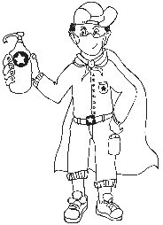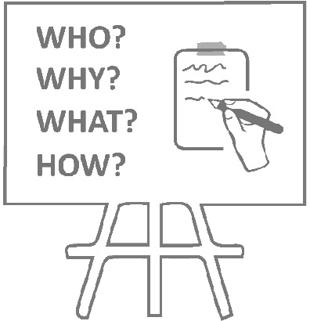



Social Learning during COVID-19 (Coronavirus)

2.

Individual learners will be “scientists” and go through a process (including elements of design thinking, problem-based learning, etc.) which will guide them to solve a problem. Learners will not have groups to work with, but the social learning can be facilitated by:

**Be available**

**The teacher’s role**

Notes/WhatsApps/face-to-face questions to teachers (give them a contact number or place a box for queries at the door of your classroom);

**Wh-wall**

A WH-wall for Who? Why? What? (and also How?) questions that are posted on the wall.

Learners write their open-ended question in large letters on pages that can be stuck on the wall, anonymously if learners wish. You could review all the questions once a week (after they have been on the wall for at least 48 hours) and answer the important questions.

The questions need not be about the project – it is a great opportunity to allay general fears about the “new normal” of living and going to school during the pandemic and also to encourage questioning techniques and so strengthen the fundamentals (especially language).

**Buddy-guard**

A buddy-guard (a safe critical friend whom s/he has identiﬁed before the project has started) is the

learner’s primary sounding board. The pair will agree that they give each other support and feedback at school with social distancing and via text and WhatsApp messages.

**The role of the family**

**Critical, safe partner.**

A buddy-guard is a special friend who cares about you and wants to support and look out for you.

The family (care-givers will also have a letter sent to them to explain their role).

**Saving water, saving lives TEACHER’S Project Notes Grade 5 | Life Skills | Term 3**

5





**3. Generic Project outline for all Projects**

**PLANNING**

1.

Learners brainstorm the problem that needs to be solved on their own, or with their buddy-guard, teacher or family. The brainstorm could also be a class activity done by the entire class.

Learners list questions that will help them think of the Big Question that will guide them in solving the problem.

2.

**RESEARCH / FINDING OUT**

1.

They note down sources of information from the following that they are planning to use to gather information:

* People they could interview
* Articles they could read
* Textbooks they could consult

They identify someone who might help them if they need information whilst stuck at home.

2.

**MAKING AND SHOWING THE EVIDENCE**

1.

2.

3.

What equipment will be needed to create the project item? Where will information on how to make the item be found? How many times did they try before they got it right?

**GETTING FEEDBACK AND CHANGING IF THEY NEED TO**

1.

2.

3.

Learners get feedback from their buddy-guard, parents or caregivers or teacher. They use information they have gathered to improve their product.

They note what they changed, when they made changes and why.

**Saving water, saving lives TEACHER’S Project Notes Grade 5 | Life Skills | Term 3**

6

**Step 1: Project topic guided by a big question**

**Step 2: Plan research sources**

**Step 3: Making creative project item and documenting the process**

**Step 4: Feedback and changes eﬀected**





**FINISHING OFF THE PROJECT**

Using all the feedback and what was learned after trying to improve their product, learners ﬁnish oﬀ their project item and the writing that goes with it.

**SHOWING OFF THEIR PROJECT**

1.

2.

They show oﬀ their project to as many people as it is safe to show it to.

People who view the projects (even those at home) write down their feedback or leave notes or send voice notes. Learners ensure that their WhatsApp number is on the project item and notes.

The ﬁnal item is taken to school and the teacher and learners arrange that the projects are shown to the rest of the school.

3.

**THINKING ABOUT IT AFTERWARDS**

Reﬂection:

1. What did I love about working on this project?

2.

3.

4.

What made this project hard for me? What did I learn by working on this project? About myself? About COVID-19? What would I do diﬀerently if I did a project like this again?

**Saving water, saving lives TEACHER’S Project Notes Grade 5 | Life Skills | Term 3**

7

**Step 5: Finishing oﬀ**

**Step 6: Showing oﬀ projects**

**Step 7: Reﬂection**





**4. Resource Pack**

See the Teacher Toolkit at the end of these notes to help you manage the project and to help you save time. Included you will ﬁnd:

**1. Project Resources:**

A letter to the parents and caregivers and notes on bullying, etc. Tools to assist with the Project, e.g.: *The diﬀerence between Primary and Secondary Resources; How to formulate the big question, etc.*

**2. Professional Development, e.g.:**

Project-based learning is a new pedagogy for teachers. We've included the E³ model and a variety of interesting articles to develop your PBL skills.

*The Project-based Learning (PBL) Cycle and your role as a Project Manager; The journey to Project- based Learning which starts with Enquiry-based Learning and Problem-based Learning, etc.*

**Resources in the Learner's Workbook**

The Learner's Project Workbook is enriched with many resources to help the learner complete the project independently. We are aware that learners will not have access to primary and secondary sources, so we've tried to address this obstacle.

And now, for a summary of the Grade 5 project.

**Saving water, saving lives TEACHER’S Project Notes Grade 5 | Life Skills | Term 3**

8

**PLEASE NOTE**

* After introducing the CAPS topic in class, learners are orientated towards the project and then left to deal with the project independently with access to all their resources.
* The number of weeks allocated to a topic in the CAPS does not mean that the length of the project is limited. Remember: the project is a tool to allow deeper investigation into a serious problem that impacts learners.
* We recommend that a learner be given 3 to 4 weeks to complete a project.



**PART 2**

**The Projects**

**5.**

**Project Summary and CAPS alignment**

**Saving water, saving lives TEACHER’S Project Notes Grade 5 | Life Skills | Term 3**

9

**ALIGNMENT CAPS (TRIMMED ATP)**

**DESCRIPTION OF PROJECT**

**Week 1**

**The importance of water:**

Water is very important for all life.

During COVID-19 (coronavirus) water plays an important role

Diﬀerent ways of saving water

Diﬀerent ways of protecting the quality of water

**Project: Saving Water (Choose 1)**

Learners investigate the importance of water in one of the following ways:

1. They research and then make a Tippy Tap, OR
2. They research and then make a water puriﬁer.
3. They research local community wastage of water and create a poster with their results.

**Week 2-5**

**Child Abuse:**

Diﬀerent forms of child abuse – physical and emotional Eﬀects of abuse on personal health Strategies to deal with abuse Where to get help and report abuse

How COVID-19 inﬂuenced the increase in violence and why.

**Dealing with violent situations:**

Identify potential violent situations at home, school and in the community.

Responding eﬀectively to violent situations.

**Project: Saving Lives**

Learner, buddy-guard and safe family members brainstorm incidents of child abuse that they have heard or read about.

The learners write anonymous letters on A3 pages to an Agony Aunt of a ChildCare magazine, asking for help.

Letters are placed on the classroom wall for other learners to read.

When letters are COVID-19 “safe” (a few days later) learners select letters written by someone else and they respond to the problem as the Agony Aunt. If uncertain, they ask caregivers, buddy-guard or even community workers and a teacher for advice.

The anonymous letter and the solution are placed side by side on the wall as part of the public display when they return to school.



**Saving water, saving lives TEACHER’S Project Notes Grade 5 | Life Skills | Term 3**

10

After display learners and their teacher summarise what they have harvested from the letters and create a class poster with the teacher either as a mind-map or under the following headings:

* Examples of physical abuse
* Examples of mental abuse
* Eﬀects of abuse on mental health
* Strategies to deal with abuse
* Where to ﬁnd help Learners become activists for change:
* They make paper pinwheels with important messages and phone numbers and post them all over their communities on their way to and from school. The poster and the pinwheel are ﬁrst submitted for assessment.

**Week 6-7**

**Healthy eating for children: South African Food- Based Dietary Guidelines**

* Dietary needs of children
* Factors inﬂuencing food intake of children during COVID-19

**Project: Healthy Eating**

Learners choose 8 food items from home and do research at home to ascertain:

* How healthy the item is i.t.o. dietary needs.
* How would you keep the item safe?
* What is an expiry date?
* How to store food to keep it fresh longer.
* What types of foods last longer and gives more bulk for the price

Factors inﬂuencing food intake of children during COVID-19 lockdown.

Public display: Each learner creates a poster (in infographic style) with their ﬁndings.



**6. The Projects in more detail**

The following step-by-step unpacking of the projects explains the teacher's or care giver's role in helping with the project, the PBL cycle and Enquiry-based and Problem-based Learning. **Items marked with (*) can be found in the Resource Library at the back of the Learner's Workbook. This will help learners to work independently at home.**

**Competencies**

The column on the right is for you to mark/underline which competencies you think you touched on in each step.

**PROJECT 1**

**6.1 Saving Water Please note: Learners must keep all evidence for assessment when they return to school.**

**Saving water, saving lives TEACHER’S Project Notes Grade 5 | Life Skills | Term 3**

11

**STEP 1: Ice-breaker and Planning**

**TASK**

**ROLE OF TEACHER OR CAREGIVER**

**RESOURCES**

**COMPETENCIES**

***(Underline which ones were developed)***

Learners discuss the importance of water for life.

They investigate ways of saving water and protecting the quality of water.

COVID-19 put a big importance on water.

Learners also brainstorm ideas on how to protect water sources.

Learners ask the BIG question.

1. Start the discussion in class or at home about the importance of water for all life forms. Especially touch on the importance of water during the COVID-19 pandemic. Learners complete Activity 1 and 2.
2. Explain the project to the learners: they will investigate the importance of water by making a Tippy Tap, OR creating a water puriﬁer. They will also research water wastage in school, at home and in the community, and make a poster on their ﬁndings to create awareness.
3. Guide learners in ﬁnding the BIG question for their research. They start by generating questions which they will answer when they have completed their model e.g. How can we make sure that the water we drink is clean? Model of water puriﬁer answers this question. There must be a link between the question and the model (the answer to the question).

*Tippy Tap instructions (WESSA)

*How to make a water puriﬁer (WESSA)

*WESSA lesson plan for parents/care givers – on the importance of saving water

Learner's Workbook Text Book

**Character** Citizenship Curiosity Resilience Mindset **Connection** Collaboration Communication Empathy **Thinking** Creativity Critical thinking Reasoning



**Saving water, saving lives TEACHER’S Project Notes Grade 5 | Life Skills | Term 3**

12

**STEP 3: Making and showing the evidence**

**TASK**

**ROLE OF TEACHER OR CAREGIVER**

**RESOURCES**

**COMPETENCIES**

***(Underline which ones were developed)***

Learners start work on their items. They make either a Tippy Tap or a water puriﬁer.

Learners create a rough draft of their posters with research outcomes: Why water is important?

3 facts about the importance of water, 3 ideas on how to save water, 3 ways of protecting the quality of water Why is it important during the COVID- 19 pandemic to use water?

Drawing to show how you built your Tippy Tap.

1. Give learners enough support and time to start work on their Tippy Taps or water puriﬁers.

Learners must ﬁrst draw up a plan for their personal Tippy Tap or water ﬁlter. (Activity 6)

1. Learners must also put their research from interviews together on a rough draft poster. The following should appear on the poster:

3 facts stating the importance of water for life

* 3 ways to save water
* 3 ways to protect the quality of our water
* The importance of water during the COVID-19 pandemic

*Tippy Tap instructions (WESSA)

*How to make a water puriﬁer (WESSA)

A4 paper for poster Learner's Workbook Text Book

**Character** Citizenship Curiosity Resilience Mindset **Connection** Collaboration Communication Empathy **Thinking** Creativity Critical thinking Reasoning

**STEP 2: Research / Finding out**

**TASK**

**ROLE OF TEACHER OR CAREGIVER**

**RESOURCES**

**COMPETENCIES**

***(Underline which ones were developed)***

Learners take a tour in the home/community or school and look for possible water wastage.

Learners research ways to create a Tippy Tap and water puriﬁer.

1. Guide learners in creating interview questions to take to family or members of the community (with safe distancing).
2. Take learners on a tour through the school grounds or ask them to do this at home. They should ﬁnd possible sources of water wastage – dripping taps, leaky water pipes, etc. (Activity 3)
3. Ask learners to start collecting material for their build/making. Help them choose to build either a Tippy Tap or a water puriﬁer. (Activity 4)
4. Learners will also present their research about water wastage in the form of a poster. These must contain:

3 facts stating the importance of water for life

* 3 ways to save water
* 3 ways to protect the quality of our water
* The importance of water during the COVID-19 pandemic (Activity 5)

*Tippy Tap instructions (WESSA)

*How to make a water puriﬁer (WESSA)

*WESSA lesson plan for parents/care givers – on the importance of saving water

**Character** Citizenship Curiosity Resilience Mindset **Connection** Collaboration Communication Empathy **Thinking** Creativity Critical thinking Reasoning



**Saving water, saving lives TEACHER’S Project Notes Grade 5 | Life Skills | Term 3**

13

**STEP 5: Finishing oﬀ your project**

**TASK**

**ROLE OF TEACHER OR CAREGIVER**

**RESOURCES**

**COMPETENCIES**

***(Underline which ones were developed)***

Learners work at home or in class to make the ﬁnal changes to their Tippy Taps or water puriﬁers.

They also make the ﬁnal changes and corrections on their posters.

Learners discuss the public display of their posters. All public displays should adhere to COVID-19

regulations.

1. Give learners time to make the ﬁnal changes to their posters. (Activity 8)
2. Discuss the possibilities of a public display of their posters. Possibly a wall in a corridor at school? Maybe outside the classroom?
3. **Please note: Learners must keep all evidence for assessment when they return to school.**

Learner's Workbook

**Character** Citizenship Curiosity Resilience Mindset **Connection** Collaboration Communication Empathy **Thinking** Creativity Critical thinking Reasoning

**STEP 4: Getting feedback and changing if you need**

**TASK**

**ROLE OF TEACHER OR CAREGIVER**

**RESOURCES**

**COMPETENCIES**

***(Underline which ones were developed)***

Learners get feedback from family members after their presentations. Learners show their rough draft posters to members of their families for feedback.

They also show their Tippy Tap/Water ﬁlter plans.

They implement the feedback and make necessary changes.

1. They get feedback. (Activity 7)
2. Guide learners through the process of change and adaptation of their poster and item designs.
3. Explain the importance of iteration and reviewing as part of the improvement of the ﬁnal quality.
4. Give them time to make the ﬁnal changes if necessary.

Learner's Workbook

**Character** Citizenship Curiosity Resilience Mindset **Connection** Collaboration Communication Empathy **Thinking** Creativity Critical thinking Reasoning



**Saving water, saving lives TEACHER’S Project Notes Grade 5 | Life Skills | Term 3**

14

**STEP 7: Thinking about it afterwards**

**TASK**

**ROLE OF TEACHER OR CAREGIVER**

**RESOURCES**

**COMPETENCIES**

***(Underline which ones were developed)***

Reﬂection on success or failure of the project and lessons learned.

1. Please don't skip this step.
2. Give learners time in class to reﬂect on the success of their project (academically and personally). (Activity 10)

4. Do the teacher's reﬂection rubric.

Teacher's Reﬂection rubric; Learner's Workbook

**Character** Citizenship Curiosity Resilience Mindset **Connection** Collaboration Communication Empathy **Thinking** Creativity Critical thinking Reasoning

**STEP 6: Showing oﬀ your project**

**TASK**

**ROLE OF TEACHER OR CAREGIVER**

**RESOURCES**

**COMPETENCIES**

***(Underline which ones were developed)***

Learners put up their posters in the designated area for display.

They ask for feedback from visitors

1. Organise the public display of learners' posters at school on a wall that can be viewed by other grades. Please keep to COVID-19 regulations. Feedback must be captured. (Activity 9)

If they are still at home, send images of poster and item to friends and family for feedback.

1. Use the rubric to assess posters and Tippy Taps/water puriﬁers

Resources for public display, e.g. Prestik, masks, sanitiser, etc.

*Rubric

Learner's Workbook

**Character** Citizenship Curiosity Resilience Mindset **Connection** Collaboration Communication Empathy **Thinking** Creativity Critical thinking Reasoning



**PROJECT 2**

**6.2 Saving Lives – Child abuse, Violence and dealing with violent situations**

**Saving water, saving lives TEACHER’S Project Notes Grade 5 | Life Skills | Term 3**

15

**STEP 1: Ice-breaker and Planning**

**TASK**

**ROLE OF TEACHER OR CAREGIVER**

**RESOURCES**

**COMPETENCIES**

***(Underline which ones were developed)***

Learners discuss the diﬀerent forms of child abuse.

They research how to deal with the problem and where to report it.

They also discuss violent situations at school, at home or in the community.

Learners create anonymous letters to an Agony Aunt. They answer these letters together to learn about ways to deal with violent situations.

Learners create a pinwheel with important messages on each segment. They display these in public spaces at school or in the community, but ﬁrst hand in with their infographic poster for assessment..

Learners ask the BIG question.

1. Lead a discussion with learners about the diﬀerent forms of child abuse – mental and physical – and the diﬀerence between the two.
2. Also discuss violent situations at school, at home or in the community. How to identify potentially violent situations.
3. Explain the outcome of the project: Learners become activists for change. They will make a pinwheel with four segments – each portraying a safety rule for dealing with child abuse and plant these on the school ground or in the community.

They also create a class poster with advice to children in need.

1. Guide learners to get to the BIG research question.

*Pinwheel template

*How to make a pinwheel

*Violence during COVID-19 times

Learner's Workbook

*Examples of infographic poster

Text Book

**Character** Citizenship Curiosity Resilience Mindset **Connection** Collaboration Communication Empathy **Thinking** Creativity Critical thinking Reasoning



**Saving water, saving lives TEACHER’S Project Notes Grade 5 | Life Skills | Term 3**

16

**STEP 3: Making and showing the evidence**

**TASK**

**ROLE OF TEACHER OR CAREGIVER**

**RESOURCES**

**COMPETENCIES**

***(Underline which ones were developed)***

Learners use the information or advice they received from family members or friends and write a response to the letter they chose.

They choose the four most impor- tant messages and write these on the pinwheel's blades.

They start planning on their pinwheel – what to write on the four blades and how to make it visible.

1. Learners use the information they got from family members to write a response to the letter to the Agony Aunt they have chosen. (Activity 2)
2. They paste these letters next to each other on the wall so that everyone can see. Discuss the solutions and responses with the learners.
3. With the help of the learners, summarise the problems and solutions on a class poster. Include headings and examples of physical and mental abuse, the eﬀects of abuse on mental health, strategies to deal with abuse and where to ﬁnd help.
4. Ask learners to start work on their windmills. They are activists for change and these pinwheels will be planted on the school grounds or in the community where they can be of value to someone who needs help/numbers. (Activity 3)

*Pinwheel design

*How to make a working paper pinwheel

Learner's Workbook Text Book

**Character** Citizenship Curiosity Resilience Mindset **Connection** Collaboration Communication Empathy **Thinking** Creativity Critical thinking Reasoning

**STEP 2: Research / Finding out**

**TASK**

**ROLE OF TEACHER OR CAREGIVER**

**RESOURCES**

**COMPETENCIES**

***(Underline which ones were developed)***

Learners write anonymous letters on A3 pages to an Agony Aunt.

They research possible answers to these letters with their buddy-guard or safe family members at home.

They research where to ﬁnd help, important numbers and organisations, but also ways in dealing with problems every day.

1. Learners write anonymous letters to an Agony Aunt about something that disturbs them; a burning question relating to violence or child abuse. (Start oﬀ with Activity 2 which introduces the topic: They write the letter and a response from Aunty Mimi.)
2. When school starts again: Paste their workbook letters, rewritten on A3 pages, on the wall for everyone to see (until 'safe' according to COVID-19 regulations).
3. Learners then choose a letter to respond to. Allow learners time to walk past all the letters and discuss the solutions to the problems with their buddy-guard and safe family members at home.

They should write a clear response to the letter with the help of family or friends.

1. Ask learners to research where to ﬁnd help, and to list important numbers and organisations in their letters.

* A3 paper for display only when learners return to school.

*Numbers and names of organisation that can help with child abuse or violence.

*Article on COVID-19

**Character** Citizenship Curiosity Resilience Mindset **Connection** Collaboration Communication Empathy **Thinking** Creativity Critical thinking Reasoning



**Saving water, saving lives TEACHER’S Project Notes Grade 5 | Life Skills | Term 3**

17

**STEP 6: Showing oﬀ your project**

**TASK**

**ROLE OF TEACHER OR CAREGIVER**

**RESOURCES**

**COMPETENCIES**

***(Underline which ones were developed)***

Learners plant their pinwheels in the public place of choice. They ask for feedback on their project.

1. Support learners in planning the public display of their pinwheels. (Activity 6)
2. Use the rubric to assess.

*Rubric

Learner's Workbook

**Character** Citizenship Curiosity Resilience Mindset **Connection** Collaboration Communication Empathy **Thinking** Creativity Critical thinking Reasoning

**STEP 5: Finishing oﬀ your project**

**TASK**

**ROLE OF TEACHER OR CAREGIVER**

**RESOURCES**

**COMPETENCIES**

***(Underline which ones were developed)***

Learners work at home or in class to make the ﬁnal changes to their pinwheels.

Learners discuss ways to publicly display their pinwheels.

1. Give learners time to make the ﬁnal changes to their pinwheels. (Activity 5)
2. Discuss the possibilities of a public display of their pinwheels. At school in a mass display? Possibly in important places in the community?

Learner's Workbook

**Character** Citizenship Curiosity Resilience Mindset **Connection** Collaboration Communication Empathy **Thinking** Creativity Critical thinking Reasoning

**STEP 4: Getti 䘰ㇾ$怀懀怀 　ng feedback and changing if you need**

**TASK**

**ROLE OF TEACHER OR CAREGIVER**

**RESOURCES**

**COMPETENCIES**

***(Underline which ones were developed)***

Learners present their plans for their pinwheels to teacher, friends and family members.

They get feedback on the eﬀectivity of the message and the attractiveness of the item.

1. Guide learners through the process of change and adaptation of their pinwheels. (Activity 4)
2. Explain the importance of iteration and reviewing as part of the improvement of the ﬁnal quality.
3. Give them time to make the ﬁnal changes if necessary.

*How to make a working paper pinwheel

*Important numbers for reporting child abuse

Learner's Workbook

**Character** Citizenship Curiosity Resilience Mindset **Connection** Collaboration Communication Empathy **Thinking** Creativity Critical thinking Reasoning



**PROJECT 3**

**6.3 Healthy eating for children – Dietary needs and factors that inﬂuence food intake**

**Saving water, saving lives TEACHER’S Project Notes Grade 5 | Life Skills | Term 3**

18

**STEP 1: Ice-breaker and Planning**

**TASK**

**ROLE OF TEACHER OR CAREGIVER**

**RESOURCES**

**COMPETENCIES**

***(Underline which ones were developed)***

Learners read the story of Thumi in class.

They discuss the dietary needs of children.

Learners do research on the dietary needs of children and factors inﬂuencing food intake.

COVID-19 article on how to save food, buying things that can last.

Learners ask the BIG question.

1. Unpack the story of Thumi with a class discussion. Why is she feeling ill? What could she do as a child with little or no choice? What should children eat to be healthy and happy? (Activity 1)
2. Explain the outcome of the infographic: A poster displaying their research ﬁnding on healthy eating.
3. Guide learners in ﬁnding the BIG research question. Activity 2 guides them in analysing what food is generally consumed at home. (Activity 2)

*SA dietary guidelines

*How to create a research poster

Learner's Workbook Text Book

**Character** Citizenship Curiosity Resilience Mindset **Connection** Collaboration Communication Empathy **Thinking** Creativity Critical thinking Reasoning

**STEP 7: Thinking about it afterwards**

**TASK**

**ROLE OF TEACHER OR CAREGIVER**

**RESOURCES**

**COMPETENCIES**

***(Underline which ones were developed)***

Reﬂection on success or failure of the project and lessons learned.

1. Please don't skip this step.
2. Give learners time in class to reﬂect on the success of their project (academically and personally). (Activity 7)

4. Do the teacher's reﬂection rubric.

Teacher's Reﬂection rubric; Learner's Workbook

**Character** Citizenship Curiosity Resilience Mindset **Connection** Collaboration Communication Empathy **Thinking** Creativity Critical thinking Reasoning



**Saving water, saving lives TEACHER’S Project Notes Grade 5 | Life Skills | Term 3**

19

**STEP 4: Getti 䛀怀妀怀剠怀 aীng feedback and changing if you need**

**TASK**

**ROLE OF TEACHER OR CAREGIVER**

**RESOURCES**

**COMPETENCIES**

***(Underline which ones were developed)***

Learners show their posters with their research ﬁnding to their buddy-guard, family members at home for feedback.

1. Guide learners through the process of change and adaptation of their rough draft posters. (Activity 5)
2. Explain the importance of iteration and reviewing as part of the improvement of the ﬁnal quality.
3. Give them time to make the ﬁnal changes if necessary.

Learner's Workbook

**Character** Citizenship Curiosity Resilience Mindset **Connection** Collaboration Communication Empathy **Thinking** Creativity Critical thinking Reasoning

**STEP 3: Making and showing the evidence**

**TASK**

**ROLE OF TEACHER OR CAREGIVER**

**RESOURCES**

**COMPETENCIES**

***(Underline which ones were developed)***

Learners start work on their posters with their ﬁndings. They create a rough draft of their research.

They present their chosen 8 food items on the poster with information about the dietary value and how to store it to keep it safe and make it last longer.

1. Allow learners to start with rough planning on their posters about their research. (Activity 4)
2. Start a class discussion on food safety. Why should some foods be refrigerated and how to think about food safety during the COVID-19 pandemic.

*Coronavirus and food safety

Learner's Workbook Text Book

**Character** Citizenship Curiosity Resilience Mindset **Connection** Collaboration Communication Empathy **Thinking** Creativity Critical thinking Reasoning

**STEP 2: Research / Finding out**

**TASK**

**ROLE OF TEACHER OR CAREGIVER**

**RESOURCES**

**COMPETENCIES**

***(Underline which ones were developed)***

Learners choose 8 food items from home to do research on. They research the dietary value of each, how to keep it safe/fresh, how to store it to last longer.

Learners discuss factors inﬂuencing the food intake of children.

1. Ask learners to each choose 8 food items from home to research.

They should research the dietary value of each, how to store it and how to keep it fresh for longer.

1. Their research ﬁndings should be recorded in the Learner's Workbook. (Activity 3)
2. Discuss the factors that inﬂuence food intake of children in class.

* SA dietary guidelines
* Safe food storage tips
* Healthy foods for brain growth

Learner's Workbook

**Character** Citizenship Curiosity Resilience Mindset **Connection** Collaboration Communication Empathy **Thinking** Creativity Critical thinking Reasoning



**Saving water, saving lives TEACHER’S Project Notes Grade 5 | Life Skills | Term 3**

20

**STEP 7: Thinking about it afterwards**

**TASK**

**ROLE OF TEACHER OR CAREGIVER**

**RESOURCES**

**COMPETENCIES**

***(Underline which ones were developed)***

Reﬂection on success or failure of the project and lessons learned.

1. Please don't skip this step.
2. Give learners time in class to reﬂect on the success of their project (academically and personally). (Activity 8)

4. Do the teacher's reﬂection rubric.

Teacher's Reﬂection rubric; Learner's Workbook

**Character** Citizenship Curiosity Resilience Mindset **Connection** Collaboration Communication Empathy **Thinking** Creativity Critical thinking Reasoning

**STEP 6: Showing oﬀ your project**

**TASK**

**ROLE OF TEACHER OR CAREGIVER**

**RESOURCES**

**COMPETENCIES**

***(Underline which ones were developed)***

Learners display their posters to the rest of the school.

1. Support learners in the public display of their posters. (Activity 7)
2. Use the rubric to assess.

Resources for the public display of posters

*Rubric

Learner's Workbook

**Character** Citizenship Curiosity Resilience Mindset **Connection** Collaboration Communication Empathy **Thinking** Creativity Critical thinking Reasoning

**STEP 5: Finishing oﬀ your project**

**TASK**

**ROLE OF TEACHER OR CAREGIVER**

**RESOURCES**

**COMPETENCIES**

***(Underline which ones were developed)***

Learners work at home or in class to make the ﬁnal changes to their posters.

Learners discuss ways to publicly display their posters at school for everybody to see and learn.

1. Give learners time to make the ﬁnal changes to their posters. (Activity 6)
2. Discuss the possibilities of a public display of their posters. Where in the school ground would it have the biggest impact and reach the most viewers? What resources would they need for the public display?

Learner's Workbook

**Character** Citizenship Curiosity Resilience Mindset **Connection** Collaboration Communication Empathy **Thinking** Creativity Critical thinking Reasoning



**7.**

**Assessment rubric**

**Saving water, saving lives TEACHER’S Project Notes Grade 5 | Life Skills | Term 3**

21

**ITEM**

**ASSESSMENT CRITERIA**

**NOT ACHIEVED (0)**

**PARTIALLY ACHIEVED (1)**

**ACHIEVED (2)**

**EXCELLENT (3)**

**LEARNER MARK**

**/30**

**Part 1 – Saving water, saving lives**

Poster and item (Tippy Tap or water puriﬁer) show 3 facts stating the importance of water and 3 diﬀerent ways to save water are clearly understood and evident

No facts given – neither on why water is important nor ways in which water can be saved

1-2 facts given on why water is important and 1- 2 facts on how water can be saved

2-3 facts given on why water is important and 2- 3 facts on how water can be saved

3 or more facts given on why water is important and 3 or more facts on how water can be saved

/3

3 diﬀerent ways of protecting the quality of water and the importance of water during COVID- 19 is apparent

No ideas on protecting the quality of water

1-2 idea on protecting the quality of water

2-3 ideas on protecting the quality of water

3 or more ideas on protecting the quality of water

/3

**Part 2 – A healthy mind… abuse and violence**

Diﬀerence between mental and physical abuse understood

Nothing provided – no evidence that learner understands the diﬀerence between mental and physical abuse

Minimal understanding that learner understands the diﬀerence between mental and physical abuse

Fair to good understanding that learner understands the diﬀerence between mental and physical abuse

Learner shows a deeply felt understanding of the diﬀerence between mental and physical abuse

/3

5 safety rules in dealing with child abuse

No or very little info on safety in evidence

2-3 ways of protecting yourself are clear on the pinwheel

3-4 ways of protecting yourself are clear on the pinwheel

4 or more ways of protecting yourself are clear on the pinwheel

/3

Where to ﬁnd help clearly marked

No info appears

Some info appears but not clear or complete

Info for ﬁnding help clearly marked but details incomplete

All info for ﬁnding help clear. Complete set of details

/3

Learner can/does identify potentially violent situations at home, school and community

Learner shows no real ability to identify potentially violent situations at home, school and community

Learner is sometimes able to identify potentially violent situations at home, school and community

Learner can and does identify potentially violent situations at home, school and community, but not always able to share the problem eﬀectively

Learner shows maturity and ability to identify potentially violent situations at home, school and community

/3

Learner is able to deal with violent situations by responding practically and eﬀectively

No evidence of ability to deal eﬀectively with violent situations

Learner is somewhat able to deal with violent situations by responding with some practicality and eﬀectiveness

Learner is able to deal with violent situations by responding practically and eﬀectively

Learner is more than able to deal with violent situations and shows maturity in responding practically and eﬀectively

/3

Learner understands the impact of the coronavirus and the eﬀect of the pandemic on increased violence in families and communities

Learner has no understanding of the inﬂuence of the coronavirus

Learner has some understanding of the inﬂuence of the coronavirus

Learner has adequate understanding of the inﬂuence of the coronavirus

Learner has very good understanding of the inﬂuence of the coronavirus on increased violence

/3



**PART 3**

**TEACHER’S RESOURCES**

This section oﬀers you all the resources you might need in launching your project (Project Resources) reﬂecting on your personal development as an active learning facilitator and Project-based Learning Project Manager, practical thinking and other tools to help you in carrying out the project.

**9. Tools to assist with the Project**

**Project Resources**

***9.1 Letter to the parents / caregivers***

A copy of the letter to copy and print is available on the following page.

**Saving water, saving lives TEACHER’S Project Notes Grade 5 | Life Skills | Term 3**

22

**ITEM**

**ASSESSMENT CRITERIA**

**NOT ACHIEVED (0)**

**PARTIALLY ACHIEVED (1)**

**ACHIEVED (2)**

**EXCELLENT (3)**

**LEARNER MARK**

**/30**

**Part 3 – A healthy body**

Learner understands the dietary needs of children

Learner shows little or no understanding of the dietary needs of children

Learner somewhat understands the dietary needs of children, but clear gaps evident in knowledge and understanding

Learner understands the dietary needs of children

Learner truly understands the dietary needs of children and shows insight beyond expectations

/3

A solid understanding of the factors that inﬂuence the food intake of children

Learner shows little or no understanding of the factors that inﬂuence the food intake of children

Learner shows some understanding of the factors that inﬂuence the food intake of children but still on a basic level

Learner shows a solid understanding of the factors that inﬂuence the food intake of children

Learner shows deep insights in understanding the factors that inﬂuence the food intake of children

/3

**TOTAL:**

**/30**



*Date:*

*Getti ng Ready*

***Dear Parents, Siblings and Caregivers***

*The Grade 5 learner in your care will be doing a project or two during the next few weeks.*

*A large part of the project will be done at school, but an important part will be done after school, at home.*

***How can you help?***

*•*

*The project plan is quite structured with dates for each step clearly set out. Check the deadlines with his / her teacher and help your child understand the importance of keeping to a schedule.*

*•*

*The project asks learners to share information with the family at home and to ask for feedback and advice. Please set aside some time to help when needed. Perhaps you can ask one member of the family to be the “Advisor” for the family. Your child will have to note the feedback/advice as part of the project, so this is a serious matter for your child.*

*•*

*The Learner’s Resource Library has all the information resources your child needs, but you may be asked for advice on how to do something. Your experience as an adult will give your child the support needed.*

*Good luck! Let's learn from each other and oﬀer our children support, empathy and care.*

***Teacher***





***9.2 The Big Question in research***

Essential questions, or driving questions, are a key element of project-based learning, so we've outlined 14 essential question stems to help you craft the most engaging PBL essential questions.

***1. How can improve ?***

*How can studying diﬀerent cultures improve our understanding of our community? How can robotics improve the healthcare industry?*

*How can access to clean water improve communities, especially during coronavirus?*

1. ***How can be applied to ?***

*How can entrepreneurship skills be applied to subjects like science and geography? How can entrepreneurship skills be applied in our daily lives?*

*How can ethics be applied to solve environmental problems?*

1. ***How can change ?*** *How can individuals change their communities? How can kindness change bullying?*

*How can the human behaviour change the environment?*

1. ***How would you design a new ?***

*How would you design a new school?*

*How would you design a new system to purify water? How would you design a new ﬂag for your community?*

***5. How does aﬀect ?***

*How do poor eating habits aﬀect communities around the world? How does bullying aﬀect our community?*

*How does violence aﬀect our daily lives?*

1. ***What impact did/does have on ?***

*What impact does climate change have on the environment during the 21st century? What impact does coronavirus have on children's sense of security?*

*What impact does social media have on our understanding of the facts surrounding the coronavirus pandemic*

1. ***What makes a good/eﬀective ?***

*What makes a good library? What makes an eﬀective school? What makes a happy classroom?*

1. ***How do/does impact my community?***

*How does racism impact my community?*

*How does the food grown in our region impact what people eat? How does bullying and violence impact my community?*

1. ***What is the relationship between and ?***

*What is the relationship between maths and everyday life? What is the relationship between science and entrepreneurship? What is the relationship between transportation and trade?*

**Saving water, saving lives TEACHER’S Project Notes Grade 5 | Life Skills | Term 3**

24



***10. What would be without ?***

*What would our school be without classrooms?*

*What would the Earth's climate be like without the atmosphere? What would the world be without art?*

***11. If you were in charge of , what would you change?***

*If you were in charge of our school, what would you change?*

*If you were in charge of our community, what would you change? If you were in charge of Facebook, what would you change?*

1. ***How can you use to inspire ?***

*How can you use poetry to inspire change?*

*How can you use storytelling to inspire people to take better care of the environment? How can you use science to inspire people to eat healthier food?*

1. ***What if ?***

*What if you could go back in time, what would you change? What if South Africa did not have schools?*

*What if the world lost the internet for one year?*

1. ***How might your community change if ?***

*How might your community change if it were twice as big?*

*How might your community change if it rained every day for a year? How might your community change if every person were given R1 million?*

Seeing the diﬀerent ways learners approach an essential question is one of the most rewarding parts of project-based learning, and you'll get to learn a lot about the learners in your class! Engage students through project-based learning by providing them with great PBL essential questions, then watch them dive in and take control of their own learning.

**Saving water, saving lives TEACHER’S Project Notes Grade 5 | Life Skills | Term 3**

25

**Source:** Staﬀ Writer, 2020. *PBL: Easy essential stems for project based learning,* viewed on 2 June 2020,

<h[ttps://www.penpalschools.c](http://www.penpalschools.com/blog/easy-project-based-learning-question-stems-for-essential-)om/blog[/easy-project-based-learning-question-stems-for-essential-](http://www.penpalschools.com/blog/easy-project-based-learning-question-stems-for-essential-) questions>

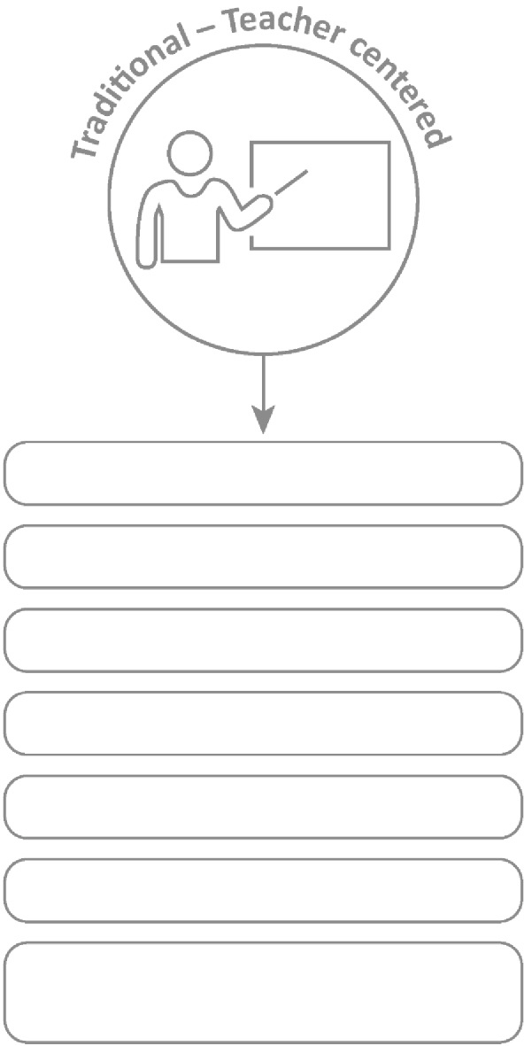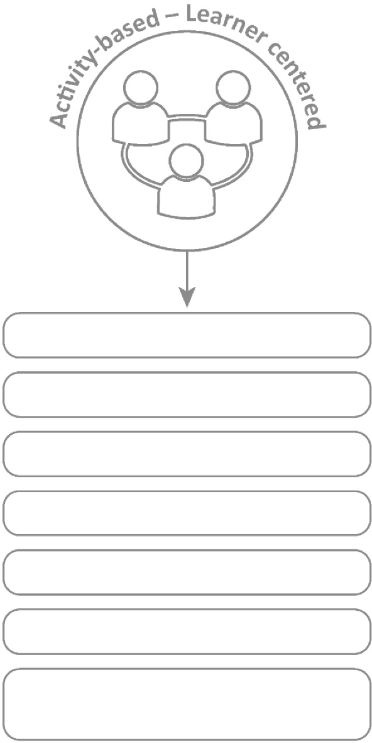



**10. Professional Development**

***10.1 Traditional vs Activity-based learning***

Projects are preferred because the learner does the work and it is activity-based learning. This leads to deeper learning.

**Basic Learning**

**In-depth learning**

**Smaller groups within class**

**Bigger class size**

**Integrated/interdisciplinary subjects**

**Isolated subjects**

**Process-oriented**

**Product-oriented**

**Learning through active involvement**

**Learning by repetition**

**Concepts questions to be investigated**

**Concepts are facts to memorize**

**Quantitative evaluation (numerical testing)**

**Authentic assessment (competencies, integrated, mindset)**

**Saving water, saving lives TEACHER’S Project Notes Grade 5 | Life Skills | Term 3**

26



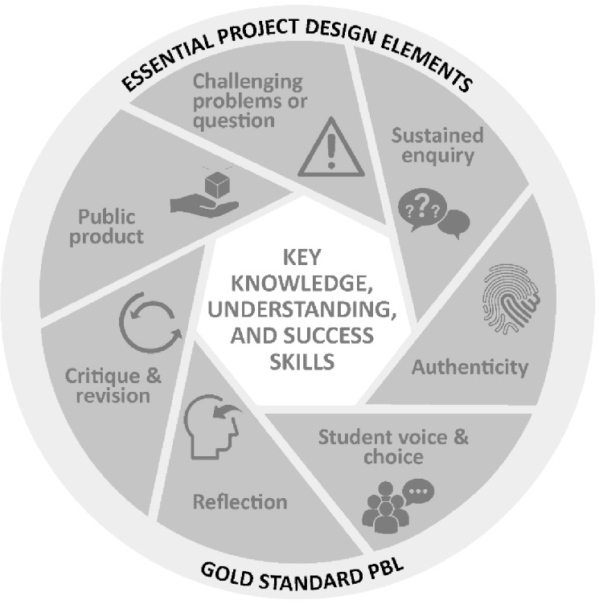

***10.2 The Project-based Learning Cycle***

Below please ﬁnd the *Key Knowledge, Understanding* and *Success Skills* to help you manage the project.

**Challenging problem or question:** Why is this project critical? What is the problem in society and at school being addressed in this project? Keep talking about how this project

will solve a local or global problem.

**Sustained enquiry:** Are learners being “researchers”?

Are they doing the research and getting deeper and deeper into the problem or are you doing all the talking? Look at the second circle overleaf to remind you of your role: manage activities and scaﬀold student learning. Learners must not be allowed to give up – you must “build a culture” of getting to the bottom of the problem and

coach them when they lose their way. With time E3 will be developing thinking tools to ensure that you are equipped with strategies to take the enquiry to a new level. (See overleaf for the

current PBL learning cycle with a built-in innovation cycle.)

**Authenticity:** Keep the project real by referring to learners' own lives – this is about them and their world.

**Student Voice and Choice:** Although learners did not choose this project, make it fun and real, and applicable to their own world, so that they own it. Their voices and opinions are what your deeper goal is – encourage their views and applaud each contribution.

**Reﬂection:** To truly embed learning, learners should be able to reﬂect on what they have learned and be able to think of better ways of doing things. The reﬂection activities in the worksheets are not just for fun. Encourage learners to spend time on them as this will deepen their learning.

**Critique and Revision:** This process is to help learners experiment with their innovation and learn how to improve their work and thinking. As you assess and evaluate their products (not them!) learners will see that there are diﬀerent ways of solving problems. It is important that learners hone their curiosity and learn how to “stick it out” and keep trying, not giving up when it doesn't work ﬁrst time round.

**Public Product:** At the end of the project what does the learner have to show or to brag about? Ensure that there is a Project Culmination Week in which each grade displays their products during a week selected by the management team to ensure that as many parents and other stakeholders as possible attend.

**Saving water, saving lives TEACHER’S Project Notes Grade 5 | Life Skills | Term 3**

27

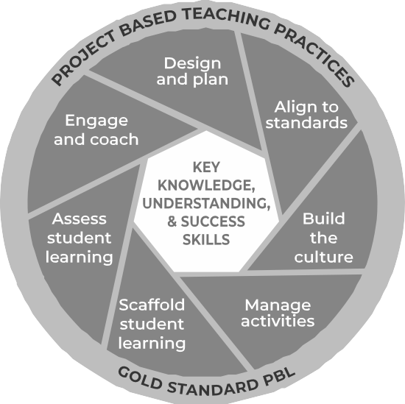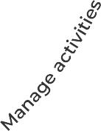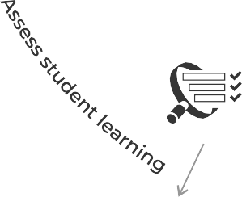

***10.3 The Project-based Learning facilitator***

***Project-based Learning: The teacher’s role as project manager***

We as teachers need to reassess our roles. The time for good lecturing has passed. The time has come to put learner needs and their problems at the centre of the lesson and to do everything in our power to make school useful for life after school, to help learners know and believe in themselves and to give them space to become problem solvers themselves... and, of course, to have fun.

Learners go to school not to WORK, but to LEARN!

**A problem arises in the learners’ world and a lesson is created around it. She knows her curriculum and this will help her to link the problem to relevant CAPS information / knowledge transfer.**

**She knows the CAPS and links her lesson to outcomes and expectations from the CAPS.**

**Her role is to pay attention to the needs of every learner and to offer them support, not via formal teaching, but by one-on-one coaching especially as they work in groups.**

**She understands that school culture plays a huge role in modeling appropriate and meaningful relationships.**

**In her classroom, there are 3 types of assessment and each is treated differently and has a different purpose.**

**She creates an authentic project, designed around practical real-life solutions. There is very little transmission teaching.**

**She understands that all learners are different in a variety of ways. She sees her role as that of supporter as each individual learner is helped to climb to the next level through her one-on-one coaching.**

**Learners are given a task with clear instructions and the teacher observes learners and helps them as and when needed. She is a classroom site and activity manager.**

**Baseline - where should we start? Formative - How are we doing, every little step of the way?**

**Summative - How did we do when tested on a chunk of work?**

**She also does not do all the marking herself - she knows that learner self and peer assessment can be powerful learning opportunities if well-managed.**

**Saving water, saving lives TEACHER’S Project Notes Grade 5 | Life Skills | Term 3**

28

**En**

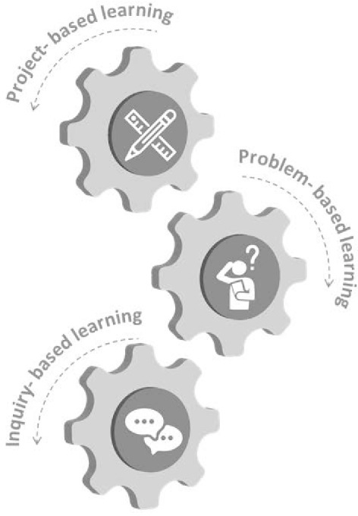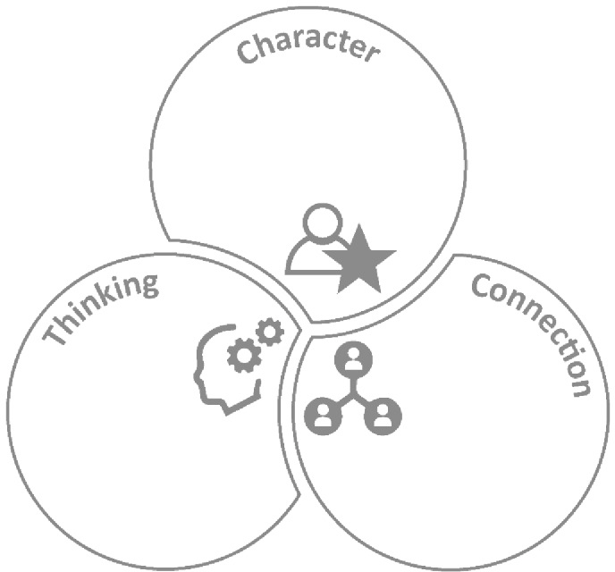



***10.4 The E3 Competencies model within the CAPS***

These appear in the competencies column of your planning. Please highlight each competency that was addressed during the lesson. Learners achieving these competencies are readier for the new world of work.

Citizenship Curiosity Resilience Mindset

Creativity Critical Thinking

Collaboration Communication Empathy

***10.5 The journey to PBL via Enquiry-based and Problem-based Learning***

* Learning by designing and building innovative products to solve complex real-world problems
* Building systems and design thinking abilities and mindsets
* Learn by engaging in complex real-world problems and developing plausible solutions
* Building critical and creative thinking and problem-solving abilities
* Learning by asking questions and engaging a topic, mastering concepts, models and theories - seeking answers
* Developing conceptual thinking and multi-literacies
* Working in groups developing communication and coordination skills

**Saving water, saving lives TEACHER’S Project Notes Grade 5 | Life Skills | Term 3**

29

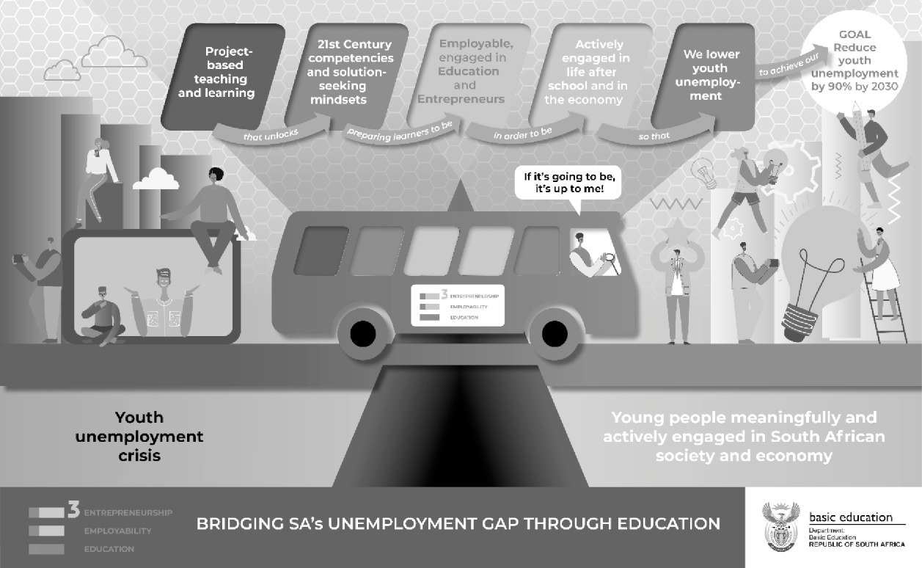



***7.9 Bridging the Unemployment gap through Education***

**Saving water, saving lives TEACHER’S Project Notes Grade 5 | Life Skills | Term 3**

30



Email your completed form to [info@ecubed-dbe.org](mailto:info@ecubed-dbe.org) with the subject line “Teacher Agency Award submission

[**info@ecubed-dbe.org**](mailto:info@ecubed-dbe.org)

Name of your solution:

Why did you choose this name?

Identifying the problem: *(Maximum 200 words)*

*I identiﬁed the following problem in my school/community/at home:*

E3 Teacher Agency Award Form | Page 1 of 5

**Saving water, saving lives TEACHER’S Project Notes Grade 5 | Life Skills | Term 3**

31

Name:

Position: (e.g. Teacher, SMT, etc.)

**If teacher:**

Subject taught:

Grade:

School name:

District:

Province:

**Your contact details:**

Email:

Cell number:

WhatsApp number:

**TEACHER AGENCY AWARD FORM**



Trying, adapting the process until problem was solved: *(Maximum 200 words)*

*Initially I …. Then …. Eventually I could solve the problem in this way: ……*

E3 Teacher Agency Award Form | Page 2 of 5

**Saving water, saving lives TEACHER’S Project Notes Grade 5 | Life Skills | Term 3**

32



Collaboration and access to information: *(Maximum 200 words)*

*I collaborated with …. And accessed information f rom …. which helped me in the following ways…*

Creativity and innovation: *(Maximum 200 words)*

*My solution was very creative because I …. My solution was unique and innovative because …*

E3 Teacher Agency Award Form | Page 3 of 5

**Saving water, saving lives TEACHER’S Project Notes Grade 5 | Life Skills | Term 3**

33



Meeting E3 standards: *(Maximum 200 words)*

Explain why you are an E3 ambassador and tribe member. Use phrases like the following in your explanation:

*I care and want to help others: ………………………………………………………...*

*I am a problem-solver:……………………………………………………………………….*

*I am awesome: …………………………………………………………………………………...*

*I am driven by purpose:……………………………………………………………………….*

*I have courage and self belief:……………………………………………………………….*

*I can keep going, despite challenges:………………………………………………………*

E3 Teacher Agency Award Form | Page 4 of 5

**Saving water, saving lives TEACHER’S Project Notes Grade 5 | Life Skills | Term 3**

34



Provide us with each of the following (please include clear notes on the pictures and videos):

•

•

•

•

Your 4 best pictures (2 in portrait and 2 in landscape)

A VoiceNote of not more than a minute reﬂecting on your growth in this project A short video that shows an important episode in the project

If minors appear in the photos and video, please submit permission f rom parents or caregiv- ers that these photos appear on E3 platforms.

E3 Teacher Agency Award Form | Page 5 of 5

**Saving water, saving lives TEACHER’S Project Notes Grade 5 | Life Skills | Term 3**

35