Teacher’s
Project Notes

GRADE 8

E³ Projects for
Trimmed ATP
PROJECT:
Celebrating COVID-19 HEROES

Table of Contents
Letter from the DBE- E³ 0
Teacher Agency Award 2
PART 1: Setting the scene 4
1. The trimmed projects - E³ response to COVID-19 4
2. Social Learning during COVID-19 (Coronavirus) 5
3. Generic Project outline for all Projects (directed at the learner) 6
1. PLANNING 6
2. RESEARCH/ FINDING OUT 6
3. MAKING AND SHOWING THE EVIDENCE 6
4. GETTING FEEDBACK AND CHANGING IF THEY NEED TO 6
5. FINISHING OFF THEIR PROJECT 7
6. SHOWING OFF THEIR PROJECT 7
7. THINKING ABOUT IT AFTERWARDS 7
4. Resource Pack 7
PART 2: The Project/s 8
5. Project Summary and CAPS alignment. 8
6. The Project in more detail 9
7. Rubric: Celebrating local COVID-19 heroes 14
PART 3: TEACHER RESOURCES 15
8. Tools to assist with the Project 15
8.1 Letter to the parents/caregivers 15
8.2 Primary vs Secondary sources 17
8.3 The Big Question in research 18
9. Professional Development 20
9.1 Traditional vs Activity-based Learning 20
9.2 The Project-based Learning Cycle 21
9.3 The Project-Based Learning facilitator 22
9.4 The E³ Competencies model within the CAPS 23
9.5 The journey to PBL via Enquiry-based and Problem-based Learning 23
9.6 Bridging the Unemployment gap through Education 24
Teacher Agency Award Entry Form………………………………………………………………………………………………….23

PLEASE NOTE

Part 1 and 2 of this booklet must be printed and are the minimum project resources you as the teacher will need. However, the rest of the booklet contains valuable tools for personal development, as well as very good sources in support of the project. You don't have to look anywhere else.

Don’t forget to enter the Teacher’s Agency Awards (see page 2)

This programme is accompanied by podcasts, audio recordings and videos.
We will send out the links shortly.

Before you start, please complete the Teacher’s Mindset Rubric on page 3.

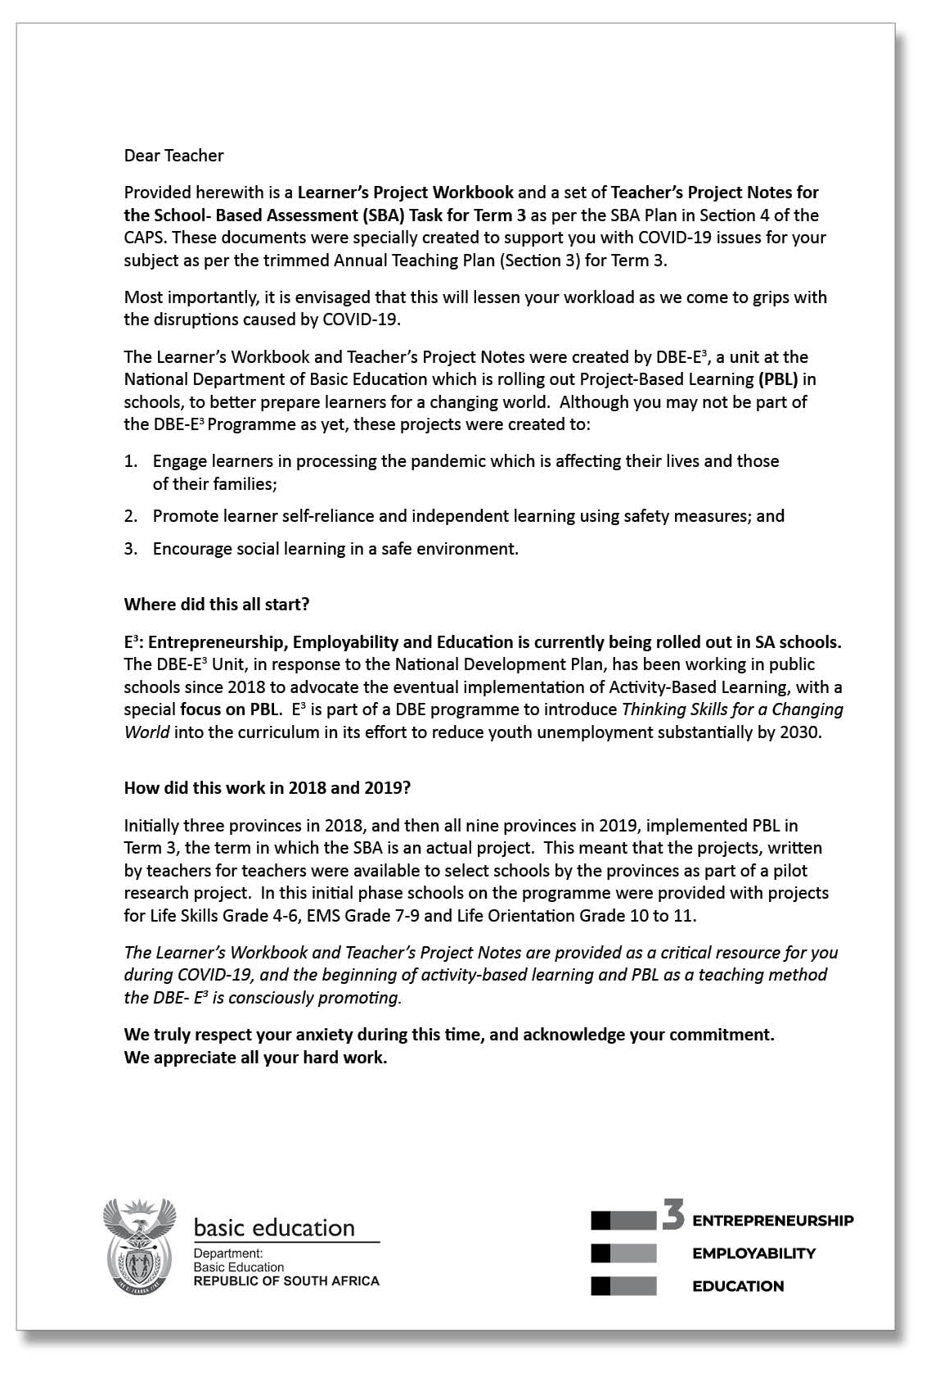

TEACHER’S PROJECT NOTES
GRADE 8
ECONOMIC MANAGEMENT SCIENCES

E³ PROJECT FOR TRIMMED ATP
Celebrating COVID-19 HEROES
Assessment Rubric /50
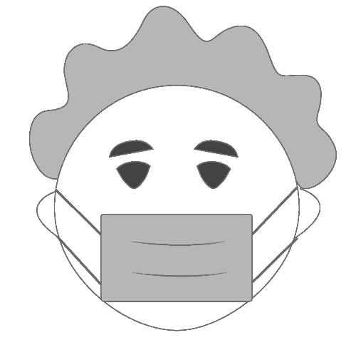

Teacher Agency Award
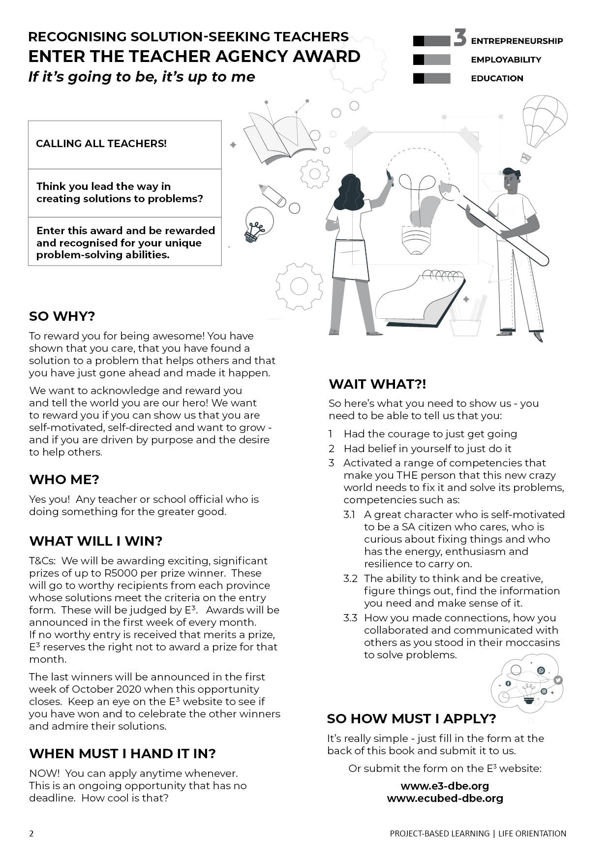

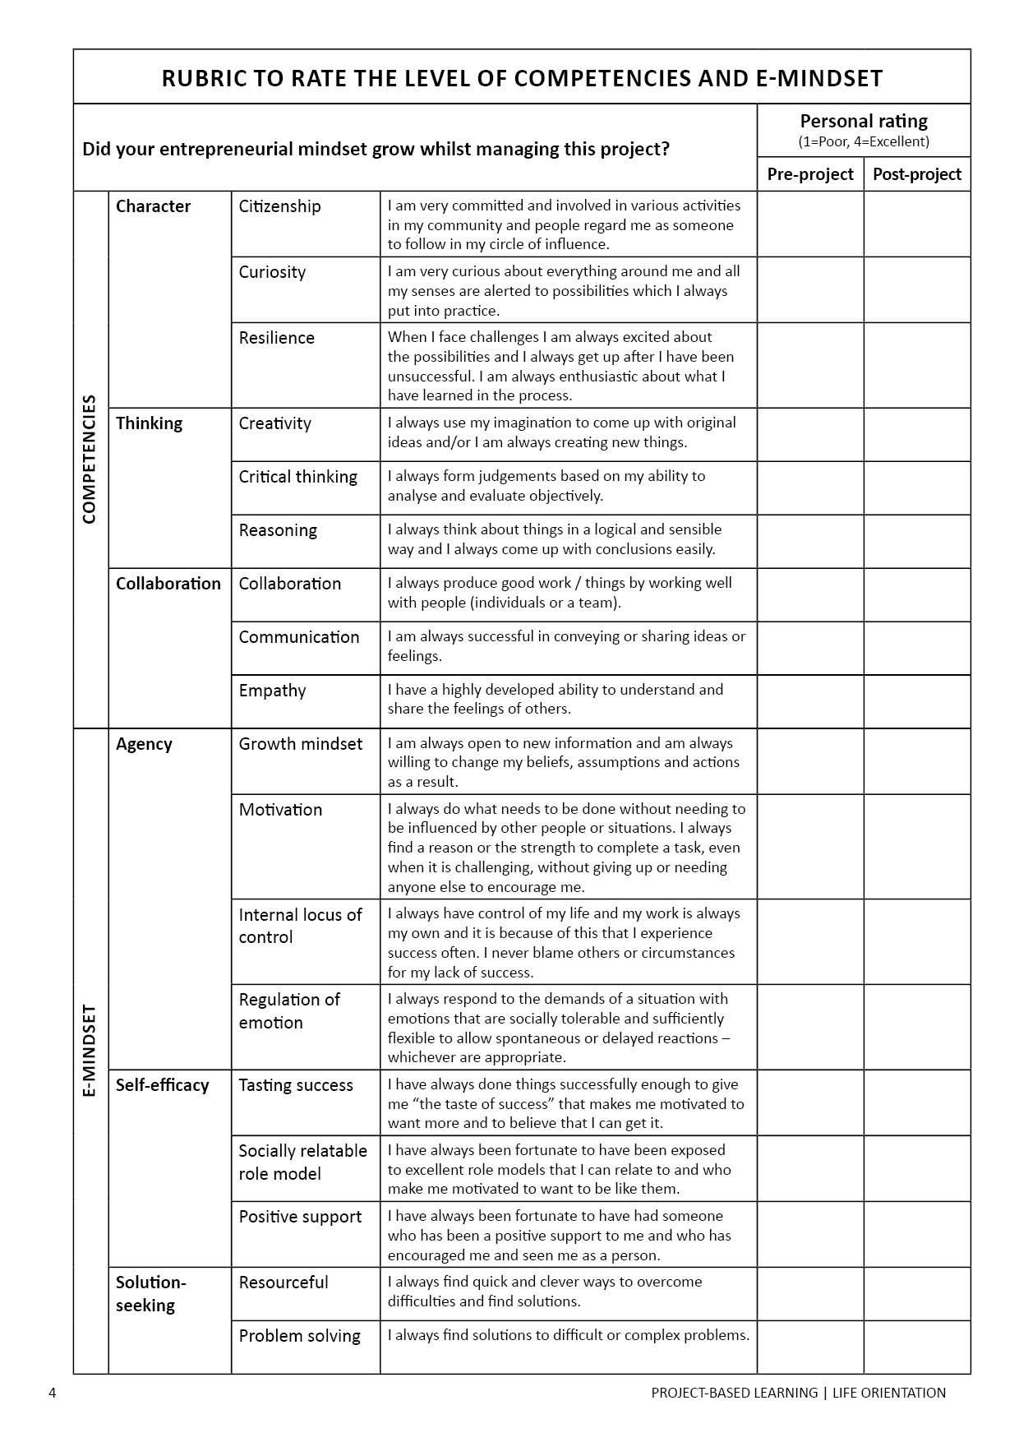

PART 1: Setting the scene

The trimmed projects - E³ response to COVID-19

In collaboration with the DBE we have created projects for the new trimmed curriculum. In the past, lead teachers would gather and projects would be created during a writers’ workshop. A similar process is being followed now, but the trimming of the curriculum has made it difficult to create one solid, clear project anchored by a community/learner problem because Term 3, the project term, now has to cover a number of themes very superficially.

We have tried to create a coherent project which follows internationally-accepted standards in that it is research-based and includes enquiry-based learning and problem-based learning as part of the Project-based Learning process whilst adhering to the CAPS requirements of the trimmed ATP.

Time frame for project completion - assessment

The assessment for Term 3 is a project. Do not use the number of hours allocated to determine which project/s you feel will be useful for your learners (e.g. Week 1). As long as there is one project mark by the end of the term for the SBA (50 marks), the CAPS requirement will have been achieved.

However, we do encourage you to use this opportunity to press learners to do as much research and investigating as is possible – if we plan this well we shall succeed.

Encourage learners to keep visual evidence of the process of their projects: E³ has invited learners to submit evidence of their project to the URLS/contact details in the Learner Workbook – we would love to showcase your school!

Ideas for planning:
Pre-plan
- Write a letter to the caregivers, parents, family and siblings (a letter is part of the Resource Pack at the end of these notes) explaining the need for their support.
- Break up the project (each could be 3-4 weeks long) into small deadlines that you will check.
- Help learners manage some social learning. (See social learning below)

Social Learning during COVID-19 (Coronavirus)

Individual learners will be “scientists” and go through a process (including elements of design thinking, problem-based learning, etc.) which will guide them to solve a problem. Learners will not have groups to work with, but the social learning can be facilitated by:
Be available

The teacher’s role

Notes/WhatsApps/face-to-face questions to teachers (give them a contact number or place a box for queries at the door of your classroom);

Wh-wall

A WH-wall for Who? Why? What? (and also How?) questions that are posted on the wall.

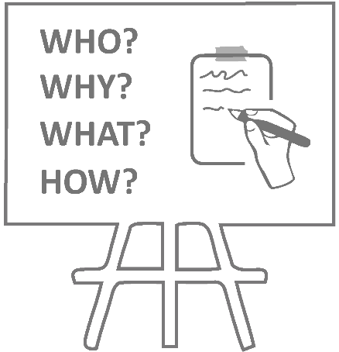
Learners write their open-ended question in large letters on pages that can be stuck on the wall, anonymously if learners wish. You could review all the questions once a week (after they have been on the wall for at least 48 hours) and answer the important questions.

The questions need not be about the project – it is a great opportunity to allay general fears about the “new normal” of living and going to school during the pandemic and also to encourage questioning techniques and so strengthen the fundamentals (especially language).

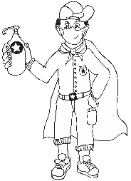
Buddy-guard
Critical, safe partner.

A buddy-guard is a special friend who cares about you and wants to support and look out for you.

A buddy-guard (a safe critical friend whom s/he has identified before the project has started) is the learner’s primary sounding board. The pair will agree that they give each other support and feedback at school with social distancing and via text and WhatsApp messages).

The role of the family

The family (care-givers will also have a letter sent to them to explain their role).

Generic Project outline for all Projects (directed at the learner)

Step 1:
Project topic guided by a big question
Step 2:
Plan research sources
Step 4: Feedback
Step 3:
Making creative project item and documenting the process

PLANNING

- Learners brainstorm the problem that needs to be solved on their own, or with their buddy-guard, teacher or family. The brainstorm could also be a class activity done by the entire class.
- Learners list questions that will help them think of the BIG question that will guide them in solving the problem.
- They write down the topic of their research – the BIG question.

RESEARCH/ FINDING OUT

- They note down five sources of information from the following that they are planning to use to gather information:
- People they could interview
- Articles they could read
- Websites they could go visit
- They identify someone who might help them if they need information whilst stuck at home.

MAKING AND SHOWING THE EVIDENCE

- What equipment will be needed to create the project item?
- Where will information on how to make the item be found?
- How many times did they try before they got it right?

GETTING FEEDBACK AND CHANGING IF THEY NEED TO

- Learners get feedback from their buddy-guard, parents or caregivers or teacher.
- They use information they have gathered to improve their product.
- They note what they changed, when they made changes and why.

FINISHING OFF THEIR PROJECT

Step 5: Finishing off
Step 6: Showing off projects
Step 7: Reflection

Using all the feedback and what was learned after trying to improve their product, learners finish off their project item and the writing that goes with it.

SHOWING OFF THEIR PROJECT

- They show their project to as many people as can be done safely.
- People who view the projects (even those at home) write down their feedback or leave notes or send voice notes. Learners ensure that their WhatsApp number is on the project item and notes.
- The final item is taken to school and the teacher and learners arrange show the projects to the rest of the school.

THINKING ABOUT IT AFTERWARDS

- What did they love about working on this project?
- What made this project hard for them?
- What did they learn by working on this project?
- What would they do differently if they did a project like this again?

Resource Pack

See the Resource Pack at the end of these notes to help you manage the project and to help you save time. Included you will find:

Resources in the Teacher’s Project Notes

- Practical Assistance, e.g.:
A letter to the parents and caregivers.
- Professional Development, e.g.:
The Project-based Learning (PBL) Cycle and your role as a Project Manager; The journey to Project-based Learning which starts with Enquiry-based Learning and Problem-based Learning, etc.

Resources in the Learner’s Workbook
The Learner’s Project Workbook is enriched with many resources to help the learner complete the project independently. There are rich resources to help you explain concepts more easily too!
Please Note
  - After discussing the CAPS topic with your class, learners are orientated towards the project and then left to deal with the project independently with access to all their resources.
  - The number of weeks allocated to a topic in the CAPS does not mean that the length of the project is limited. Remember: the project is a tool to allow deeper investigation into a serious problem that impacts learners.
  - We recommend that a learner be given 3 to 4 weeks to complete a project.

PART 2: The Project/s

Project Summary and CAPS alignment.

Alignment CAPS (trimmed ATP) | Description of Project
Weeks 7-8  Entrepreneurship:  Forms of Ownership:  Different forms of ownership  - Sole traders  - Partnerships  - Private and public companies  Levels and functions of Management:  Different levels of management and management.  Tasks such as planning, organising, leading and controlling.  Characteristics of good management  COVID-19 framework | Project: Celebrating COVID-19 Heroes  Learners showcase local heroes during a public event.  A local hero can be described as someone who has made a difference in the community, created a business against all odds, or solved a problem during the COVID-19 pandemic.  Learners interview COVID-19 entrepreneurs who are using the opportunity that COVID-19 provided to pivot their business, or create a whole new business.  The information is compiled in poster format for display on a heroes’ wall for a public viewing at school (or an online platform if COVID-19 regulations don’t allow public gatherings).  Learners also study case studies of local businessmen/women. They recognise different forms of ownership, levels of management and characteristics of good management in these case studies.

The Project in more detail

The following step-by-step unpacking of the project explains the teacher’s or care giver’s role in the roll-out of the project, the PBL cycle and Enquiry-based and Problem-based Learning. Items marked with (*) can be found in the Library at the back of the Learner’s Workbook.
Competencies
The column on the right is for you to mark/underline which competencies you think you touched on in each step.
PROJECT 1
  - Celebrating COVID-19 Heroes: Entrepreneurs who used COVID-19 to grow stronger personally and professionally. Creating a COVID-19 Poster Gallery of Heroes.

STEP 1: Planning

Task | Role of Teacher or Caregiver | Resources | Competencies touched on in this step
Learners watch the videos of young entrepreneurs or study the scripts of the videos and decide what makes these young entrepreneurs successful. How do these businesses solve a COVID-19 problem?  Learners create a definition of a hero and COVID-19 hero.  Learners ask the BIG question. | - Show the video/s to the learners or have learners read the script. (Ice-breaker)  - Discuss why these young people stand out as heroes in the business communities.  What were their challenges? How did they prevail, etc.?  What are the forms of ownership?  - With a critical thinking exercise, ask learners to come up with a definition of a local hero. Also define a COVID-19 hero. (Activity 1)  - Lead learners in discovering the BIG question for this project with special emphasis on young role models during COVID-19 pandemic. (Activity 2)  - 5. Discuss the outcome of the project: Creating a COVID-19 Gallery of Heroes. | Videos of COVID-19 hero, Ludwick Marishane  *Video transcription of Ludwick Marishane talk  Memorandum  *Article: Overview of Management  Learner’s Workbook  Text Book  Extended Learning Opportunity: Research Ludwick’s business trajectory over the years (after his TED talk) and how his business is currently doing | Character  Citizenship  Curiosity  Resilience  Mindset  Connection  Collaboration  Communication  Empathy  Thinking  Creativity  Critical thinking  Reasoning

STEP 2: Research/ Finding Out

Task | Role of Teacher or Caregiver | Resources | Competencies touched on in this step
Learners search for COVID-19 entrepreneurship heroes in their community.  Why do they consider these people heroes?  Learners discuss ideas with neighbours and family members about who they recognise as local COVID-19 heroes.  They contact these people and ask for interviews. Each learner contacts one hero for an interview.  Learners compile interview questions (with safe distancing, i.e. via WhatsApp or email). | - Open a discussion about local heroes in the community. (Activity 3)  - Ask learners to come up with names of their favourite local heroes.  - Assist learners to contact these heroes for personal interviews.  - Guide learners in compiling questionnaires for their local heroes. Ensure that all requirements of the trimmed ATP come up in their questions. Guide the questions or give them key works for formulating questions.  - Discuss the possible outcome of the project, i.e. a public display celebrating local heroes – physical poster display once school reopens or on a WhatsApp chat group created by learners.  Extended Learning Opportunity:  Learners create videos of the interviews with COVID-19 heroes for public or online display. | *5 tips for arranging interviews with entrepreneurs  *Typical Questions to ask during interviews  Learner’s Workbook  Text Book | Character  Citizenship  Curiosity  Resilience  Mindset  Connection  Collaboration  Communication  Empathy  Thinking  Creativity  Critical thinking  Reasoning

STEP 3: Making and showing the evidence

Task | Role of Teacher or Caregiver | Resources | Competencies touched on in this step
Learners read or listen to the 8 case studies.  They discuss how COVID-19 has influenced these entrepreneurs.  How can they become COVID-19 success stories? Give examples and good advice.  They interview their chosen local entrepreneur (COVID-19 hero).  Learners complete their poster planning on the local entrepreneur and present these to family/friends/buddy-guard for feedback | - Reflect on local heroes and COVID-19 entrepreneurial heroes. (Activity 3)  - Select one to interview and prepare interview questions. (Activity 4)  - Play the 8 case studies to learners in class. (Or read the scripts.)  - Open the discussion on how COVID-19 has influenced these people and their businesses. What safety measures should they take. What advice would you give them?  - Create a table (see Learner’s Workbook) on how COVID-19 has affected their businesses. How it influences people and businesses? In terms of Operations, what safety measures should they take? What are their chances of survival? Ensure that the outcomes of the trimmed ATP are captured. Learners give creative ideas to improve these businesses or make them COVID-19 proof. (Activity 5)  - Interview the hero and record the data. (Activity 6)  - Give learners time in class or at home to finish the planning (rough drafts) of their posters or videos about local heroes. (Activity 7) | 8 case studies of local entrepreneurs  *5 tips for arranging interviews with entrepreneurs  *Typical Questions to ask.  *COVID-19 safety Rules in businesses.  A3 pages for each learner for final poster design  Learner’s Workbook  Text Book | Character  Citizenship  Curiosity  Resilience  Mindset  Connection  Collaboration  Communication  Empathy  Thinking  Creativity  Critical thinking  Reasoning

STEP 4: Getting feedback and changing if you need

Task | Role of Teacher or Caregiver | Resources | Competencies touched on in this step
Learners get feedback from family/friends/buddy-guard.  They make changes to the poster as they see fit. | - Teacher/caregiver discusses feedback and guides learner in getting and applying feedback. (Activity 8) | *What is a research poster?  *Sample of well-designed poster  Learner’s Workbook | Character  Citizenship  Curiosity  Resilience  Mindset  Connection  Collaboration  Communication  Empathy  Thinking  Creativity  Critical thinking  Reasoning

STEP 5: Finishing off your project

Task | Role of Teacher or Caregiver | Resources | Competencies touched on in this step
Learners work at home or in class, finishing off their posters with changes they are considering after the feedback.  Brainstorm ideas on the safety for the final showing of their posters on the Hero Wall – to the rest of the community or the rest of the school. If it is still unsafe to organise public gathering, online display is an option.  Talk about safety measures for public display according to COVID-19 regulations. | - Guide learners through the process of change and adaptation of their posters, and the reason for these changes. Explain importance of iteration and reviewing projects as part of the improvement of the final quality. (Activity 9)  - Give them time to complete or redesign their posters in class and at home.  - Brainstorm ideas with learners for the public display of their posters. (In class? In the school hall? Online? Safety measures?)  - Learners prepare final posters for display.  Extended Learning Opportunity:  Learners create videos of the interviews with COVID-19 heroes for public or online display with their posters. | Learner’s Workbook  Learners’ posters | Character  Citizenship  Curiosity  Resilience  Mindset  Connection  Collaboration  Communication  Empathy  Thinking  Creativity  Critical thinking  Reasoning
STEP 6: Showing off your project

Task | Role of Teacher or Caregiver | Resources | Competencies touched on in this step
(Should learners be back at school and able to display posters:)  Learners present their posters in a gallery of COVID-19 heroes to other classes/rest of the school/parents or members of the community according to plan (and with safety measures in mind).  Alternatively, learners can display their posters online, possibly on a WhatsApp group, the school’s website or Facebook. | - Help learners to set up their display.  - Appoint a COVID-19 officer or two from class. They should see to it that all COVID-19 regulations are followed during any public event. (Activity 10)  - Use rubric to assess the project.  Extended learning opportunity:  Display posters online on school’s website, Facebook or a specially created blog. | Public area for presentation  Sanitiser, masks, gloves or other safety measures  *COVID-19 safety Rules in businesses.  Posters for display  Equipment to show posters  *Rubric  Learner’s Workbook | Character  Citizenship  Curiosity  Resilience  Mindset  Connection  Collaboration  Communication  Empathy  Thinking  Creativity  Critical thinking  Reasoning

STEP 7: Thinking about it afterwards

Task | Role of Teacher or Caregiver | Resources | Competencies touched on in this step
Reflection on success or failure of the project and lessons learned. | - Please don’t skip this step.  - Give learners time in class to reflect on the success of their project (academically and personally). (Activity 11)  - Do the teacher’s reflection rubric. (Post-project rubric) | Teacher’s Reflection rubric;  Learner’s Workbook | Character  Citizenship  Curiosity  Resilience  Mindset  Connection  Collaboration  Communication  Empathy  Thinking  Creativity  Critical thinking  Reasoning

7. Rubric: Celebrating local COVID-19 heroes

Assessment Criteria | Not Achieved  (0-2) | Partially Achieved  (3-5) | Achieved  (6-8) | Outstanding Achievement  (9-10) | Learner Mark
1.  Recognise forms of ownership: Sole traders  Partnerships  Private and public companies | Learner has no idea about forms of ownership | Learner has some idea about forms of ownership | Learn has a fair idea about forms of ownership | Learner has an excellent idea about forms of ownership in business.
2.  Critical thinking exercise: Definition for hero and COVID-19 hero | No attempt at critical thinking | Some attempts at critical thinking | Fair attempt at critical thinking | Excellent critical thinking
3.  Compile good interview questions | Completed last minute and/ or after the time. Rushed, with no sign of commitment | Effort was made. | Commitment is evident. Good list of questions | Obvious commitment to create an excellent set of questions for the interview/s
4.  Feedback gathered through interviews | No feedback gathered | Some feedback gathered | Good feedback gathered | Excellent feedback from many sources
5.  Presentation or public display of research poster to other classes/rest of school or online | Presentation unsatisfactory, unprepared. Unsatisfactory design and content | Presentation not ideal, somewhat unprepared. Little design effort and not enough content | Presentation good, well prepared.  Good design and content satisfactory | Great presentation, excellent preparation.  Striking creative design and well researched content
Total |  |  |  |  | /50

PART 3: TEACHER RESOURCES

8. Tools to assist with the Project

8.1 Letter to the parents/caregivers

See the next page.

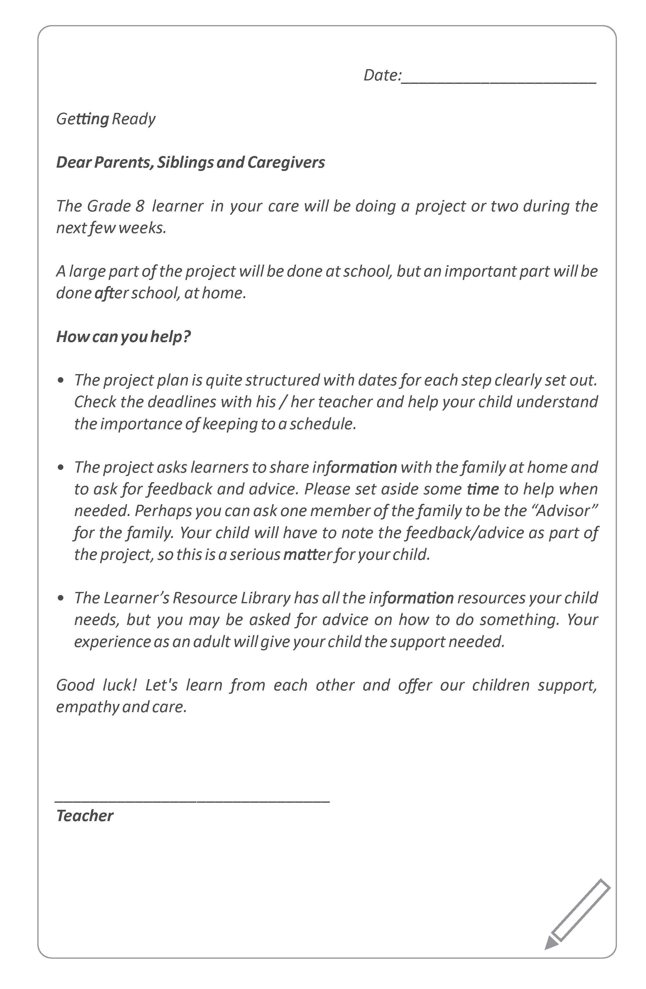

8.2 Primary vs Secondary sources
Sources of information are often categorized as primary or secondary depending upon their originality.

Primary Sources
- Direct or first-hand evidence about an event, object, person, or work of art
- Published materials written or produced by someone with first-hand experience of the event.
- Individual viewpoint of a participant or observer.

Examples of primary sources:
- Interviews, surveys, and fieldwork
- Diaries, personal letters, and correspondence
- Internet communications on email, blogs, and newsgroups
- Photographs, drawings, and posters
- Books, magazine and newspaper articles and ads published at the time
- Public opinion polls
- Speeches
- Original documents (birth certificates, property deeds, trial transcripts)
- Research data, such as census statistics
- Official and unofficial records of organizations and government agencies
- Radio interviews, DVDs, and video recordings
- Government documents (COVID-19 pamphlets, reports, etc.)
- Scientific journal articles reporting experimental research results

Secondary Sources
- Describe, discuss, interpret, comment upon, analyse, evaluate, summarize, and process primary sources
- Written or produced after the fact with the benefit of hindsight
- Lack the freshness and immediacy of the original material
- Collect, organize, and repackage primary source information to increase usability and speed of delivery, such as an online encyclopaedia.
- Can be written or non-written (sound, pictures, movies, etc.).

Examples of secondary sources:
- Bibliographies
- Biographical works
- Reference books, including dictionaries, encyclopaedias, and atlases
- Articles from magazines, journals, and newspapers after the event
- Literature reviews and review articles (e.g., movie reviews, book reviews)
- History books and other popular or scholarly books
- Works of criticism and interpretation
- Commentaries and treatises
- Textbooks
- Indexes and abstracts

SOURCE | https://sccollege.edu/Library/Pages/primarysources.aspx

8.3 The Big Question in research

Essential questions, or driving questions, are a key element of project-based learning, so we’ve outlined 14 essential question stems to help you craft the most engaging PBL essential questions.

1. How can ______ improve _______?
How can studying different cultures improve our understanding of our community?
How can robotics improve the healthcare industry?
How can access to clean water improve communities, especially during the coronavirus pandemic?
2. How can _______ be applied to ________?
How can entrepreneurship skills be applied to subjects like science and geography?
How can entrepreneurship skills be applied in our daily lives?
How can ethics be applied to solve environmental problems?
3. How can _______ change ________?
How can individuals change their communities?
How can kindness change bullying?
How can the human behaviour change the environment?
4. How would you design a new _______?
How would you design a new school?
How would you design a new system to purify water?
How would you design a new flag for your community?
5. How does _________ affect __________?
How do poor eating habits affect communities around the world?
How does bullying affect our community?
How does violence affect our daily lives?
6. What impact did/does __________ have on ________?
What impact does climate change have on the environment during the 21st century?
What impact does coronavirus have on children’s sense of security?
What impact does social media have on our understanding of the facts surrounding the coronavirus pandemic
7. What makes a good/effective _________?
What makes a good library?
What makes an effective school?
What makes a happy classroom?
8. How do/does __________ impact my community?
How does racism impact my community?
How does the food grown in our region impact what people eat?
How does bullying and violence impact my community?
9. What is the relationship between _________ and ___________?
What is the relationship between maths and everyday life?
What is the relationship between science and entrepreneurship?
What is the relationship between transportation and trade?
10. What would __________ be without __________?
What would our school be without classrooms?
What would the Earth’s climate be like without the atmosphere?
What would the world be without art?
11. If you were in charge of ____________, what would you change?
If you were in charge of our school, what would you change?
If you were in charge of our community, what would you change?
If you were in charge of Facebook, what would you change?
12. How can you use __________ to inspire ________?
How can you use poetry to inspire change?
How can you use storytelling to inspire people take better care of the environment?
How can you use science to inspire people to eat healthier food?
13. What if _______________?
What if you could go back in time, what would you change?
What if South Africa did not have schools?
What if the world lost the internet for one year?
14. How might your community change if ______________?
How might your community change if it were twice as big?
How might your community change if it rained every day for a year?
How might your community change if every person were given R1 million?
Seeing the different ways learners approach an essential question is one of the most rewarding parts of project-based learning, and you’ll get to learn a lot about the learners in your class! Engage students through project-based learning by providing them with great PBL essential questions, then watch them dive in and take control of their own learning.

SOURCE | https://www.penpalschools.com/blog/easy-project-based-learning-question-stems-for-essential-questions

9. Professional Development

9.1 Traditional vs Activity-based Learning
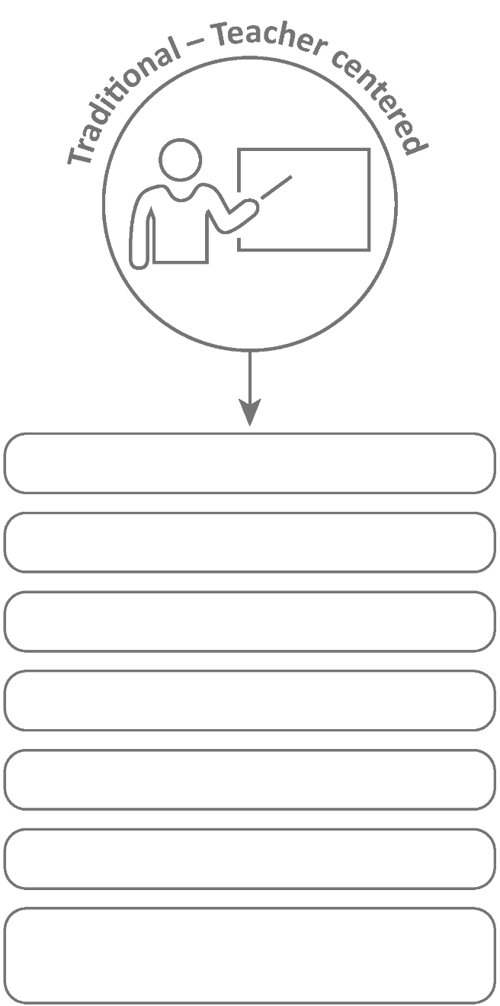
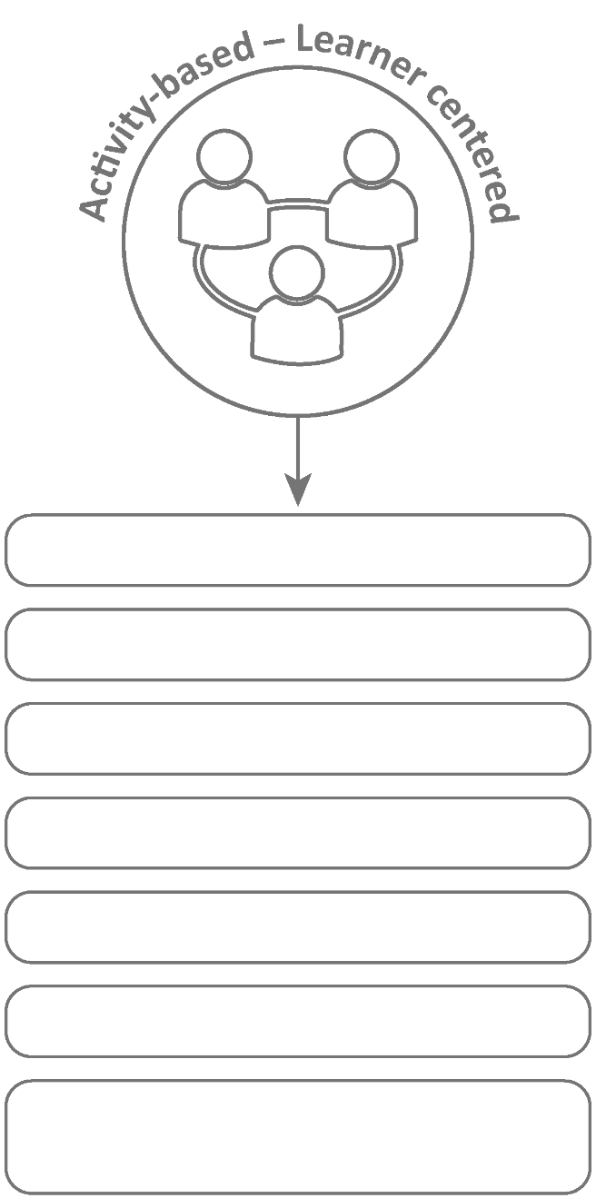
Basic Learning

Bigger class size

Isolated subjects

Product-orientated

Learning by repetition

Concepts are facts to memorize

Quantitative evaluation (numerical testing)

In-depth learning
Smaller groups within class
Integrated/interdisciplinary subjects
Process-oriented
Learning through active involvement
Concepts questions to be investigated
Authentic assessment (competencies, integrated, mindset)

9.2 The Project-based Learning Cycle
Below please find the Key Knowledge, Understanding and Success Skills to help you manage the project.
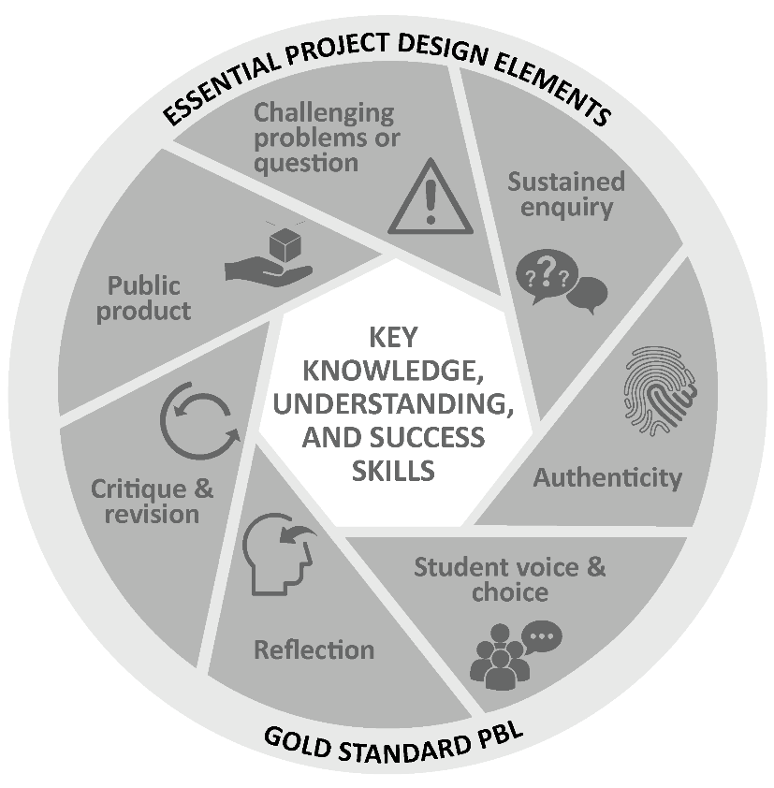
Challenging problem or question: Why is this project critical? What is the problem in society and at school being addressed in this project? Keep talking about how this project will solve a local or global problem.
Sustained enquiry: Are learners being “researchers”? Are they doing the research and getting deeper and deeper into the problem or are you doing all the talking? Look at the second circle overleaf to remind you of your role: manage activities and scaffold student learning. Learners must not be allowed to give up – you must “build a culture” of getting to the bottom of the problem and coach them when they lose their way. With time E³ will be developing thinking tools to ensure that you are equipped with strategies to take the enquiry to a new level. (See overleaf for the current PBL learning cycle with a built-in innovation cycle.)
Authenticity: Keep the project real by referring to learners’ own lives – this is about them and their world.
Student Voice and Choice: Although learners did not choose this project, make it fun and real, and applicable to their own world, so that they own it. Their voices and opinions are what your deeper goal is – encourage their views and applaud each contribution.
Reflection: To truly embed learning, learners should be able to reflect on what they have learned and be able to think of better ways of doing things. The reflection activities in the worksheets are not just for fun. Encourage learners to spend time on them as this will deepen their learning.
Critique and Revision: This process is to help learners experiment with their innovation and learn how to improve their work and thinking. As you assess and evaluate their products (not them!) learners will see that there are different ways of solving problems. It is important that learners hone their curiosity and learn how to “stick it out” and keep trying, not giving up when it doesn’t work first time round.
Public Product: At the end of the project what does the learner have to show or to brag about? Ensure that there is a Project Culmination Week in which each grade displays their products during a week selected by the management team to ensure that as many parents and other stakeholders as possible attend.

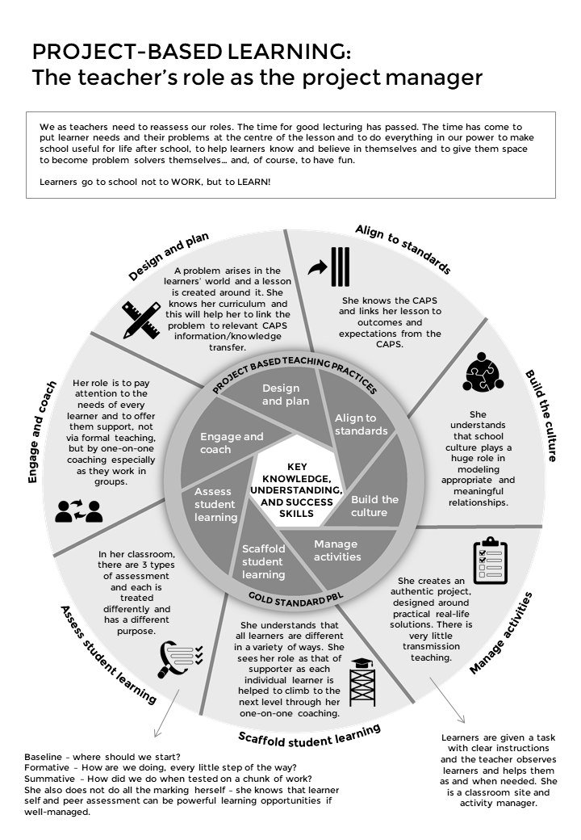
9.3 The Project-Based Learning facilitator

9.4 The E³ Competencies model within the CAPS
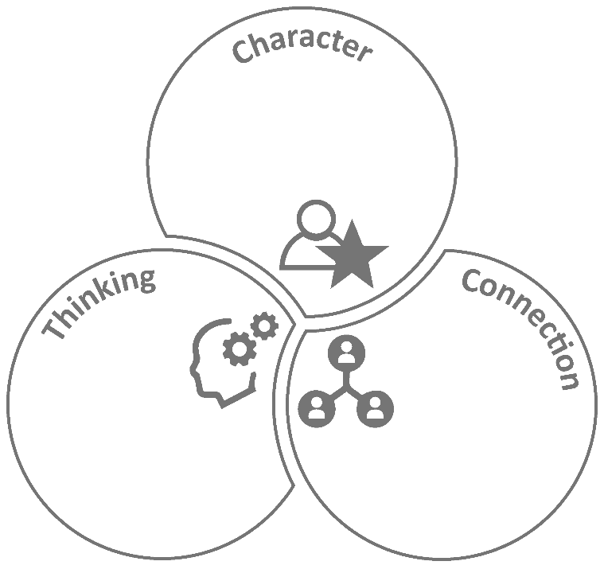
Citizenship
Curiosity
Resilience
Mindset
Collaboration
Communication
Empathy
Creativity
Critical Thinking
Reasoning

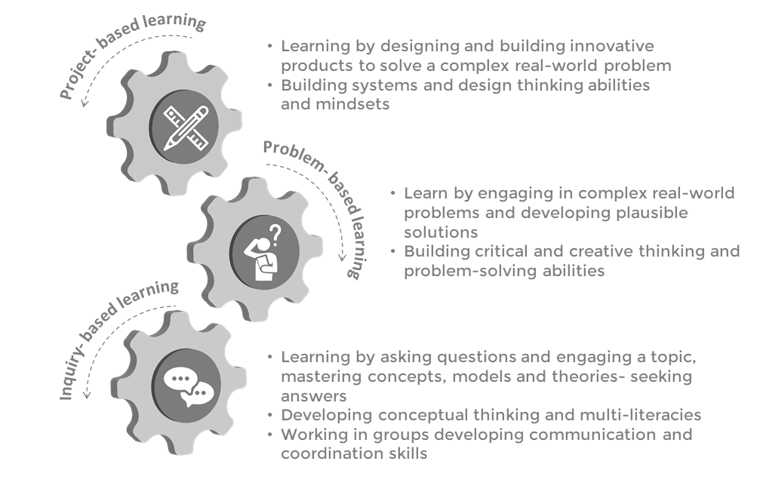
9.5 The journey to PBL via Enquiry-based and Problem-based Learning

9.6 Bridging the Unemployment gap through Education
