

**FACING THE DRAGONS**

**PROJECT-BASED LEARNING | EMS**

**9**



**Teacher’s Project Notes**

**GRADE 9**

**E³ Projects for Trimmed ATP**

**Facing the Dragons**

**Table of Contents**

Letter from the DBE Teacher Agency Award Mindset Rubric for Teachers **PART 1: Setting the Scene**

2

3

**4**

4

5

6

*6*

*6*

*6*

*6*

*7*

*7*

*7*

8

**9**

9

10

14

1.

2.

3.

The trimmed projects - E3 response to COVID-19 Social Learning during COVID-19 (Coronavirus)

Generic Project outline for all Projects (directed at the learner)

*-*

*-*

*-*

*-*

*-*

*-*

*-*

*PLANNING RESEARCH / FINDING OUT*

*MAKING AND SHOWING THE EVIDENCE GETTING FEEDBACK AND CHANGING IF THEY NEED TO FINISHING OFF THEIR PROJECT*

*SHOWING OFF THEIR PROJECT*

*THINKING ABOUT IT AFTERWARDS*

4.

Resource Pack

**PART 2: The Project**

5.

6.

7.

Project Summary and CAPS alignment The Project in more detail

Assessment Rubric

**PART3: Teacher’s Resources**

**15**

15

*16*

*17*

9.

Tools to assist with the Project

*9.1*

*9.2*

*Letter to the parents / caregivers The Big Question in research*

10.

Professional Development

19

*19*

*20*

*21*

*22*

*22*

*23*

*10.1*

*10.2*

*10.3*

*10.4*

*10.5*

*10.6*

*Traditional vs Activity-based learning The Project-based Learning Cycle*

*The Project-based Learning facilitator The E3 Competencies model within the CAPS*

*The journey to PBL via Enquiry-based and Problem-based Learning Bridging the Unemployment gap through Education*

Teacher Agency Award Entry Form

24

**PLEASE NOTE**

* **Part 1 and Part 2 of this booklet must be printed** and are the minimum project resources you as teacher will need. However, the rest of the booklet contains valuable tools for personal development, as well as very good sources in support of the project. You don’t have to look anywhere else.
* Don't forget to **enter the Teacher's Agency Awards** (see page 2). The entry form is at the back of this booklet (page 24).
* This programme is accompanied by **podcasts, audio recordings and videos**. You will ﬁnd them at the following URL: **https://learn.ecubed-dbe.org/resources/**
* Before you start, please **complete the Pre-project section of the Teacher's Mindset Rubric** on page 3. **Complete the Post-project section** upon completion of the project.



Dear Teacher

Provided herewith is a **Learner’s Workbook** and a set of **Teacher’s Project Notes for the School- Based Assessment (SBA) Task for Term 3** as per the SBA Plan in Section 4 of the CAPS. These documents are specially created to support you with COVID-19 issues for your subject as per the trimmed Annual Teaching Plan (Section 3) for Term 3.

Most importantly it is envisaged that this will lessen your workload as we come to grips with the disruptions caused by COVID-19.

The Learner’s Workbook and Teacher’s Project Notes were created by DBE-E3, a unit at the National Department of Basic Education which is rolling out Project-Based Learning **(PBL)** in schools, to better prepare learners for a changing world. Although you may not be part of the DBE-E3 Programme as yet, these projects are created to:

1.

Engage learners in processing the pandemic which is aﬀecting their lives and those of their families;

Promote learner self-reliance and independent learning using safety measures; and Encourage social learning in a safe environment.

2.

3.

**Where did this all start?**

**E3: Entrepreneurship, Employability and Education is currently being rolled out in SA schools.** The DBE-E3 Unit, in response to the National Development Plan, has been working in public schools since 2018 to advocate the eventual implementation of Activity-Based Learning, with a special focus on **PBL**. **E3** is part of a DBE programme to introduce *Thinking Skills for a Changing World* into the curriculum in its eﬀort to reduce youth unemployment substantially by 2030.

**How did this work in 2018 and 2019?**

Initially three provinces in 2018, and then all nine provinces in 2019, implemented PBL in Term 3, the term in which the SBA is an actual project. This meant that the projects, written by teachers for teachers were available to select schools by the provinces as part of a pilot re- search project. In this initial phase schools on the programme were provided with projects for Life Skills Grade 4-6, EMS Grade 7-9 and Life Orientation Grade 10 to 11.

*The Learner’s Workbook and Teacher’s Project Notes are a critical resource for you during COVID-19, and the beginning of activity-based learning and PBL as a teaching method the DBE-E3 is consciously promoting.*

**We truly respect your anxiety during this time, and acknowledge your commitment. We appreciate all your hard work.**





**E³ TEACHER’S PROJECT NOTES | GRADE 9 | EMS | TERM 3**

**Facing the Dragons**

**Read to Lead**

A Reading Nation is a Leading Nation



**RECOGNISING SOLUTION-SEEKING TEACHERS**

**ENTER THE TEACHER AGENCY AWARD**

***If it’s going to be, it’s up to me***

**SO WHY?**

To reward you for being awesome! You have shown that you care, that you have found a solution to a problem that helps others and that you have just gone ahead and made it happen.

We want to acknowledge and reward you and tell the world you are our hero! We want to reward you if you can show us that you are

self-motivated, self-directed and want to grow - and if you are driven by purpose and the desire to help others.

**WHO ME?**

Yes you! Any teacher or school ofﬁcial who is doing something for the greater good.

**WAIT WHAT?!**

So here’s what you need to show us - you need to be able to tell us that you:

1. Had the courage to just get going
2. Had belief in yourself to just do it

3

Activated a range of competencies that makes you THE person that this new crazy world needs to ﬁx it and solve its problems such as:

* 1. A great character who is self-motivated to be a SA citizen who cares, who is curious about ﬁxing things and who has the energy, enthusiasm and resilience to carry on.
  2. The ability to think and be creative, ﬁgure things out, ﬁnd the information you need and make sense of it.
  3. How you made connections, how you collaborated and communicated with others as you stood in their moccasins to solve problems.

**WHAT WILL I WIN?**

T&Cs: We will be awarding exciting, signiﬁcant prizes of up to R5000 per prize winner. These will go to worthy recipients f rom each province whose solutions meet the criteria on the entry form. These will be judged by E³. Awards will be announced in the ﬁrst week of every month starting in August 2020. If no worthy entry is received that merits a prize, E³ reserves the right not to award a prize for that month.

The last winners will announced in the ﬁrst week of October 2020 when this opportunity closes.

Keep an eye of the E³ website to see if you have won and to celebrate the other winners and admire their solutions.

**SO HOW MUST I APPLY?**

It’s really simple - just ﬁll in the form at the back of this book and submit it to us.

Or submit the form on the E3 website:

[**www.e3-dbe.org**](http://www.e3-dbe.org/)[**www.ecubed-dbe.org**](http://www.ecubed-dbe.org/)

**WHEN MUST I HAND IT IN?**

NOW! You can apply anytime whenever. This is an ongoing opportunity that has no deadline. How cool is that?

**Facing the Dragons TEACHER’S Project Notes Grade 9 | EMS | Term 3**

2

**CALLING ALL TEACHERS!**

**Think you lead the way in creating solutions to problems?**

**Enter this award and be rewarded and recognised for your unique problem-solving abilities.**



**Facing the Dragons TEACHER’S Project Notes Grade 9 | EMS | Term 3**

3

**RUBRIC TO RATE THE LEVEL OF COMPETENCIES AND E-MINDSET**

**Did your entrepreneurial mindset grow whilst managing this project?**

**Personal rating**

(1=Poor, 4=Excellent)

**Pre-project**

**Post-project**

**COMPETENCIES**

**Character**

Citizenship

I am very committed and involved in various activities in my community and people regard me as someone to follow in my circle of inﬂuence.

Curiosity

I am very curious about everything around me and all my senses are alerted to possibilities which I always put into practice.

Resilience

When I face challenges I am always excited about the possibilities and I always get up after I have been unsuccessful. I am always enthusiastic about what I have learned in the process.

**Thinking**

Creativity

I always use my imagination to come up with original ideas and/or I am always creating new things.

Critical thinking

I always form judgements based on my ability to analyse and evaluate objectively.

Reasoning

I always think about things in a logical and sensible way and I always come up with conclusions easily.

**Collaboration**

Collaboration

I always produce good work / things by working well with people (individuals or a team).

Communication

I am always successful in conveying or sharing ideas or feelings.

Empathy

I have a highly developed ability to understand and share the feelings of others.

**E-MINDSET**

**Agency**

Growth mindset

I am always open to new information and am always willing to change my beliefs, assumptions and actions as a result.

Motivation

I always do what needs to be done without needing to be inﬂuenced by other people or situations. I always ﬁnd a reason or the strength to complete a task, even when it is challenging, without giving up or needing anyone else to encourage me.

Internal locus of control

I always have control of my life and my work is always my own and it is because of this that I experience success often. I never blame others or circumstances for my lack of success.

Regulation of emotion

I always respond to the demands of a situation with emotions that are socially tolerable and suﬃciently ﬂexible to allow spontaneous or delayed reactions – whichever are appropriate.

**Self-eﬃ**cacy

Tasting success

I have always done things successfully enough to give me “the taste of success” that makes me motivated to want more and to believe that I can get it.

Socially relatable role model

I have always been fortunate to have been exposed to excellent role models that I can relate to and who make me motivated to want to be like them.

Positive support

I have always been fortunate to have had someone who has been a positive support to me and who has encouraged me and seen me as a person.

**Solution- seeking**

Resourceful

I always ﬁnd quick and clever ways to overcome diﬃculties and ﬁnd solutions.

Problem solving

I always ﬁnd solutions to diﬃcult or complex problems.





**PART 1: Setting the scene**

1.

The trimmed projects - E³ response to COVID-19

In collaboration with the DBE we have created projects for the new trimmed curriculum. In the past, lead teachers would gather and projects would be created during a writers’ workshop. A similar process is being followed now, but the trimming of the curriculum has made it diﬃcult to create one solid, clear project anchored by a community/learner problem because Term 3, the project term, now has to cover a number of themes very superﬁcially.

We have tried to create a coherent project which follows internationally-accepted standards in that it is research-based and includes enquiry-based learning and problem-based learning as part of the Project-based Learning process whilst adhering to the CAPS requirements of the trimmed ATP.

**Time frame for project completion - assessment**

The assessment for Term 3 is a project. Do not use the number of hours allocated to determine which project/s you feel will be useful for your learners (e.g. Week 1). As long as there is one project mark by the end of the term for the SBA (50 marks), the CAPS requirement will have been achieved.

However, we do encourage you to use this opportunity to press learners to do as much research and investigating as is possible – if we plan this well we shall succeed.

**Encourage learners to keep visual evidence of the process of their projects: E3 has invited learners to submit evidence of their project to the URLS/contact details in the Learner Workbook – we would love to showcase your school!**

**Ideas for planning:**

**Pre-plan**

1. Write a letter to the caregivers, parents, family and siblings (a letter is part of the Resource Pack at the end of these notes) explaining the need for their support.
2. Break up the project (each could be 3-4 weeks long) into small deadlines that you will check.
3. Help learners manage some social learning. (See social learning below)

**Facing the Dragons TEACHER’S Project Notes Grade 9 | EMS | Term 3**

4

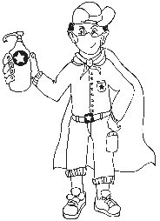



Social Learning during COVID-19 (Coronavirus)

2.

Individual learners will be “scientists” and go through a process (including elements of design thinking, problem-based learning, etc.) which will guide them to solve a problem. Learners will not have groups to work with, but the social learning can be facilitated by:

**Be available**

**The teacher’s role**

Notes/WhatsApps/face-to-face questions to teachers (give them a contact number or place a box for queries at the door of your classroom);

**Wh-wall**

A WH-wall for Who? Why? What? (and also How?) questions that are posted on the wall.

Learners write their open-ended question in large letters on pages that can be stuck on the wall, anonymously if learners wish. You could review all the questions once a week (after they have been on the wall for at least 48 hours) and answer the important questions.

The questions need not be about the project – it is a great opportunity to allay general fears about the “new normal” of living and going to school during the pandemic and also to encourage questioning techniques and so strengthen the fundamentals (especially language).

**Buddy-guard**

A buddy-guard (a safe critical friend whom s/he has identiﬁed before the project has started) is the

learner’s primary sounding board. The pair will agree that they give each other support and feedback at school with social distancing and via text and WhatsApp messages.

**The role of the family**

**Critical, safe partner.**

A buddy-guard is a special friend who cares about you and wants to support and look out for you.

The family (care-givers will also have a letter sent to them to explain their role).

**Facing the Dragons TEACHER’S Project Notes Grade 9 | EMS | Term 3**

5





**3. Generic Project outline for all Projects**

**PLANNING**

1.

Learners brainstorm the problem that needs to be solved on their own, or with their buddy-guard, teacher or family. The brainstorm could also be a class activity done by the entire class.

Learners list questions that will help them think of the Big Question that will guide them in solving the problem.

2.

**RESEARCH / FINDING OUT**

1.

They note down sources of information from the following that they are planning to use to gather information:

* People they could interview
* Articles they could read
* Textbooks they could consult

They identify someone who might help them if they need information whilst stuck at home.

2.

**MAKING AND SHOWING THE EVIDENCE**

1.

2.

3.

What equipment will be needed to create the project item? Where will information on how to make the item be found? How many times did they try before they got it right?

**GETTING FEEDBACK AND CHANGING IF THEY NEED TO**

1.

2.

3.

Learners get feedback from their buddy-guard, parents or caregivers or teacher. They use information they have gathered to improve their product.

They note what they changed, when they made changes and why.

**Facing the Dragons TEACHER’S Project Notes Grade 9 | EMS | Term 3**

6

**Step 1: Project topic guided by a big question**

**Step 2: Plan research sources**

**Step 3: Making creative project item and documenting the process**

**Step 4: Feedback and changes eﬀected**





**FINISHING OFF THE PROJECT**

Using all the feedback and what was learned after trying to improve their product, learners ﬁnish oﬀ their project item and the writing that goes with it.

**SHOWING OFF THEIR PROJECT**

1.

2.

They show oﬀ their project to as many people as it is safe to show it to.

People who view the projects (even those at home) write down their feedback or leave notes or send voice notes. Learners ensure that their WhatsApp number is on the project item and notes.

The ﬁnal item is taken to school and the teacher and learners arrange that the projects are shown to the rest of the school.

3.

**THINKING ABOUT IT AFTERWARDS**

Reﬂection:

1. What did I love about working on this project?

2.

3.

4.

What made this project hard for me? What did I learn by working on this project? About myself? About COVID-19? What would I do diﬀerently if I did a project like this again?

**Facing the Dragons TEACHER’S Project Notes Grade 9 | EMS | Term 3**

7

**Step 5: Finishing oﬀ**

**Step 6: Showing oﬀ projects**

**Step 7: Reﬂection**





**4. Resource Pack**

See the Teacher Toolkit at the end of these notes to help you manage the project and to help you save time. Included you will ﬁnd:

**1. Project Resources:**

A letter to the parents and caregivers and notes on bullying, etc.   
Tools to assist with the Project, e.g.: *The diﬀerence between Primary and Secondary Resources; How to formulate the big question, etc.*

**2. Professional Development, e.g.:**

Project-based learning is a new pedagogy for teachers. We've included the E³ model and a variety of interesting articles to develop your PBL skills.

*The Project-based Learning (PBL) Cycle and your role as a Project Manager; The journey to Project- based Learning which starts with Enquiry-based Learning and Problem-based Learning, etc.*

**Resources in the Learner's Workbook**

The Learner's Project Workbook is enriched with many resources to help the learner complete the project independently. We are aware that learners will not have access to primary and secondary sources, so we've tried to address this obstacle.

And now, for a summary of the Grade 9 project.

**Facing the Dragons TEACHER’S Project Notes Grade 9 | EMS | Term 3**

8

**PLEASE NOTE**

* After introducing the CAPS topic in class, learners are orientated towards the project and then left to deal with the project independently with access to all their resources.
* The number of weeks allocated to a topic in the CAPS does not mean that the length of the project is limited. Remember: the project is a tool to allow deeper investigation into a serious problem that impacts learners.
* We recommend that a learner be given 3 to 4 weeks to complete a project.



**PART 2**

**The Project**

**5.**

**Project Summary and CAPS alignment**

**Facing the Dragons TEACHER’S Project Notes Grade 9 | EMS | Term 3**

9

**ALIGNMENT CAPS (TRIMMED ATP)**

**DESCRIPTION OF PROJECT**

**Weeks 9-10**

**Entrepreneurship:**

Business Plan: Concepts, components and format of a business plan

SWOT Analysis and Financial Plan Doing business within the COVID-19 framework

**Project: Facing the Dragons**

Learners (2 per group) create a business idea on paper.

They prepare a business plan with all the components in the correct format, including a sound ﬁnancial plan.

Learners present this business plan to a 'Dragon's Den'; a group of investors who help them see the viability of their business by asking diﬃcult questions and grilling students to think out of the box.

This must all happen within a COVID-19 framework of social distancing and creative new ways of discussion and planning in business environments.



**6. The Project in more detail**

The following step-by-step unpacking of the project explains the teacher's or care giver's role in the roll- out of the project, the PBL cycle and Enquiry-based and Problem-based Learning. ***Items marked with (*) can be found in the Library at the back of the Learner's Workbook.***

Competencies

The column on the right is for you to mark/underline which competencies you think you touched on in each step.

**PROJECT 1**

**6.1 Facing the Dragons – Preparing and presenting a business plan**

**Facing the Dragons TEACHER’S Project Notes Grade 9 | EMS | Term 3**

10

**STEP 1: Ice-breaker and Planning**

**TASK**

**TEACHER’S ROLE**

**RESOURCES**

**COMPETENCIES**

***(Underline which ones were developed)***

Learners watch the video on boat-making, or carefully read the instructions in the Learner's Workbook.

They teach this game to their family members at home and play it a few times.

Learners now unpack the valuable lessons they have learned in their Learner's Workbook.

The revise the 8 business functions according to the game.

Learners start thinking of at least 3 new business ideas.

Learners ask the BIG question.

1. Show the boat-making video to learners, or ask them to read the rules of the game.
2. Ask them to teach their family members at home how to play and then play a few rounds.
3. Learners unpack the game according to the questionnaire in their Learner's Book. (Activity 1)
4. They must recognise some, if not all of the 8 business functions they have come across while playing the game.
5. Learners should start thinking about 3 good business ideas. They will develop and discuss these ideas with one friend (their buddy-guard) and together they will present their idea to a Dragon's Den of “business people” who could potentially invest in the Grade 9 businesses.
6. They devise the BIG question for this research project.

*Video of boat making game

*Rules for playing the boat-making game

*Where do business ideas come from?

Learner's Workbook Text Book

**Character** Citizenship Curiosity Resilience Mindset **Connection** Collaboration Communication Empathy **Thinking** Creativity Critical thinking Reasoning



**Facing the Dragons TEACHER’S Project Notes Grade 9 | EMS | Term 3**

11

**STEP 2: Research / Finding out**

**TASK**

**TEACHER’S ROLE**

**RESOURCES**

**COMPETENCIES**

***(Underline which ones were developed)***

Learners discuss their business ideas with their buddy-guards. They decide on ONE idea to develop further and eventually present to the Dragon's Den.

Learners research the viability of their business idea:

They share their ONE idea with family members, members of their community (via WhatsApp and safe distancing) until they have enough feedback to ensure at least some feasibility.

They watch videos or study good business plans to research what a business plan should include.

Learners carefully study ﬁnancial plans provided in the resource library.

Learners do a SWOT analysis on mock business plans.

1. Ask learners to discuss their business ideas with their buddy-guard. They will further research and develop the business idea, and present it to a Dragon's Den. (Activity 2 and 3)
2. Learners should now go to members of their family or community to research the viability of this one idea. They use a set of questions to test it on buyers. (Activity 4)
3. Learners research good business plans and formats they should use.
4. Learners also study good presentations and unpack the ingredients of a good presentation in their Learner's Book.
5. Discuss the use of a SWOT analysis on one's one business. Learners complete the SWOT analysis on the business plan in their Learner's Workbook. They should include a SWOT analysis in their business presentation. (Activity 5)
6. Spend some time on ﬁnancial plans and how to make safe assumptions for new businesses.

6. Discuss SAFE ways to set up a Dragon's Den with learners within COVID-19 restrictions. WhatsApp video call? Zoom meeting? Videos delivered via email?

*Product development cycle

*How to do a great presentation

*The ingredients of a good business plan

*SWOT analysis

*Videos or transcripts of Sally and Nabira on their personal SWOT analysis

*How to come up with a good idea

*Ludwick Marishane TED talk

Learner's Workbook Text Book

Extended Learning Opportunity:

Ask learners to approach successful entrepreneurs in the community to join the Dragon's Den. To be able to reach out to people is a great skill.

**Character** Citizenship Curiosity Resilience Mindset **Connection** Collaboration Communication Empathy **Thinking** Creativity Critical thinking Reasoning



**Facing the Dragons TEACHER’S Project Notes Grade 9 | EMS | Term 3**

12

**STEP 4: Getting feedback and changing if you need**

**TASK**

**TEACHER’S ROLE**

**RESOURCES**

**COMPETENCIES**

***(Underline which ones were developed)***

Learners get feedback from family members after their presentations.

Learners start a discussion in class around criticism and how to deal with it.

1. Guide learners through the process of change and adaptation of their business plans and presentations, and the reason for these changes after their feedback. (Activity 10)
2. Explain the importance of iteration and reviewing as part of the improvement of the ﬁnal quality.
3. Give them time to make the ﬁnal changes if necessary.
4. Discuss criticism with the learners and how to deal with it. Tough critics can really discourage an adolescent. (Activity 11)

*How to deal with criticism

Learner's Workbook

**Character** Citizenship Curiosity Resilience Mindset **Connection** Collaboration Communication Empathy **Thinking** Creativity Critical thinking Reasoning

**STEP 3: Making and showing the evidence**

**TASK**

**TEACHER’S ROLE**

**RESOURCES**

**COMPETENCIES**

***(Underline which ones were developed)***

Learners work on their business plans with their buddy-guards.

They practise their presenta- tions in front of family members.

If applicable, they produce a basic mock-up of their product or role- play their service.

1. Guide learners in putti 楰ㇾß ng their business plans together. These can be written out neatly, typed out or done in PowerPoint. (Activity 6)
2. The teams practise their presentations. They should also think of creative ways to make their presentation stand out in the crowd. What props are they using? Do they have a minimum viable product to show? (Activity 7)
3. Ask learners to practice as much as possible in front of family members at home.
4. Check that they understand the ﬁnancial plan. (Activity 8)
5. Brainstorm ways to present the ﬁnal business plans to the Dragon's Den. (Activity 9)

*How to do a great presentation

*The ingredients of a good business plan

Computer facilities at school or home

A4 paper for writing/typing their business plans

Learner's Workbook Text Book

**Character** Citizenship Curiosity Resilience Mindset **Connection** Collaboration Communication Empathy **Thinking** Creativity Critical thinking Reasoning



**Facing the Dragons TEACHER’S Project Notes Grade 9 | EMS | Term 3**

13

**STEP 7: Thinking about it afterwards**

**TASK**

**TEACHER’S ROLE**

**RESOURCES**

**COMPETENCIES**

***(Underline which ones were developed)***

Reﬂection on success or failure of the project and lessons learned.

1. Please don't skip this step.
2. Give learners time in class to reﬂect on the success of their project (academically and personally). (Activity 13)
3. Do the teacher's reﬂection rubric.

Teacher's Reﬂection rubric;

Learner's Workbook

**Character** Citizenship Curiosity Resilience Mindset **Connection** Collaboration Communication Empathy **Thinking** Creativity Critical thinking Reasoning

**STEP 6: Showing oﬀ your project**

**TASK**

**TEACHER’S ROLE**

**RESOURCES**

**COMPETENCIES**

***(Underline which ones were developed)***

Learners present their business plans to the Dragon's Den.

This is either via Zoom, or on recorded video sent to the Dragons.

Learners capture feedback in their Learner's Workbook.

1. Organise the set-up for the Dragon's Den. If you decided (and have the resources) on a Zoom meeting, set up the time with the participants from the community. (Activity 12)
2. Presentations can also be recorded on cell phones and sent via email for feedback. Please be creative in getting valuable feedback.
3. Use rubric to assess the project.

Resources for presentation

e.g. computers, screens, recorder equipment.

*Rubric

Learner's Workbook

**Character** Citizenship Curiosity Resilience Mindset **Connection** Collaboration Communication Empathy **Thinking** Creativity Critical thinking Reasoning

**STEP 5: Finishing oﬀ your project**

**TASK**

**TEACHER’S ROLE**

**RESOURCES**

**COMPETENCIES**

***(Underline which ones were developed)***

Learners work at home or in class to make the ﬁnal changes to their business plan and presentation as they see ﬁt.

1. Give learners time to make the ﬁnal changes to their business plan and practise their presentations.
2. Set up the necessary resources for their presentations.

Learner's Workbook

**Character** Citizenship Curiosity Resilience Mindset **Connection** Collaboration Communication Empathy **Thinking** Creativity Critical thinking Reasoning



**7. Assessment rubric**

Facing the Dragon's Den – Business plans, SWOT analysis, ﬁnancial plans and presentations

**Facing the Dragons TEACHER’S Project Notes Grade 9 | EMS | Term 3**

14

**ASSESSMENT CRITERIA**

**NOT ACHIEVED (0-2)**

**PARTIALLY ACHIEVED (3-5)**

**ACHIEVED (6-8)**

**OUTSTANDING ACHIEVEMENT (9-10)**

**LEARNER MARK**

1. Entrepre- neurship: Understand and apply the concepts, components and format of a business plan

Learner does not understand concepts, components and format of business plan

Learner has some idea about concepts, components and format of business plan

Learner has a fair idea about concepts, components and format of business plan

Learner has an excellent understanding of concepts, components and format of business plan.

2. SWOT analysis. Critical thinking exercise

No attempt at critical thinking

Some attempts at critical thinking

Fair attempt at critical thinking

Excellent critical thinking

3. Compiling a financial plan for the business idea

No eﬀort was made in compiling and understanding the financial plan

Some eﬀort was made in compiling a financial plan

Financial plan was satisfactory

Excellent understanding and execution of financial plan for the business idea

4. Quality of business idea. General creativity shown in COVID-19 environment.

No attempt at creativity in creating a business idea

Some attempt at creativity shown within COVID-19

environment

Good and creative ideas within COVID- 19 environment

Excellent business ideas and general creativity within COVID-19

environment

5. Presentation of the business plan to the Dragon's Den

Presentation unsatisfactory, unprepared

Presentation not ideal, somewhat unprepared. Not enough content

Presentation good, well prepared Content satisfactory

Great presentation, excellent preparation Well researched content

**TOTAL:**

**/50**



**PART 3**

**TEACHER’S RESOURCES**

This section oﬀers you all the resources you might need in launching your project (Project Resources) reﬂecting on your personal development as an active learning facilitator and Project-based Learning Project Manager, practical thinking and other tools to help you in carrying out the project.

**9. Tools to assist with the Project**

**Project Resources**

***9.1 Letter to the parents / caregivers***

A copy of the letter to copy and print is available on the following page.

**Facing the Dragons TEACHER’S Project Notes Grade 9 | EMS | Term 3**

15



*Date:*

*Getting Ready*

***Dear Parents, Siblings and Caregivers***

*The Grade 9 learner in your care will be doing a project or two during the next few weeks.*

*A large part of the project will be done at school, but an important part will be done after school, at home.*

***How can you help?***

*•*

*The project plan is quite structured with dates for each step clearly set out. Check the deadlines with his / her teacher and help your child understand the importance of keeping to a schedule.*

*•*

*The project asks learners to share information with the family at home and to ask for feedback and advice. Please set aside some time to help when needed. Perhaps you can ask one member of the family to be the “Advisor” for the family. Your child will have to note the feedback/advice as part of the project, so this is a serious matter for your child.*

*•*

*The Learner’s Resource Library has all the information resources your child needs, but you may be asked for advice on how to do something. Your experience as an adult will give your child the support needed.*

*Good luck! Let's learn from each other and oﬀer our children support, empathy and care.*

***Teacher***





***9.2 The Big Question in research***

Essential questions, or driving questions, are a key element of project-based learning, so we've outlined 14 essential question stems to help you craft the most engaging PBL essential questions.

***1. How can improve ?***

*How can studying diﬀerent cultures improve our understanding of our community? How can robotics improve the healthcare industry?*

*How can access to clean water improve communities, especially during coronavirus?*

1. ***How can be applied to ?***

*How can entrepreneurship skills be applied to subjects like science and geography? How can entrepreneurship skills be applied in our daily lives?*

*How can ethics be applied to solve environmental problems?*

1. ***How can change ?*** *How can individuals change their communities? How can kindness change bullying?*

*How can the human behaviour change the environment?*

1. ***How would you design a new ?***

*How would you design a new school?*

*How would you design a new system to purify water? How would you design a new ﬂag for your community?*

***5. How does aﬀect ?***

*How do poor eating habits aﬀect communities around the world? How does bullying aﬀect our community?*

*How does violence aﬀect our daily lives?*

1. ***What impact did/does have on ?***

*What impact does climate change have on the environment during the 21st century? What impact does coronavirus have on children's sense of security?*

*What impact does social media have on our understanding of the facts surrounding the coronavirus pandemic*

1. ***What makes a good/eﬀective ?***

*What makes a good library? What makes an eﬀective school? What makes a happy classroom?*

1. ***How do/does impact my community?***

*How does racism impact my community?*

*How does the food grown in our region impact what people eat? How does bullying and violence impact my community?*

1. ***What is the relationship between and ?***

*What is the relationship between maths and everyday life? What is the relationship between science and entrepreneurship? What is the relationship between transportation and trade?*

**Facing the Dragons TEACHER’S Project Notes Grade 9 | EMS | Term 3**

17



***10. What would be without ?***

*What would our school be without classrooms?*

*What would the Earth's climate be like without the atmosphere? What would the world be without art?*

***11. If you were in charge of , what would you change?***

*If you were in charge of our school, what would you change?*

*If you were in charge of our community, what would you change? If you were in charge of Facebook, what would you change?*

1. ***How can you use to inspire ?***

*How can you use poetry to inspire change?*

*How can you use storytelling to inspire people to take better care of the environment? How can you use science to inspire people to eat healthier food?*

1. ***What if ?***

*What if you could go back in time, what would you change? What if South Africa did not have schools?*

*What if the world lost the internet for one year?*

1. ***How might your community change if ?***

*How might your community change if it were twice as big?*

*How might your community change if it rained every day for a year? How might your community change if every person were given R1 million?*

Seeing the diﬀerent ways learners approach an essential question is one of the most rewarding parts of project-based learning, and you'll get to learn a lot about the learners in your class! Engage students through project-based learning by providing them with great PBL essential questions, then watch them dive in and take control of their own learning.

**Facing the Dragons TEACHER’S Project Notes Grade 9 | EMS | Term 3**

18

**Source:** Staﬀ Writer, 2020. *PBL: Easy essential stems for project based learning,* viewed on 2 June 2020,

<h[ttps://www.penpalschools.c](http://www.penpalschools.com/blog/easy-project-based-learning-question-stems-for-essential-)om/blog[/easy-project-based-learning-question-stems-for-essential-](http://www.penpalschools.com/blog/easy-project-based-learning-question-stems-for-essential-) questions>

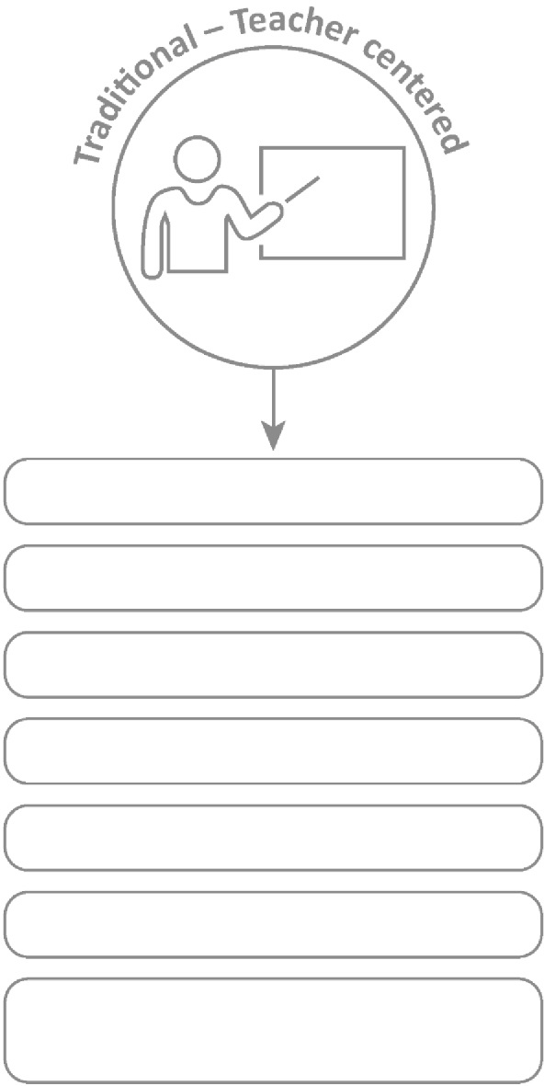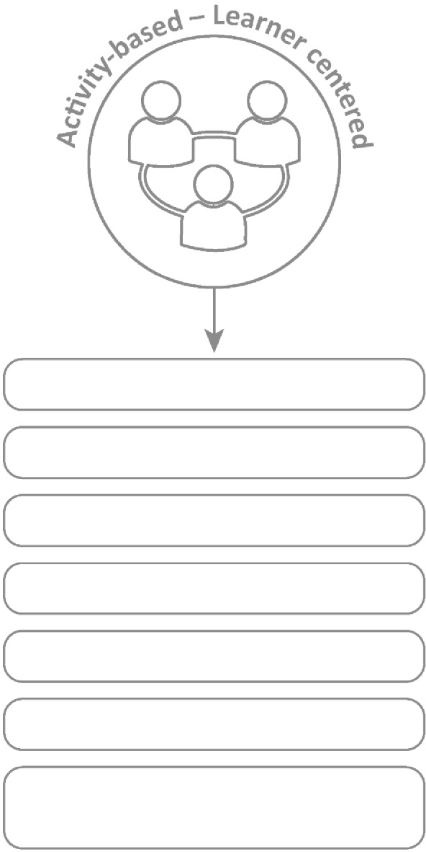



**10. Professional Development**

***10.1 Traditional vs Activity-based learning***

Projects are preferred because the learner does the work and it is activity-based learning. This leads to deeper learning.

**Basic Learning**

**In-depth learning**

**Smaller groups within class**

**Bigger class size**

**Integrated/interdisciplinary subjects**

**Isolated subjects**

**Process-oriented**

**Product-oriented**

**Learning through active involvement**

**Learning by repetition**

**Concepts questions to be investigated**

**Concepts are facts to memorize**

**Quantitative evaluation (numerical testing)**

**Authentic assessment (competencies, integrated, mindset)**

**Facing the Dragons TEACHER’S Project Notes Grade 9 | EMS | Term 3**

19



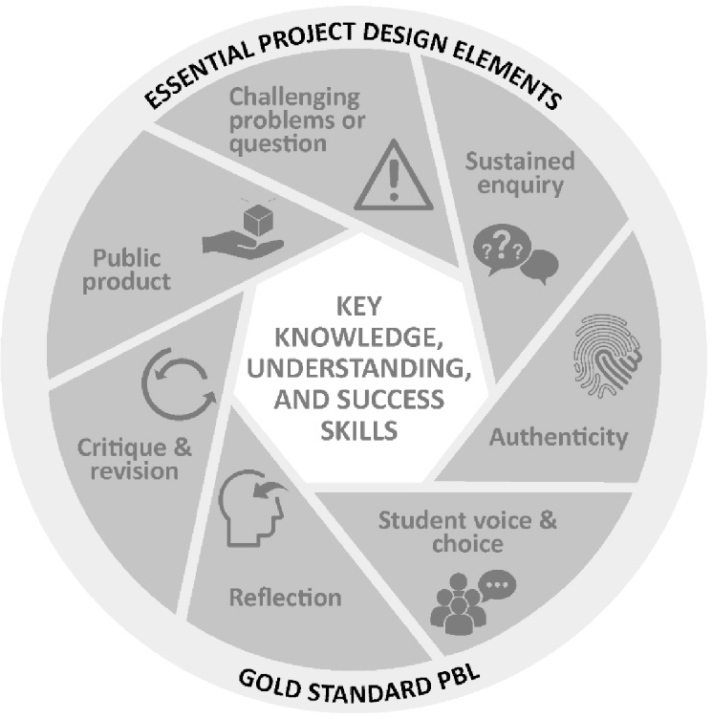

***10.2 The Project-based Learning Cycle***

Below please ﬁnd the *Key Knowledge, Understanding* and *Success Skills* to help you manage the project.

**Challenging problem or question:** Why is this project critical? What is the problem in society and at school being addressed in this project? Keep talking about how this project

will solve a local or global problem.

**Sustained enquiry:** Are learners being “researchers”?

Are they doing the research and gettingdeeper and deeper into the problem or are you doing all the talking? Look at the second circle overleaf to remind you of your role: manage activities and scaﬀold student learning. Learners must not be allowed to give up – you must “build a culture” of gettingto the bottom of the problem and

coach them when they lose their way. With time E3 will be developing thinking tools to ensure that you are equipped with strategies to take the enquiry to a new level. (See overleaf for the

current PBL learning cycle with a built-in innovation cycle.)

**Authenticity:** Keep the project real by referring to learners' own lives – this is about them and their world.

**Student Voice and Choice:** Although learners did not choose this project, make it fun and real, and applicable to their own world, so that they own it. Their voices and opinions are what your deeper goal is – encourage their views and applaud each contribution.

**Reﬂection:** To truly embed learning, learners should be able to reﬂect on what they have learned and be able to think of better ways of doing things. The reﬂection activities in the worksheets are not just for fun. Encourage learners to spend time on them as this will deepen their learning.

**Critique and Revision:** This process is to help learners experiment with their innovation and learn how to improve their work and thinking. As you assess and evaluate their products (not them!) learners will see that there are diﬀerent ways of solving problems. It is important that learners hone their curiosity and learn how to “stick it out” and keep trying, not giving up when it doesn't work ﬁrst time round.

**Public Product:** At the end of the project what does the learner have to show or to brag about? Ensure that there is a Project Culmination Week in which each grade displays their products during a week selected by the management team to ensure that as many parents and other stakeholders as possible attend.

**Facing the Dragons TEACHER’S Project Notes Grade 9 | EMS | Term 3**

20

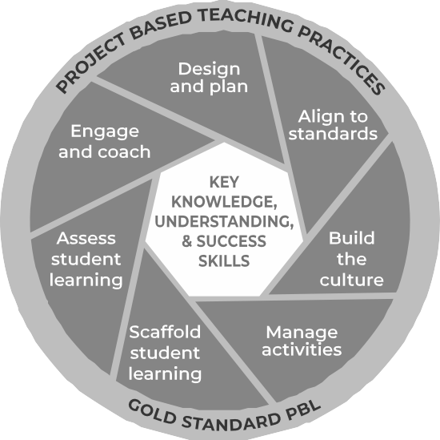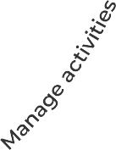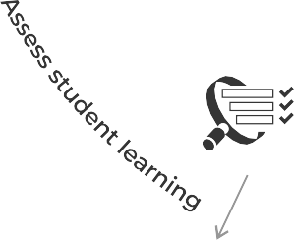

***10.3 The Project-based Learning facilitator***

***Project-based Learning: The teacher’s role as project manager***

We as teachers need to reassess our roles. The time for good lecturing has passed. The time has come to put learner needs and their problems at the centre of the lesson and to do everything in our power to make school useful for life after school, to help learners know and believe in themselves and to give them space to become problem solvers themselves... and, of course, to have fun.

Learners go to school not to WORK, but to LEARN!

**A problem arises in the learners’ world and a lesson is created around it. She knows her curriculum and this will help her to link the problem to relevant CAPS information / knowledge transfer.**

**She knows the CAPS and links her lesson to outcomes and expectations from the CAPS.**

**Her role is to pay attention to the needs of every learner and to offer them support, not via formal teaching, but by one-on-one coaching especially as they work in groups.**

**She understands that school culture plays a huge role in modeling appropriate and meaningful relationships.**

**In her classroom, there are 3 types of assessment and each is treated differently and has a different purpose.**

**She creates an authentic project, designed around practical real-life solutions. There is very little transmission teaching.**

**She understands that all learners are different in a variety of ways. She sees her role as that of supporter as each individual learner is helped to climb to the next level through her one-on-one coaching.**

**Learners are given a task with clear instructions and the teacher observes learners and helps them as and when needed. She is a classroom site and activity manager.**

**Baseline - where should we start? Formative - How are we doing, every little step of the way?**

**Summative - How did we do when tested on a chunk of work?**

**She also does not do all the marking herself - she knows that learner self and peer assessment can be powerful learning opportunities if well-managed.**

**Facing the Dragons TEACHER’S Project Notes Grade 9 | EMS | Term 3**

21

**En**

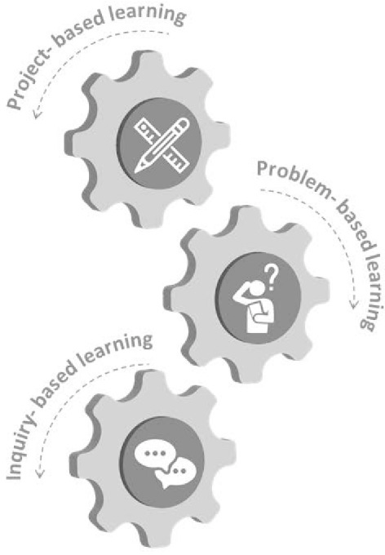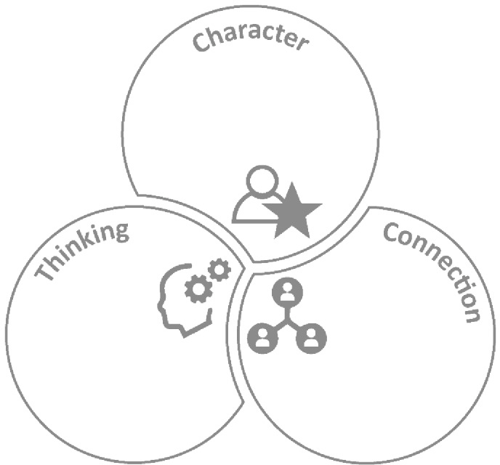



***10.4 The E3 Competencies model within the CAPS***

These appear in the competencies column of your planning. Please highlight each competency that was addressed during the lesson. Learners achieving these competencies are readier for the new world of work.

Citizenship Curiosity Resilience Mindset

Creativity Critical Thinking

Collaboration Communication Empathy

***10.5 The journey to PBL via Enquiry-based and Problem-based Learning***

* Learning by designing and building innovative products to solve complex real-world problems
* Building systems and design thinking abilities and mindsets
* Learn by engaging in complex real-world problems and developing plausible solutions
* Building critical and creative thinking and problem-solving abilities
* Learning by asking questions and engaging a topic, mastering concepts, models and theories - seeking answers
* Developing conceptual thinking and multi-literacies
* Working in groups developing communication and coordination skills

**Facing the Dragons TEACHER’S Project Notes Grade 9 | EMS | Term 3**

22

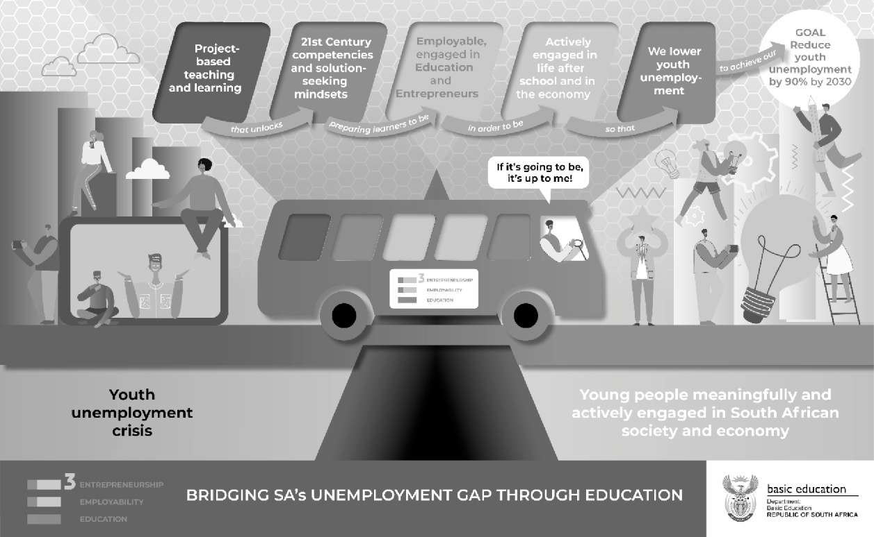



***7.9 Bridging the Unemployment gap through Education***

**Facing the Dragons TEACHER’S Project Notes Grade 9 | EMS | Term 3**

23



Email your completed form to [info@ecubed-dbe.org](mailto:info@ecubed-dbe.org) with the subject line “Teacher Agency Award submission

[**info@ecubed-dbe.org**](mailto:info@ecubed-dbe.org)

Name of your solution:

Why did you choose this name?

Identifying the problem: *(Maximum 200 words)*

*I identiﬁed the following problem in my school/community/at home:*

E3 Teacher Agency Award Form | Page 1 of 5

**Facing the Dragons TEACHER’S Project Notes Grade 9 | EMS | Term 3**

24

Name:

Position: (e.g. Teacher, SMT, etc.)

**If teacher:**

Subject taught:

Grade:

School name:

District:

Province:

**Your contact details:**

Email:

Cell number:

WhatsApp number:

**TEACHER AGENCY AWARD FORM**



Trying, adapting the process until problem was solved: *(Maximum 200 words)*

*Initially I …. Then …. Eventually I could solve the problem in this way: ……*

E3 Teacher Agency Award Form | Page 2 of 5

**Facing the Dragons TEACHER’S Project Notes Grade 9 | EMS | Term 3**

25



Collaboration and access to information: *(Maximum 200 words)*

*I collaborated with …. And accessed information f rom …. which helped me in the following ways…*

Creativity and innovation: *(Maximum 200 words)*

*My solution was very creative because I …. My solution was unique and innovative because …*

E3 Teacher Agency Award Form | Page 3 of 5

**Facing the Dragons TEACHER’S Project Notes Grade 9 | EMS | Term 3**

26



Meeting E3 standards: *(Maximum 200 words)*

Explain why you are an E3 ambassador and tribe member. Use phrases like the following in your explanation:

*I care and want to help others: ………………………………………………………...*

*I am a problem-solver:……………………………………………………………………….*

*I am awesome: …………………………………………………………………………………...*

*I am driven by purpose:……………………………………………………………………….*

*I have courage and self belief:……………………………………………………………….*

*I can keep going, despite challenges:………………………………………………………*

E3 Teacher Agency Award Form | Page 4 of 5

**Facing the Dragons TEACHER’S Project Notes Grade 9 | EMS | Term 3**

27



Provide us with each of the following (please include clear notes on the pictures and videos):

•

•

•

•

Your 4 best pictures (2 in portrait and 2 in landscape)

A VoiceNote of not more than a minute reﬂecting on your growth in this project A short video that shows an important episode in the project

If minors appear in the photos and video, please submit permission f rom parents or caregiv- ers that these photos appear on E3 platforms.

E3 Teacher Agency Award Form | Page 5 of 5

**Facing the Dragons TEACHER’S Project Notes Grade 9 | EMS | Term 3**

28